Day 43:
FTP (file transfer protocol) & TFTP (trivial file transfer protocol)
-are industry standard protocol used to transfer files over a network
-both use client-server model
-clients can use FTP or TFTP to copy files from a server
-clients can use FTP or TFTP to copy files to a server

The most common use for FTP/TFTP for network engineers is the process of upgrading the operating system of a network device
-use FTP/TFTP to download the newer version of the IOS from a server, and then reboot the device with the new IOS image
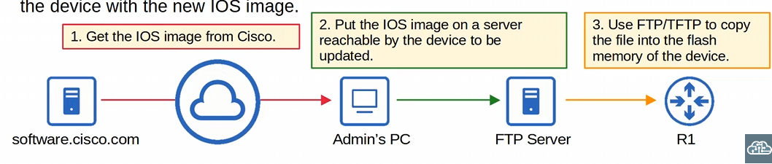
-step #4 is to reboot the device with the new IOS image

TFTP (trivial file transfer protocol)
-created after FTP, but is simpler in concept
-named trivial because it is simple and has only basic features compared to FTP
-only allows a client to copy a file to OR from a server
-not a replacement for FTP, just another tool from lightweight simplicity

-TFTP doesn’t use authentication (username/password) so servers will respond to all TFTP requests
-No encryption, so everything is in plain text

Best to use TFTP in a controlled environment to transfer small files quickly (DO NOT USE TFTP TO TRANSFER IMPORTANT FILE ON THE INTERNET)
TFTP server listen on UDP port 69
-UDP is connectionless and doesn’t provide reliability with retransmissions, but TFTP does have its own checking mechanism
-built in reliability features within the protocol itself, using acknowledgements and retransmissions

Every TFTP data message is acknowledged
-if a client is sending a file to a server the server will send ACK messages
-one for each data message
-vice versa, if a server is sending a file to a client, the client will send ACK messages
-timers are used, and if an expected messages isn’t received in time, the waiting device will re-send its previous messages

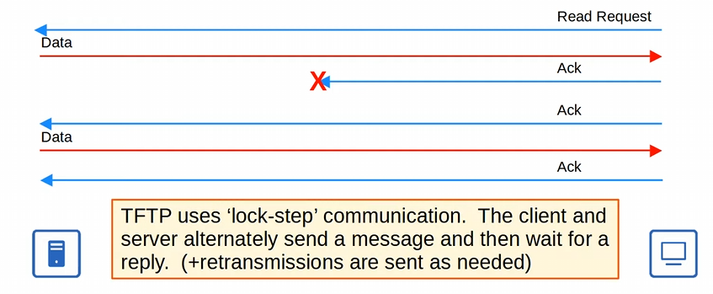
-this is built into TFTP
-client or server will send a message, wait for a reply ACK, send a message, wait for a reply … all the way till the full file is transferred
-server will not send two data messages in a row
-except in the case of retransmission
-this alternate message exchange between server and client is call Lock-Step communications
TCP uses the three-way handshake, and then forward acknowledgement with its sequence (and might uses a sliding window for the sequence) and ACK numbers then terminates its connection with the four-way handshake

TFTP only uses lockstep communication within UDP
-this method of reliability isn’t as efficient as TCP’s method of sliding window and forward acknowledgement, but its good enough for TFTP

TFTP connections
TFTP file transfers have three phases:
- Connection: the TFTP client send a request to a server, and the server responds back, initializing the connection
- Data Transfer: the client and server exchange TFTP messages. One sends data and the other sends acknowledgements
- Connection Termination: After the last data message has been sent, a final acknowledgement is sent to terminate the connection
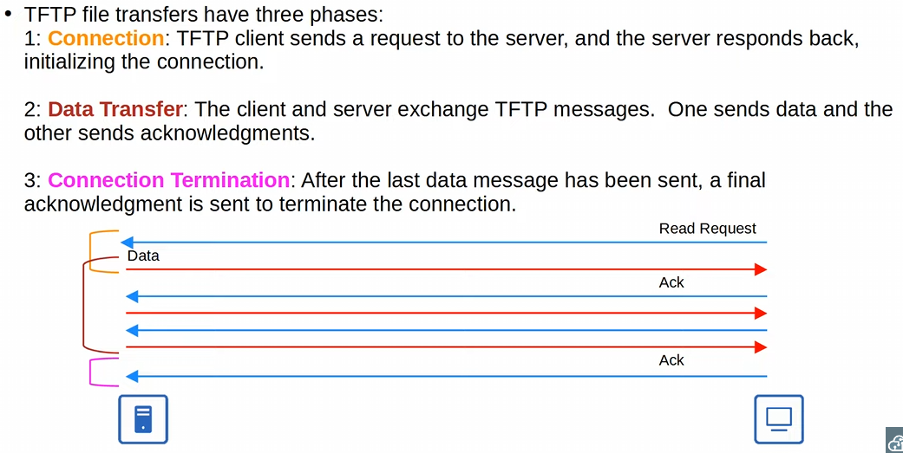
-connection has the read request and the first ACK, data transfer is in the middle, and connection termination is the final ACK message
-TFTP does have a basic way to manage connections within its own protocol while using UDP

When the client sends the first message to the server the destination port is UDP 69, and the source is a random ephemeral port
-in TFTP this random port is called a Transfer Identifier (TID) and identifies the data transfer
-interestingly, the server than also selected a RANDOM TID to use as the source port when it replies
-IT DOES NOT USE UDP 69!
-when the client sends the next message, the destination port will be server’s TID, NOT 69

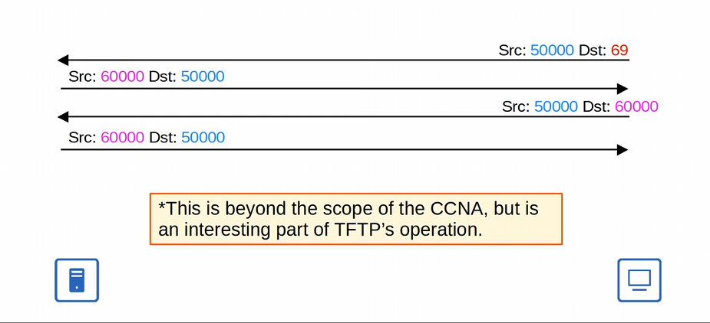
-port 69 in TFTP is only used once during the read request of the connection phase (not used in the reply ack
-TID uses a random ephemeral port for both destination and src afterwards!

FTP is an old protocol that was used before TCP & IP
-it has been updated since
FTP uses TCP port 20 and 21
-FTP control TCP 21
-FTP data TCP 20

FTP uses usernames and passwords for authentication
-unlike TFTP
-however, FTP does not use any encryption just like TFTP
-username and password are sent in plaintext

-For greater security use FTPS (FTP over SSL/TLS) can be used
-also known as FTP secure
-this is an upgrade to FTP

-SSH File Transfer Protocol (SFTP) can also be used for greater security
-SFTP is a new different protocol entirely, doesn’t deal with FTP

FTP is more complex than TFTP and allows not only file transfers, but clients can also navigate file directories, add and remove directors, list files, etc.
-in TFTP the client could only tell the server hand me the file or take this file, couldn’t even ask the server what files it had

The client sends FTP commands to the server to perform these functions

FTP uses two types of connections:
-FTP control connection (TCP 21) is established and used to send FTP commands and replies
-the data transfer uses the data connection (TCP 20) when files or data need to be transferred
-connections are established are terminated as needed
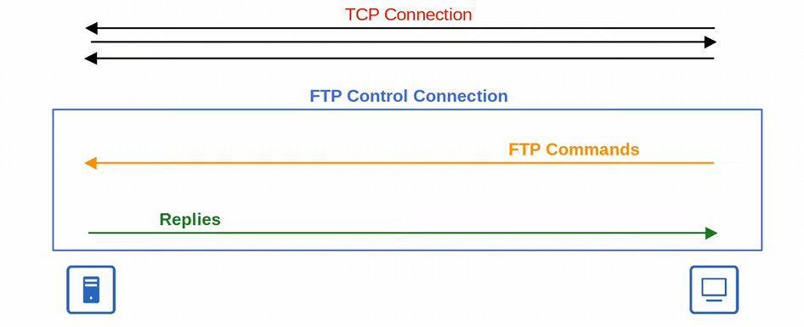
-the client initiates the connection with the usual TCP three-way handshake
-syn, syn ack, ack
-afterwards, the FTP control connection is established, where the client will send FTP commands and the server will reply to acknowledge the command
-Now we need an FTP data connection to transfer the data that the FTP command requested

Two different modes to establish an FTP data connection: Active Mode & Passive Mode

Active mode: the server initiates the TCP connection (default method)
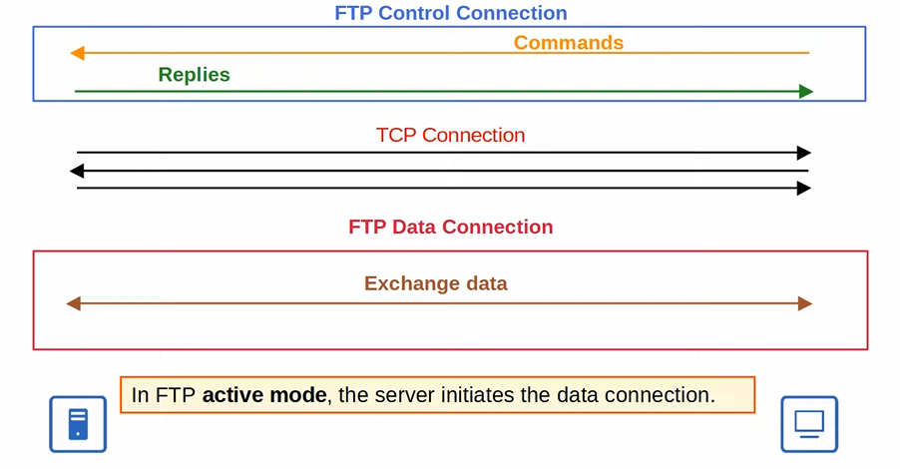
-the data connection needs to go through its own three-way handshake since it’s using a new TCP connection
-in FTP active mode the SERVER initiates the data connection
-FTP control connection is maintained throughout the whole process
-there are TWO active connections

Passive mode: the client initiates the data connection
-it is necessary when the client is behind a firewall, which could block the incoming connection from the server

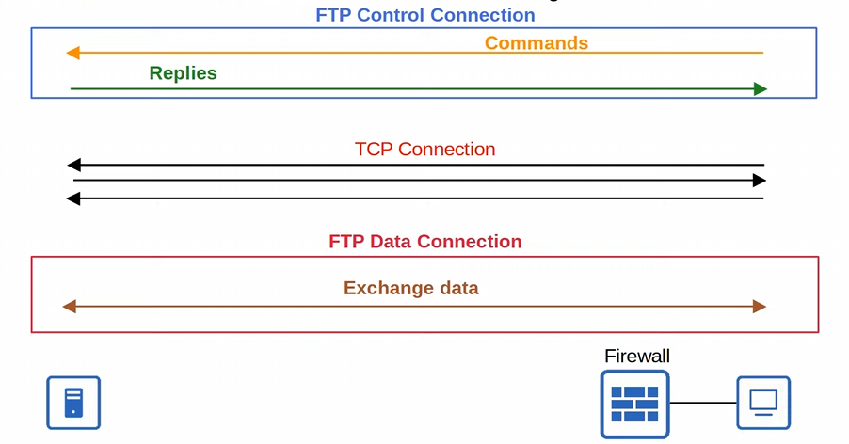
-The client is now behind a firewall which prohibits an active FTP mode
-the client needs to initiate the connection with FTP passive mode
-The control connection (TCP 21) is initiated by the client just like active mode
-Next, the TCP SYN message of the three-way handshake is sent by the CLIENT, not the server
-once the FTP data connection is established the data is exchanged

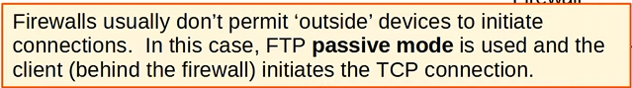
-the key difference between Active FTP mode and Passive FTP mode is who initiates the data connection’s first SYN message in the three-way TCP connection
-Active is the server
-Passive is the client
-firewalls will not permit outside devices to initiate connections
Theres is much more to FTP, but this is as far as we need to know for the CCNA

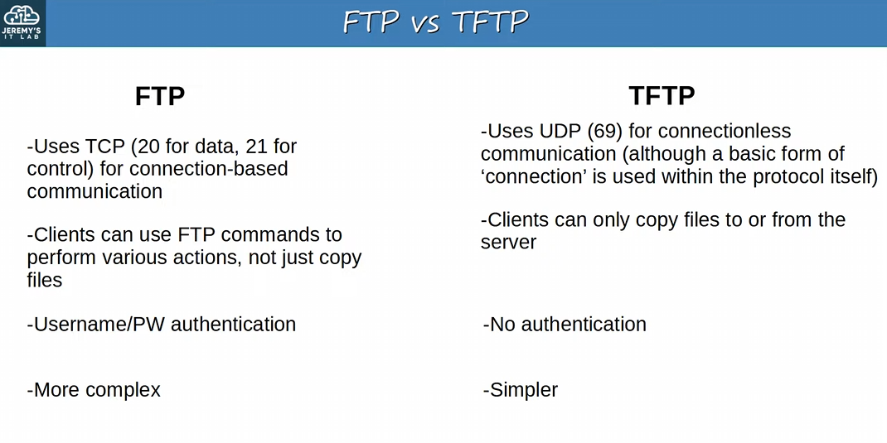

IOS File Systems
-a file system is a way of controlling how data is store and retrieved
-organizes files and directories, and keeps track of which area of the media belongs to which file
-using the command “show file systems” you can view the file system of a cisco IOS device
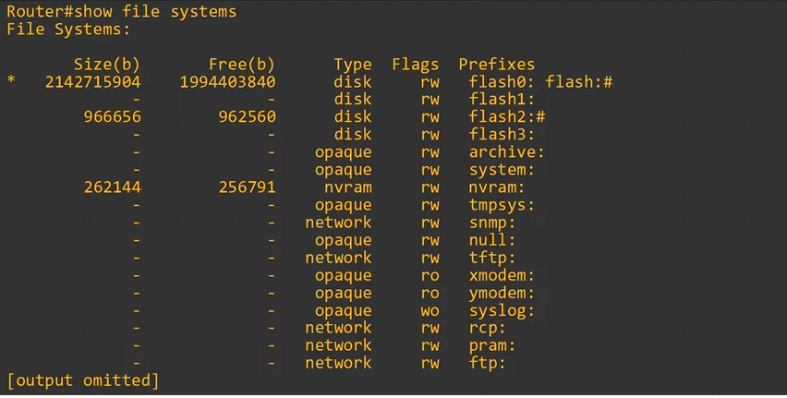
-types of file systems
-Disk type: storage devices such as flash memory (usually where cisco IOS stored)
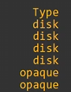
-Opaque type: used for specific internal functions (logical internal systems, not separate storage devices)
-NVRAM type: is the nonvolatile RAM where the startup-config is stored
-NVRAM isn’t like RAM, which loses all its memory when the device powers down
-Network type: represents external file systems, for example external FTP/TFTP servers

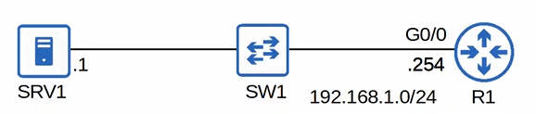
-R1 is a cisco router running an old cisco IOS we want to update
-we downloaded the new version of IOS and saved it on SRV1
-SVR1 is running both TFTP and FTP

-first, we want to see the current version of IOS on R1 with “show version”
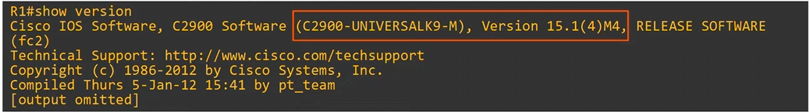
-not important for FTP/TFTP, but notice the K9 (supports cryptographic features like SSH)
-we also see the version of IOS R1 is uses as well

You can view the contents of flash with “show flash”
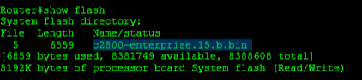
-we can see the IOS image here as well (using netsim for myself)

Now that we know we are working with an old IOS image, we will be using TFTP to copy a newer version of IOS from SRV1 to the flash of R1, configure to boot R1 to the new IOS, and lastly delete the old version of IOS from flash
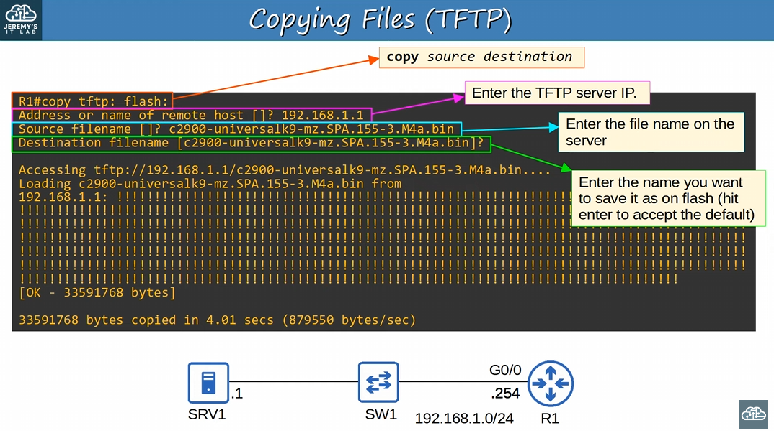
-to copy files using TFTP use the command “copy tftp: <destination:>”
-by using tftp as the source (“copy tftp: flash:”) you tell the router you want to access a TFTP server
-router then asks for the TFTP server IP

-router then asks for the source filename
-the name of the file you want to download
-TFTP can’t find the file names on the server, so you need to know beforehand

-router then wants the name you want to save it as on flash (just hit enter)

-Finally, its downloaded via TFTP

Next, we want to boot R1 on the new IOS, and finally delete the old IOS
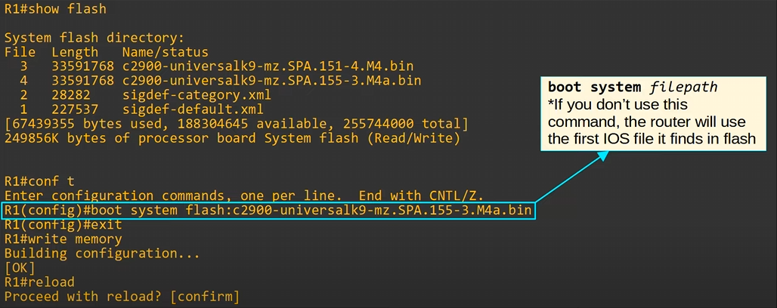 -we use “show flash” to check the contents of flash, and we see the new IOS
-from global config mode, use “boot system <insert filepath>”
-if you don’t use this command, the device will use the first IOS system it finds in flash
-then finally you need to save the configuration in startup-config

-reload the device with “reload”, to boot the system up with the new IOS
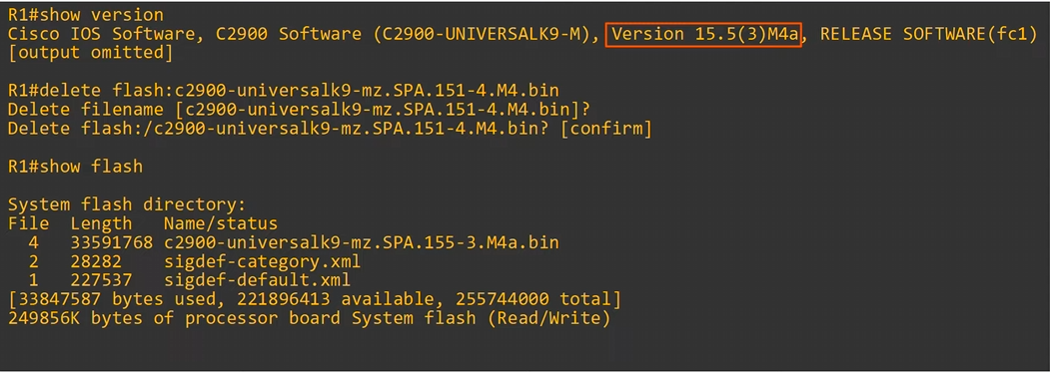
-we can see the new IOS version 15.5 is now used with the command “show version”
-to delete the old IOS, use the command “delete flash: <file path>”

Now for FTP
-we will only show how to transfer the file from server to the router, the selecting boot file, saving the config, and deleting the old IOS is the same as TFTP
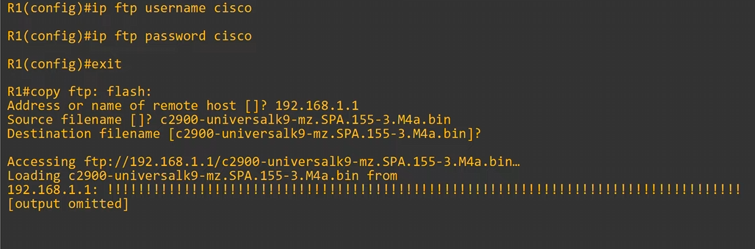
-first, we need to set the username and password we plan to use in FTP
-“ip ftp username <user>” & “ip ftp password <password>”
-FTP authenticates using a username and password
-then we use the command “copy ftp: <location:>”

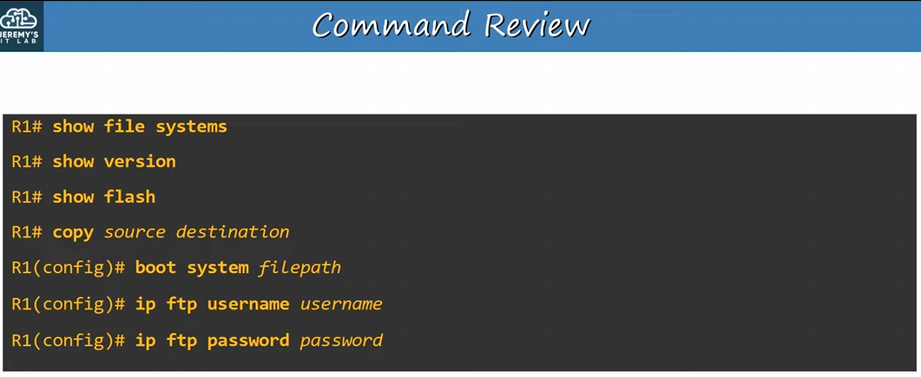

Day 44:
NAT: network Address Translation
-used to translate the source and/or destination IP address of a packet to a different ip address

Private IPv4 address (RFC 1918): IPv4 doesn’t provide enough addresses for all devices that need an IP address in the modern world
-long term solution is to swap over to IPv6 (but it’ll take a long time)
-dual stacking IPv6 and IPv4 addresses
-short term solution is CIDR, NAT, and private IPv4 addresses

-the private IPv4 ranges are: 10.0.0.0 /8, 172.16.0.0 /12, and 192.168.0.0 /16 (Important)
-10.0.0.0 - 10.255.255.255 /8 contains Class A
-172.16.0.0 - 172.31.255.255 /16 contains Class B
-192.168.0.0 – 192.168.255.255 /24 contains Class C

-containing these classes doesn’t mean /12 is class B ( /16), it just means that it has Class B within its range

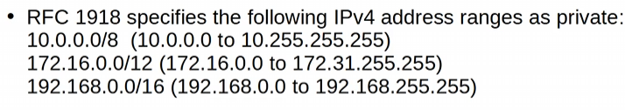
-free to use these addresses in your network, and they don’t need to be globally unique
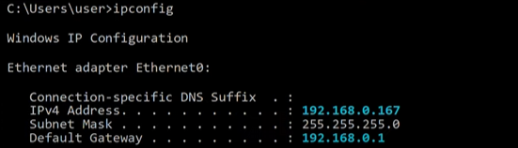
-private IP addresses cannot be used over the internet (ISP will drop the traffic)
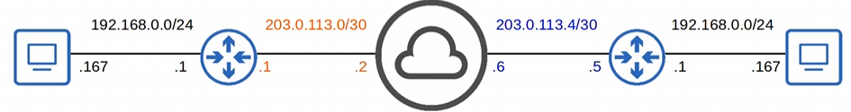
-without NAT, the two PCs would have duplicate address: 192.168.0.167, and private IP addresses cannot be used over the internet
-even though the private IP addresses are not unique, the Public IP address need to be unique
-the router will change the private IP address into a public IP address that is unique whenever the PC needs to reach a destination over the internet with NAT
-all devices within the home can use that singular public IP address to access the internet all at the same time

-PC on the left can use the public IP address 203.0.113.1 on the public internet
-PC on the right can use the public IP address 203.0.113.5 on the public internet

REMEMBER Private IPv4 addresses = RFC 1918!

NAT: is used to modify the source and/or destination IP address of packets
-the most common reason for using NAT is to allow hosts with private IP addresses to communicate with other hosts over the internet
-in addition, hosts in a LAN share a single IP address
-just need to understand source NAT for CCNA and its configuration

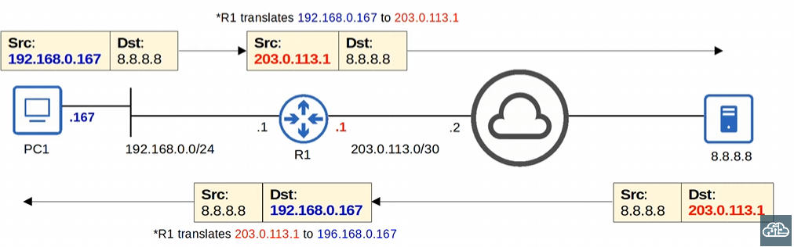
-example of source NAT, where R1 changes/translates the IP packet source IP
-PC1 sends the packet to its default gateway, R1, and this is where the NAT occurs
-DG/R1 changes PC1’s packet source address from 192.168.0.167 to its interface IP address facing the internet, 203.0.113.1
-there are other types of NAT that don’t use the interface facing the internet

-the packet arrives to 8.8.8.8, which responds back and uses the R1 interface IP address as the destination
-the Router receives the packet and translates the destination back to PC1’s IP with NAT, and sends it off to PC1
-this IS NOT DESTINATION NAT, R1 is reverting the previously translated address back to PC1’s actual IP address

Static NAT: involves statically configuring one-to-one mappings of private IP addresses to public IP addresses
-it doesn’t need to be private to public, you can NAT any address to any other address
-inside local IP address is mapped to an inside global IP address
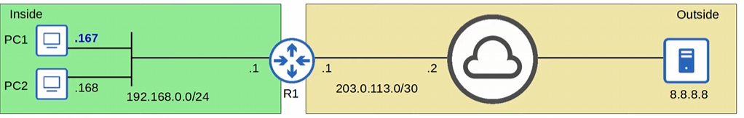
-inside local: the IP address the host has within the LAN
-the IP address configured on the inside host, usually a private address
-Inside Global: the IP address of the inside host, from the perspective of OUTSIDE hosts
-the IP address of the inside host AFTER NAT, a public address

-The Inside local address is translated into the inside global address
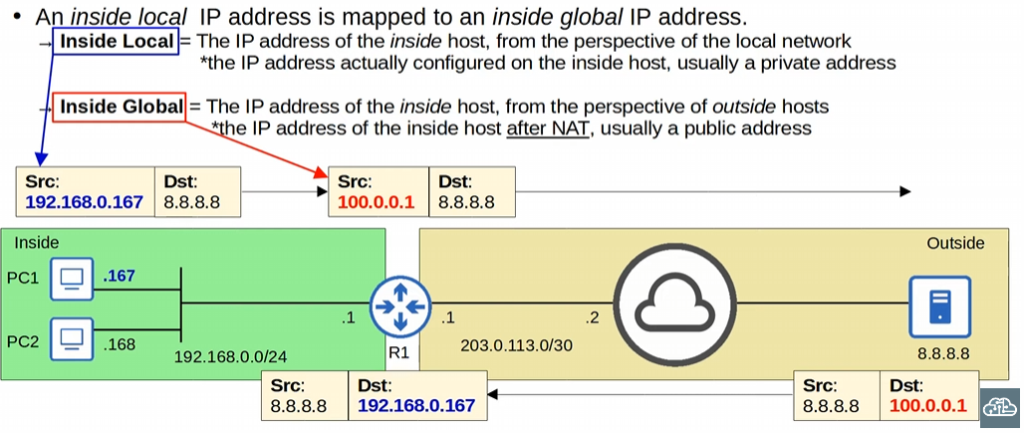
-in static NAT we aren’t using R1’s interface IP, this is a separate public IP address reserved just for PC1
-from the server perspective it’s communicating with the inside global address, not the inside local address
-it’s not communicating with the IP address configured on PC1, its communicating with the inside global address configured on R1

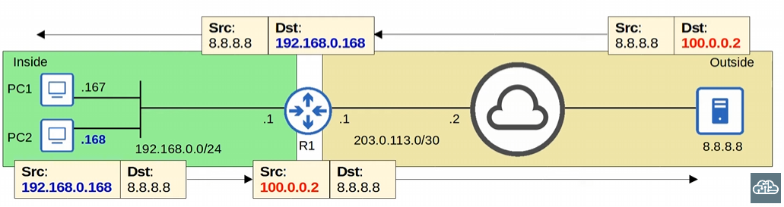
-if PC2 wants to communicate with the internet, it needs its own inside global address
-PC1 has the address of 100.0.0.1 and PC2 is 100.0.0.2
-IMPORTANT: Static NAT does not preserve IPv4 address, since static NAT uses 1-to-1 inside local -> inside global address translation

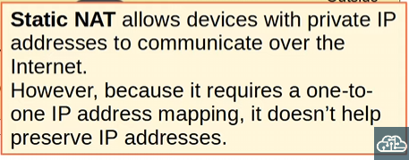
-for the purposes of preventing IPv4 exhaustion, static NAT is not useful for us

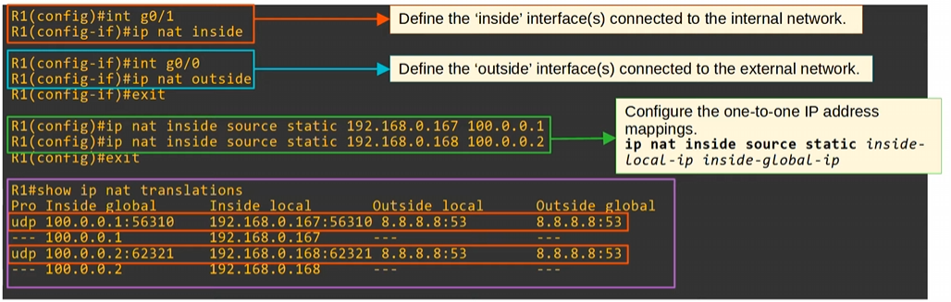
-to configure static NAT we need to define the inside and outside interfaces
-on the inside interface use the command “ip nat inside”
-on the outside interface use the command “ip nat outside”

-next we configure the network translation with “ip nat inside source <inside local IP> <inside global IP> ”
-to use the inside global IP your company needs to own the IP address

-to see what NAT we have on a network use the command “show ip nat translation”
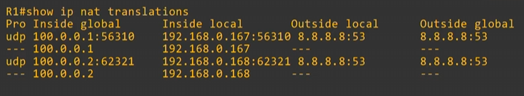
-you can see the inside local and global address
-pro: protocol that was use (UDP in this case)
-these are the port numbers listed out
-for static NAT you don’t have to worry about port number (only care when PAT is involved)
-the port number stay the same even after the IP has changed
-dynamic entries can appear on this table as well

-Outside local: the IP address of the outside host from within its own LAN
-Outside Global: the IP address of the outside host outside the outside host’s LAN
-tricky to think about, but it means why will other devices on the internet see as an IP address

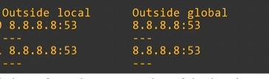
-the outside local and outside global addresses are the same
-unless destination NAT is used, these two addresses will be the same
-not going to be on the CCNA so just expect these two to be the same

-Port 53 with protocol UDP is DNS (TCP is used for DNS messages greater than 512 bytes)

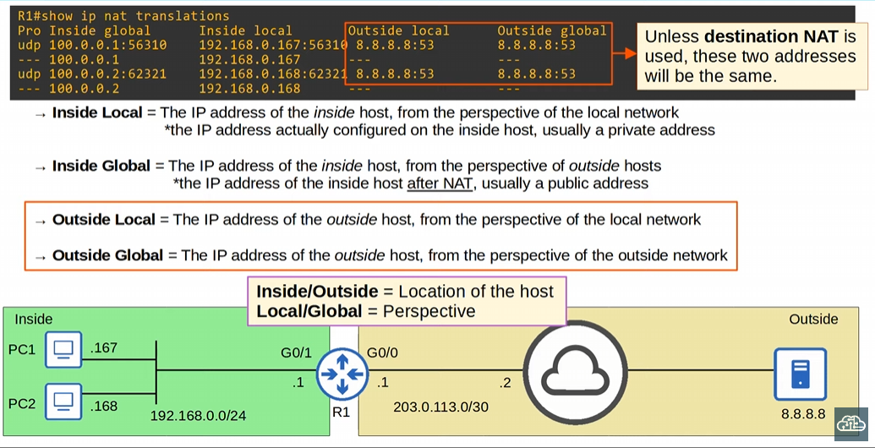

-Inside and outside indicate location of host
-local and global indicate perspective

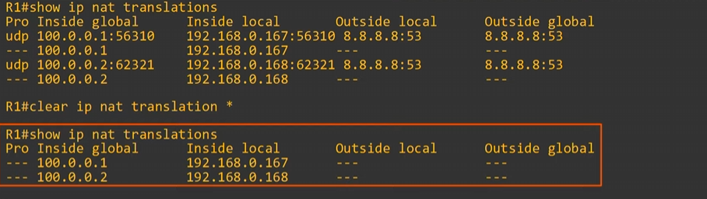
-“clear ip nat translation *” clears the dynamic entries (don’t forget the *)
-the static entries cannot be deleted unless you remove the “ip nat inside source static <inside local IP> <inside global IP>” commands !!!

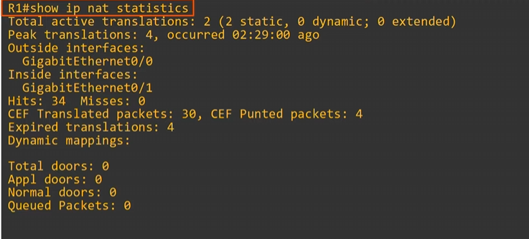
-“show ip nat statistics”
-will show active translations and what kind of NAT translation it is

-peak translations is the highest number of translations that has occurred

-you can also see the inside and outside interfaces that NAT uses
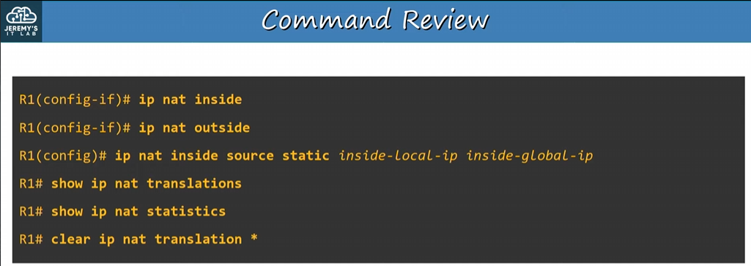
-just specify the inside and outside interfaces, and then configure the NAT translation

IMPORTANT: know inside local, inside global, outside local, and outside global

if you have already statically mapped a private IP to a public IP address, if you try to map another private IP to that same public IP, the command will be rejected
-only 10.0.0.1 will be translated to 20.0.0.1

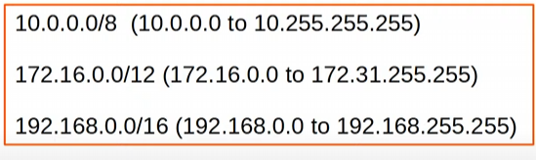
-RFC 1918

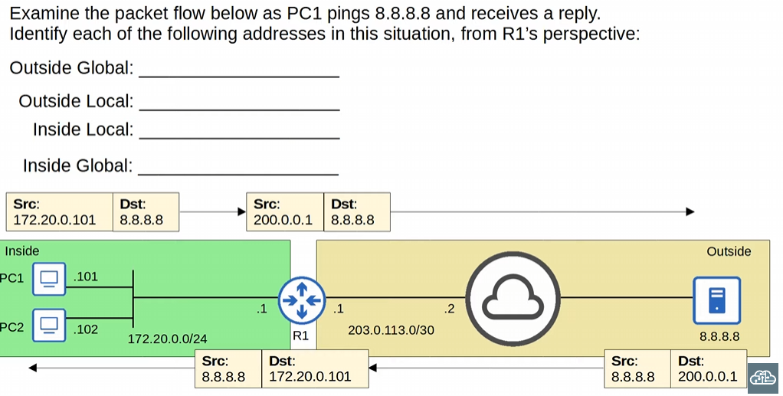
-Outside global: 8.8.8.8
-Outside local: 8.8.8.8
-Inside local: 172.20.0.101
-Inside global: 200.0.0.1

-can use the command “show ip nat translations” to confirm

Day 45:
We will focus on dynamic NAT, and Dynamic PAT
-PAT doesn’t only translate ip address, but port number

Static NAT is 1-to-1 mapping of private IP address to public addresses

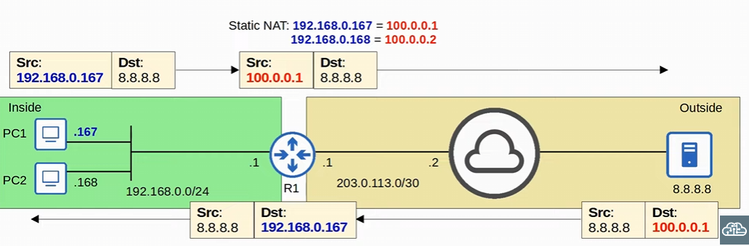
-static NAT
-this 1-to-1 mapping ALSO allows external hosts to access the internal host via the Inside global address
-works two ways, not just inside to outside, but outside to inside as well

Dynamic NAT: the router dynamically maps inside local addresses to inside global addresses as needed
-which is different than static NAT that does 1-to-1 addressing statically
-router will dynamically choose, and clear the dynamic entry when it’s no longer needed

-An ACL will be used to select which traffic will be chosen
-ACLs can be used to accept traffic or block traffic, but ACLs can ALSO be used to identify traffic
-if the source IP is permitted by an ACL, the source IP will be translated by NAT
-if the source IP is denied by an ACL, the source IP will not be translated by NAT
-traffic isn’t be dropped here, just not translated

We are not dropping the traffic, because its not being applied to an interface

Dynamic NAT will use a NAT pool to define the available inside global addresses
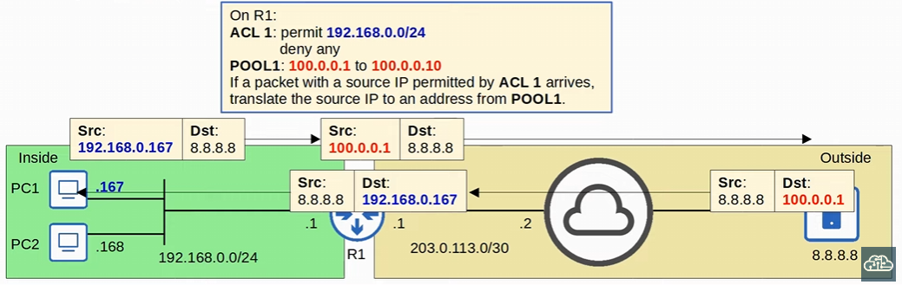
-On R1 we configured ACL 1, and set up a pool of addresses
-if the address fits the ACL list and is permitted, use one of the addresses in the Pool of addresses to translate the IP address into
-R1 automatically chose an address

IMPORTANT: if the source IP address doesn’t fit the ACL, the traffic will NOT be dropped
-It will NOT be translated

Although Dynamic NAT are dynamically assigned, the mapping is still one-to-one
-one inside local IP address per inside global address

NAT Pool Exhaustion: aren’t enough inside global IP addresses available for translation
-all inside global IP addresses are being used
-if there is no available address and a packet arrives needing NAT, the router WILL DROP the packet
-the host will be unable to access outside networks until one of the inside global addresses becomes available

-dynamic NAT entries will time out automatically if not used, or you can clear them manually
-“clear ip nat translation *” manually
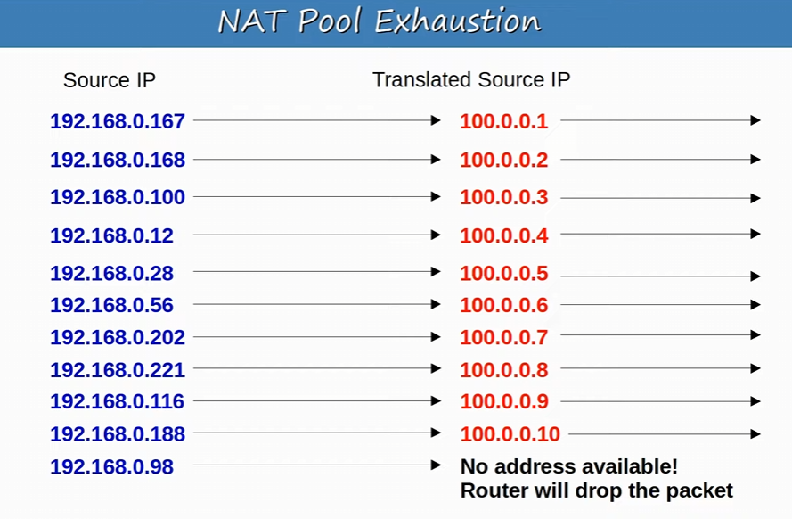
-the pool of available addresses has become filled
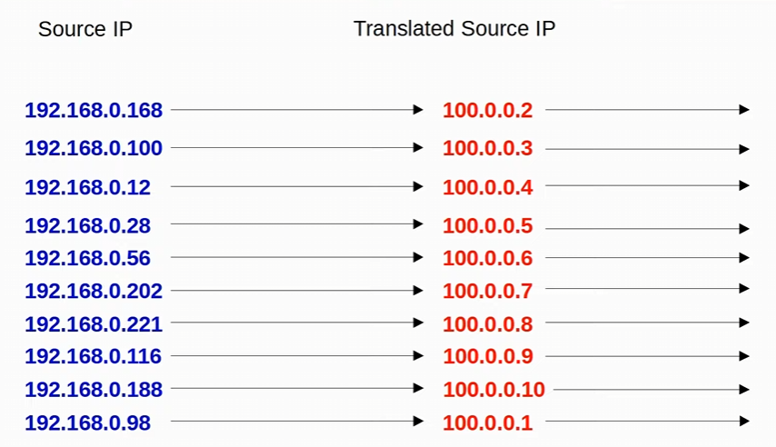
-192.168.167 timed out, and 100.0.0.1 becomes available to use
Static NAT vs Dynamic NAT
-both are one-to-one mappings
-static NAT mappings are permanent, dynamic NAT mappings are temporary
-wait for a time out or manual clearing

To use the same inside global address, we need to use PAT ( port address translation)
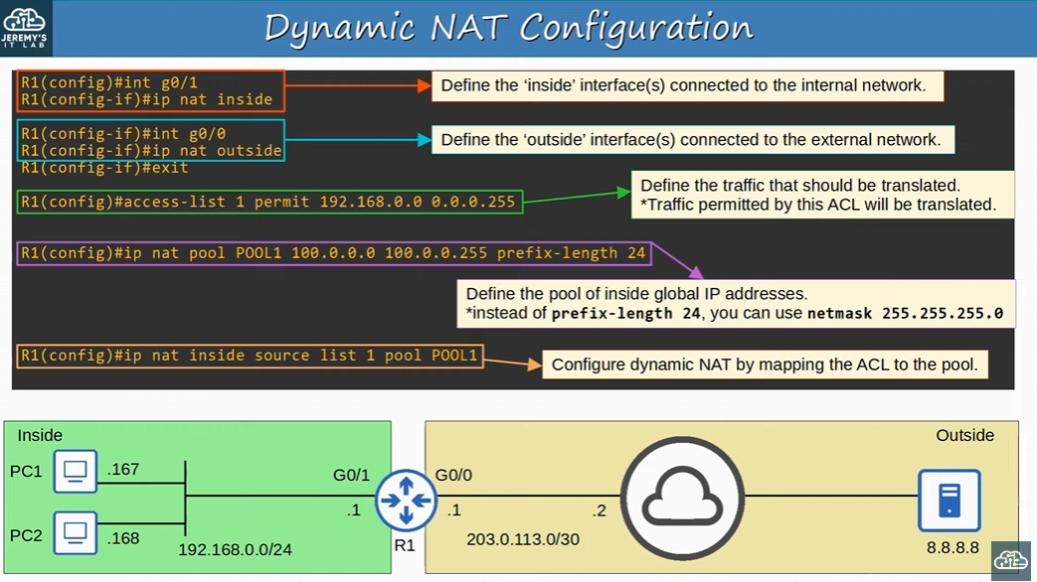
-just like static NAT, need to define the inside and outside interfaces
-go into inside interface config mode and use “ip nat inside”
-go into outside interface config mode and use “ip nat outside”

-configure the standard ACL “access-list permit <ip address> <subnet mask>”

-next create the NAT pool “ip nat pool <pool name> < lowest inside global IP address> <highest inside global IP address> netmask <mask>”
-you can use prefix-length instead!

-then set the ACL to the NAT pool with “ip nat inside source list <acl name> pool <pool name>”
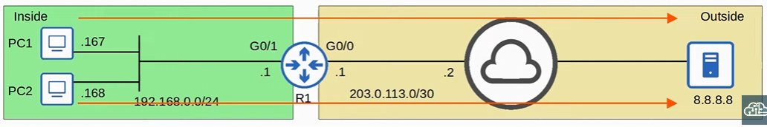
-sent ping traffic to 8.8.8.8
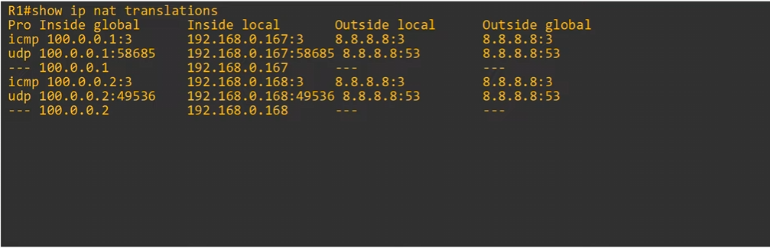
-“show ip nat translations”
-went the router dynamically translated inside local to inside global, these are the entries
-when the translations are made, separate entries like the UDP and ICMP entries are created off them
-the UDP and ICMP entries will be cleared after a minute
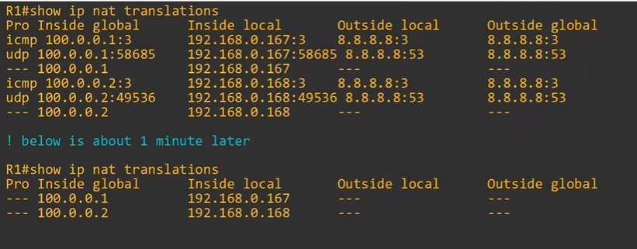
-the original dynamic mapping will stay for 24 hours!
-every time a translation is made, the dynamic mapping timer will reset
-if you use the “clear ip NAT translation *” command these entries will be cleared
-only static entries will stay, and these entries are dynamic
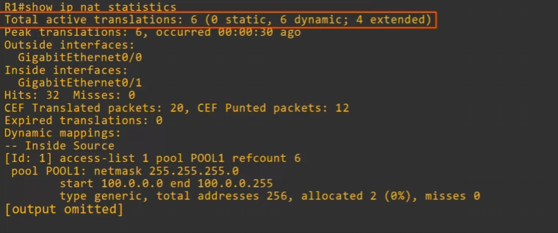
-the extended dynamic entries are the ICMP and UDP entries that were made of the dynamic entries

-you can see ACL 1 mapping to Pool 1 in the “show ip nat statistics” command !!!

-remember “show ip nat translations” & “show ip nat statistics”

PAT (aka NAT overload) translated both the IP address and the port number (if necessary)
-by using a unique port number for each communication flow, a single IP address can be used by many different internal hosts
-port numbers are 16 bits= over 65000 available port numbers

-Router will keep track of which inside local address is using with inside global address AND port
-router will keep track of communication flows by using unique port numbers for each flow!
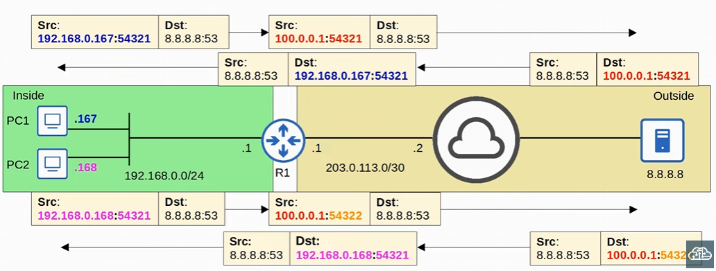
-PC1 and PC2 are using the same inside global address, with DIFFERENT port address numbers
-PC1 and PC2 is sending a DNS message to port 8.8.8.8 with a random source port number
-both pc1 and pc2 are using the same random source port number, but this doesn’t matter
-router 1 keeps PC1’s source port number the same and translates the IP address
-router 2 CHANGES PC2’s source port number and also translate the IP address
-changes the source port number to keep track of the flow with a unique port number

-CANNOT have PAT for two end hosts using the same translated NAT inside global IP and same port number once the packet is global, needs to have a unique port number in the global end (aka once it’s sent out the router)
-the router will then translate the traffic back to its original port and IP address once the packet comes back into the local area
-source port gets translated if end hosts use the same random source port!!

Because many hosts can share a single public IP, PAT is very useful for preserving public IP addresses, and it’s used in networks all over the world
-PAT (aka NAT overload) is the most widely used in networks!
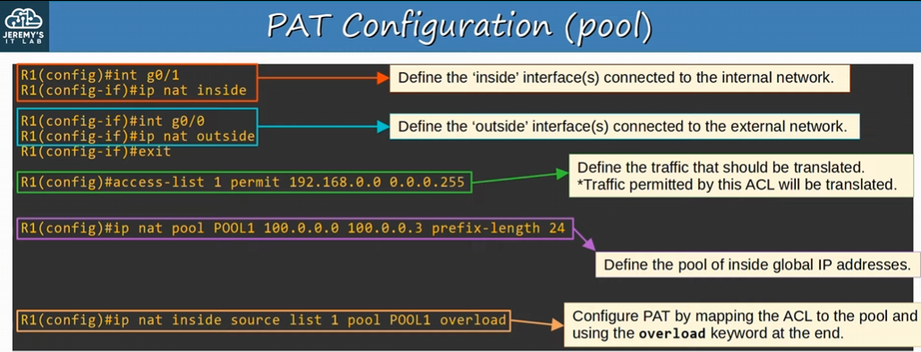
-define inside port “ip nat inside” & outside port “ip nat outside” on interface mode
-set up the standard ACL for what IP traffic will be dynamically chosen “access-list <ACL #> permit <ip address> <wildcard mask>”
-then create the NAT pool “ip nat pool <pool name> <lowest inside global> <highest inside global> prefix-length <prefix length>”
-map the pool to the ACL “ip nat inside source list <acl> pool <pool name> overload”
-the difference between dynamic NAT configuration and PAT is just adding overload to the mapping command

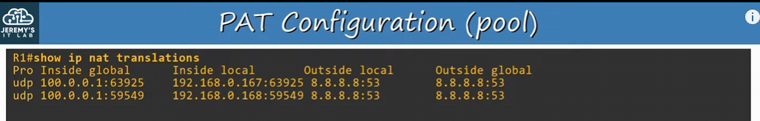
-when using “show ip nat translations” you can see there are no one-to-one dynamic mappings
-PAT is MANY-to-one, many inside local addresses to one inside global address

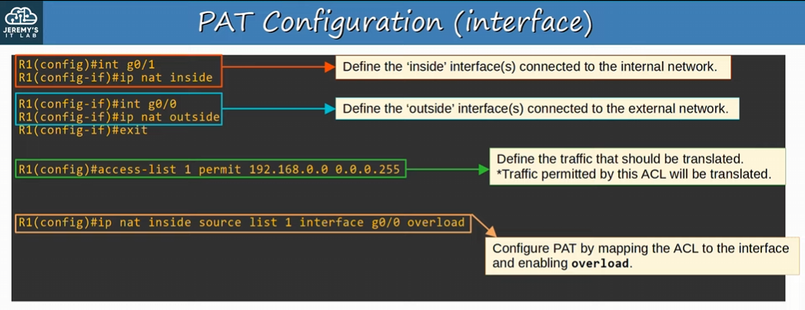
-different way to configure PAT
-configuring the router to use its own public IP address (more common way)
-we aren’t using a pool of addresses, just the outside interface IP address

-denote the inside and outside interfaces in int config mode with “ip nat inside” & “ip nat outside”
-create the standard ACL “access-list <acl #> permit <ip address> <wildcard mask>”
-finally create the mapping of the interface to the ACL range “ip nat inside source list <acl #> int <interface number> overload”

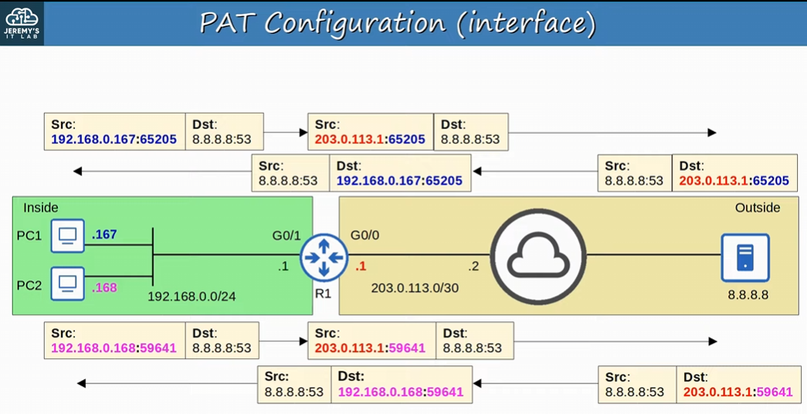
-both source port numbers are different, so no need to translate the port numbers
-R1 is just using its outside interface IP address to translate into the local global address

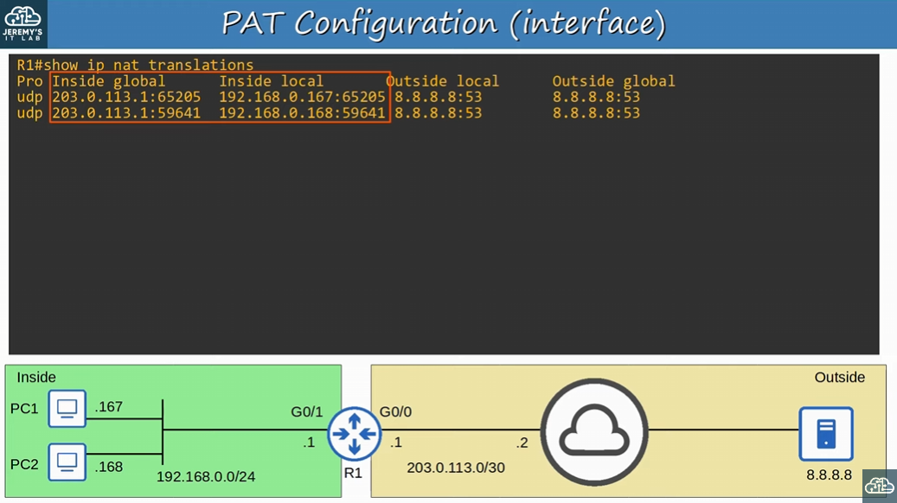
-the source port numbers are already unique, so there’s no need for the router to change the port number
-using R1’s g0/0 ip address
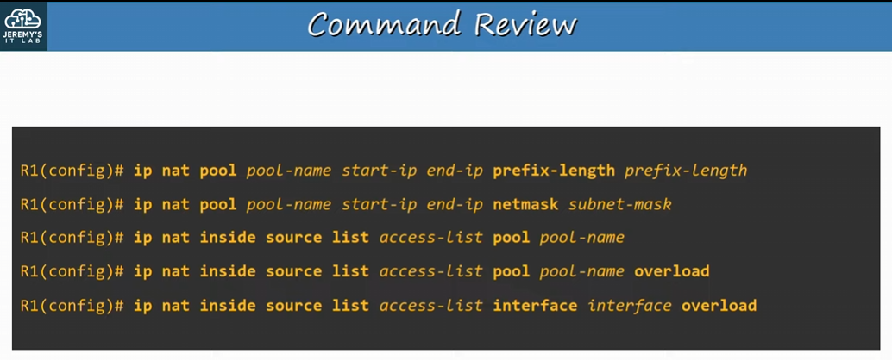

Day 46:
QOS: Quality of Service
-gives priority to certain types of network traffic to minimize delay and packet loss

PoE: Power over ethernet
-devices will receive power over an ethernet cable instead of a separate power cable

Voice VLANs

IP phones uses QOS, PoE, and Voice VLANs

Traditional phones operate over the PSTN (public switched telephone network)
-also known as POTS (plain old telephone service)

IP phones use VOIP (Voice over IP) technology to enable phone calls over an IP network, such as the internet
-audio data is encapsulated in IP packets and sent over the network
-IP phones are connected to a switch just like any other end host
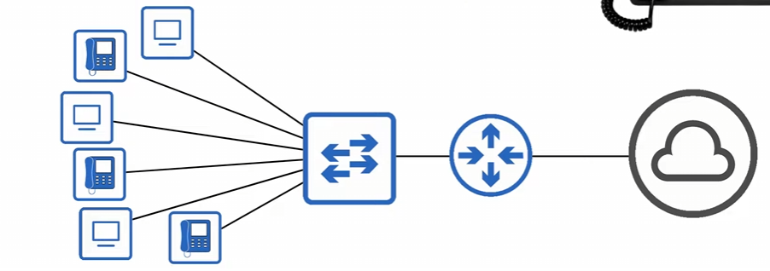
-can use this topology, but there is a better way to hook up IP phones
-IP phones have an internal 3-port switch

IP phone internal 3-port switch
-1 port is the ‘uplink’ to the external switch
-1 port is the ‘downlink’ to the PC
-1 port connects internally to the phone itself!

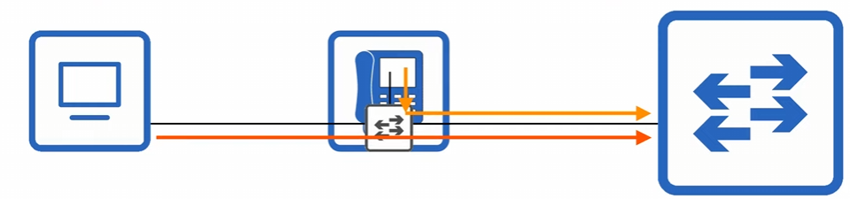
-these are using an ethernet cable
-with the IP phone internal 3-port switch, the PC and the IP phone share a single switch port
-traffic from the PC passes through the IP phone to the switch
-traffic from the IP phone can also go through to the switch as well

-IMPORTANT: it’s recommended to separate ‘voice’ traffic (from the IP phone) and ‘data’ traffic (from the PC) by place them into separate VLANs!
-when configuring QOS, we want to specify what’s voice traffic, and what’s data traffic, and give the voice traffic a higher priority
-separate VLANS, by configuring a Voice VLAN

-When we create a voice VLAN, traffic from the PC will be untagged, but traffic from the phone will be tagged with a VLAN ID

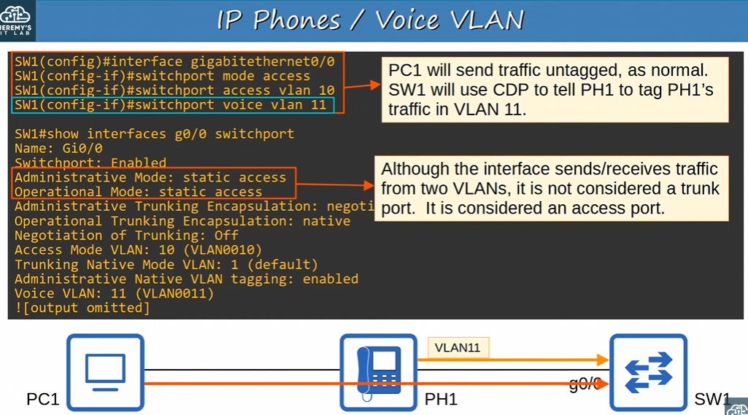
-like before with access ports connecting to end host, we go into interface config mode and use the command “switchport mode access”, set the VLAN of the access port with “switchport access vlan <vlan>”
- next we configure the voice vlan with “switchport voice vlan <vlan>”
-made sure to use a different VLAN than the vlan configured for the PC

-PC1 will send untagged traffic (like access ports typically do), BUT sw1 will use CDP to tell the phone to tag the phone’s traffic in VLAN 11!!!
-another use of CDP

-despite SW1’s g0/0 interface is carrying multiple VLANs on its link, THIS IS NOT A TRUNK PORT
-this is STILL an ACCESS PORT!
-we can use “show int <int> switchport” to see SW1’s port is still an access port

We can also use the command “show interfaces trunk” or “show int <int> trunk”to see if g0/0 is still an access port after carrying a voice VLAN and data VLAN (multiple VLANs)
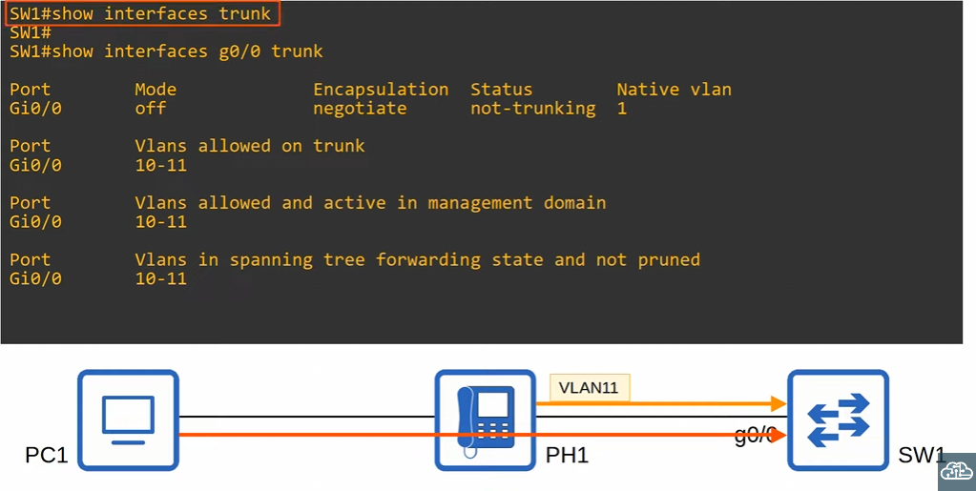
-even though it says ‘VLANs allow on trunk’, its not trunking. Just a weird CLI thing

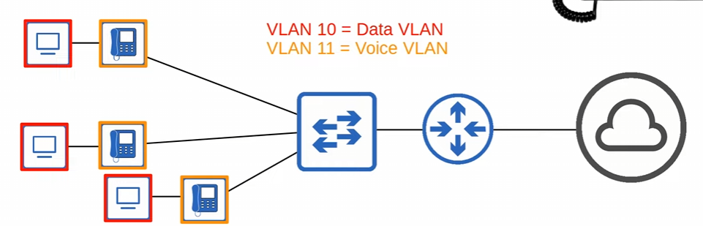
-always separate the voice VLAN and data VLAN, and configure the switch interface to be an access port
-instead of using 6 interfaces before, we are using 3 here!

-we don’t need to even plug the IP phones into a wall socket for power, we can use PoE

PoE (power over ethernet) allows power source equipment (PSE) to provide power to Power devices (PD) over an ethernet cable
-PSE is typically a switch, and PDs are IP phones, IP cameras, WAP, etc.
-the cable will both do data transmission, and power at the same time
-the PSE receives AC power from the outlet, converts it in DC power, and supplies that DC power to the PDs
- for example, switch takes the AC -> DC as a PSE, and the IP phone will use the DC power supplied over the ethernet cable

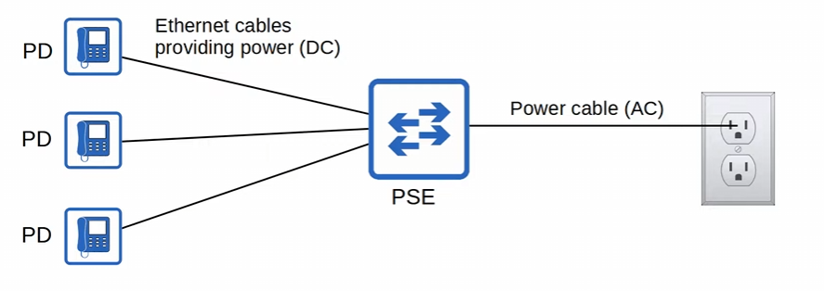
-switch is the power sourcing equipment (PSE), and the IP phones are the powered devices (PD)
-the switch/PSE converts AC from the wall socket to DC, to send over the ethernet cable to the IP phones/PD
-ethernet cable is also actively sending data at the same time

Must be careful with how much electrical current is sent to devices
-too much electrical current can damage electrical devices
-PoE has a process to determine if a connected device needs power, and how much power it needs
-when a device is connected to a PoE-enabled port, the PSE (switch) sends low power signals, monitors the response, and determines how much power the PD needs
-using CDP or LLDP to detect the power needs
-the first signals are very weak, so that the PSE doesn’t even too much power to the PD, causing more harm
If the device needs more power, the PSE supplies the power to allow the PD to boot
-PSE continues to monitor the PD and supply the required amount of power (but not too much!)

The command “power inline police” on an interface configures power policing with the default settings
-will disable the port AND send a syslog message if a PD draws too much power
-same as “power inline police action err-disable“ which disables the interface
-both commands will put the interface in an ‘error-disabled’ state and can be re-enabled with “shutdown” -> “no shutdown”

The command “power inline police action log” just sends a syslog message and restart the interface
-does NOT place the interface in an ‘error-disable’ state
-the connected PD will lose power and restart as well, then it will renegotiate its power needs

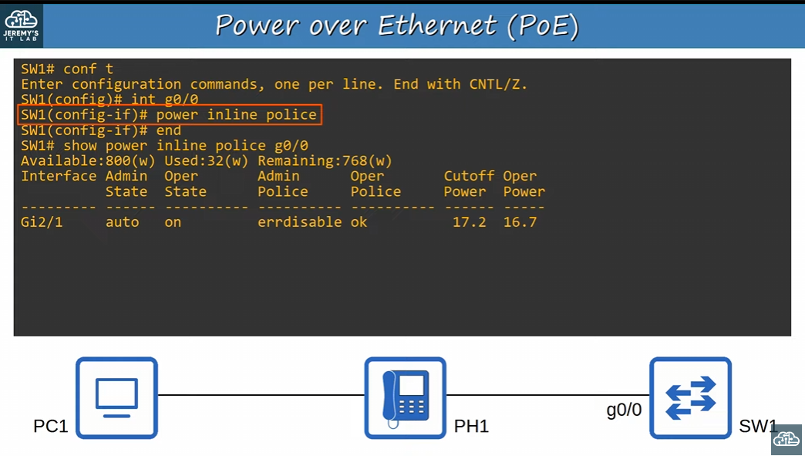
-using the command int interface mode “power inline police” the interface configures the power policing with default settings
-default settings are disabling the port and syslog message if PD draws too much power than it can use
-CDP/LLDP is used to detect power needs for PoE
We can use the command “show police inline police” to see how much power is available, used, and remaining, as well as the police method and operational state
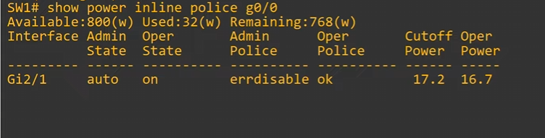
-even though we didn’t specify the action to be err-disable in the command “power inline police”, the DEFAULT action will shut down the interface!

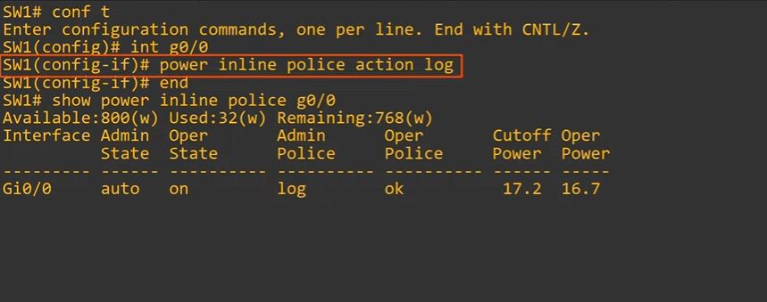
-with “power incline police action log” the command will only log the interface drawing too much power, and not disable it
-again, we use the command “show power inline police <int>” to see it as log

All you need to know for the CCNA is that power policing prevents too much power being draw

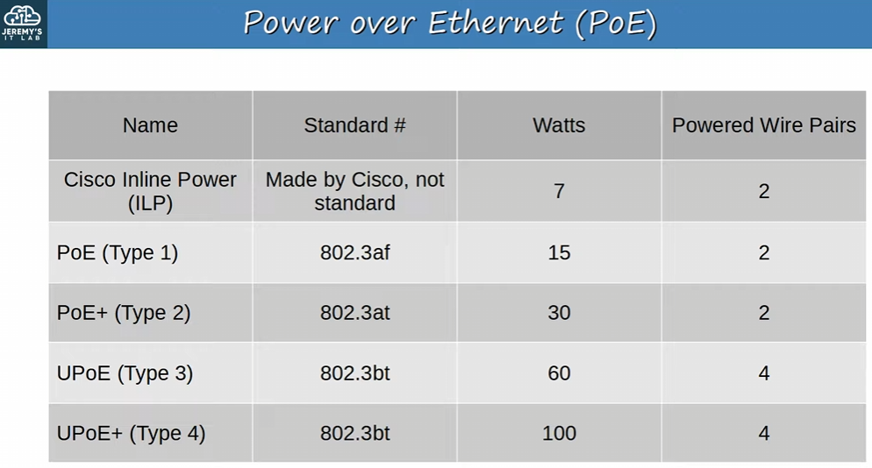
-PoE standards
-PoE was originally a cisco protocol known as ILP (inline power)
-cisco used the other for wires in UTP that weren’t being used (4-5 7-8)
-PoE was standardize
-Probably not important to memorize this table for the CCNA

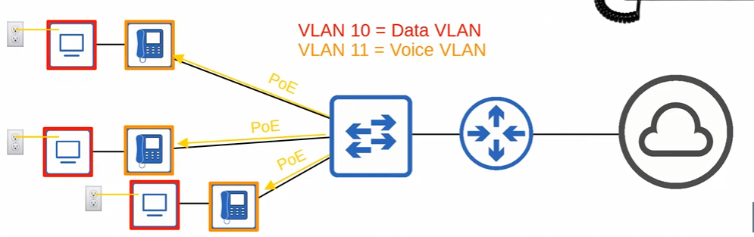
-PCs will still need to be plugged into a wall socket, PoE will only supply electricity to the PD

Voice data on IP phones is what we want to apply QOS to, to give higher priority to the voice data!

Voice traffic used to use PSTN/POTS while data traffic used IP network
-both traffics were on entirely separate networks

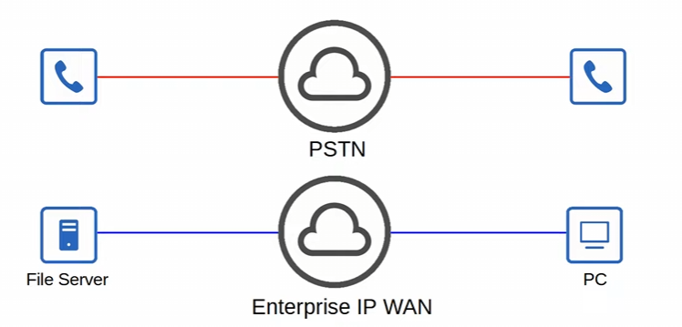
-QOS wasn’t necessary as the different kinds of traffic didn’t compete for bandwidth
-audio quality of a phone wouldn’t be affected since it was on a different network

Modern networks are typically Converged Networks in which IP Phones, video traffic, regular data traffic, etc. share the same IP network!
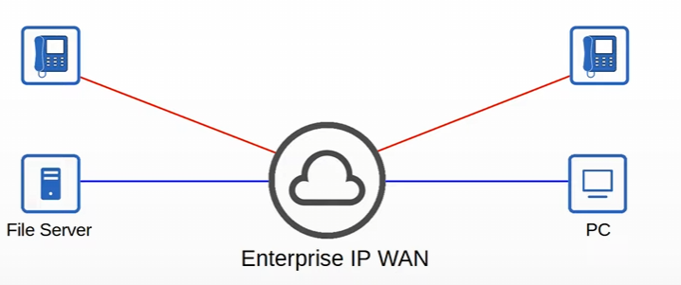

-PSTN has disappeared, but we will only focus on the IP network
Converged Networks enable cost savings as well as more advanced features for voice and video traffic, for example integration with collaboration software (Cisco Webex, Microsoft Teams, etc.)
-IP phones can integrate with these collaboration softwares!

-however, the different kinds of traffic now have to compete for bandwidth
-if there is plenty of available bandwidth, and the network isn’t congested, there is no problem. But, if the network traffic is congested and the bandwidth isn’t enough, we have a problem for voice and voice traffic, which is sensitive to delay

QoS is a set of tools used by network devices to apply different treatment to different packets
-certain kinds of traffic get higher priority treatment, while others don’t

QoS is used to manage the follow 4 characteristics of network traffic
- Bandwidth: the overall capacity of the link, measured in bits per second (Kbps, Mbps, etc.)
  - QoS tools allow you to reserve a certain amount of a link’s bandwidth for specific kinds of traffic!
    - For example, 20% of bandwidth of voice, 30% for specific kinds of data traffic, leaving 50% for all other traffic
- Delay
  - Measured either by one-way delay OR two-way delay
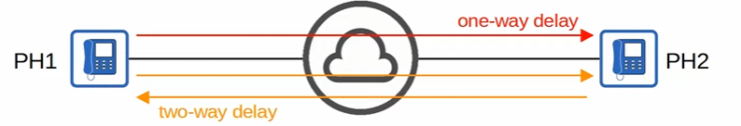

- Jitter: the variation in one-way delay between packets sent by the same application
  - For example, some packets of a voice application might be sent in 10 ms, while other packets are 100 ms is a lot of jitter!
  - Jitter will negatively affect the audio quality of phone calls with, so IP phones have a jitter buffer to provide a fixed delay to audio packets
    - If the jitter is too high for the jitter buffer, the quality will be negatively affected

- Loss: the % of packets send that do not reach the destinations
  - Possible issues: bad cables, or if the network is congested and the device’s packet queues get full and the device starts discarding packets

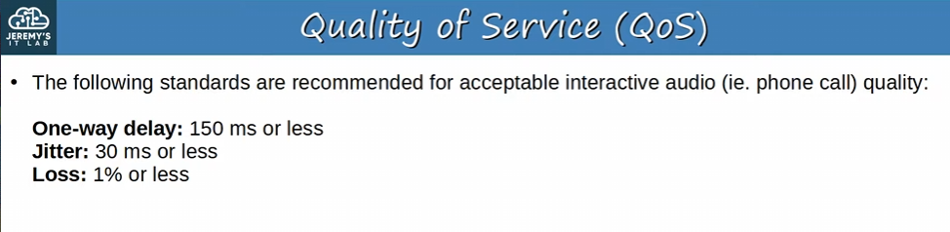
-the standards:
-One-way delay of 150 ms or less
-Jitter of 30 ms or less
-Loss of 1% or less

-if the standards aren’t met, there is a noticeable reduction in the quality of the phone call

QoS – Queuing
-if a network device receive messages faster than it can forward them out of the appropriate interface, the messages are places in a queue
-the queue can quickly fill up if a lot of traffic is sent on a small bandwidth
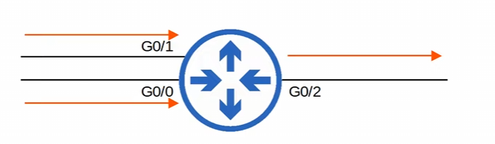
-receive more traffic than it can send out on the g0/2 interface
-By default, Queued messages will be forwarded with FIFO (first in first out) manner!!!
-IMPORTANT: default settings, messages with be sent in the order they are received for FIFO

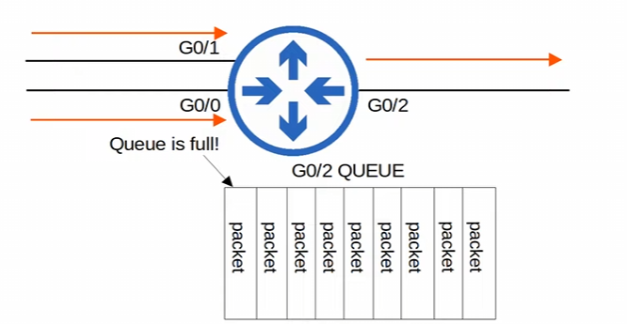
-once the queue is full the new packets will be dropped!

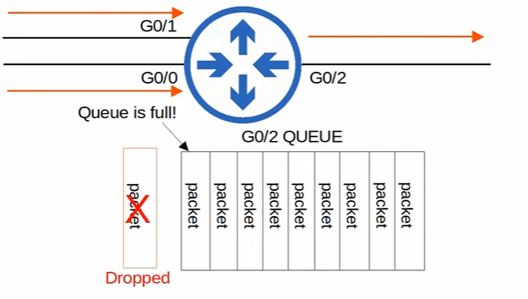
-there is not enough room in the queue
-this causes Tail Drop

Tail Drop is harmful because it can cause TCP Global Synchronization
-when TCP global Synchronization occurs, the TCP sliding window shifts from sending traffic too quickly to sending traffic too slowly for all packets using TCP, which affects transmission rate

TCP sliding window: Hosts using TCP use the ‘sliding window’ increase/decrease the RATE at which they send traffic as needed
-when a packet is dropped it will be re-transmitted, and the send will reduce the rate it sends traffic
-the packet will gradually increase the rate again, and the process will repeat when the queue fills up

When the queue fills up and tail drop occurs, all TCP hosts sending traffic will slow down the rate at which they send traffic -> slowly increase the rate at which they send traffic, which rapidly leads to more congestion, dropped packets, and the process happens again

With TCP global synchronization, we have waves of the network being under-utilized and then congested!!!

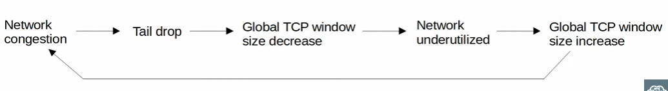
-global TCP windows size decrease: all hosts sending TCP traffic will decrease their window size
-TCP window size decrease = slow the rate down
-TCP window size increase = speed the rate UP

To prevent Tail drop and TCP global synchronization, we can use Random Early Detection (RED)

Random Early Detection: when the amount of traffic in the queue reaches a certain threshold, the device will start randomly dropping packets from select TCP flows!
-the TCP flows that dropped packets will reduce the rate at which traffic is sent, but you will avoid GLOBAL TCP synchronization, in which ALL TCP flows reduce and then increase the rate of transmission at the same time in waves
-ideally it will keep the rate of traffic even

-In standard RED, all kinds of traffic are treated the same
-there is a global threshold, and if the amount of traffic in the queue crosses the threshold, the device will start dropping traffic randomly!!!

Weighted Random Early Detection (WRED) is an improved version of RED, which allows you to control which packets are dropped depending on the traffic class
-for example, you can use WRED to drop HTTP packets when the queue is a certain amount of full, FTP packets when the queue is up to a certain limit, etc.!

-traffic configured as lower-priority will be dropped sooner

Day 47:
QOS is used to prioritize traffic to reduce one-way delay, jitter, loss of important traffic, and give ample bandwidth

Classification/marking is how routers & switches select which traffic should be given higher priority

Shaping & policing are two ways of controlling the rate of how traffic enters or exits an interface

Classification organizes network traffic (packets) into traffic classes (categories)
-the purpose of QoS is to give certain kinds of network traffic priority over others during congestion
-Classification is important to QOS which needs the traffic first to be identified/classified, before QoS can do anything to the traffic
-Methods to classify traffic: ACL, NBAR, Layer 2 & 3 headers specific fields

An ACL would be used the same what we used ACLs in NAT, we aren’t dropping traffic just identifying/classifying traffic

NBAR (Network Based Application Recognition) performs a deep packet inspection, looking beyond the Layer 3 and Layer 4 information up to Layer 7 to identify the specific fields used for this purpose

Classification with Layer 2 & 3 header fields is what we will be using
-PCP (Priority code point) field of 802.1Q tag (in the ethernet header) can be used to identify high/low priority traffic
-can only be used if there is trunking and tagging with dot1q!
-DSCP (Differentiated Services Code Point) field of the IP header can also be used to identify high/low priority traffic

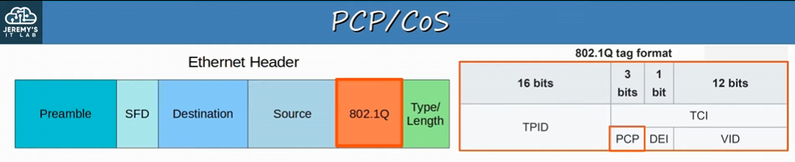
- TPID has a tagging of 0x8100 in the TPID field
-PCP (Priority Code Point) is placed between the source and type/length within the TCI field
-PCP is alco known as CoS (Class of service) and is defined by 802.1p
-DON’T confused CoS with QoS
-3 bits in the PCP field = 8 possible values

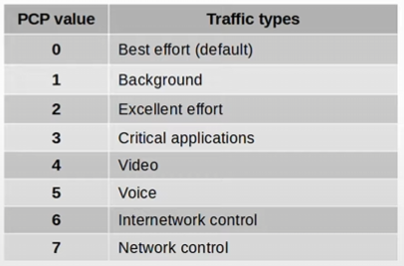
-the 7 higher value is the most important traffic
-Remember 0 = best effort, 3 = critical application, 4 = video, and 5 = voice

-0 = best effort delivery means there is no guarantee that data is delivered or that it meets any QoS standard. This is regular traffic, and not a high priority!
-this is default
-IP phones MARK call signal traffic (used to establish calls) as PCP3
-the actual VOICE TRAFFIC is MARKED as PCP5

Call signaling traffic is used to establish phone calls (PCP3) , but once the call is established the voice traffic itself is marked as PCP5
-IMPORTANT

To mark traffic is to set the value in the PCP or DSCP field

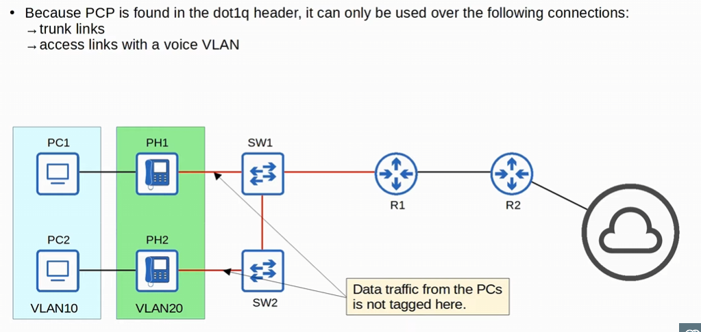
-PCP field is found in the dot1q header: trunk links (unless it’s in the native VLAN where the dot1q isn’t being used), access links with a voice VLAN
-connections between the phones and the switches are the access link with a voice VLAN
-tagging voice VLAN occurs here with the PCP field
-connection between sw1 and sw2 and sw1 to R1 are trunk links tagged traffic in VLAN 10 or 20
-tagging data traffic occurs here with the PCP field

-traffic between R1 and R2, or between R2 and external destinations will not have a dot1q tag. So, traffic over those links PCP cannot be marked with a PCP value!
-this is a limitation that Layer 3 classification methods don’t have

The IP ToS byte is the DSCP (Differentiated source code point, 6 bits) + ECN (Explicit congestion notification 2 bits)
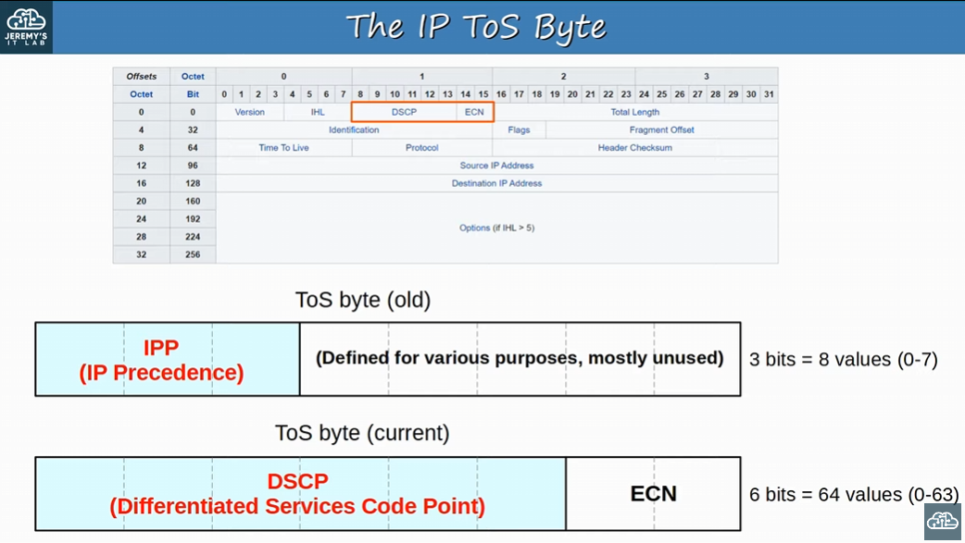
-in the past the TOS byte used the IPP (IP Precedence) with 3 bits while the rest of the byte (5 bits) was mostly unused
-they updated the ToS byte currently uses DSCP and ECN
-DSCP is backwards compatible with IPP
-DSCP uses 64 values and IPP uses 8 values

Standard IPP markings are similar to PCP values!
-6 & 7 are reserved for ‘network control’ traffic
-Like OSPF messages between routers
-5 = interactive voice traffic
-4 = interactive video traffic
-3 = voice signaling traffic ( for setting up and tearing down phone calls!)
-0 = best effort (regular traffic, no priority)

-With 6 & 7 reserved, only 6 possible values remain, an although 6 values are sufficient for many networks, the QoS requirements of some networks demand more flexibility
DSCP decided to use the mostly unused bits in the ToS byte
-defined with RFC 2474, and other ‘diffserv’ RFC elaborated on its use
-with IPP updated to DSCP, new standardized markings have to be decided upon
-having it standardized QoS design & implementation is simplified, QoS words better between ISPs and enterprises, etc. Industry markings were standardized

DSCP standardized marking:
-DF (Default Forwarding) - best effort traffic (normal traffic)
-EF (Expedited Forwarding) - low loss/latency/jitter traffic (usually voice)
-AF (Assured Forward) - A set of 12 standard values
-CS (Class Selector) – a set of 8 standard values, provide backward compatibility with IPP

IPv6 also has a traffic class byte used for QoS!

QoS configuration isn’t a CCNA topic however it’ll help us learn.
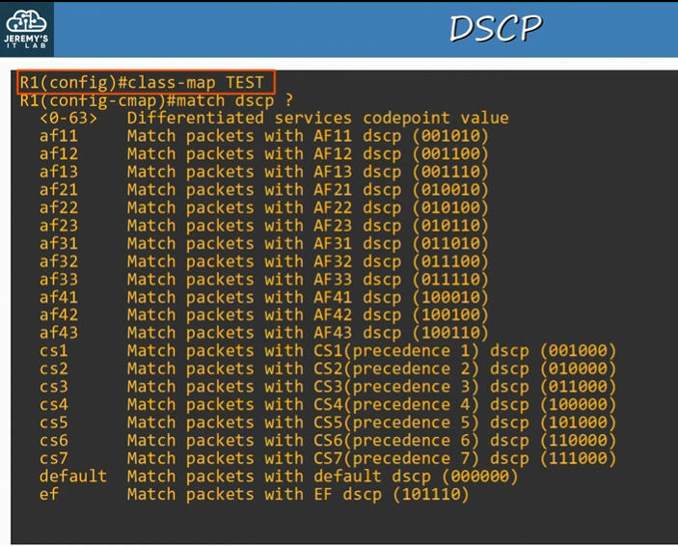
-when configuring QoS class maps are used to identify which traffic you want to match
-the “match dscp” command specifies which traffic you want based on the DSCP value in the IP header
-first opinion is 0 - 63
-second opinion is AF11-AF43 or Assured forwarding
-third opinion is cs 1-7 or class selectors used for backwards compatibility with IPP
-there are 8 cs value because technically default is a CS value as well
-Default is DF: Default Forwarding
-finally, EF is EF: Expedited Forwarding

DF (Default forwarding)
-Used for best-effort traffic aka normal traffic
-DSCP marking for DF is 0 or 000000 in bits
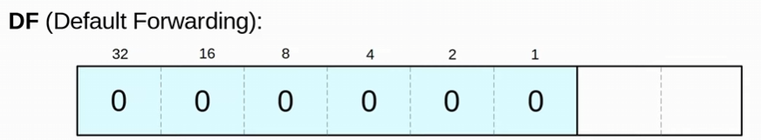
-no special treatment is required

EF (Expedited Forwarding)
-Used for traffic that requires low loss/latency/jitter
-typically voice traffic is marked as EF
-DSCP marking for DF is 46 or 101110
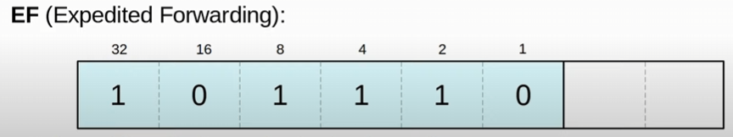

AF (Assured Forwarding)
-defines four traffic classes
-all packets in a class have the same priority
-better service than lower priority packets
-Within each class, there are three levels of drop precedence
-higher drop precedence = more likely to drop the packet during congestion
-using WRED to drop

-The 6th bit the DSCP AF value will always be 0
-first three bits are class
-bits 4 & 5 are the drop precedence

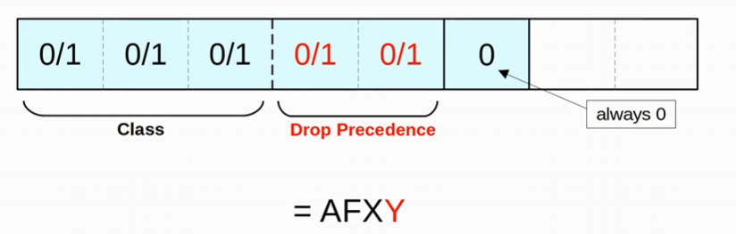
-AF X Y, X= the decimal number of the class, & Y is the decimal number of the Drop precedence

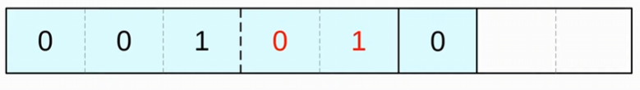
-What AF number is this ? 001 = decimal 1 for X, and 01 is decimal number 1
-AF 11
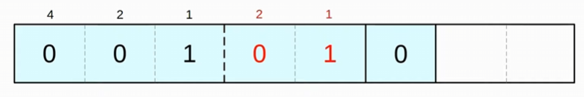
-split the first three bits from bit 4 & 5, then find the decimal number
-the third bit starts with 1 for X, and the fifth bit starts with 1

To find the DSCP value use the entire 6 bits to find the value
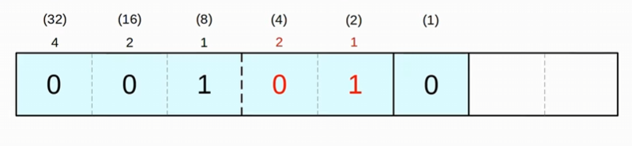
-AF11 is DSCP 10

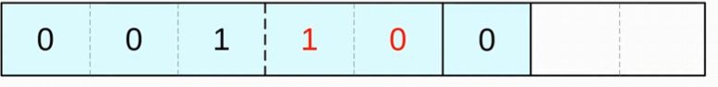
-What is the AF number and the DSCP number
1) Separate the third bit from the fourth and make these two different values
2) find the X value
4 | 2 | 1
0 | 0 | 1

-AF 1 Y
3) now find the Y value
2 | 1
1 | 0

-AF 12

-To find the DSCP value put all the bits together
32 | 16 | 8 | 4 | 2 | 1
0 | 0 | 1 | 1 | 0 | 0

-DSCP value of 12

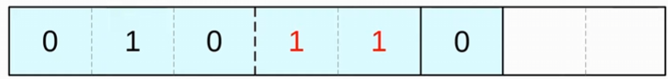
-What is the AF value and the DSCP value?
-AF is AF23, DSCP is 22

32 16 8 4 2 1 for DSCP, AF X Y: x = 4 2 1, y = 2 1 then calculate

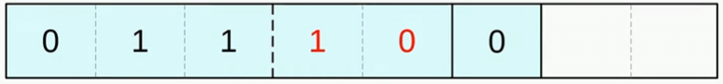
-What AF value and DSCP value is this?
- AF 32, DSCP 28

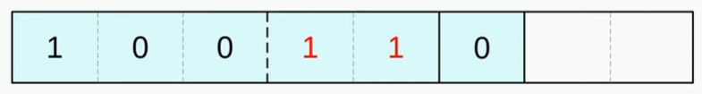
-AF43 & DSCP 38
-within AF, AF 43 is the highest value

Know how to convert AF and DSCP value from the 6 DSCP bits

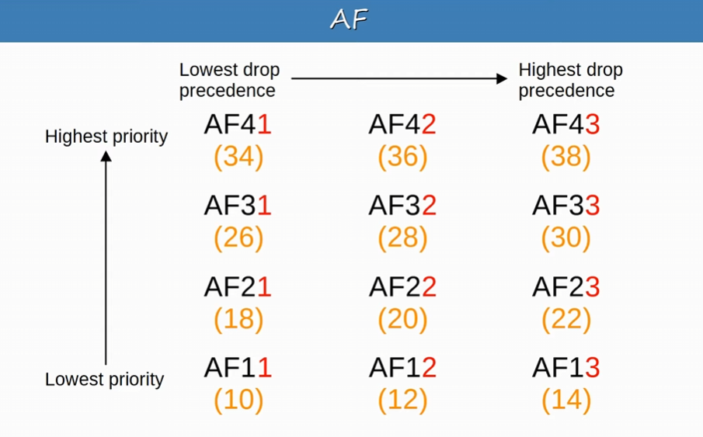
-Remember this, very important!
-traffic in higher class is given priority should congestion occur between classes!!
-if congestion occurs WITHIN a class, the packets with the higher drop precedence are discarded first
-drop precedence with WRED

DSCP CS values (class selector)
-eight DSCP values for backwards compatibility with IPP
-the three bits that were added for DSCP are set to 0, and the original IPP bits are used to make 8 values
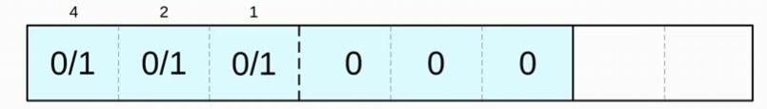
-2^3 = 8 total values from 0-7
-IPP also uses 3 bits for values 0-7

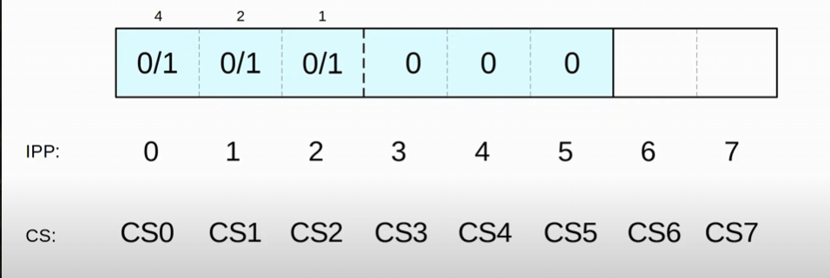
To convert CS to a DSCP value, just multiply the CS decimal number by 8
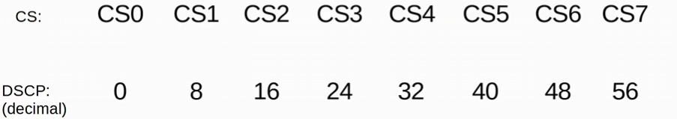

RFC 4594 was developed with the help of cisco to bring all these values together and standardize their use
-Voice traffic is marked as EF (needs low delay jitter and loss)
-Interactive video is marked as AF4x (AF41, AF42 & AF43)
-Streaming video is marked as AF3x (AF31, AF32 & AF33)
-High priority data is marked as AF2x (AF21, AF11 & AF23)
-Best effort data is marked as DF (DSCP value of 0)

-these are just standard recommendations

Trust boundaries: defines where devices trust/don’t trust the QoS markings of received messages
-if the markings are trusted, the device will forward the message without changing the markings
-if the markings are NOT trusted, the devices will forward the message after changing the markings
-change the markings according to the configured policy
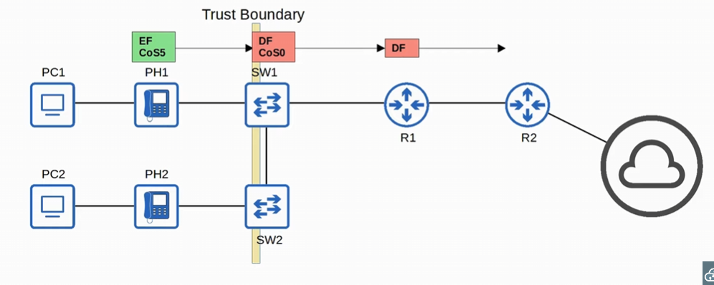
-CoS5 basically means PCP5, you can use CoS and PCP interchangeably
-PH1 uses both PCP and DSCP markings with EF (expedited forwarding) and PCP 5 (for voice)
-SW1 sees the traffic is untrusted (since its outside the trust boundary) and changes the marking accordingly to the configured policy
-R1 will remove the CoS0 tagging since R1 -> R2 doesn’t use a trunk link
Usually, we want to trust the configuration from an IP phone, because we want its traffic to be high priority anyway

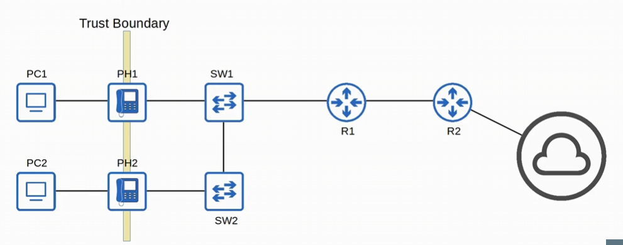
-we want to move the trust boundary to the IP phone
-this is done via configuration on the switch port connected to the IP phone

-if a user marks their PC’s traffic with a high priority, the marking will be changed (not trusted)

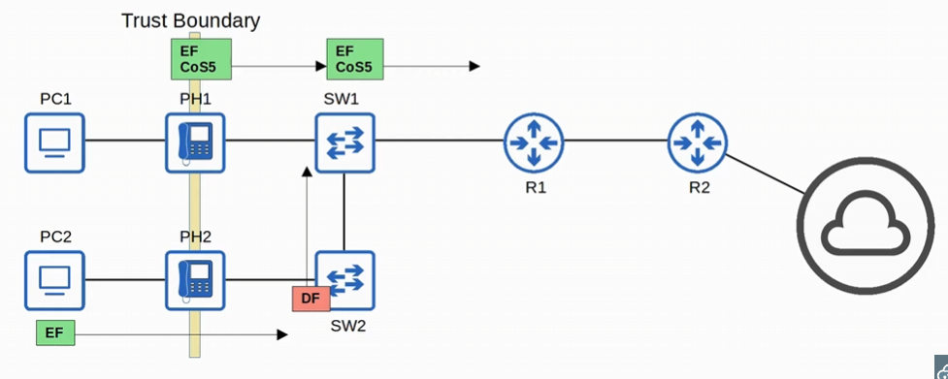
-PH1 traffic markings are trusted now, not PCs are not
-you don’t want data traffic from the PCs to be treated the same way as voice traffic

Just know what trust boundaries are and how they work
Remember, when a network device receives traffic at a faster rate than it can forward the traffic out of the appropriate interface, packets are placed in that interface’s queue as they wait to be forwarded
-tail drop occurs to packets if the queue is full

RED and WRED drop packets early to avoid tail drop

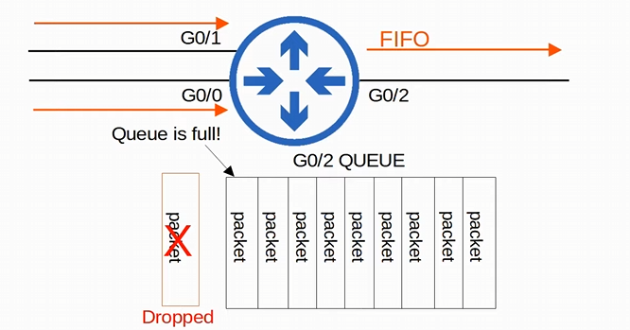
-FIFO packets
-RED & WRED can help avoid this by dropping packets earlier

Queuing/congestion management
-An essential part of QoS is the use of multiple queues
-classification plays a role, where the device can match traffic based on various factors and then place it in the appropriate queue
-Factors like the DSCP marking in the ip header
-the device is only able to forward one frame out of an interface at once, so a scheduler is used to decide which queue traffic is forwarded next
-prioritization allows the scheduler to give certain queues more priority than others

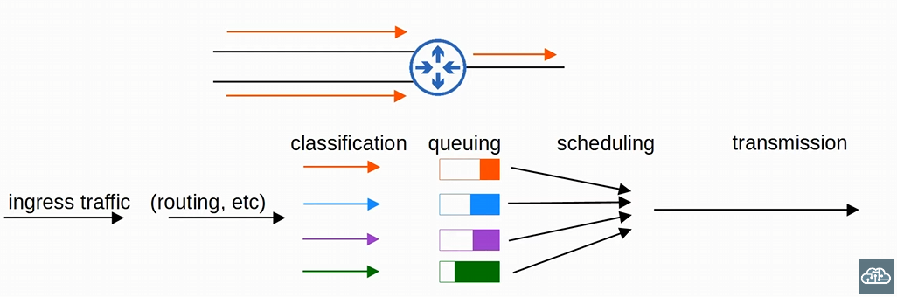
-the router egress is configured with multiple queues
-ingress traffic is received by the router (incoming traffic)
-Router then chooses which interface to send the traffic out of with routing
-NAT occurs here as well
-then classification of the packet occurs, which then leads the router to place it in the appropriate queue
-traffic is placed in a queue depending on the markings ( DSCP or PCP/CoS etc.)

-next, the scheduler decides how much traffic to send from each queue, in which order!!
-finally, the router forwards the traffic, one packet at a time

-after the router figures out which interface to send the traffic out of, the packet is classified, queued, scheduled, and transmitted
For queue/congestion management, the command scheduling method is Weighted Round-Robin
-round-robin = packets are taken from each queue in order, cyclically
-weighted = more data is taken from high priority queues each time the schedular reaches that queue
-weighted = more high priority data is taken

CBWFQ (Class-Based Weighted Fair Queueing) is a popular method of scheduling, using a weighed round-robin schedular while guaranteeing each queue a certain percentage of the interface’s bandwidth during congestion

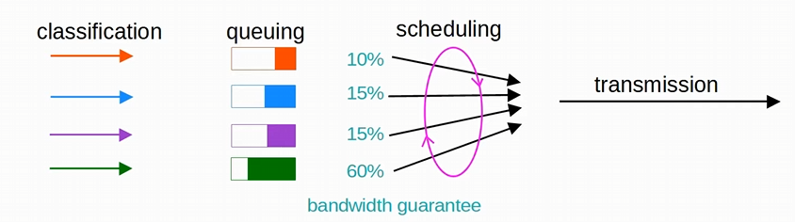
-classification -> queuing -> scheduling with a weighted round robin -> transmission
-sending a certain amount of traffic from each queue in cycles
-each queue gets a minimum amount of bandwidth, each if the queues are congested
-this is a Class-based Weighted Fair queuing

-Round-robin scheduling is not ideal for voice/video traffic
-even if the voice/video traffic receives a guaranteed minimum amount of bandwidth, round robin can add delay and jitter because even the high priority has to wait their turn in the schedular
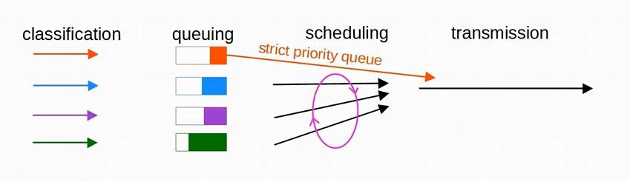
-LLQ (Low Latency Queueing) designates one (or more) queues as strict priority queues
-Strict Priority queues means that if there is traffic in the queue, the schedular will ALWAYS take the next packet from the strict priority queue first until its EMPTY
-will reduce delay & jitter of voice/video traffic
-schedular will let the orange queue to go first, until there are no more packets
-once finished the weighted round robin schedular starts again

Low Latency Queuing (LLQ) has the downside of potentially starving other queues if there is always traffic in the designated strict priority queue
-Policing can control the amount of traffic allowed in the strict priority queue so that it can’t take all the link’s bandwidth

Within EACH of these queues’ congestion prevention tools like RED and WRED can be used to avoid tail drop if the queue is becoming full

Shaping and Policing: both are used to control the rate of traffic
-you might want to limit the rate of traffic to below the actual maximum capacity of the link

-Shaping buffers traffic in a queue if the traffic rate goes over the configured rate
-Policing drops traffic if the traffic rate goes over the configured rate
-also has the option of re-marking the traffic instead of dropping it
-‘burst’ traffic over the configured rate is allowed for a short period of time
-this accommodates data applications which typically are ‘bursty’ in nature. Instead of a constant stream of data, they send data in bursts
-amount of bursts data is also configurable

-for both, classification can be used to allow for different rates for different kinds of traffic

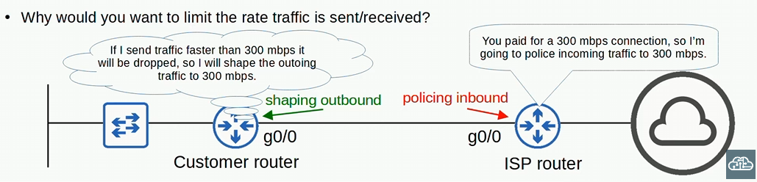
-perhaps the customer is paying for 300 mbps connection
-ISP will police the incoming traffic to be 300 mbps
-customer will shape the outgoing traffic to 300, so that faster traffic that is sent to the ISP isn’t dropped by the ISP router doing policing

After classification and marking you need to do queueing/congestion management!!!
-marking the traffic isn’t enough for QoS, need to use CBWFQ and LLQ for QoS

Strict-priority queueing can cause bandwidth starvation! We use Shaping and policing for bandwidth starvation!!

Day 48:
AAA standard of: Authentication. Authorization, & Accounting
The principles of the CIA triad: Confidentiality, Integrity, Accessibility
- Confidentiality: Only authorized users should access the data (varying degrees)
- Integrity: the data should not be altered by unauthorized users. Data should be correct and authentic
- Accessibility: we should be able to access the data/systems for authorized users (varying degrees)

-CIA triad is the foundation of security
-Attackers can threaten the confidentiality, integrity, and accessibility of an enterprise system

Vulnerability is any potential weakness that can compromise the CIA of a system/info
-a POTENTIAL weakness isn’t a problem on its own
-for example, a window is a potential weakness or vulnerability for a house

Exploit is something that can POTENTIALLY be used to exploit the vulnerability
-something that can potentially be used as an exploit isn’t a problem on its own
-for example, a rock can potentially break a window therefore exploiting the window of a house

Threat is the potential of a vulnerability to be exploited
-for example, a robber (threat) used the rock (exploit) to break the window (vulnerability)
-a hacker exploiting a vulnerability in your system is a threat

Mitigation Technique is something that can protect against threats
-for example, bars on a window
-should be implemented everywhere a vulnerability can be exploited: client devices, servers, switches, routers, firewalls, etc. !!
-another mitigation technique is preventing people from getting access to physical devices!

No system is perfectly secure!
-chance of any device getting infected by malware is never going to be 0%

Common Attacks that compromised the CIA triad (confidentially, Integrity, & Accessibility):
-DOS (denial of service)
-Spoofing attacks
-Reflection/amplification attacks
-Man-in-the-middle attacks
-Reconnaissance attacks (not really an attack)
-Malware
-Social engineering attacks
-Password-related attacks
-And many more!!

Denial-of-service attacks: attack threat the availability of a system (A of the CIA triad)
-one common DoS attack is the TCP SYN flood
-exploits the TCP three-way handshake
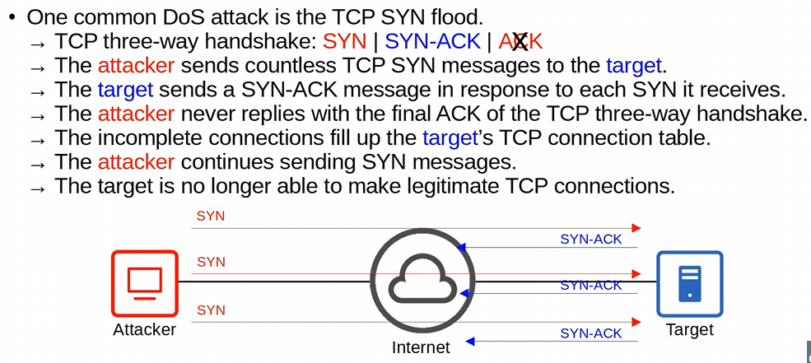
-the attacker spoof’s their IP address so the syn-ack flags are never sent back!
-Ping of death
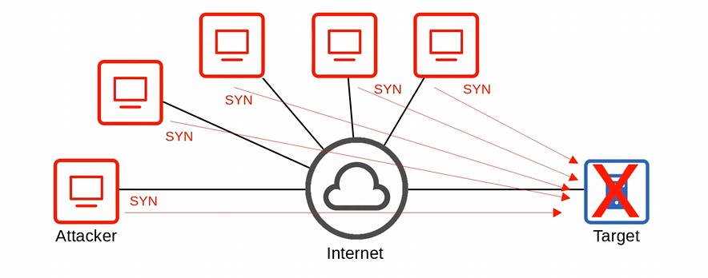
-a botnet is used (group of infected computers) to spoof their IP addresses, and send SYN messages to the target computer
-the botnet is created via malware

Spoofing attacks: use a fake source address (IP or MAC address)
-numerous attacks involve spoofing, not a single type of attack
-DHCP exhaustion attack: attacker uses a spoofed mac address to flood DHCP discover messages
-the DHCP pool becomes full, resulting in a denial-of-service to other devices (the devices won’t be able to get an IP address)

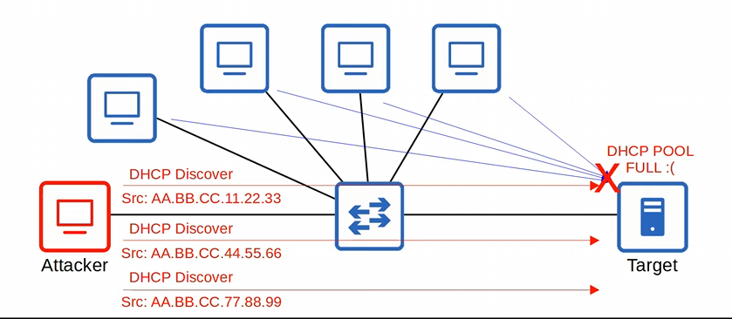
-using a fake source mac addresses to fill up the DHCP pool
-sending these messages at a quick pace
-the server will reply with offer messages to assign an IP, but they aren’t being used
-as a result, the offered IP addresses (D O R A) will not be given to any devices
-DHCP exhaustion attack is considered a DOS attack

-TCP SYN flood also uses Spoofing attacks

-Targets the A in the CIA triad

Not all spoofing attacks are DOS attacks

Reflection: the attacker sends traffic to a reflector, and spoofs the source address of its packets using the target’s IP address
-the reflector (like a DNS server) sends the reply to the target’s IP address
-if the traffic sent is large enough, this can result in a DOS attack

A reflection attack becomes an Amplification attack when the amount of traffic sent by the attack is small, but it triggers a large amount of traffic to be send from the reflector to the target

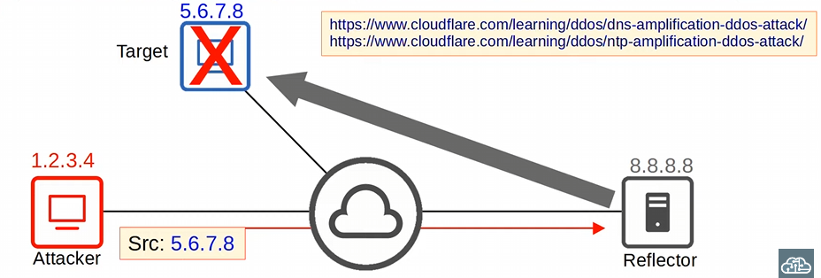
-tricks the DNS server (or even an NTP server) into thinking that the victim’s computer sent a request by spoofing the source address

Man-in-the-middle attack: the attack places himself between the source and destination to eavesdrop on communications, or to modify traffic before it reaches the destination
-Common example: ARP spoofing/Poisoning
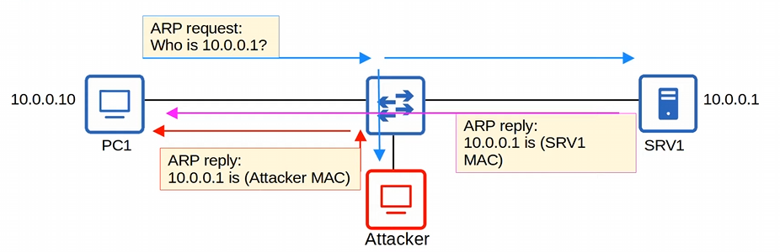
-host sends an ARP request asking for the MAC address of another device
-the target of the request sends an ARP reply, informing the requester of its MAC address
-the attacker waits and sends another ARP reply after the legitimate replier
-the last ARP reply will overwrite the legitimate ARP entry in PC1’s ARP table

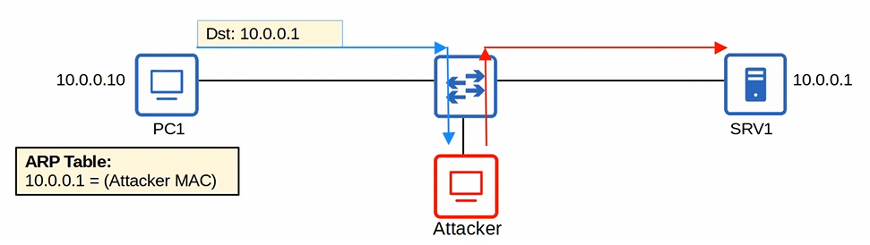
-now the victim’s ARP table will send packets destined to SRV1, to the attacker since the attacker spoofed his PC’s IP address to be srv1’s IP address
-the attacker can inspect or modify the messages, and then forward them on to SRV1

Man-in-the-middle attacks compromises the Confidentiality and Integrity of communications between PC1 and SRV1!

Reconnaissance: aren’t attacks per say, but they are used together information about a target which can be used for a future attack
-often publicly available information
-For example, you can perform a nslookup to learn the IP address of a site
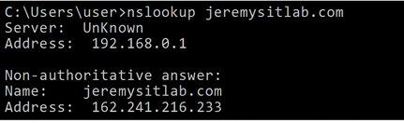
-from here you can probe for open ports with NMAP

-you can also use a whois query to learn email addresses, phone number, physical addresses
-you can perform whois on websites or even a CLI on some devices

Malware: Malicious software, refers to a variety of harmful programs that can infect a computer
-Viruses infect other software (a ‘host program’). The virus spreads as the software are shared by users. Typically, they corrupt or modify files on the target computer.
-viruses can corrupt or modify files on the target computer

-Worms do not require a host program. They are standalone malware, and they can spread on their own, WITHOUT user interaction. The spread of worms can congest the network, but the ‘payload’ of a worm can cause additional harm to target devices

-Trojan Horses are harmful software that is disguised as legitimate software. They are spread through user interaction such as opening email attachments, or downloading a file from the internet

-Types of malwares are defined mostly by how the malware infects a system and how it spreads, not the attacks they carry out after infecting the system
-Exploits various vulnerabilities to threaten any part of the CIA triad
Many types of malware!

Social engineering targets people, which is the most vulnerable part of a system
-involves psychological manipulation to make the target reveal confidential information or perform some action

-Phishing typically involves fraudulent emails that appear to come from a legitimate business (Amazon, bank, credit card company, etc.)
-users are told to login to the fraudulent website, and provide their credentials

-Spear Phishing is a more targeted form of phishing (aimed at certain employees)
-Whaling is phishing targeted at a high-profile individual (company president)

-Vishing (voice phishing) is phishing performed over the phone
-for example, ‘hi, this is your ISP, we require …’ or ‘this is Jeremy from the IT department, we need to reset your password. Could you tell me your password before we reset it?’
-Smishing (SMS phishing) is phishing using SMS text messages

-Watering hole attacks compromise sites that the target frequently visits
-if a malicious link is placed on a website the target trusts, they might not hesitate to click the link

-Tailgating attacks involve entering restricted, secured areas by simply walking being an authorized person as they enter the building. The target will be polite and hold the door open

Social engineering doesn’t exploit companies IT systems, but instead exploit people

Password-related attacks: Most systems use a username/password combination to authenticate users
-the username is often simple/easy to guess (for example the user’s email address), and the strength and secrecy of the password is relied on to provide the necessary security

-Attackers can learn the passwords via multiple methods
-Guess, bruteforce, database leaks, dictionary attack

Dictionary attack: a program tries every possible combination of letter, numbers, and special characters to find the target’s password
Bruteforce attack: a program tries every possible combination of letters, numbers, and special character to find the target’s password
-needs a powerful computer/ botnet

-Strong passwords should contain at least 8 characters, a mix of uppercase and lowercase, and a mix of special characters and numbers too ’lovelywf%@#$^123’
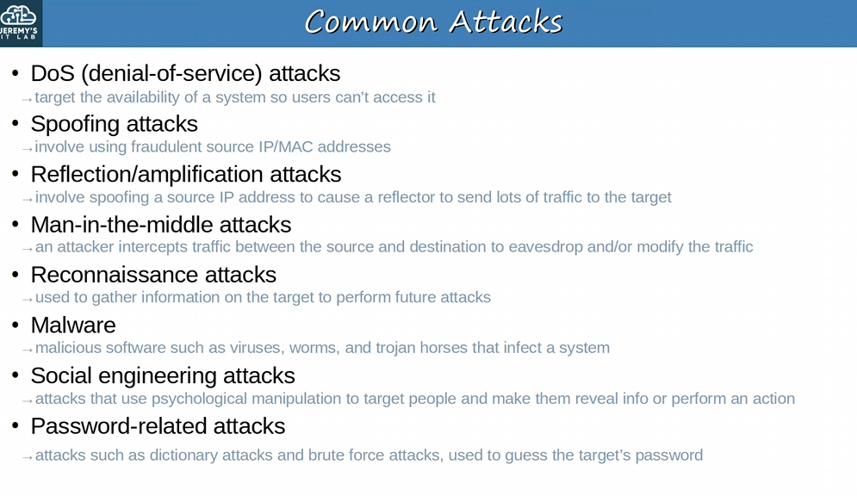

Multi-factor Authentication (MFA) involves providing more than just a username/password to prove your identity
-it usually involves providing two of the following (two- factor authentication)
-Something you know: Username/password combination, a PIN, etc.
-Something you have: Pressing a notification on a phone, a badge to scan, etc.
-Something you are: Biometrics (face/palm/fingerprint scan)

-requiring multiple factors of authentication greatly increases the security!

Digital Certificate are another form of authentication used to prove the identity of the holder of the certificate.
-used by websites to verify that the website being accessed is legitimate
-entities that want a certificate to prove their identity send a CSR (certificate Signing Request) to a CA (Certificate Authority), which will generate and sign the certificate
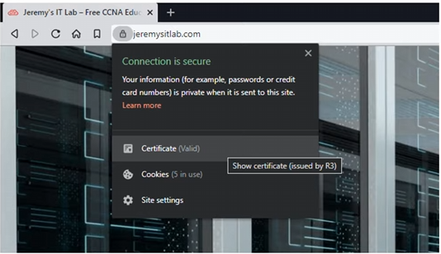
-we see a valid certificate, and this is how we can tell this website is the real website

AAA (triple A) stands for Authentication, Authorization, and Accounting
-framework for controlling and monitoring users of a computer system

-Authentication is verifying the user’s identity
-logging in = authentication

-Authorization is the process of granting the user the appropriate access and permissions
-granting the user access to some files/services, restricting access to other files/services

-Accounting is the process of recording the user’s activities on the system
-logging when a user makes a change to a file

-Enterprises typically uses a AAA server to provide AAA services
-ISE (Identity Services Engine) is Cisco’s AAA server

AAA servers usually support the following two AAA protocols:
-Radius: As open standard protocol (UDP ports 1812 and 1813)
-TACACS+: A Cisco proprietary protocol (TCP port 49)

Security program elements:
-A security program is an enterprise’s set of security policies and procedures

-User Awareness programs are designed to make employees aware of potential security threats and risks
-for example, a company might send out fake phish emails to make employees click a link and sign in with their login credentials. Although the emails are harmless, employees who fall for the false emails will be informed that it is part of a user awareness program, and they should be more careful about phishing emails!

-User training programs are more formal than user awareness programs
-dedicated classes to educate employees about security polices
-should happen when employees enter the company, and regular intervals

-Physical Access Control protects equipment and data from potential attackers by only allowing authorized users into protected areas such as network closets or data centre floors
-not only for people outside the organization to gain access to hardware, but even people within the organization
-multifactor locks can protect access to these restricted areas
-for example, a badge swipe and a fingerprint scan

-permissions of the badge can be changed immediately after the employee leaves the company

Day 49:
Port security:
- is a security feature on cisco switches that allows you to control what SOURCE MAC addresses & how many are allowed on a switchport
-configured on a per interface basis
-a security feature for cisco switches
-if an unauthorized source MAC address enters the port, an action will be taken
-default action: err-disable state (basically shutting down the interface)
-can configure other actions

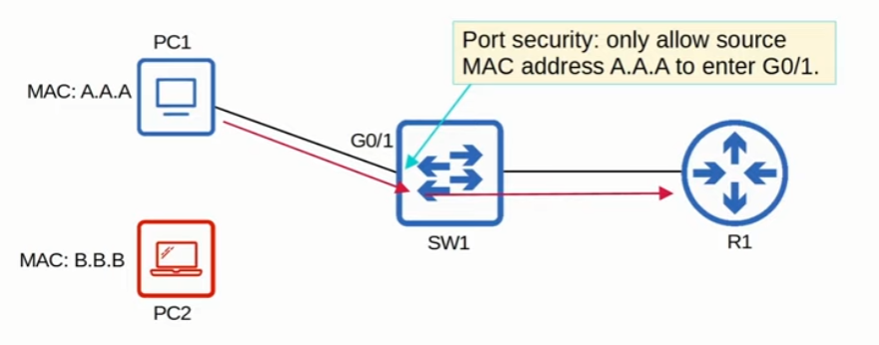
-port security only allows source MAC a.a.a frames to go though
-if the computer with MAC b.b.b tries to connect and send frames, SW1 will shutdown its interface with an err-disable

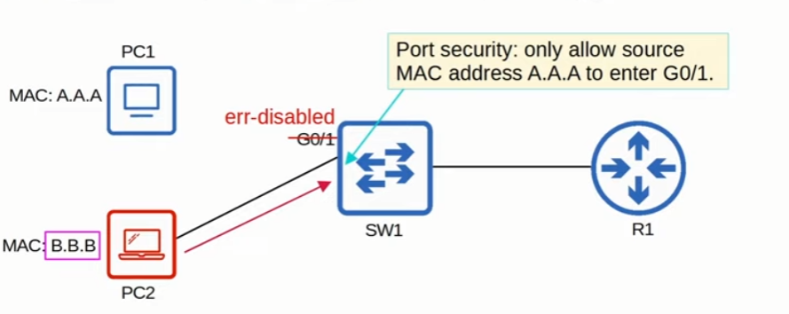
-b.b.b source MAC frames disable G0/1, since G0/1 only accepts a.a.a
-interface would send or receive data until you enable the interface again
-default action of shutdown

-what happens if you try to plug in PC1 now into SW1?
-the interface will still be shutdown
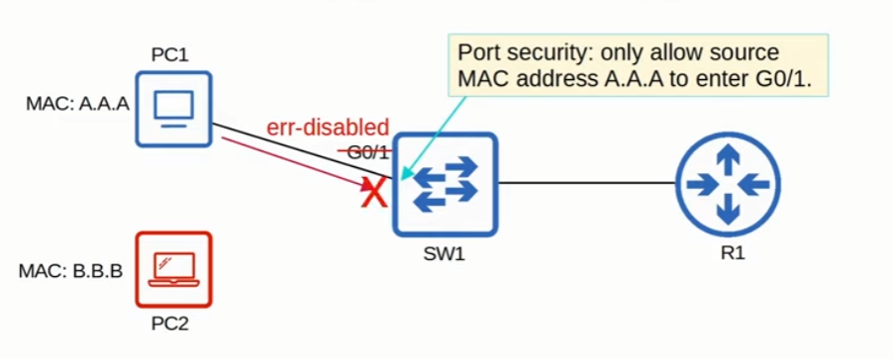
-since the interface is still err-disabled with default settings, PC1 will not be able to send any frames over to SW1

Port security default settings only ONE MAC address is allowed! (Important)
-can configure it manually, or the switch will allow the first source MAC address that enters the interface! That MAC will be allowed, and all others will be blocked

Outside default settings, you can change the maximum number of MAC addresses allow on an interface
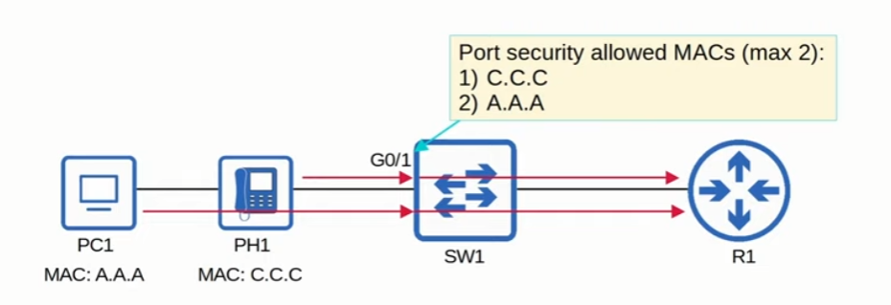
-a case where two MAC addresses need to be configured on the port and default settings would not work
-PH1 and PC1 have different source MAC addresses
-We can have switch 1 dynamically learn the allowed MAC addresses, just by having PH1 and PC1 interact with the interface by sending frames
-PH1 sends a frame with its own source MAC
-PC1 sends a frame with its own source MAC

-this is dynamically learned, since we didn’t configure anything manually

-If another device connected to that interface, SW1 will shutdown the interface since the max allow devices is 2!

Again, default number of MAC addresses is 1 when you enable port security, but you can configure it to be more. You can manually or dynamically learn MAC addresses for switches in port security
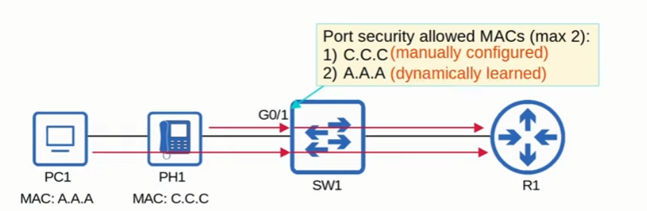
-one MAC address can be dynamically learned, and one can be manually configured
-the switch doesn’t need to have the MAC addresses ALL be manually configured or ALL be dynamically found. You can have a mix of both!

Port security allows network admins to control which devices are allowed to access the network
-someone can’t just plug an unauthorized device into a switchport and gain access to the network
-however, MAC address spoofing is a simple task
-easy to configure a device to send frames with a different source MAC address
-port security isn’t a perfect solution
-rather than manually specifying the MAC addresses allowed on each port, port security ability to limit the number of MAC addresses allowed on an interface is more useful
-If someone runs a DHCP starvation attack with thousands of fake MAC addresses, but port security limits the number of MAC addresses allowed on the interface, the attack will not work
-DHCP starvation attack the DHCP server assigned IP addresses to these fake MAC address, exhausting the DHCP pool
-switch MAC address table can also become full from a DHCP starvation attack

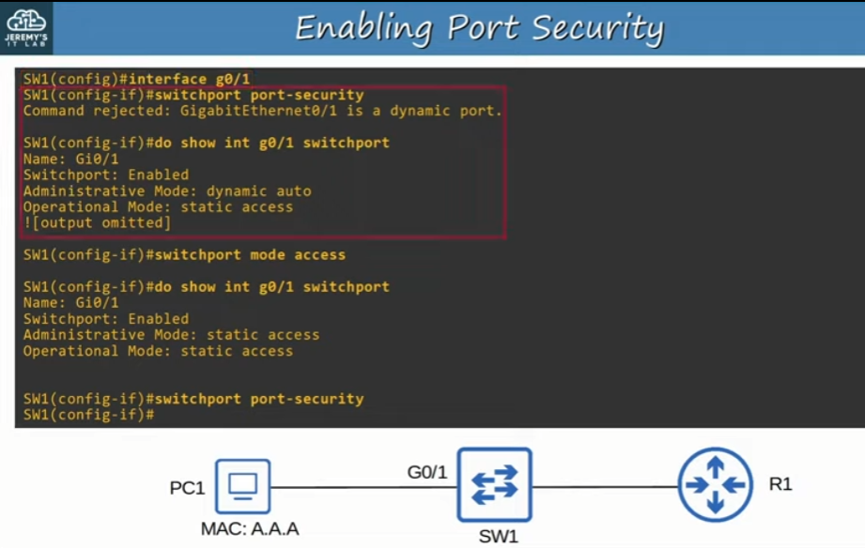
-to enable port security, you must make sure DTP isn’t enabled otherwise this will happen
-clarify the port is an access or trunk port first with “switchport mode <access/trunk>”
-dynamic auto is the DTP mode
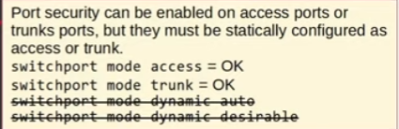
-use the command “show int <int> switchport” to see what mode the switchport is set to
-once you see its either trunk or access you can configure the “switchport port-security” command!
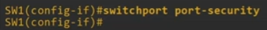

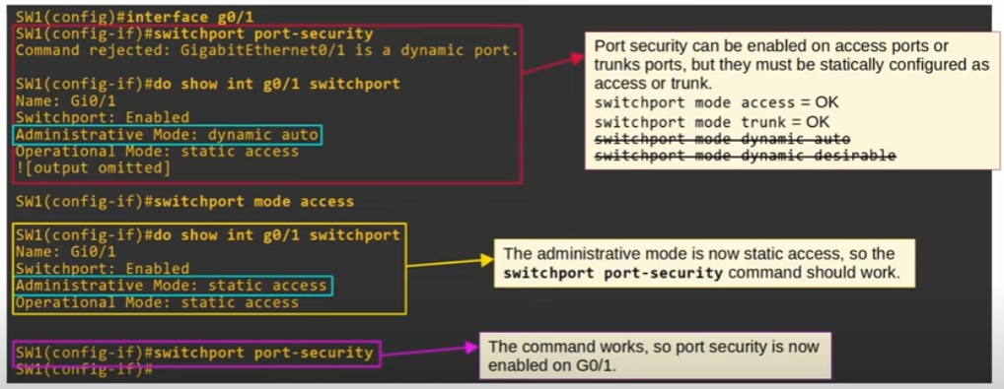
-static access administrative mode on the switchport when you configured “switchport mode access”

With “switchport port-security” we’ve enabled the default settings
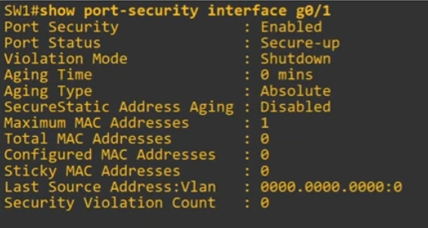
-to see the port-security settings, we use the command “show port-security int <int>”
-since we configured the default settings, everything in the show command is default
-port security is enabled

-Secure UP on port status, means port security is enabled and the port is UP

-Violation mode: what the interface will do if a violation occurs

-Timers default settings: aging time of 0 mins means the addresses will never timeout
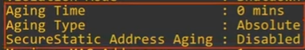

-shows the MAC addresses allowed, how many are on the interface, what MACs are configured, and which were stickied
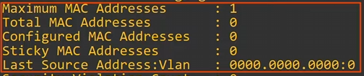
-SW1 hasn’t received any traffic or has had any manual configurations

-Counter of how many violations have occurred

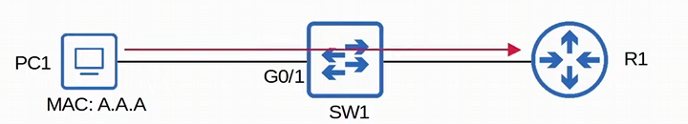
-what changes in the command “show port-security int <int>” when PC1 pings R1
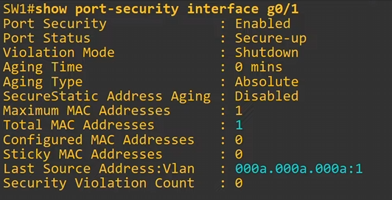
-the total MAC address & last source address: VLAN changes when a ping is sent
-a frame with a source MAC address of PC1 is sent
-SW1 dynamically learns PC1’s Mac address
-shows not only the MAC address of PC1, but also the VLAN

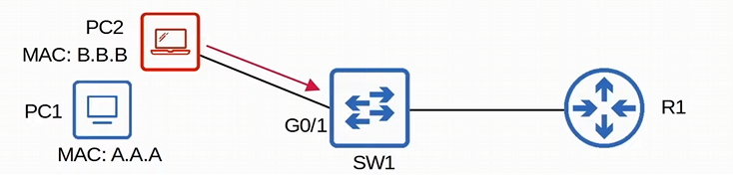
-what will the “show port-security int <int>”show if PC2 connects, after PC1 MAC was dynamically learned

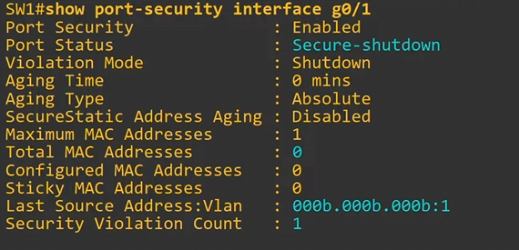
-PC2 will connect and cause the port to shutdown in an err-disabled state

-when a violation occurs in default mode, the Port status will read ‘secure shutdown’

-total MAC addresses: 0
-changed to 0 since the interface shutdown, PC1 MAC address was cleared

-Last source address:Vlan will be PC2’s address (NOT PC1)
-it’s the LAST MAC:VLAN the interface was connected to

-Security Violation count increments to 1 since a violation occurred (only goes up 1)
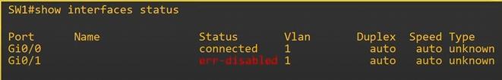
There are two ways to re-enable the interface:
1) manually with “shutdown” -> “no shutdown”
-you need to disconnect the violating device first before you re-enable an interface
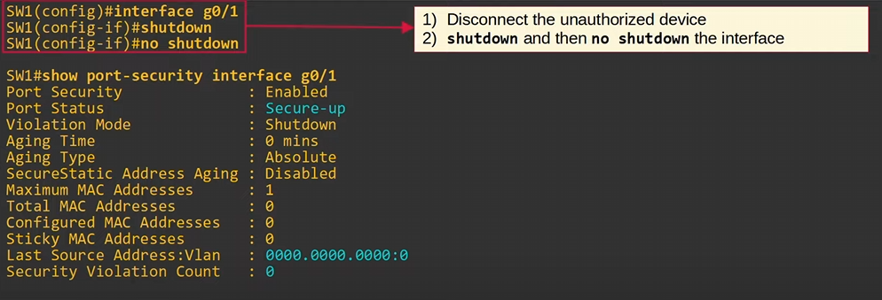
-port status is back to secure up
-Last source address:Vlan is cleared
-security violation count is back to zero

2) with errdisable recovery will make errdisabled interfaces re-enable after a certain period of time
-command is “errdisable recovery cause psecure-violation”

To see all the reasons why errdisable occurs use the command “show errdisable recovery”
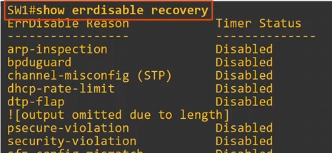
-many reasons why errdisable goes off
-left is the reason, right is the timer (by default, errdisable is disabled for all reasons)
-psecure-violation: port security violation
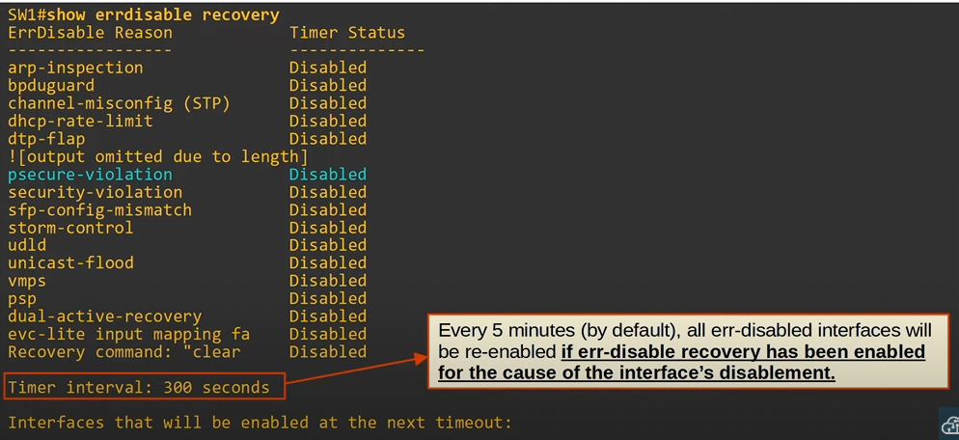
-default timer for errdisable recovery is 5 minutes!

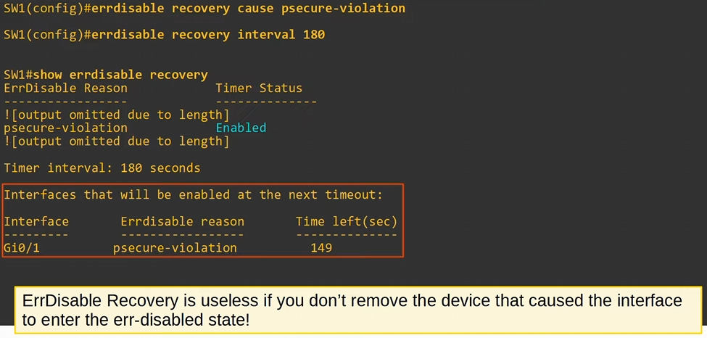
-Again, to turn on errdisable recovery use the command “errdisable recovery cause psecure-violation”
-to shorten the timer of errdisable, use the command “errdisable recovery interval <secs>”

-“show errdisable recovery” shows the timer status as enabled, and the timer interval as 180 seconds like we configured

-made G0/1 errdisabled again, we can see a timer counting down here

Step 1) remove the device causing the errdisable
Step 2) Manually shutdown and re-enable the interface OR use “errdisable recovery cause psecure-violation” to do re-enable the interface automatically

IF you don’t remove the device and you manually re-enabled the interface, the interface will go back into an errdisable state
-however, if you used automatic re-enabling with “errdisable recovery cause psecure-violation” the unauthorized device might become the authorized device for port-security!
-really bad

Three Violation modes from port-security: Shutdown (default), Restrict, Protect
-Shutdown: Places the port into a shutdown mode with errdisable
-will generate a Syslog and/or SNMP message when the interface is disabled
-only one message is generated after the interface is down
-violation counter is set to 1 when interface is disabled !!
-when re-enabled violation counter is set back to 0

-Restrict: Switch DISCARDS traffic from unauthorized MAC addresses
-interface is NOT disabled
-generates a Syslog and/or SNMP message EACH TIME an unauthorized MAC is detected
-Violation counter is incremented by 1 for EACH unauthorized frame

-Protect: Switch discards traffic from unauthorized MAC addresses
-interface is NOT disabled, frames are only discarded
-does NOT generate Syslog/SNMP messages for unauthorized traffic
-does NOT increment the violation counter

-basically, silently discards unauthorized traffic

Shutdown will only have its violation counter show as 1, restrict will increment per violation
-when using the “show port-security int <int>”

-restrict violation mode

-first, we need to enable port security with “switchport port-security”
-then we set up the violation mode with “switchport port-security violation restrict”

-optional, we manually configure an authorized MAC with the command “switchport port-security mac-address <MAC>”

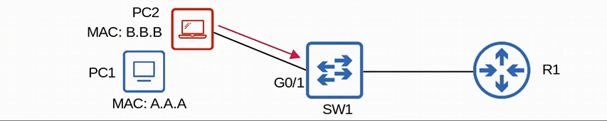
-we let PC2 ping SW1 on the restricted port security interface and we can see a violation occur
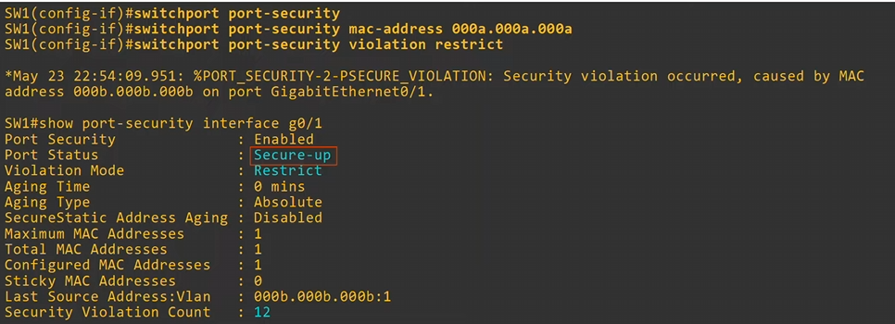
-in restrict port security, the port status will still be up, and SNMP/syslog message will be sent for every violation, and the violation count increments by 1 every time PC2 sends a frame
-we use the command “show port-security int <int>”

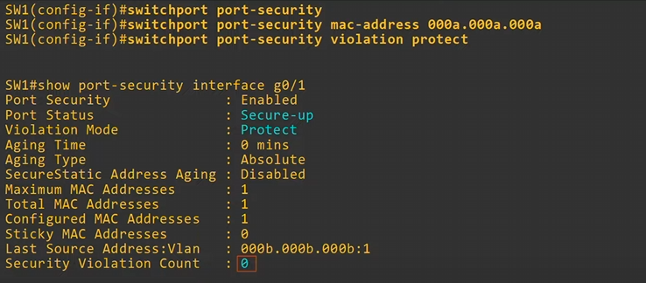
-to enable port security protect mode, use the command “switchport port security” -> then use “switchport port-security violation protect”
-we can see with the “show port-security int <int>” the violation mode is protected, the status of the port is up, and the violation count does increment at all!
-Also, in protect mode NO syslog/SNMP messages are sent!

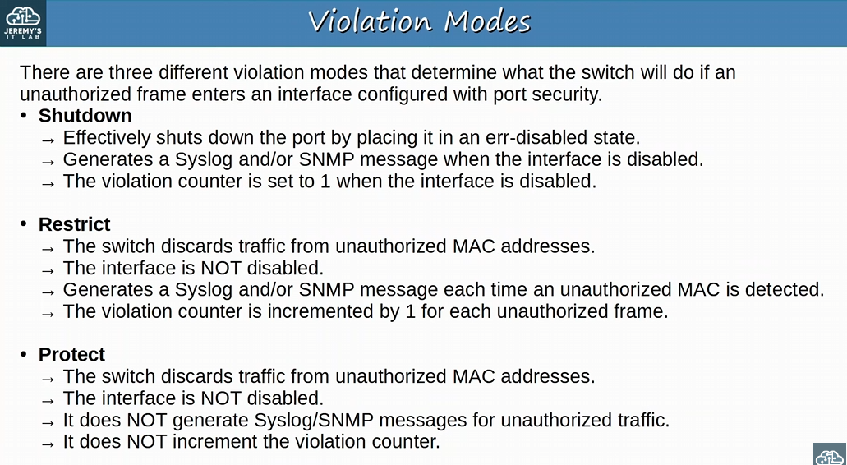
-what a switch does when a port security violation occurs (IMPORTANT)
-shutdown was the default mode
MAC addresses dynamically learned or statically configured on a port-security enabled port are called secure MAC addresses
-by default, a default secure MAC address will NOT ‘age out’ (aging time : 0 mins)
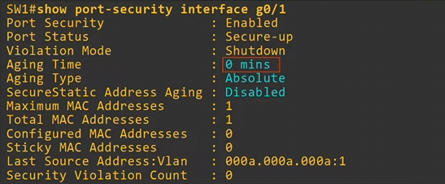

Can configure Secure MAC addresses to age with the command “switchport port-security aging time <minutes>”
-if you do configure an aging time, the default aging type is Absolute

Absolute: After the secure MAC address is learned, the aging timer starts and the MAC is removed after the timer expires, EVEN IF the switch continues receiving frames from that source MAC address
-After the MAC address ages out, it can be relearned with the source MAC in a frame!

Inactivity: After the secure MAC address is learned, the aging timer starts but is reset every time a frame from that source MAC address is received on the interface
-this is like regular MAC address aging (which ages out in 5 mins)
-if a switch keeps receiving frames with original source MAC address regularly, it will never be age out

Secure MAC address aging types: Absolute & Inactivity
-use the command “switchport port-security aging type <absolute/inactivity>”

By default, only DYNAMICALLY LEARN SECURE MAC ADDRESSES will age out
-manual secure mac addresses will not age out “switchport port-security mac-address <mac>”

With the command “switchport port-security aging static” you can have manually configured secure MAC addresses age out!
-manual configuration of the secure MAC address command will be removed from the running-config and removed from the MAC address table

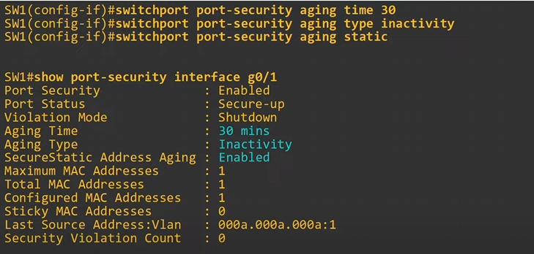
- “switchport port-security aging time <min>” we change how long the aging will occur
- “switchport port-security aging type <absolute/inactivity>” we change the aging type
- “switchport aging static” ages out static secure MAC addresses (and not just dynamic MAC addresses)

-we can see the aging time, aging type, and secure static address aging occurs

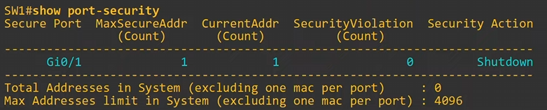
-the command “show port-security” is another useful show command that lists out the interfaces with port security, max MAC addresses allowed, how many MAC addresses are connected, how many security violations have occurred, and violation action

Sticky Secure MAC addresses learning can be enabled with “switchport port-security mac-address sticky”
-dynamically learned secure MAC addresses will be added to the running-config like ‘switchport port-security mac-address sticky <MAC address>’
-need to copy the running-config to the startup config AFTER configuring the sticky secure MAC address
-sticky secure MAC addresses will NEVER age out!
-even if you enable static secure MAC address aging!

-after using the “switchport port-security mac-address sticky” command ALL current dynamically learned secure MAC addresses will be converted to sticky secure MAC addresses

-If you issue the “no switchport port-security mac-address sticky” command all current sticky secure MAC addresses will be converted to regular dynamically-learn secure MAC addresses

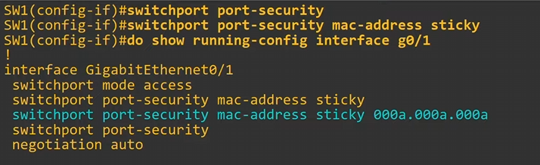
-enabled sticky mac-addresses, and you can see it in the running config
-need to save running-config
-sticky security mac addresses are a way to configure dynamic MAC addresses into static MAC addresses without manually configuring them
-“switchport port-security mac-address <mac>” command for manual configuration

Secure MAC addresses will be added to the MAC address table like any other MAC address
-Sticky and Static secure MAC addresses will have a type of STATIC
-Dynamic-learned secure MAC addresses will have a type of DYNAMIC

-see all secure mac addresses in the MAC address table with “show mac address-table secure”
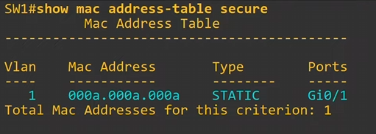
-we didn’t configure this MAC address manually, but since it’s a sticky MAC address its static
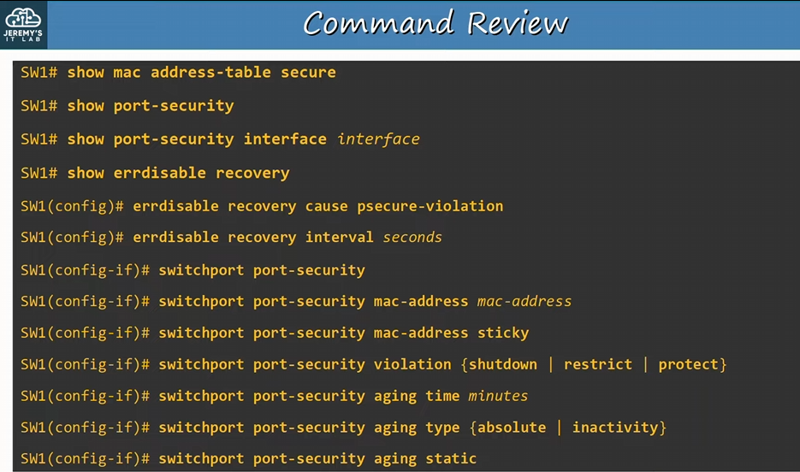

To add a maximum number of MAC addresses “switchport port-security maximum <number of MACs>”

Day 50:
DHCP snooping protects against attacks that use DHCP
-filters DHCP messages receive on untrusted ports of switches
-all ports are untrusted by default
-only filters DHCP messages

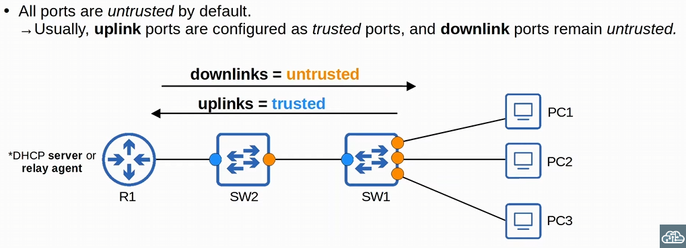
-downlinks are links pointing towards the endhosts
-we apply DHCP snooping on the downlink ports, which are untrusted
-applied on downlink switch ports!
-downlinks are untrusted since a malicious endhost can initiate a DHCP attack

-uplinks are links AWAY from the endhosts
-towards the network
-DHCP snooping won’t inspect any traffic on trusted ports!
-switch will forward thew traffic as normal

-We are filtering endhost messages that USE the DHCP Offer and ACK on the untrusted/downlink ports
-discarding the DHCP offer & ack on the downlink ports we configured
-also checking the DHCP client messages
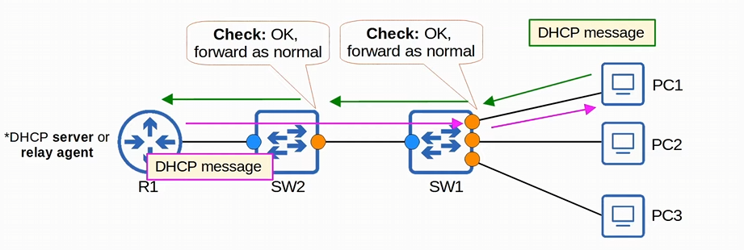
-trusted ports forward DHCP message with no issue

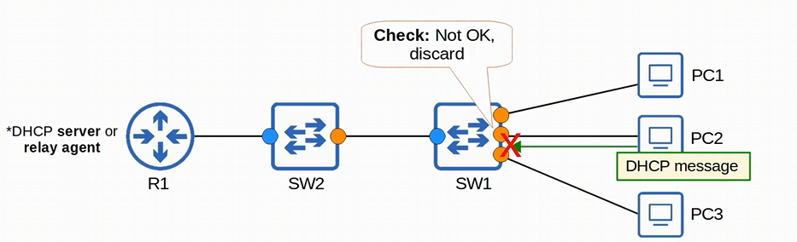
-PC2 gets blocked for acting like as a rogue DHCP client

DHCP snooping prevents DHCP starvation/exhaustion attacks & DHCP poisoning attacks
-DHCP starvation occurs when an attacker uses spoofed MAC addresses to flood DHCP discover messages, which fills the DHCP pool

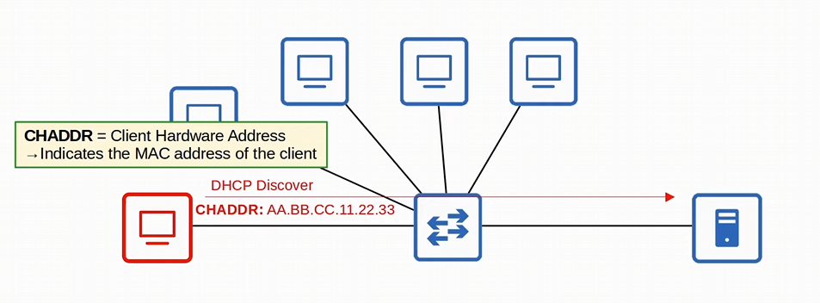
-the rogue endhost sends DHCP discover messages with fake source MAC addresses
-Client Hardware Address (CHADDR) indicates the MAC address of the client, which is useful if the DHCP server is outside the local LAN
-if there is a DHCP relay agent sending DHCP messages to a remote network, the source MAC of the frame sent to the server won’t be the source mac of endhost

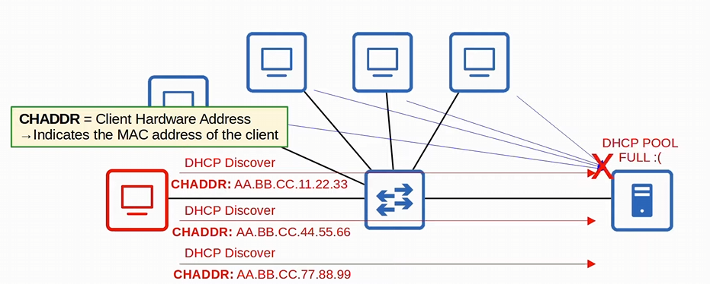
-several DHCP discover messages are send to the DHCP server, leading to a DOS

DHCP poisoning is used to perform a Man-in-the-middle attack
-A spurious DHCP server replies to clients’ DHCP discover messages and assigns them IP addresses, but makes the clients use the spurious server’s IP as the default gateway

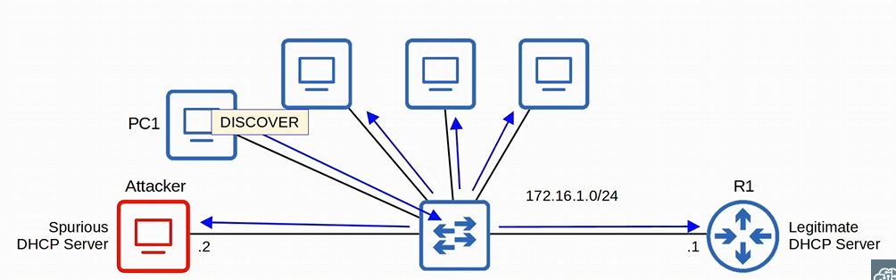
-R1 is the legitimate DHCP server and the default gateway
-Attacker PC is the Spurious DHCP server trying to do a man-in-the-middle attack
-remember the discover message is broadcasted on the network
-D & R broadcast, O & A broadcast or unicast depending on the bootp value of D & R

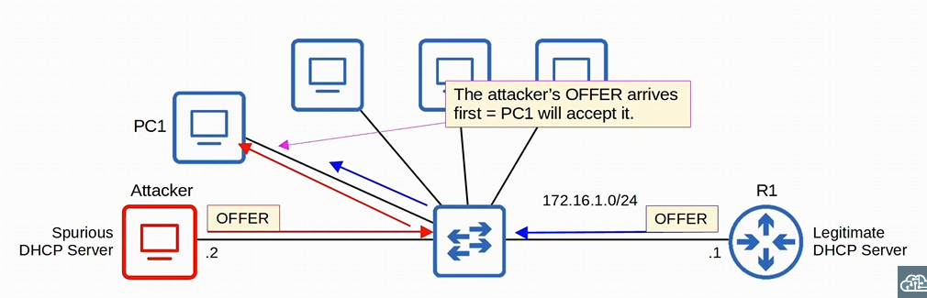
-both the spurious DHCP server and the legitimate DHCP server will send offer requests to PC1, but whichever offer reaches PC1 first will be the DHCP server used by PC1
-the spurious DHCP server Offer reaches PC1 first

-the spurious DHCP server is now ready and primed to finish the rest of the DHCP steps (DORA) with request and acknowledge
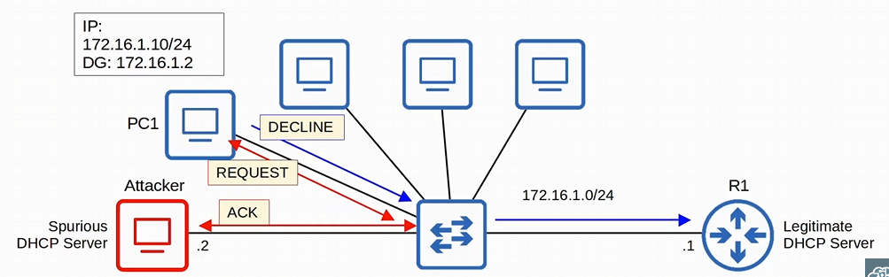
-the spurious DHCP server now gives an IP address to PC1 and make the default gateway the attacker’s IP address
-whatever traffic PC1 wants to send to a default gateway will now go to the attacker hence the man-in-the-middle attack

-the attacker can the examine/modify the traffic before forwarding it to the legitimate default gateway

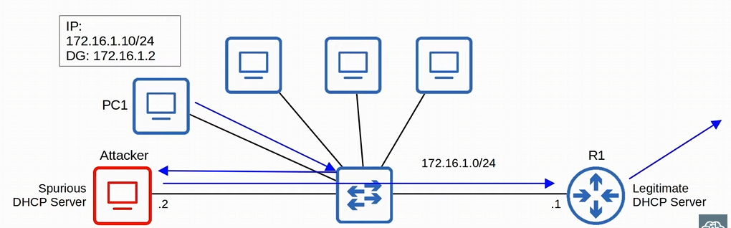
-PC1 send the traffic to its default gate (the attacker’s PC), the Attacker read/ modifies the traffic and then sends it to the legitimate default gateway, and the legitimate default gateway sends the traffic out
-PC1 won’t notice its traffic is being intercepted by an attacker
-when the traffic comes back, the legitimate default gateway will send the traffic to the spurious DHCP server, which can read/modify the traffic again, and then forward the traffic back to PC1

DHCP snooping prevents against DHCP starvation/exhaustion and DHCP poisoning
When DHCP snooping filters messages, it differentiates between DHCP server messages and DHCP client messages
-DHCP client messages: discover, request, release, decline
-Release = used to tell the server the client no longer needs its IP address
-Decline = used to decline the IP address offered by a DHCP server
-DHCP server messages: offer, acknowledge, NAK
-NAK = the opposite of ACK, used to decline a client’s Request

-DHCP server messages will be discarded with NO FUTHER CHECKS on downlink ports
-DHCP client messages will be inspected further on downlink ports
-switch will decide to forward to discard the frame

DHCP Snooping operations:
-messages received on trusted port, forward it as normal without inspection
-messages received on an untrusted port, inspect it and act as follow:
-DHCP server message (offer, acknowledge, NAK) discard it

-DHCP Client messages, perform the following checks:
-Discover/Request messages: check if the frame source MAC address and the DHCP message’s CHADDR fields match
-if CHADDR matches frame source MAC address, switch will forward
-If CHADDR doesn’t match frame source MAC -> discard

-Release/decline messages: Check if the Frame source IP address and the receiving interface match the entry in the DHCP Snooping Binding Table
-Matches = forward
-mismatch = drop

When a client successfully leases an IP address from a server, create a new entry in the DHCP snooping Binding Table (DHCP snooping need to be enabled first!)
Attacker can bypass CHADDR matching with source MAC address, by spoofing the source MAC address as well!
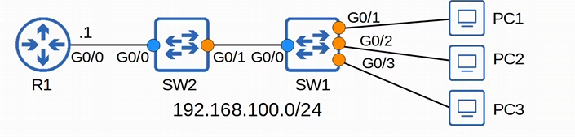
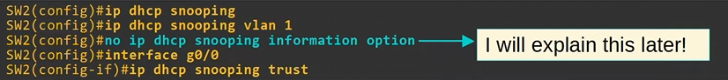
-to enable DHCP snooping, use the command “ip dhcp snooping” and “ip dhcp snooping vlan <vlan>”
-need to use both commands, enable DHCP globally, and on each VLAN

-“no ip DHCP snooping information option” disables DHCP option 82 data insertion
-depending on the network design you might need it

-finally select the trusted ports with “ip dhcp snooping trust” in int mode
-since we enabled DHCP snooping globally, we need to make exceptions. By default, all ports are untrusted
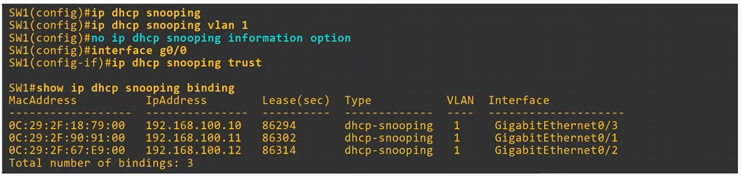
-we use the same commands for SW2
-to see the DHCP binding table we use the “show ip dhcp snooping binding” command
-shows MAC addresses, IP addresses, Lease times for DHCP, Type, VLAN, and interface
-Release/Decline messages will be checked to make sure their IP address/in ID match the entry in the DHCP snooping table!!
By checking the Release/decline messages of DHCP snooping binding table, DHCP snooping prevents attackers sending release/decline messages on the behalf of a victim’s computer!!
-makes the DHCP server think the victim’s computer doesn’t need the IP address anymore

DHCP snooping can limit the rate at which DHCP messages are allowed to enter an interface
-preventing the DHCP exhaustion/starvation attack
-rate of DHCP messages crosses the configured limit, the interface is err-disabled

-just like port-security, the interface can be manually re-enabled, or automatically re-enabled with errdisable recovery

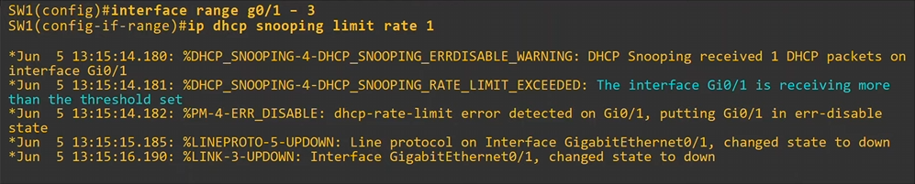
-to configure rate-limit in DHCP snooping, first enable DHCP snooping “ip dhcp snooping” & “ip dhcp snooping vlan <vlan>” then use the command “ip dhcp snooping limit rate <number of DHCP messages per second>”
-“ip DHCP snooping limit rate 1” is too low, and the switch interface will disable
-G0/1 received more DHCP messages than it’s allowed to

-to enable the interface again, either manually do it (“shut” and “no shut”) or use errdisable recovery
-“errdisable recovery cause dhcp-rate-limit”
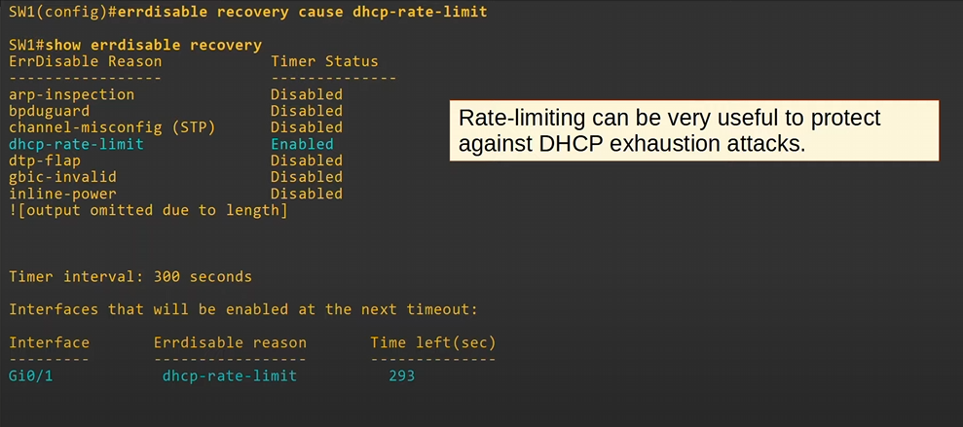
-automatically re-enabling the interface with the command “errdisable recovery cause dhcp-rate-limit”
-again, we can see the errdisable recovery methods with “show errdisable recovery”
-can change the recovery time “errdisable recovery interval <secs>”
-Timer counting down till interface is re-enabled

Rate-limiting DHCP with “ip dhcp snooping limit rate <# of DHCP per second>” will prevent DHCP exhaustion attacks

By spoofing the CHADDR and the source MAC, attackers can bypass the DHCP snooping filtering of discover and request messages. At least with rate limiting added to DHCP snooping, if spoofing occurs, we limit how many DHCP messages are sent out preventing DHCP exhaustion/starvation attacks
-the interface will be errdisable

DHCP Option 82 (Information Option)
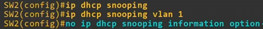
-Option 82, also known as the ‘DHCP relay agent information option’ is one of many DHCP options
-option 82 provides additional information about which DHCP relay agent received the client’s messages, on which interface, in which VLAN, etc.
-DHCP relay agents can add Option 82 to messages the forward to the remote DHCP server
-with DHCP snooping enabled, by DEFAULT cisco switches will add Option 82 to DHCP messages they receive from clients, EVEN IF THE SWITCH ISN’T ACTING AS A DHCP RELAY AGENT
-By default, cisco switches WILL DROP DHCP messages with option 82 that are received on an untrusted port

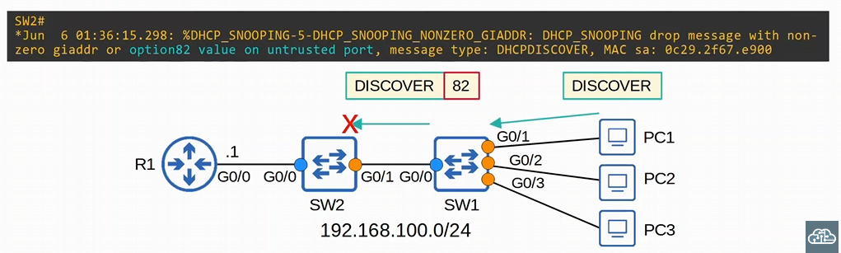
-PC1 sends the discover DHSP messages, and SW1 with DHCP snooping enabled ADDS Option 82 to the discover message -> SW2 received the discover message with option 82 attached to it and DROPS the frame
-If the switch 2 is a layer 3 device relay agent, the default settings work well, but in this topology it will not
-we need to use “no ip dhcp snooping information option” to disable the default setting

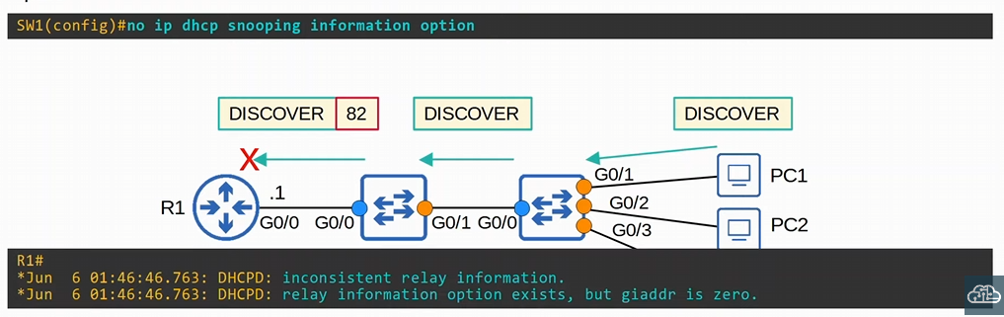
-R1 drops the option 82 frame because it wasn’t sent be a relay agent
-only SW1 has the “no ip dhcp snooping information option” in this case
-Need SW2 to have it as well

-Wasn’t sent by a relay agent

Option 82 by default needs to be send by a relay agent!

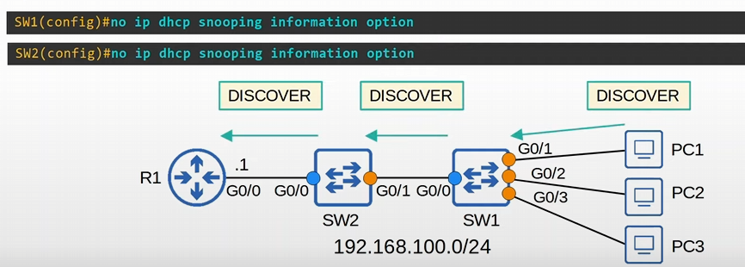
-no option 82 added to the frames, so the discover message goes through normally
-option 82 is only a problem when you use DHCP snooping

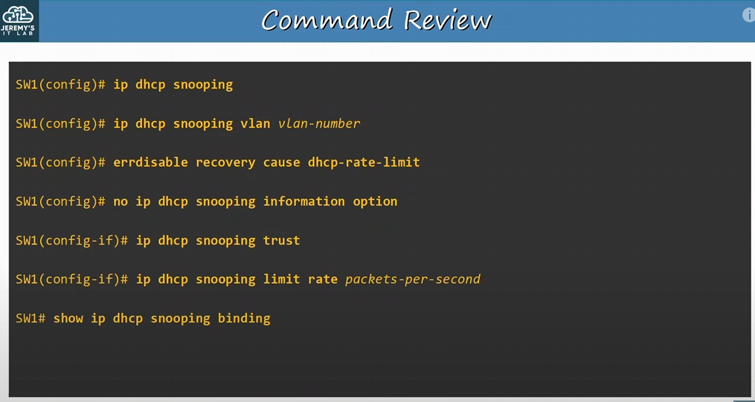
-enable DHCP globally -> VLAN -> configure the trusted ports -> remove option 82 -> finally limit the DHCP rate per interface

Day 51:
Dynamic ARP Inspection (DAI)
-Just like DHCP snooping, and port security, is another Layer 2 security feature
-inspects ARP messages to prevent Man-In-The-Middle attacks or other ARP exploits

ARP is used to learn the MAC address of another device with a known IP address
-Mapping the IP address to a MAC address for devices like endhosts
-For example, a PC will use ARP to learn the MAC address of its default gateway to communicate with external networks (or even a local network and a PC in the local network)
-two message exchange: ARP request and ARP reply
-Unknown MAC addresses have the FFFF.FFFF.FFFF in the destination MAC field to broadcast an ARP request ( the switch will flood this frame)
-ARP reply is a unicast reply

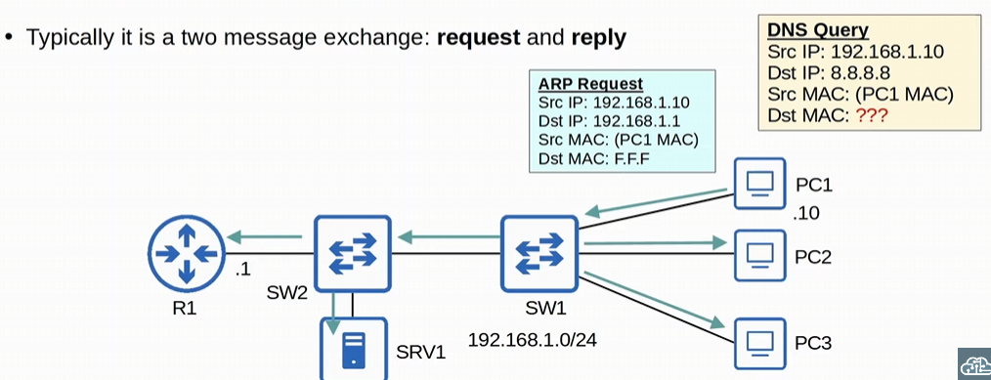
-Before PC1 can send a DNS query, it must figure out the MAC address of the default gateway
-sends a broadcast of an ARP request

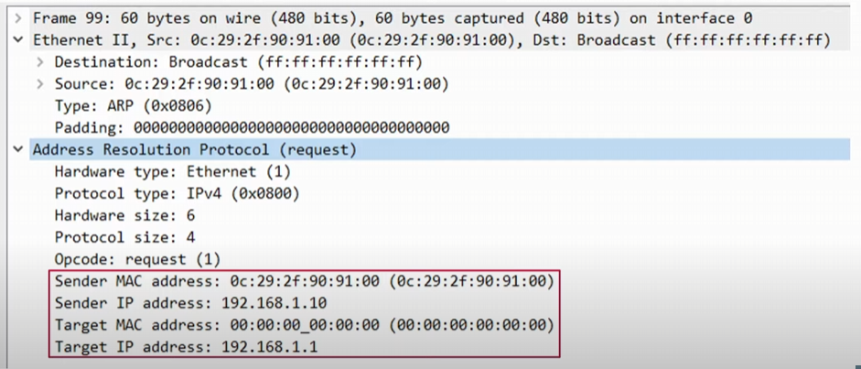
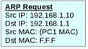
-Sender IP address is the source IP address, and Target IP is the destination IP address

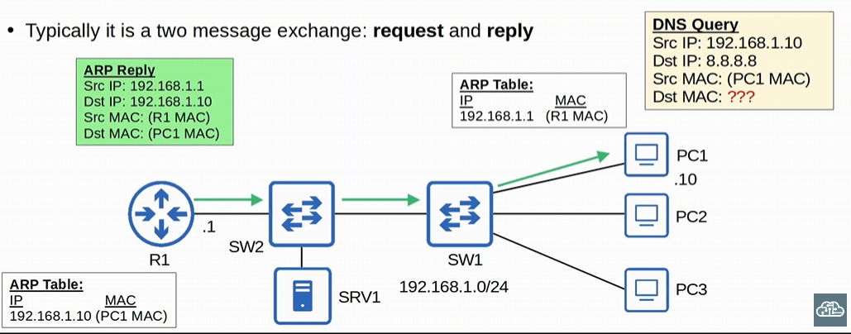
-R1 and PC1 add each other in their ARP table
-We see an ARP reply from R1/DG to PC1
-PC1 can now send the DNS query other the internet
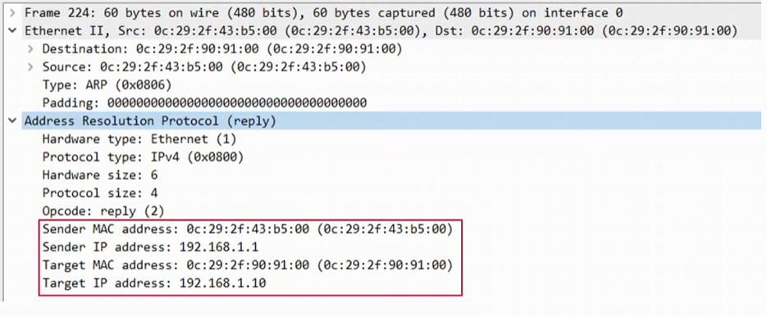

Gratuitous ARP is when an ARP reply is broadcasted, without the use of an ARP request
-using the broadcast MAC address (FFFF.FFFF.FFFF)
-allows other devices to learn the MAC address of the sending device without having to send ARP requests
-Some devices automatically send GARP messages when an interface is enabled, IP address is changed, MAC address is changed, etc.
-depends on the device maker

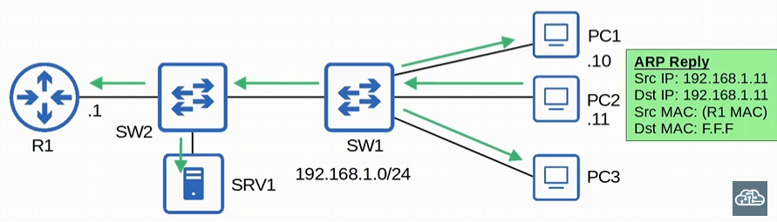
-After the GARP is sent out, the other devices will add PC2 to their ARP tables, while SW1 and SW2 will add PC2’s MAC address to the MAC address table

Dynamic ARP inspection is a security feature of switches that is used to filter ARP messages received on UNTRUSTED ports
-filters ONLY ARP messages, non-ARP messages aren’t affected (like DHCP snooping)
-all ports are untrusted by default (like DHCP snooping)

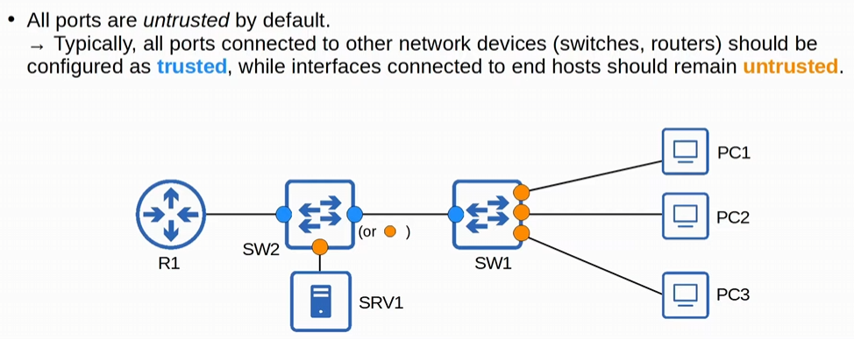
-similar to DHCP snooping, only difference is that the interface SW2 has connected to SW1 is trusted
-cisco recommends all interface connected to switches, routers, etc. should be configured as trusted
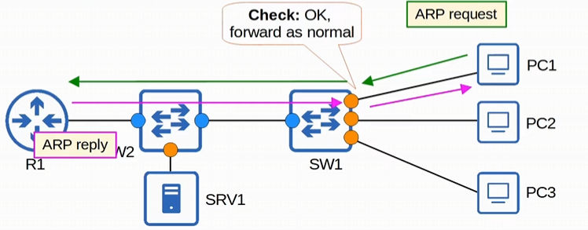
-DAI only checks ARP on untrusted ports

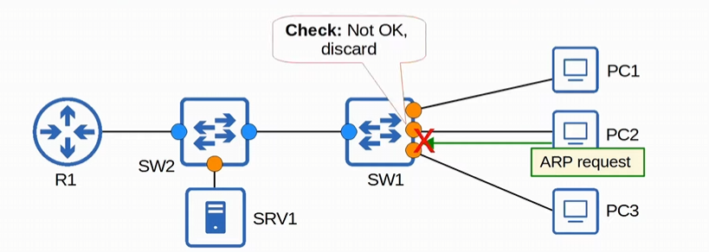
-PC2 tries to send an ARP but is blocked on the untrusted port

ARP Poisoning: Similar to DHCP poisoning, ARP poisoning involves an attacker manipulating targets’ ARP tables, so traffic is sent to the attacker
-Attacker can send GARP (gratuitous ARP) messages using another device’s IP address
-another opinion, is to send replies to the target’s legitimate ARP request messages
-Other devices in the network will receive the GARP and update their ARP tables, causing them to send traffic to the attacker instead of the legitimate destination
-similar to DHCP poisoning

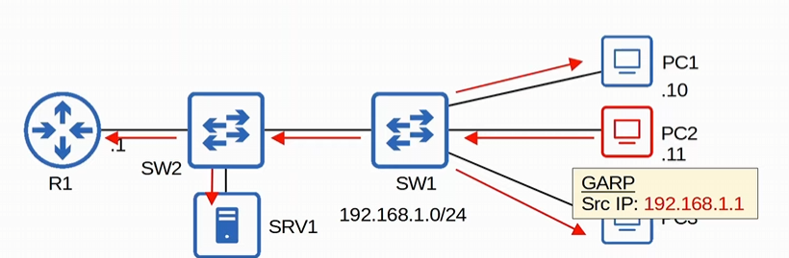
-PC2 is the attacker, that makes everyone on the network think PC2’s MAC address is mapped to 192.168.1.1
-PC2 will now get traffic from everyone in the local LAN that was really meant for R1/DG
-both DHCP poisoning, and ARP poisoning attacks focus on making the attacker’s PC the Default gateway
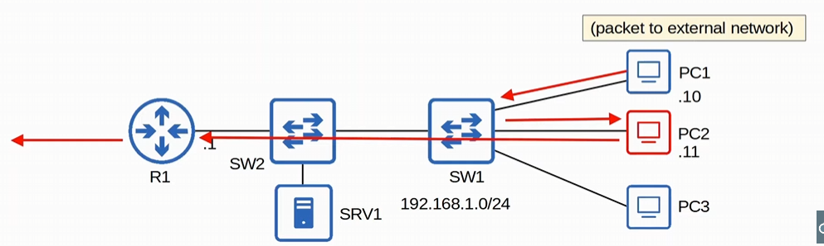
ARP poisoning is also known as a Man-in-the-middle attack

DAI inspects the sender MAC and sender IP fields of ARP messages received on untrusted ports
-checks if there is a matching entry in the DHCP snooping binding table

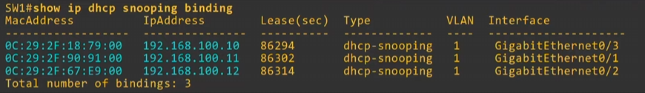
-remember DHCP snooping creates a binding table
-DAI checks the MAC address and IP address field of the DHCP snooping binding table, and compares the table to the ARP message to see if there is a matching entry
-if there is a matching entry between the table and the ARP message, ARP is forwarded normally
-no matching entry, the ARP message is discarded
-DIA doesn’t inspect messages received on trusted ports, forward as normal

DHCP snooping compares DHCP release/decline messages to the DHCP binding table’s IP address and interface. Meanwhile, DIA compares the DHCP snooping binding table’s MAC addresses and IP addresses to ARP packets
-use the command “show ip dhcp snooping binding” to see the table

DAI operations are reliant on DHCP snooping but there’s a second opinion
-ARP ACLs can be manually configured to MAP IP addresses/MAC addresses for DAI to check
-useful for hosts that don’t use DHCP (won’t have a DHCP snooping table

DAI can be configured to perform more in-depth checks also, but these are optional

Like DHCP snooping, DAI also supports rate-limiting to prevent attackers from overwhelming the switch with ARP messages
-both DHCP snooping and DAI both require work from the switch’s CPU!!
-even if the attacker’s messages are blocked, they can overload the switch’s CPU with ARP messages or DHCP messages
-rate-limiting will disable the interface before the CPU cooks itself alive

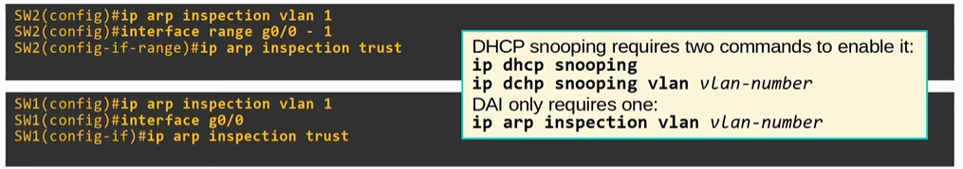
-DAI you only enable on a vlan with the command “ip arp inspection vlan <vlan>”
-unlike DHCP snooping where you enable it globally, and then on a VLAN
-need to apply DAI on all VLANs in the switch
-to enable trusted ports, use the command “ip arp inspection trust” on int mode

To see the DAI interfaces, use the command “show ip arp inspection int”
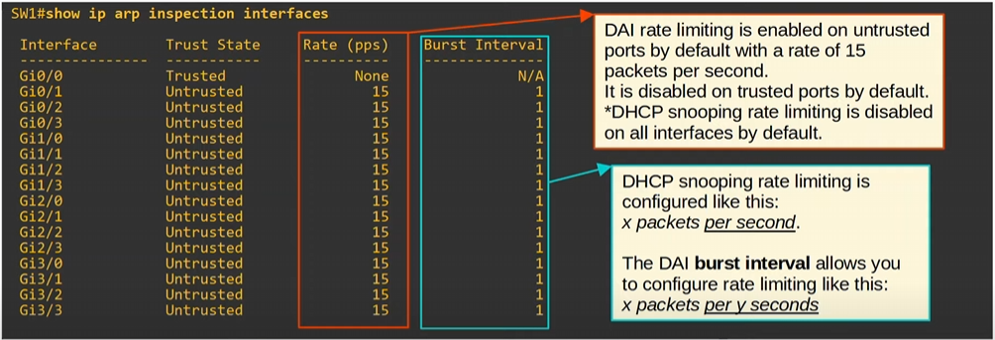
-shows the trust state of each int
-DAI rate limiting is enabled on untrusted ports by default with 15 packets per second
-DHCP snooping has it disabled by default

-DHCP snooping is configured with “ip dhcp snooping limit rate <packet per second>” while DAI burst interval works like ‘x packets PER y seconds’
-interval measured isn’t per second for DAI like it is for DHCP snooping

To configure DAI rate limiting use the command “ip arp inspection limit rate <# of ARP> burst interval <seconds>” in int mode
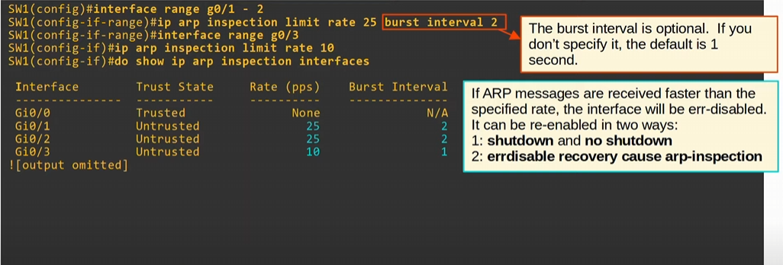
-you can remove the “burst interval <seconds>” and the default will be # of packet per second
-this is 25 packets per 2 sec burst
-“show IP arp inspection int” lists out the rate and bursts
IF ARP messages are received faster than the specified rate, the interface will be err-disabled
-rate limiting limits the rate that ARP messages are received on an interface, NOT sent by an interface
-we can recover a err-disabled interface with “shutdown” & “no shutdown” OR “errdisable recovery cause arp-inspection”

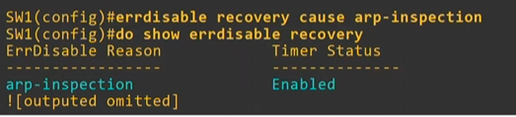

By default, DAI checks the sender MAC and send IP address to the DHCP snooping binding table

DAI Optional checks can be enabled by using the “ip arp inspection validate <check method>”
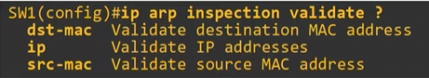
-dst-mac/src-mac checks the ethernet header destination/source and compares it to the ARP message’s target/sender MAC
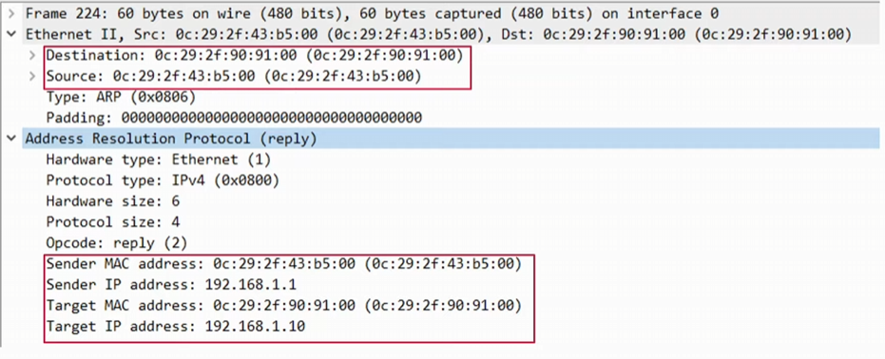

-IP addresses are checks invalid and unexpected IP addresses, checks the sender IP address & target IP address

Additional checks are done in addition to the standard DAI check (sender MAC/IP). If configured, an ARP message must pass ALL the checks to be considered valid.
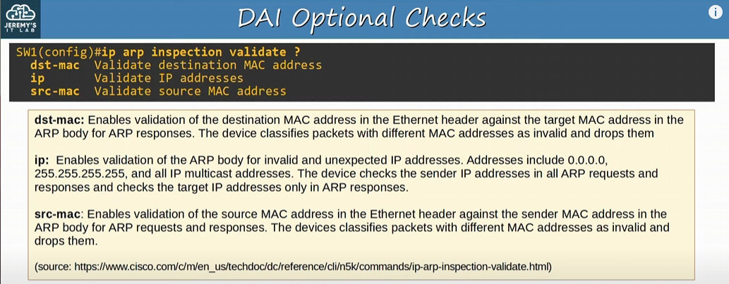

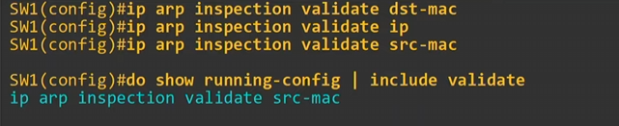
-OPTIONAL checks will OVERWRITE the previous one configured
-the last optional check is what is going to be used

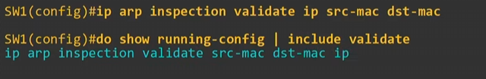
-need to write ALL the optional checks in one command “ip arp inspection validate <method> <optional method> <optional method>”
-all three will be used as an optional check
-enter all validation checks you want in a single command, can specify up to all three!
-order isn’t significant

ARP ACLs
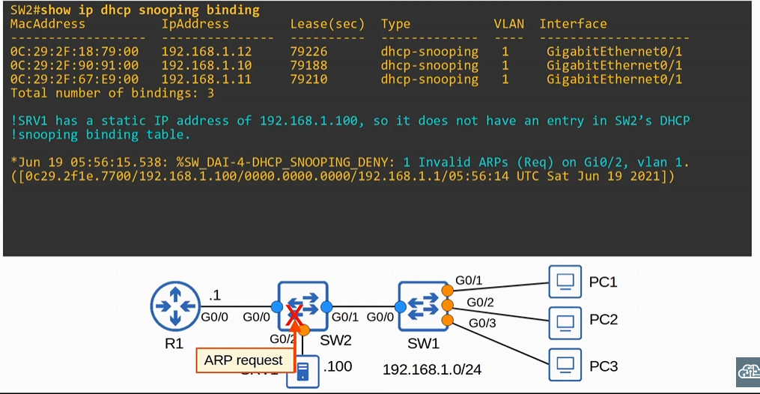
-SVR1 doesn’t have an entry in the DHCP snooping binding table
-SW2 will drop the ARP request
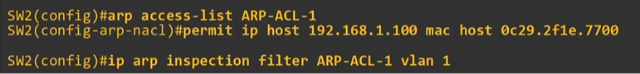
-to create the ARP ACL we use the command “arp access-list <name>” to go into ARP ACL config mode and use the command “permit ip host <IP> mac host <mac>”
-next we need to apply the ARP ACL with the command “ip arp inspection filter <ARP ACL name> vlan <vlan>”

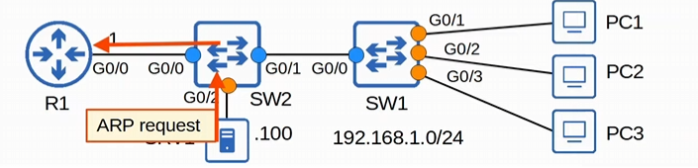
-since we created the ACL and applied it, the ARP request of SRV2 will go through

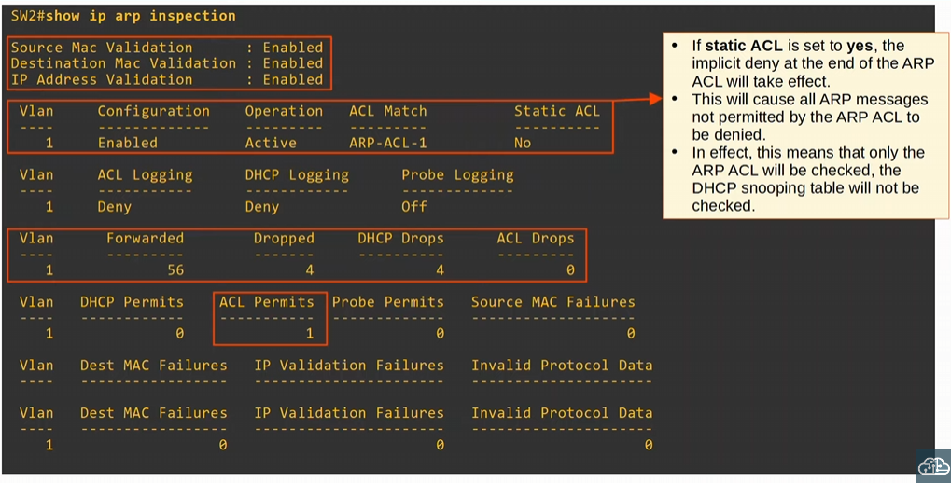
-we can use “show ip arp inspection” to see the DAI optional checks
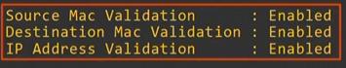

-DAI is configured and operational in VLAN 1, and the ACL is working too
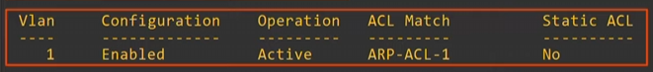
-if static ACL is set to yes, the implicit deny of ACL will take effect
-if implicit deny is working because a static ACL was configured, all ARP messages will not be permitted by the ARP ACL to be denied
-usually, we have the setting for static ACL as no, not really a CCNA topic

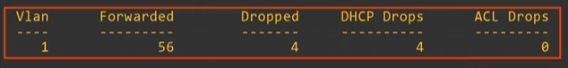
-we can see how many ARP messages were forwarded & dropped
-DHCP drops mean the ARP message was compared to the DHCP snooping binding table and there wasn’t a matching entry
-we tried to ping from SRV1 before configuring the ARP ACL

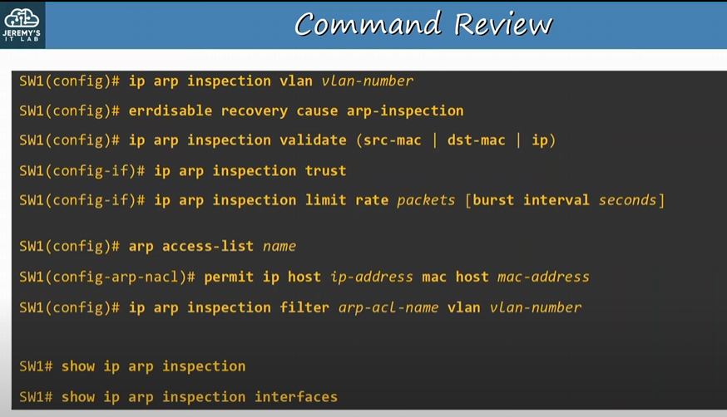

Day 52:
LAN architectures
-2/3 tier LAN architectures
-used in most enterprise networks
-Spine-Leaf architecture
-Data centre environments
-SOHO small office/home office
-one device acting as router, switch, DG, firewall, and WAP

Need to understand the general principles of a LAN architecture, as well as the needs of the customer
-there are some ‘best practices’ in network design, but few universal ‘correct answers’
-most general questions about network design is ‘it depends’
-requirements of each network are different
-we need to learn the basics of network design and architecture!

Star topology: several devices all connected to one central device
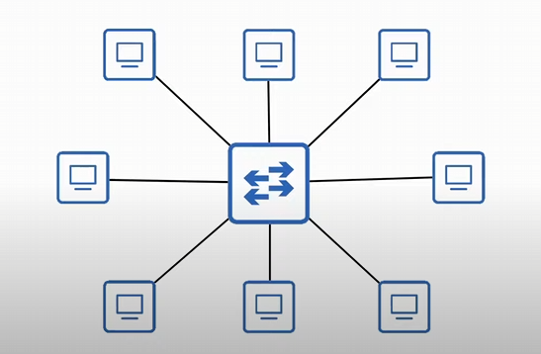
-many devices connected to one central device

Full Mesh: when each device is connected to each other device in the network
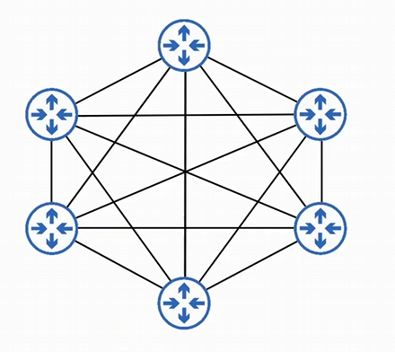
-redundancy

Partial Mesh: When some devices are connected to each other, but not all

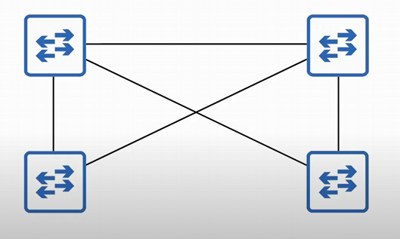
-not all devices are connected to each other (bottom two switches)
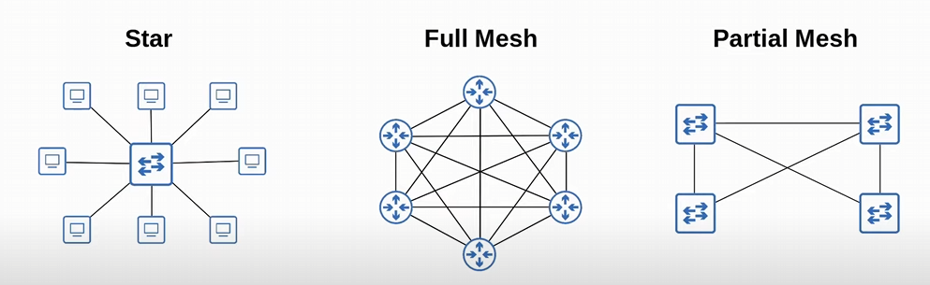

Two-tier Campus LAN design
-campus LAN: LAN of devices in a building or perhaps multiple buildings that are close to each other
-LAN is Local Area Network
-Two-tier LAN contains the Access-Layer and Distribution-Layer
-also known as the collapsed core design (two layers are collapsed into one when compared to a three-tier design)
-doesn’t have the Core layer found in the Three-tier Design

-Access Layer: layer that connected to the endhosts (PCs, printers, cameras, etc.), typically a switch
-endhosts connecting to an access layer switch!
-Access Layer switches have lots of ports for end hosts to connect to
-QOS marking is typically done here
-want to mark traffic as early as possible in the network
-security services like port-security, DAI, DHCP snooping, etc. are typically performed here
-switchports might be PoE-enabled for wireless Aps, IP phones, etc.

-Distribution Layer: aggregates connections from the access layer switches (layer 3 switches)
-border between Layer 2 & Layer 3 (switches will run both layer 2 and layer 3 protocols)
-endhosts might use the SVIs of the distribution layer multilayer switches as their default gateways
-distribution layer connects to services such as Internet, WAN, etc.
For Two-Tiered Campus LAN designs, you’ll have endhosts connect to access layer switches and those access layer switches are connected to a distribution layer switch

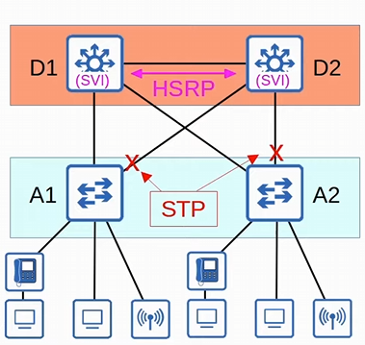
-Access Layer deal with layer two switches, and security services
-Distribution Layer deals with layer 3 switches using both layer 2 and 3 protocols
-redundancy occurs here with access layer switches connected to both distributed layer switches

-Loops can occurs between the access layer switches and distributed layer switches, so STP is used
-endhosts are using the HSRP VIP of both distributed layer switch as a default gateway, just in case one switch goes down

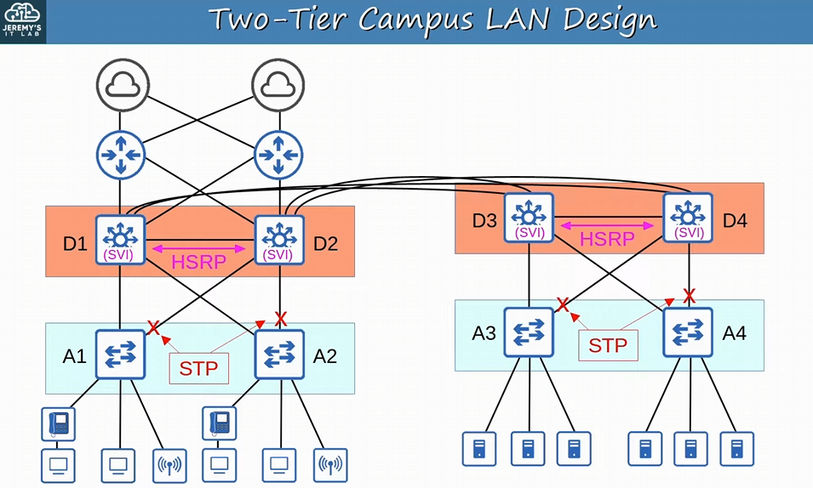
-the distribution Layer is connected to two redundant ISP
-the distribution layer switches are Full Mesh topology
-every distribution layer switch is connected to each other
-the connection between distribution layer switches is LAYER 3, where routing information can be shared via OSPF or other routing protocols

-in a collapsed core design (two-tier LAN design), the Distribution layer is sometimes called the Core-Distribution Layer!!
-the distribution layer of a two-tier design is both the core and the distribution layer of a three-tier design!!

Access-Layer switch performs QoS marking and security features
-IP phones can push the trust boundary down to their level, but you can keep it at the access-layer switch

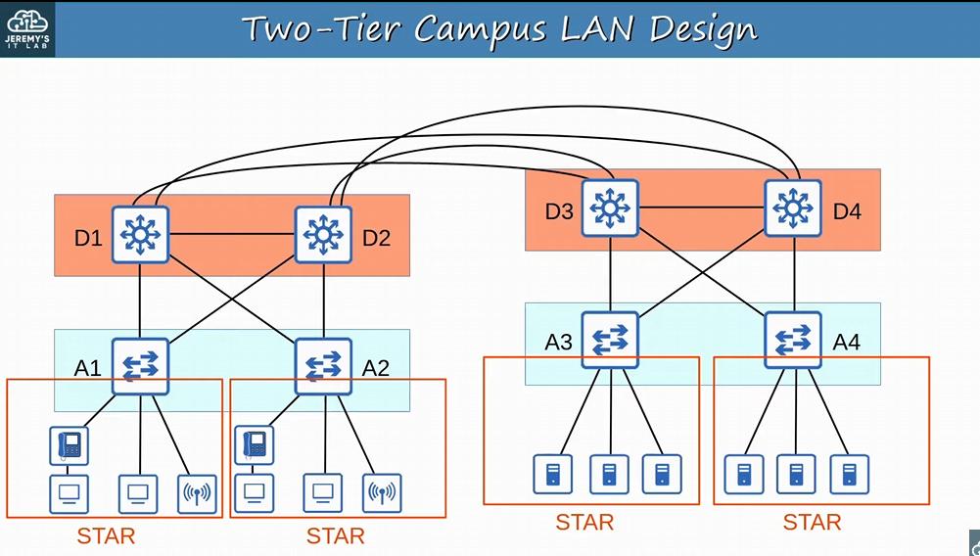
-Access layer switch is one centralized device, connected to multiple devices -> Star topologies

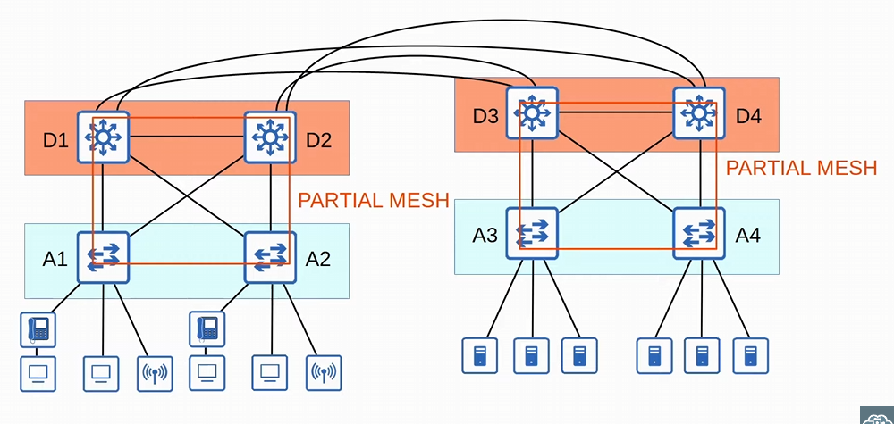
-Between the access layer and the distribution layer are partial meshes
-access switches aren’t connected to each other

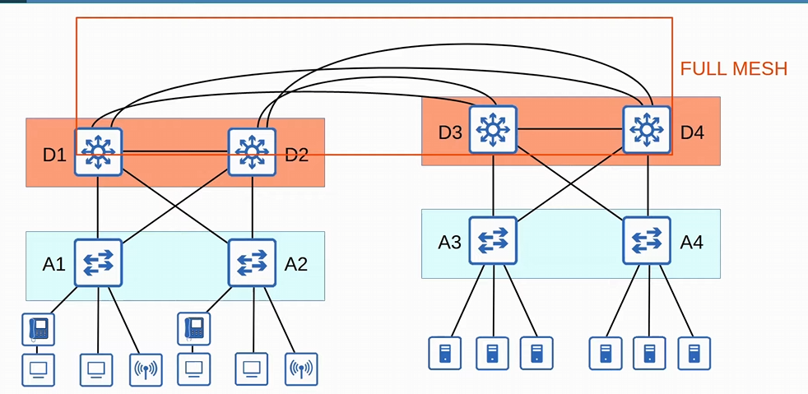
-each distribution switch is connected to each other making a full mesh

You will see elements of full mesh, partial mesh, and star topologies in network designs
-some might have a mix of the three topologies, making a Hybrid Topology

You want a maximum of THREE distribution layers in a location, before adding a Core Layer
-in large LAN networks with many distribution Layer switches (for example in separate buildings), the number of connections required between Distribution Layer switches grows rapidly

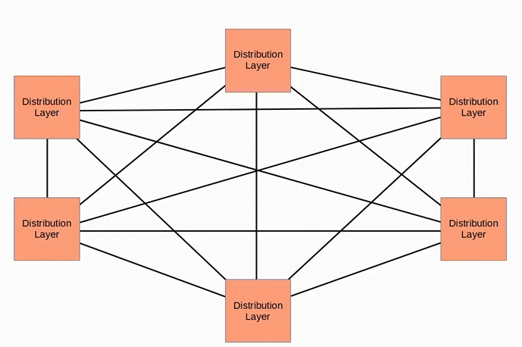
-we have six in a single location, so we need to add a Core layer

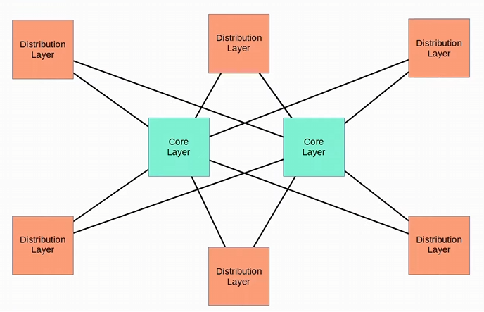
-we’ve created a Three-Tier campus LAN design
-Core layer switches are a pair of very powerful & fast switches
-this is now a partial mesh design

Three-Tier LAN design:
-Access layer
-Distribution Layer
-Core Layer: connects distribution Layers together in large LAN networks
-focus is SPEED (‘fast transport’)
-ALL CPU-intensive operations such as security, QoS marking/classifications, etc. SHOULD BE AVOIDED AT THIS LAYER (fast forwarding of packets ONLY)
-connections are ALL LAYER 3 (NO spanning-tree)
-should maintain connectively throughout the LAN even if devices fail
-because it’s the backbone of the LAN, redundancy is important

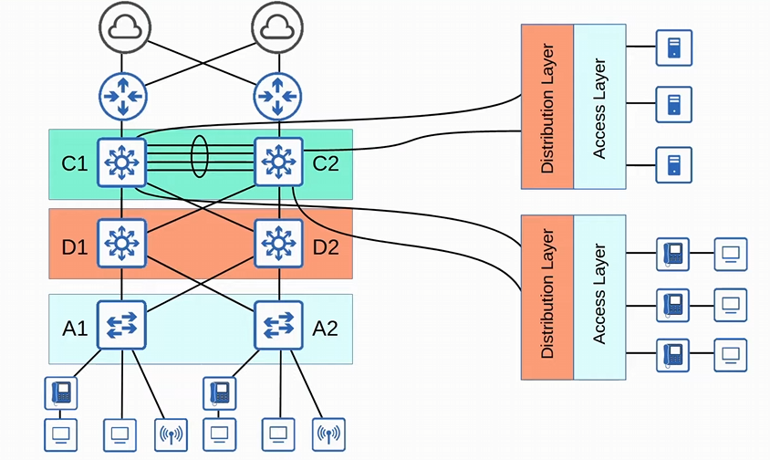
-core switches are connected to the internet routers
-core switches are connected to each other via etherchannel
-between the distribution layer switches and the core layer switches is JUST layer 3 connectivity

Smaller LANs will be two-tiered while larger LANs will be three tiered

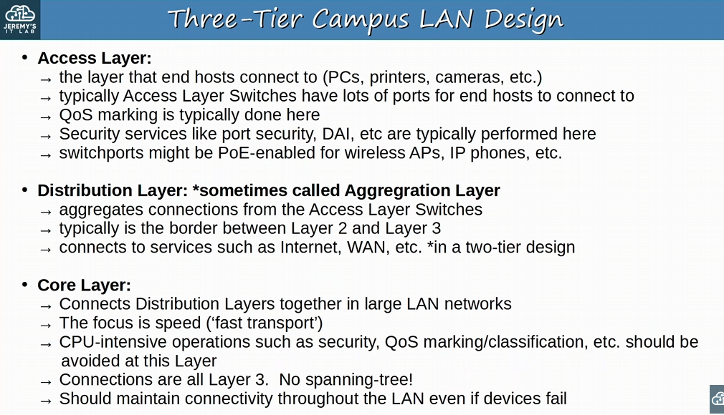
-distribution layer is also sometimes called the Aggregation Layer
-Aggregation is an essential function of this layer

Spine-Leaf Architecture
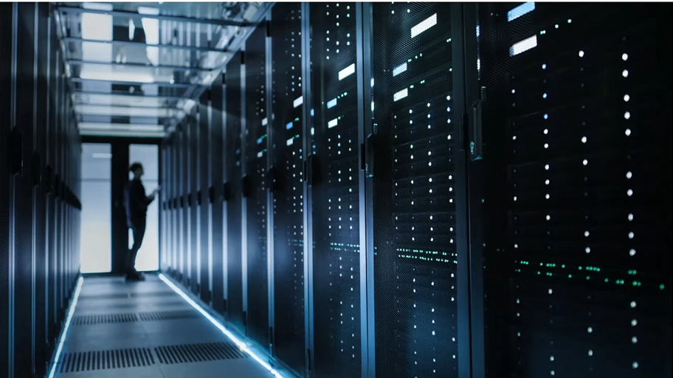
-this is a data centre
-Data centres are dedicated spaces/buildings used to store computer systems such as servers and network devices
-contains halls of racks where servers and network devices are mounted on the racks
-traditional data center designs used a three-tier architecture (Access-Distribution-Core)
-works well when most traffic in the data centre was North-South

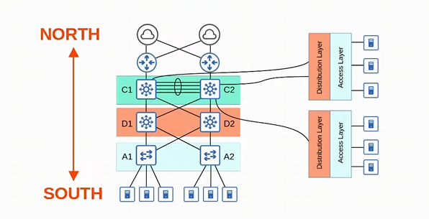
-north south refers to traffic from the access layer up to distribution then core, and finally out to the internet or back down south to the other distribution and access layers
-these are also north-south

East-west traffic occurs between servers
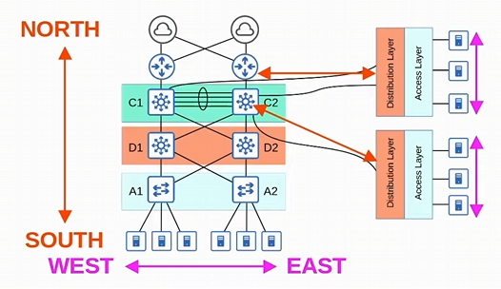
-east-west traffic doesn’t go out to the LAN or other parts of the internet
-with the precedence of virtual servers, applications are often deployed in a distributed manner (across multiple physical servers), which increases the amount of East-West Traffic in a data centre
With the traditional three-tier architecture, bottlenecking in bandwidth occurred, as well as variability in the server-to-server latency depending on the path the traffic takes
-Spine leaf architecture/Clos architecture has become prominent in data centres

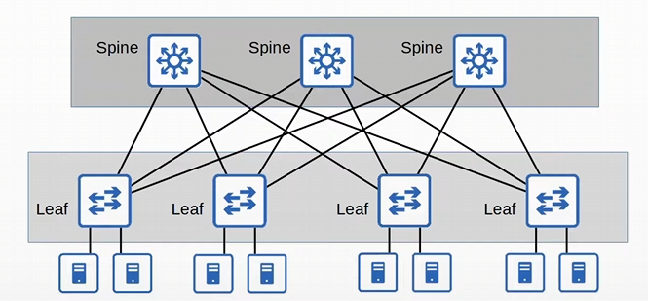
-this is two tiered, but are different than the traditional two-tiered architecture

Rules of the Spine-Leaf architecture:
-EVERY leaf switch is connected to EVERY spine switch
-EVERY spine switch is connected to EVERY leaf switch

-Leaf switches are NOT connected to other leave switches
-Spine switches are not connected to other spine switches

-Endhosts only connect to Leaf switches
-leaf switches are like the access layer of the Spine-Leaf architecture

The path taken by traffic in a Spine-Leaf architecture is randomly chosen to balance the traffic load among the Spine switches
-each server is separated by the same number of ‘hops’ (except those connected to the same leaf switch), providing consistent latency for east-west traffic
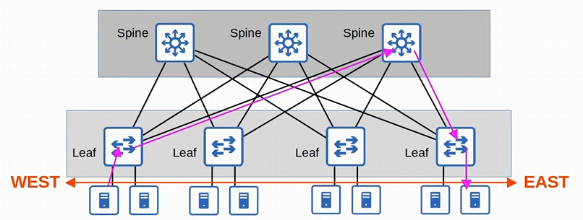
-traffic passes through three switches

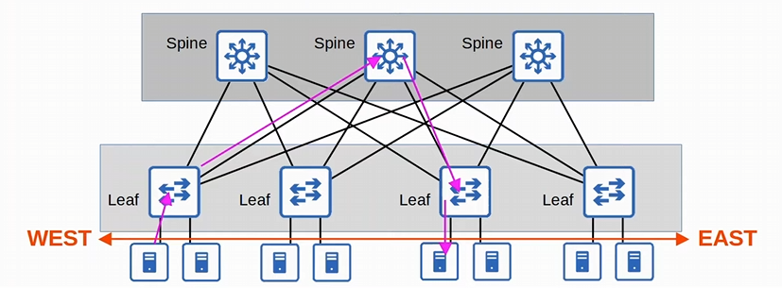
-traffic passes through three switches here as well

The number of hops is less if endhosts are connected to the same Leaf switch

Easy to scale, all you need to do is connect a leaf switch to existed spine switches

SOHO Networks (Small Office/Home Office) refers to the office of a small company, or a small home office with few devices
-if your home has a network connected to the internet it is a SOHO network (doesn’t need to be an ‘office’)
-don’t have complex needs, so all networking functions are typically provided by a single device, often called a ‘home router’ or ‘wireless router’
-don’t need a dedicated device for each function
-one device can be a router, switch, firewall, WAP, and Modem
-modem is used for cable internet, but sometimes you’ll have a router a modem separated
-switchports are on the back of the router
-for small networks you don’t need a separated device dedicated to routing
-the firewall of a router allows internal devices to access outside network, but not have the outside network connect internally (basic firewall configurations)

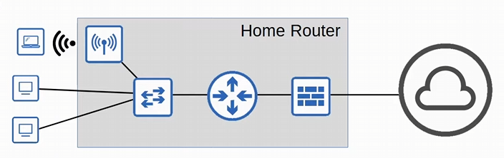
-all connected to one device

Cisco ACI architecture, Clos architecture, and Cisco ACI are all the same

Need to synchronize the default gateway/HSRP priority device with the primary STP to have traffic go to one singular device
Day 53:
Looking at WAN architecture, VPNs, and MPLS VPNs

WAN: Wide area network, extend over a large geographic area
-used to connect geographically separated LANs
-for example, a company has an office in Toronto and New York, each office is a LAN and the connections between them is a WAN

Although the Internet is technically a WAN, the term WAN is typically used to refer to an enterprise’s private connections that connects their offices, data centres, and other sites
-VPNs can be used to create private WAN connections over the internet

There are many different WAN technologies over the years which depends on the location where the WAN is installed
-Legacy technology (old technology) is one country might still be used in other countries

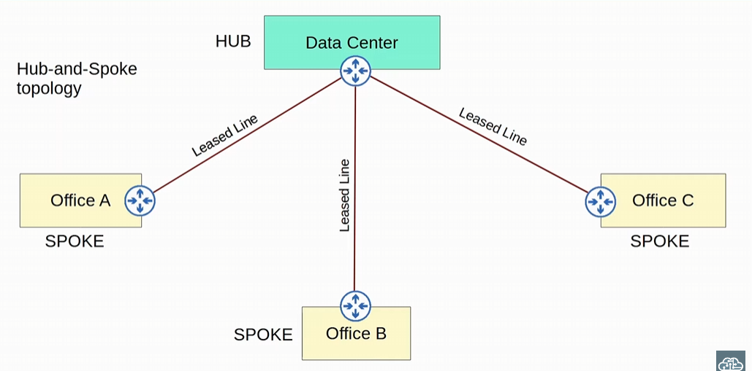
-This is a Hub-And-Spoke set up, where LANs are connected to one centralized area
-Lease line is a dedicated physical connection between two sites
-this is not the internet; this is a private connection the company uses
Hub-and-spoke topology is like the Star topology, but one is for WAN (Hub-and-spoke), and one is for LANs (Star) !!

Hub-and-spoke allows for central control what traffic is allowed and what isn’t
-all traffic between offices can be sent to a firewall in the data centre, and could control traffic

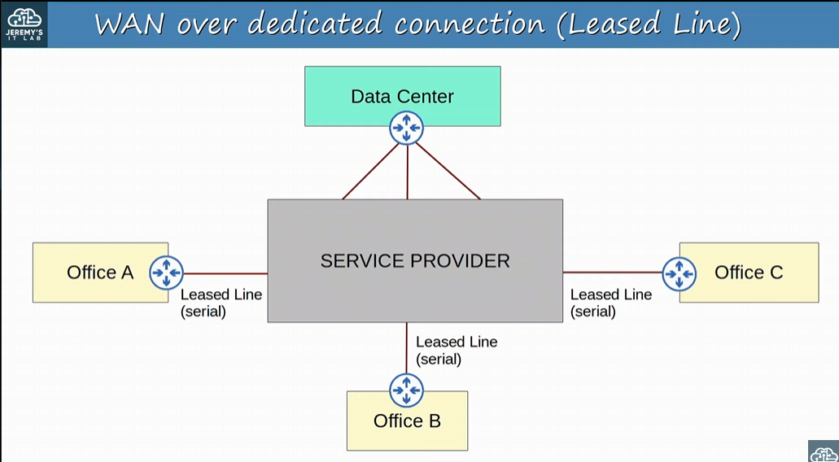
-this is more of an accurate example of what occurs, there isn’t a physical Lease line directly connected to the central Data centre
-the service provider connected the sites together
-Lease Line use typically use serial lines (HDLC)
-these days WAN connections over ethernet is more common

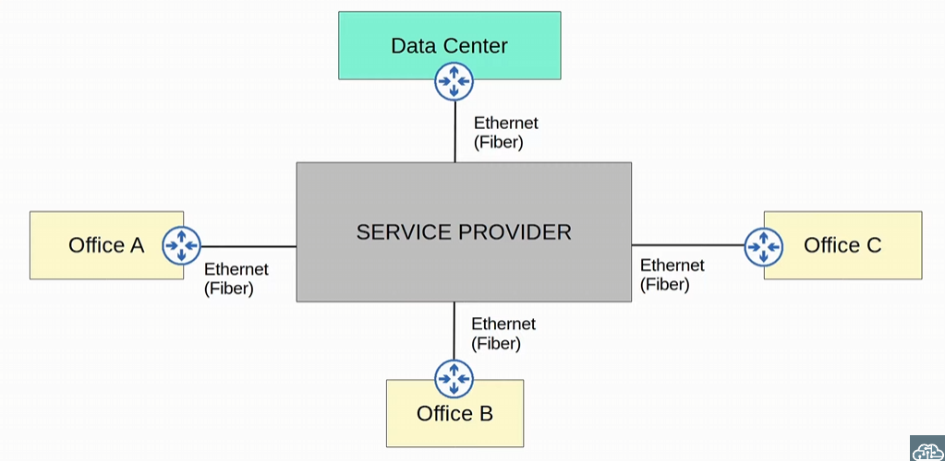
-optical fibre cables are much longer so these day WANs prefer using fibre optic cables

We will be focusing on the WAN connection of the enterprise since that will be on the CCNA

Internet can also be used for an enterprise’s WAN connection between sites/LAN
-internet itself is not a private network, it’s a shared public network
-Sending private information on the internet unprotected is not a good idea
-We will use a VPN
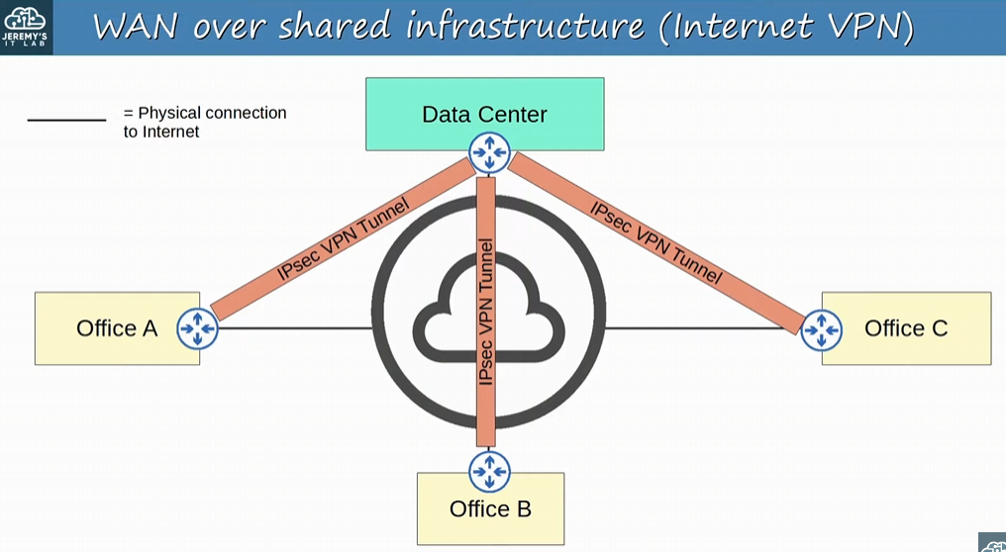
-the Company will set up VPNs (virtual private networks); packets will be encrypted so the contents can only be read by the intended recipients
-encrypted packet is encapsulated in a new packet and sent
-packet will be protected even when it’s sent over the public internet

Lease line: dedicated physical link, typically connecting two sites
-use serial connections with PPP or HDLC encapsulation (remember the OSPF P2P type)
-NOT ethernet links, the layer 2 encapsulation is PPP or HDLC
-Various standards that provide different speeds, and different standards are available in different countries
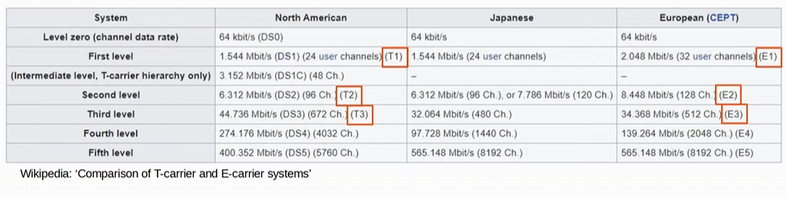
-learn the T1, T2, T3, E1, E2,E3 speeds (T for north America, E for Europe)

Leased lines are being taken over by ethernet WAN technologies
-Lease lines have a high cost, higher installation lead time, and slower speeds
-lead time is how long it takes to install the line
-Ethernet WAN technologies are more popular than Leased lines

MPLS (Multi-protocol Label Switching): like the internet, service providers’ MPLS networks are shared infrastructure because many customer enterprises connect to and share the same infrastructure to make WAN connections
-Label Switching in the name of MPLS allows VPNs to be created over the MPLS infrastructure using labels
-Labels are used to separate the traffic of different customers as it travels over the shared infrastructure, and prevent traffic from mixing with other customers

-MPLS terms:
-CE router = Customer Edge Router
-PE router = Provider Edge Router
-P = Provider Core router

-CE router connects to the PE router
-P routers are not on the edge of the router and do not connect to customer routers
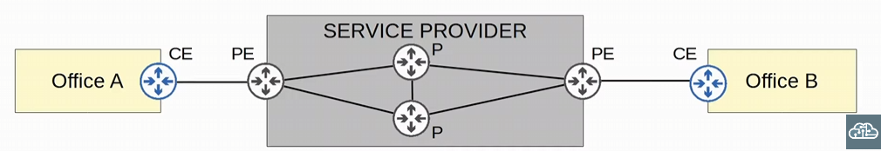
-P routers create the internal network of the service provider’s network
-When the PE routers receive a frame from the CE routers, they add a label to the frame
-Label is added between the layer 2 ethernet header and the layer 3 IP header
-sometimes MPLS is called a layer 2.5 protocol
-Labels are used to make forwarding decisions within the service provider network NOT THE DESTINATION IP
-CE routers do not use MPLS, it is only used by the PE/P routers
-CE routers don’t need to run MPLS or even be able to run MPLS

MPLS uses the MPLS label for forwarding decisions!

Layer 3 MPLS VPN: the CE and PE routers peer using a routing protocol OR static route to share routing information
-for example, the CE and PE routers using OSPF to peer

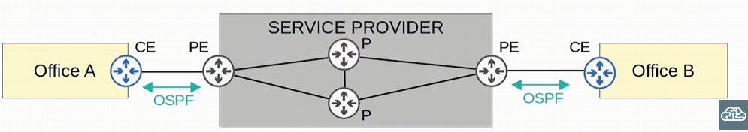
-Using static or dynamic routing protocols, the CE & PE router will peer using either a static route or dynamic route
-after the PE and CE peer with each other, office A’s CE will learn about office B’s routes via static or dynamic routes

-CE routers either form dynamic routing protocol peering with the PE routes, or they use the PE routes as the next hop of their static route
-PE router translates the CE routing information into VPN routes

Layer 2 MPLS VPN: the CE and PE routers do not form peerings, and instead the service provider’s network is entirely transparent to the CE routers
-even though, technically the CE router is connected to a PE, its like the two CE routers are directly connected
-WAN interfaces will be in the SAME subnet
-if a routing protocol is used, the two CE routers will peer directly with each other

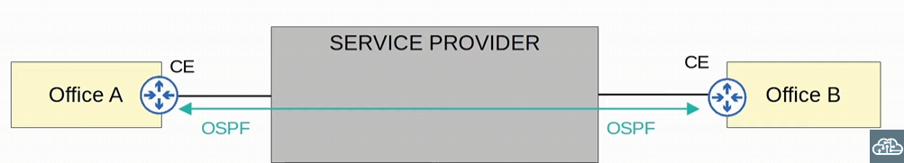
-service provider is still running MPLS like before, but it is doing so like the entire service provider network is just a big switch, connecting the two CE routers together
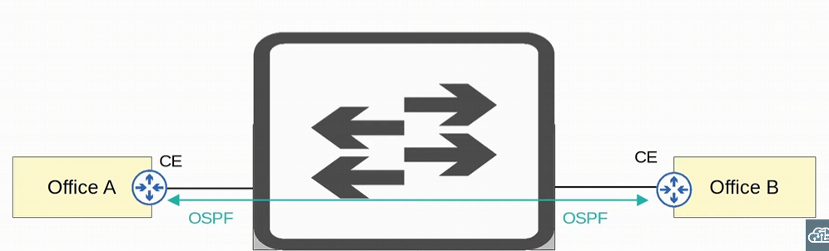
-since the two CE routers are in the same subnet, its like the service provider is a switch for Layer 2 MPLS VPNs
-there is still MPLS PE routers and P routers
-in this example, OSPF peering is directly form with CE routers

MPLS is a network running in the service provider network, but many different technologies can be used to connect to a service provider’s MPLS network for WAN service

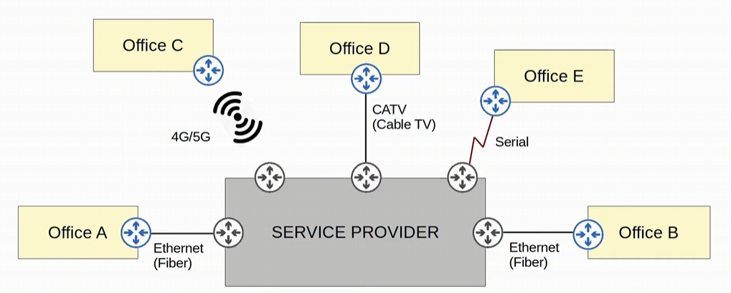
-all these different technologies are connecting to the PE router of the service provider, which uses MPLS in the service provider’s core network
-using the service provider’s MPLS network for WAN
-Serial connection is a Lease Line
-ALL these LANS will be able to communicate with each other over the service providers MPLS infrastructure

For the CCNA know MPLS uses Labels to forward traffic, NOT IP addresses, know CE PE & P routers
-Layer 3 MPLS VPNs have CE routers and PE routers forming peerings using a routing protocol such as OSPF or static routers
-Layer 2 MPLS VPNs it is as if the CE routers are all directly connected to each other. The service provider routers are totally transparent, acting like a big switch connecting the CE routers together

Internet Connections
-multiple ways to connect
-for private WAN technologies such as lease lines and MPLS VPNs can be used to connect to a service provider’s Internet infrastructure
-even though, the lease line or MLPS VPN is a private network you can use it to access the public network that is the internet

-technologies such as CATV and DSL commonly used by consumers (home internet access) can also be used by an enterprise
-CATV is cable internet
-again, these days fibre optics ethernet connections are growing in popularity for both enterprise and consumer access

Both DSL and CATV (cable internet) use modems, and uses existing lines to give access to a service provider connected to the internet
-DSL uses Phone lines
-CATV uses cable TV lines
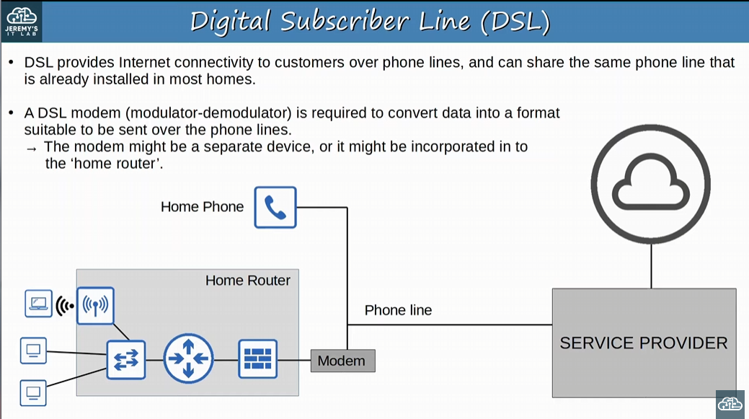
-DSL: Digital Subscriber Line
-DSL works over a phone line using a modem
-Modem (modulator-demodulator) is required to convert data into a format suitable to be sent over the phone lines
-modem can be one device connected to a home router OR a home router can have a modem built into the device
-Modem is REQUIRED to connect the user to the service provider using home lines

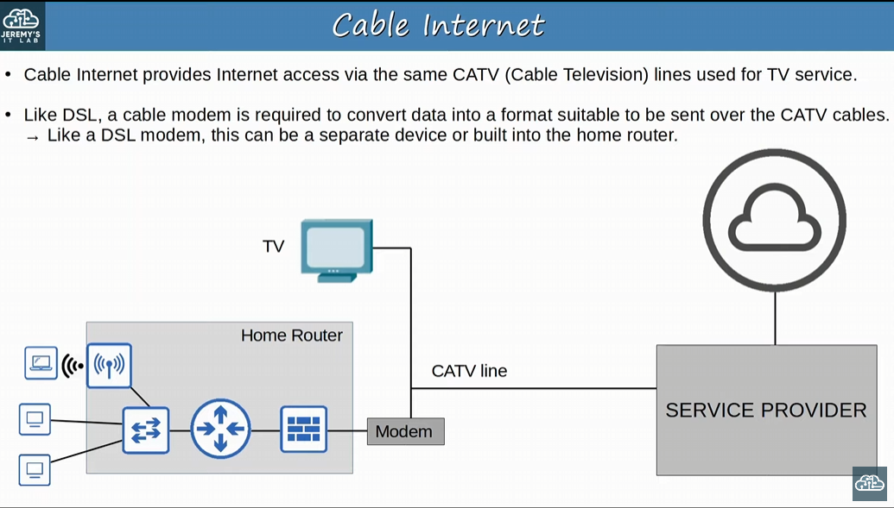
-cable internet provides internet access via the SAME CATV (Cable television) lines used for TV services
-need to use a Modem (modulator demodulator)
-like DSL the device can be separate or working inside of a home router
-similar to DSL, but DSL uses phone lines

For home connections having one connection to the internet isn’t a problem, but for enterprises you want to have redundant internet connection just in case
-1 Connection to 1 ISP = Single Homed
-2 Connections to 1 ISP = Dual Homed
-not ideal for enterprises, if the ISP goes down, you’ll lose connection
-1 Connection to each of the 2 ISPs = Multihomed
-more ideal for enterprises
-2 Connections to EACH of 2 ISP = Dual Multihomed
-provides the most redundancy but the most expensive

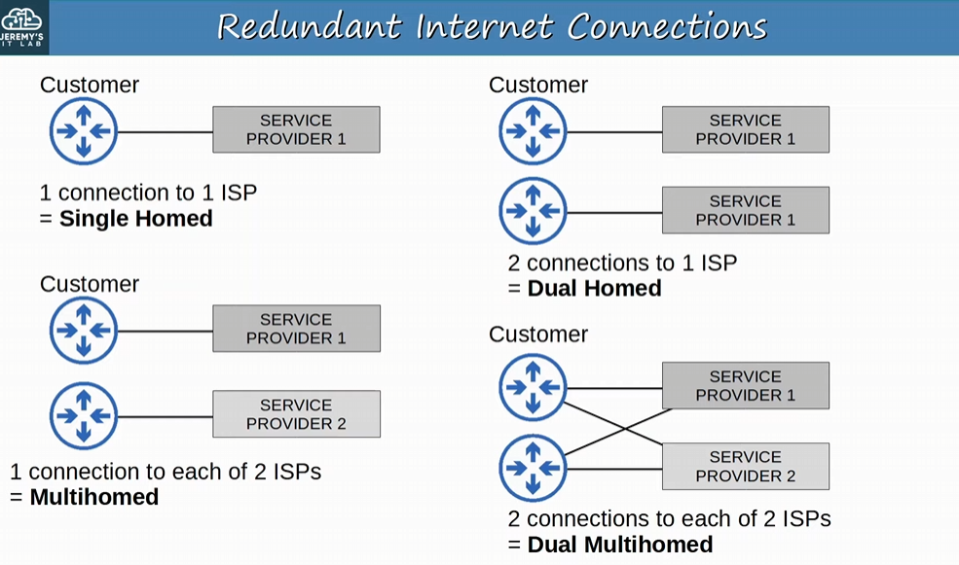
-Remember this!

Private WAN services such as leased lines and MPLS provide security because each customer’s traffic is separated by using dedicated physical connections (leased line) or by MPLS tags
-Using the internet as a WAN to connect sites together, there is NO BUILT-IN security by default

Internet VPNs: provides secure communications over the Internet, VPNs (Virtual Private Networks) are used
-2 kinds of Internet VPNs we need to know:
1) Site-to-Site VPNs using IPsec
2) Remote-access VPNs using TLS

Site-to-Site VPN is a VPN between two devices and is used to connect two sites together over the Internet
-the devices in each office can communicate security with each other
-A VPN ‘tunnel’ is created between the two devices by encapsulating the original IP packet with a VPN header and a new IP header
-IPsec: the original packet is encrypted before being encapsulated with a new header

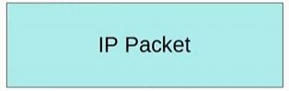 turns into 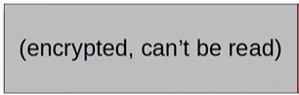 than adds a VPN header, and IP header
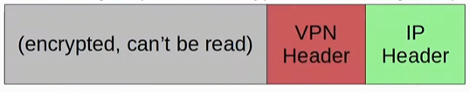
-to begin with, IPsec will encrypt the ENTIRE original packet

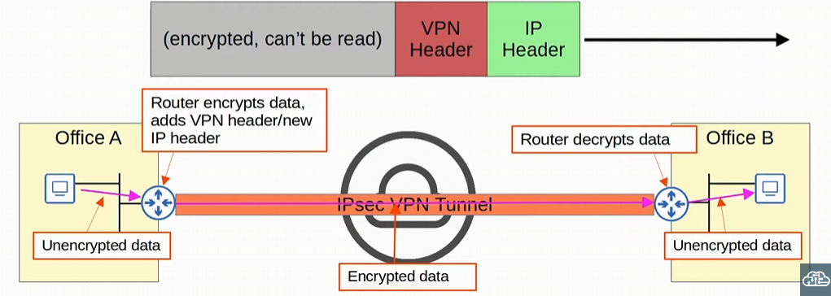
-we configured an IPsec tunnel between the two routers
-ROUTER will encrypt the data from PC in Office A destined to PC in Office B
-VPN between two devices, to connect two sites together over the internet!
-router will encrypt, and add a new VPN header and IP header
-the receive router will decrypt the data and send the information to PC in Office B
Site-to-Site VPN:
- The sending device (default gateway of the network) combines the original packet and session key (encryption key) and runs them through an encryption formula
- The sending device adds encapsulation on the encrypted packet using a VPN header and a new IP header
- The new packet is sent to the other device on the other side of the tunnel (only one receiving router)
- The receiving device decrypts the data to get the original packet, and then forwards the original packet to its destination

Tunnel is formed only between TWO tunnel endpoints (for example, the two routers connected to the Internet)
-all other devices in each site using the default gateway endpoint don’t need to create a VPN for themselves
-can send unencrypted data to their site’s router, which will encrypt it and forward it in the tunnel as described above

Limitations of Site-to-Site VPNs (and standard IPsec):
-IPsec doesn’t support broadcast and multicast traffic, only unicast. This means routing protocols such as OSPF CAN’T be used over the tunnels, because they rely on multicast traffic
-can use GRE over IPsec to solve this issue
-configuring a full mesh of tunnels between many sites is a labor-intensive task
-it will take a lot of time to design a bunch of Site-to-Site VPNs
-can use Cisco’s DMVPN to fix this issue

GRE: creates tunnels like IPsec, however it DOES NOT encrypt the original packet, so it’s NOT secure
-has the advantage of being able to encapsulate a wide variety of Layer 3 protocols, as well as broadcast and multicast messages
-to get the flexibly of GRE with the security of IPsec, ‘GRE over IPsec’ can be used
-the original packet will be encapsulated by a GRE header and a new IP header, and then the GRE header will be encrypted and encapsulated with an IPsec VPN header and new IP header

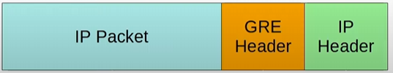
-IP packet gets a GRE Header and IP header
-this packet becomes encrypted


-an IP sec VPN header and new IP header are added

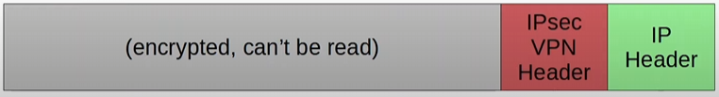
-we are combining GRE tunneling (for Layer 3 protocols, broadcast traffic and multicast traffic) with IPsec to create GRE over IPsec

DMVPN (Dynamic Multipoint VPN) helps create full-mesh IPsec tunnels
-cisco-developed solution that allows routers to dynamically create a full mesh of IPsec tunnels without having to manually configure every single tunnel

- Configure IPsec tunnels to a hub site (the central router in the hub-and spoke WAN topology)
- The hub router gives each router information about how to form an IPsec tunnel with the other routers

-DMVPN provides the configuration simplicity of Hub-and-spoke (each spoke router only needs one tunnel configured) and the efficiency of direct spoke-to-spoke communication (spoke routers can communicate directly without traffic passing through the hub)!!

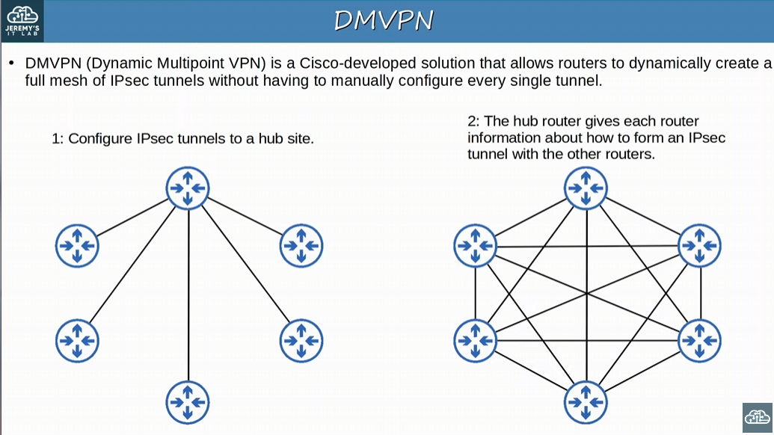
-each router only needs one tunnel configured

Some companies might want all traffic to flow through the hub site so that a central firewall can control the traffic, but other companies might want the efficient direct spoke-to-spoke communication that a full-mesh provides

Remote-Access VPNs
-remote-access VPNs are used to allow end devices (PCs, mobile phones) to access the company’s internal resources securely over the internet
-in contrast, site-to-site VPNs are used to make a point-to-point connection between two sites over the internet

-Remote-access VPNs typically use TLS (Transport Layer Security)
-site-to-site use IPsec
-TLS is also what provides security for HTTPs (HTTP secure)
-TLS was formerly known as SSL (Secure Socket Layer) and developed by Netscape
-renamed to TLS when it was standardized

-VPN client software is installed on end devices
-form example, Cisco AnyConnect on company laptops that employees use to work from home
-if you work on at an enterprise from home, you need a VPN client software installed
-End devices them form secure tunnels to one of the company routers/firewalls acting as a TLS server
-secure access to resources on the company’s internal network without being directly connected to the company network
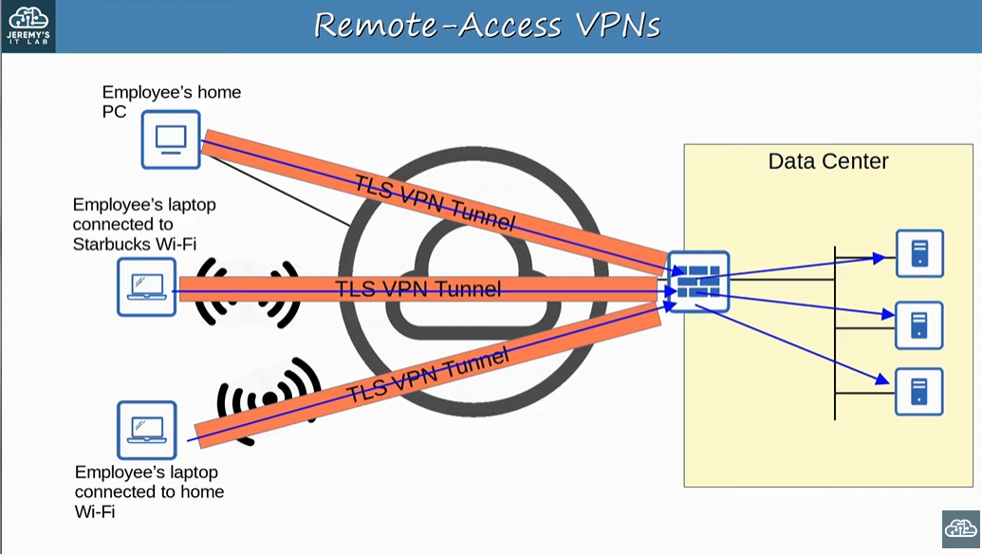
-employee wants to access the company’s Data centre, so it will use a remote-access VPN
-the TLS VPN tunnel is configured to the firewall at the data centre
-securely communicate with the company’s servers through the firewall

-Just like IPsec, TLS involves encrypting packets and adding additional header

Site-to-Site VPN vs Remote-Access VPNs
-Site-to-Site VPNs uses IPsec or even GRE over IPsec
-Remote-Access VPNs typically uses TLS (formerly known as SSL)

-Site-to-Site VPNs is one network connected to another network on the enterprise, providing services to many devices within the sites they are connecting (two sites together)
-one IPsec tunnel between two routers or firewalls provides traffic security for all hosts within!
-Remote Access VPNs can be used anywhere, using a VPN client software for ONE end device

-Site-to-Site VPNs are typically used to permanently connect two sites over the Internet
-Remote-Access VPNs are typically used to provide on-demand access for end devices that want to securely access company resources while connected to a network which is not secure
-like a public network

Day 54:
Looking at Virtualization, Cloud, Containers & VRF
-Virtualization is an important part of cloud services

Cisco does create hardware servers, like the UCS (Unified Computing System)
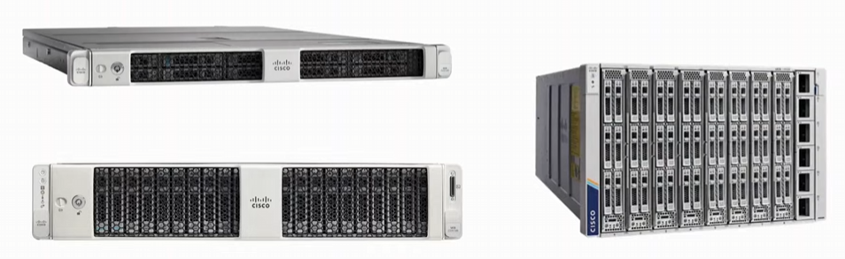

Largest vendors of hardware server include Dell EMC, HPE, and IBM

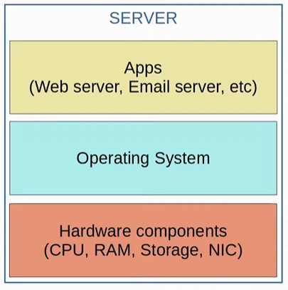
-before virtualization there was a one-to-one relationship between a physical server and an operating system
-in the OS, apps providing services (like a web server, email server, etc.) would run
-one physical server would be used for the web server, one for the email server, on for Database etc.
-wanted to isolate the servers, just in case one server goes down, all the applications in the enterprise wouldn’t go down
Using one physical server per app is expensive (power, space, etc.), resources on each server are typically under-used

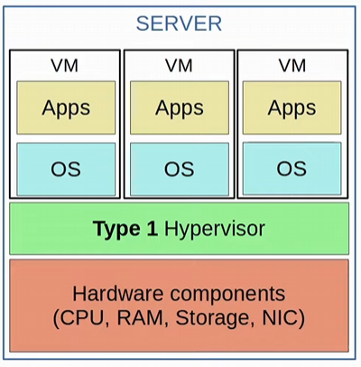
-Virtualization (Type 1 hypervisor)
-with virtualization we break the one-to-one relationship of hardware to OS
-allows us to run multiple OS’s on a single physical server
-each instance is called a VM (virtual machine)
-three in this server example

-A Hypervisor is used to manage and allocate the hardware resources (CPU, RAM, etc.) to each VM
-also known as A VMM (virtual Machine Monitor)
-Type 1 Hypervisors runs directly on top of the hardware
-examples: VMware ESXi, Microsoft Hyper-V, etc.
-Also known as Bare-metal Hypervisors or Native Hypervisors

-Type 2 Hypervisors run as a program on an operating system like a regular computer program
-for example: VMware, Oracle VB, etc.
-the OS running directly on the hardware is called the Host OS and the OS running in a VM is called a Guest OS
-Also known as a Hosted Hypervisor
-used mostly on personal-use devices where the Host OS cannot support an app, so they use a type 2 hypervisor on their PC to create a Guest OS

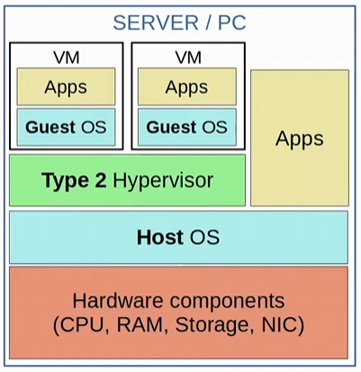
-Type 1 running on top of the hardware
-Type 2 running on top of the host OS

Type 1 Hypervisors are used in data centres environments, efficient since it runs on the hardware and requires few resources
Why use Virtualization?
-Partitioning: run multiple operating systems on one physical machine, and divide the system resources between virtual machines (like how much RAM is used etc.)
-solves the problem of hardware underuse in the one-to-one OS to hardware setup

-Isolation: provides fault and security isolation at the hardware level
-preserve performance with advance resource control
-If one VM goes down, the entire system will not go down with it
-one server app on one VM, multiple VMs on the server

-Encapsulation: Can save the entire state of a virtual machine to files, which you can move and copy to other devices since it’s a file.

-Hardware Independence: Provision or migrate any virtual machine to any physical server
-if the hypervisor you are running can run on the physical server, it doesn’t matter what kind of VM you run on top of that hypervisor

Virtualization reduces capital costs and operating costs, less time for set up & downtime compared to multiple hardwares, and faster provisioning of applications and resources
-its easy to set up a VM so downtime will be significantly less

VM’s connect to each other via a virtual switch within the hypervisor in the server hardware (type 1) or OS (type 2)
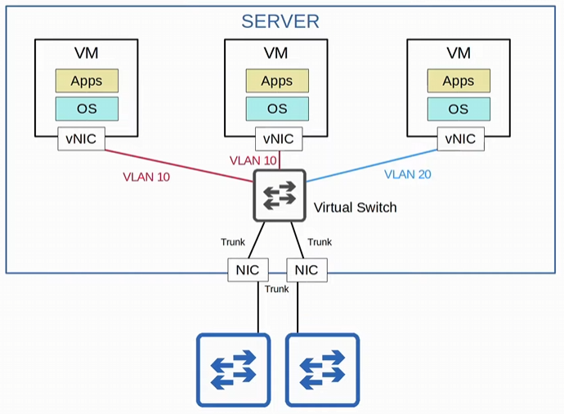
-vSwitch’s interfaces can operate as access or trunk ports and use VLANs to separate the VMs at layer 2
-interfaces on the vSwitch connect to the physical NIC (or NICs) of the server to communicate with the external network

Traditional IT infrastructure deployments were some combination of the following: On-Premises or Colocation
-On-Premises: all servers, network devices, & other infrastructure are located on company property
-all equipment is purchased and owned by the company using it
-company is responsible for the necessary space, power, and cooling

-Colocation: data centres that RENT OUT space for customers to put their infrastructure (servers, network devices)
-PCs and endhosts are still on the company premises, but networking devices are not
-data centres provide the space, electricity, and cooling
-servers, network devices, etc. are still the responsibility of the end customer, although they are not located on the customer’s premise!!

-Cloud services provide an alternative to the Traditional IT infrastructure, and is hugely popular

Most people think cloud is AWS, but there’s more to cloud than that

Cloud computing is a model for ready, convenient, on-demand network access to a shared pool of configurable computing resources (for example, networks, servers, storage, etc.) that can be immediately provisioned and released with minimal management effort or service provider interaction
-5 essential characteristics
-3 service models
-4 deployment model

https://nvlpubs.nist.gov/nistpubs/Legacy/SP/nistspecialpublication800-145.pdf
-read this for cloud information

Cloud Services:
-5 essential characteristics of a cloud service

1) On demand self-service: a customer can use the service (or stop using the service) freely (via a web portal) without direct communication to the service provider
-don’t need to contact AWS customer support to help you, whatever you need is on demand via web portal

2) Broad network access: you can use any device to access the cloud services with a private WAN connection or the internet
-access AWS web portal through a PC, phone, etc.

3) Resource Pooling: a pool of resources is provided by a service provider, and when a customer requests a service (for example, creates a new VM), the resources to fulfill that request are allocated from a shared pool (with other customers using that service provider)
-cloud offers a pool of resources shared by other customers that could fulfill the consumer’s needs

4) Rapid Elasticity: Customers can quickly expand the services they use in the cloud (to create new VMs, expand storage, etc.) from a pool of resources that appears to be infinite. Can also quickly reduce their services when not needed
-how much service that needed is rapidly given

5) Measured service: Cloud service provider measures the customer’s usage of cloud resources, and the customer can measure their own use as well. Usages charges are given to the customer.
-all usage of the cloud services is measured in a web portal and charged based on how much was used

Cloud services’ 3 main service models:
-everything is provided on a ‘service’ model
-for example, rather than the end user buying a physical server, mounting it on a rack, installing the hypervisor, creating the VMs, etc., the service provider offers all of this as a service

1) SaaS: Software as a service
-use the provider’s applications running on a cloud infrastructure, and the consumer does not manage or control the underlying cloud infrastructure
-for example, Microsoft office 365, web-based emails

2) PaaS: Platform as a service
-developers can build, run, and manage applications on top of an operating system
-developers use this platform to make applications
-for example, AWS Lambda & Google App Engine

3) IaaS: Infrastructure as a service
-consumer can provision processing, storage, networks, and other fundamental computing resources, as well as limited control of select networking components (like firewalls)
-cannot control the underlying cloud infrastructure but has control over OS, storage, and deployed applications
-can run what ever operating system the want on whichever server they choose
-For example, making VMs in AWS & Google Compute engine

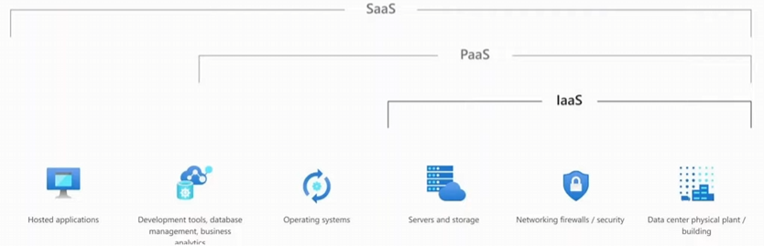
-SaaS controls host-based application
-PaaS controls development tools on the operating system
-IaaS controls up to the operating systems and a little bit of the networking component

-these three form the foundation of Cloud services

Most people assume that ‘cloud’ means public cloud providers such as AWS, Azure, and GCP
-there are 4 types of cloud deployment methods

-Cloud service’s 4 deployment models
-Focus on the USE of the deployment models. Location of the servers DOESN’T MATTER.

-Private Cloud: exclusive USE by a SINGLE organization comprising multiple consumers
-it may be owned, managed, and operated by the organization, a third party, or some combination of them, and it may exist on or off premise
-private clouds are generally only used by large enterprises
-private in terms of USE not in terms of ownership
-for example, AWS provides private cloud services for the American DoD (infrastructure is amazon, but it’s reserved for use by the DoD)
-Private clouds may be on OR off premises (it only depends on USE)
-same kinds of services offered are the same as in public clouds (SaaS, PaaS, IaaS), but the infrastructure is reserved for a SINGLE organization

-Community Cloud: The cloud infrastructure is USED by a specific community of consumers
-may be on or off premises
-least common cloud deployment, where the infrastructure is reserve for use by only a specific group of organizations

-Public Cloud: Is USED by the public
-exists on the premise of the cloud provider, and owned by a business, academic, or government organization
-anyone can access the cloud
-most common cloud deployment

-Hybrid Cloud: mix of any of the three above (Private, Community, Public)
-for example, some parts of the cloud service are public, while the rest is private
-the private cloud can offload to a public cloud when necessary due to resource restrictions

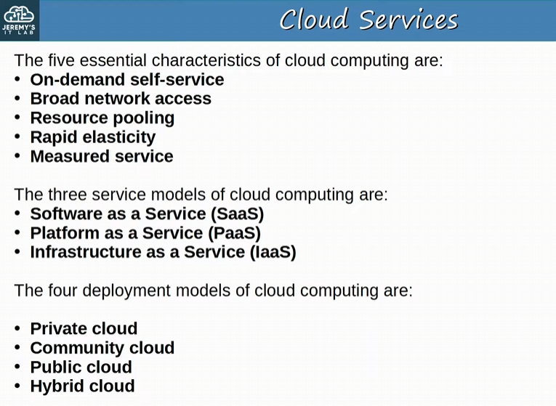
-generally, understand this!

Benefits of Cloud Computing
-Cost: capex (capital expenses) of buying hardware and software, setting up data centres etc. are reduced or eliminated
-costs are OPex (operational costs)
-Global scale: Cloud services can scale globally at a rapid pace and services can be set up to customers from a geographic location close to them
-can choose a service in a location nearby
-Speed/Agility: services are provided on demand, and vast amounts of resources can be provisioned within minutes
-Productivity: Cloud services remove the need for many time-consuming tasks such as procuring physical servers, racking then, cabling, installing, and updating etc.
-reduced costs
-Reliability: Backups in the cloud are very easy to perform to support disaster recovery

Cloud isn’t always the BEST opinion
-a company should weigh out the benefits of a cloud before choosing to use it

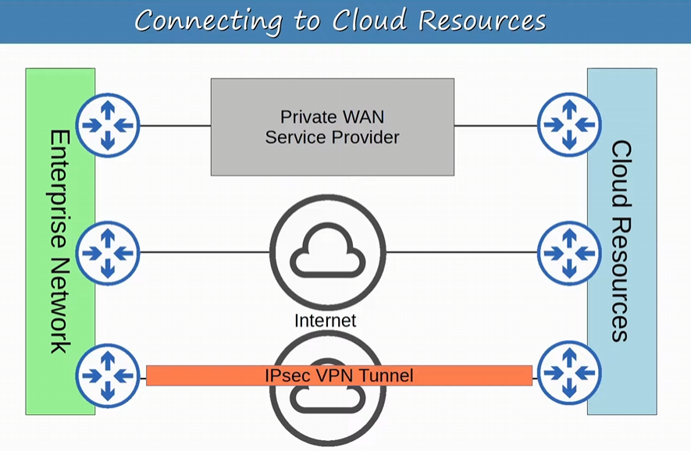
-example of how an enterprise might connect to their resources on a public cloud
-might use a private WAN like an MPLS VPN
-might directly use the internet, but its dangerous without a secure connection
-A VPN can be used to connect directly on the cloud

-redundant connections to the cloud resources are always preferable
-must set up the connection to the cloud resources

Containers:
-similar to VMs

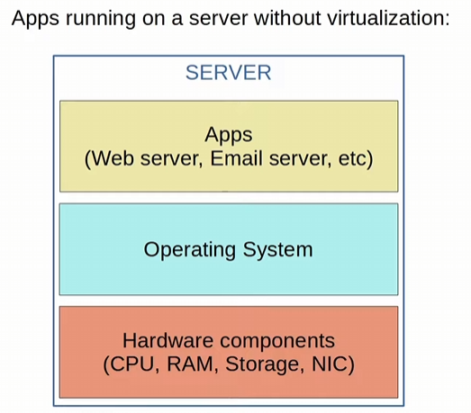
-no virtualization in this example, just one-to-one OS on the hardware
-Apps are not isolated, one app problem might affect all the other apps
-you might isolate by buying a separate physical server for each app, but why do what when we have virtualization

-with virtualization (VMs) we can running multiple OS’s on a physical server
Again, a Hypervisor is used to manage and allocate hardware resources to each VM
-Apps are install onto each OS in type 1 hypervisor and Guest OS in type 2 hypervisor

OS in each VM can be different (Windows, Linux, etc.)

Binaries/Libraries are software libraries/services needed by the Apps running in each VM

A VM allows its app/apps to run in an isolated environment, separate from the apps in OTHER VMs
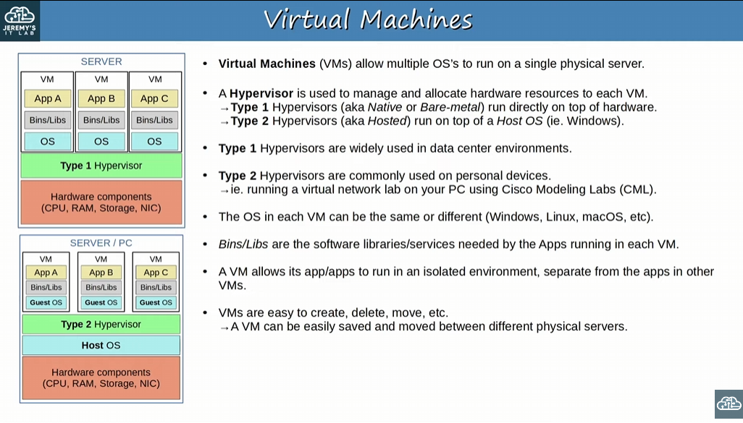
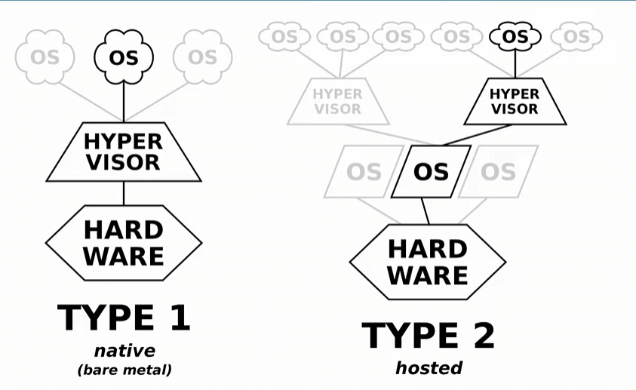

Virtualizations using VMs is much more efficient use of hardware

Containers are software packages that contain an App and all dependencies (Bin/Libs in the diagram) for the contained App to run
-multiple Apps can be run in a single container, but this is not how containers are usually used
-containers run on a Container Engine (like Docker Engine)
-the container engine is run on a host OS (usually linux)
-containers are LIGHTWEIGHT (small compared to VMs) and include ONLY the dependencies required to run a SPECIFIC APP
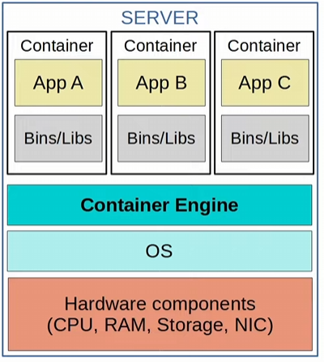
VMs run an OS in each VM, whereas containers don’t!!!

A Container Orchestrator is a software platform for automating the deployment, management, scaling, etc. of containers
-Kubernetes (originally designed by google) is the most popular Container Orchestrator
-Docker Swarm is docker’s container orchestrion tool

-in small numbers, manual operation is possible, but large-scale systems (like with Microservices) can require THOUSANDS of containers
-cannot manage thousands of containers manually

Microservice Architecture is an approach to software architecture that divides a larger solution into smaller part (microservices)
-instead of one big app, you have hundreds of microservices running together to form a larger solution
-microservices all run in containers that can be orchestrated by Kubernetes (or another platform)

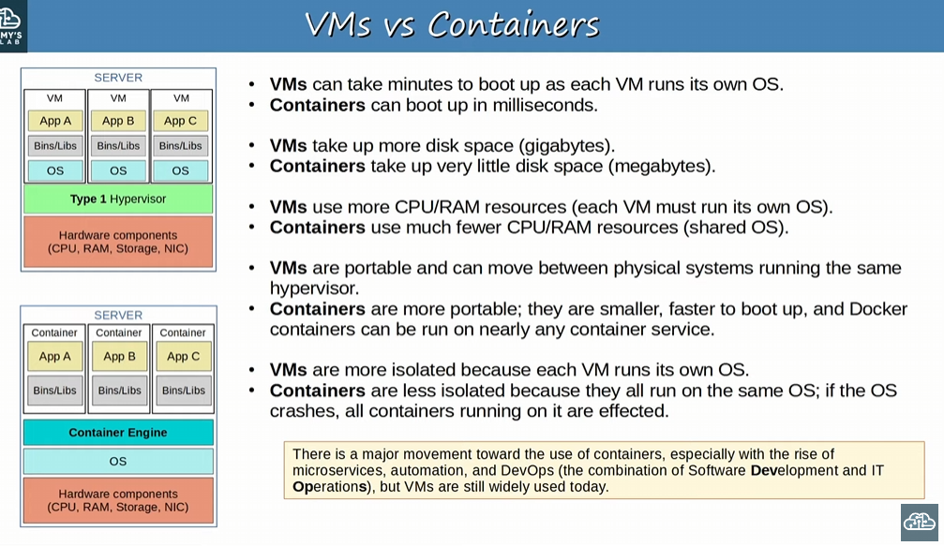
-VMs run on its own OS, whereas containers run on a SHARED OS
-if one container has issues and crashes the OS, all containers go down (not the same with VMs)
-VMs are also more secure by separating the OS
-helps boot the container quickly in milliseconds (much faster than VMs)
-Containers take up very little disk space compared to VMs
-containers use less CPU/RAM
-VMs are portable and can move between physical systems running the same hypervisor, whereas Containers are MORE portable, smaller, and faster to boot up
-Docker Containers can be run on nearly any container service, and aren’t limited by a hypervisor like VMs

-Important!!

VRF: Virtual Routing & Forward
-splits up one Router into multiple virtual routers
-similar to VLANs on layer 2 that split up one physical switch into multiple virtual switches

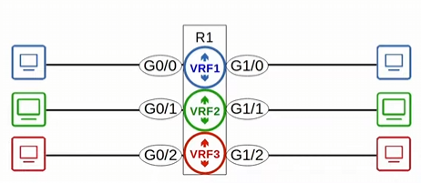
-VRF takes one physical router, into multiple virtual routers

Traffic received on one router interface, can be forwards out of any other interface on the router, if the routing table says to do so
-for example, without using VRF in the diagram below traffic received on R1’s G0/0 interface can be routed to and forwarded out of R1’s G1/2 interface
-But WITH VRF that wouldn’t be possible, because g0/0 is in VRF 1, and g1/2 is in VRF 2

VRF allows a router to build multiple separate routing tables
-normally routers have 1 routing table, but with VRF its multiple
-interfaces & routers configured using VRF are called a VRF Instance

Only Router interfaces, SVIs & routed ports on multilayer switches can be configured in a VRF
-only a layer 3 concept

Again, traffic in one VRF cannot be forwarded out an interface in another VRF
-You can configure VRF leaking to allow traffic to pass between VRF’s in a router

VRFs are commonly used to facilitate MPLS!!!
-the kind of VRF we are looking at Is VRF-Lite (VRF without MPLS)
-VRF is commonly used by service providers to allow one device to carry traffic from multiple customers!!!
-each customer’s traffic is ISOLATED from the others (as each customer connects to their own router within the service provider’s router using VRF)
-customer IP addresses can OVERLAP without issues

-All customers of a service provider connect to their own router (a VRF) within the service provider’s router

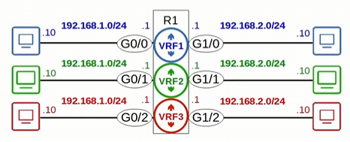
-with VRF you can have overlapping IP addresses (for example, for customers of an ISP)
-a normal router cannot have overlapping routes

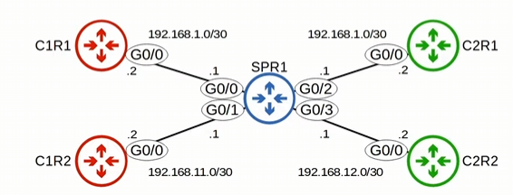
-SPR1 is a service provider router providing WAN to customers
-C1R and C2R are routers owned by two customers
-both use the same subnets, which will overlap (need to use VRFs)
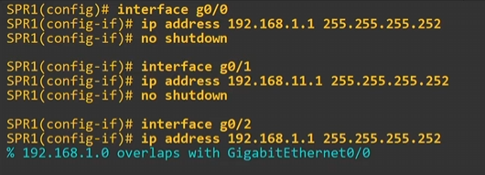
-two interfaces on the same router cannot be in the same subnet
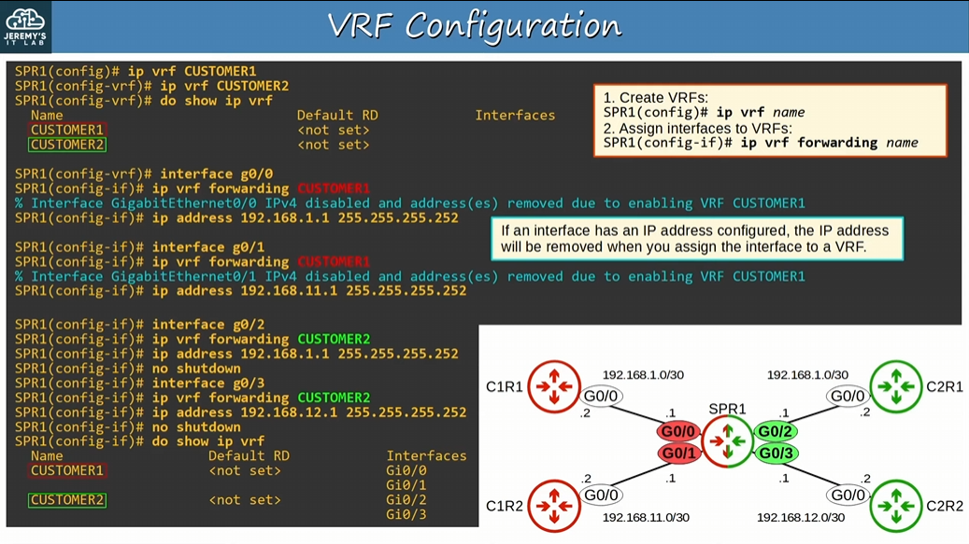
-don’t need to learn how to configure VRFs
-first you need to create the VRF -> then go into int mode and assign the VRF on each interface -> add an IP address
-SPR1 is configured as two separate routers with VRF, and can now use overlapping ip addresses for each customer

After creating VRFs they will not show in the routing table with the “show ip route”, since that show command only lists out global information
-need to use the command “show ip route vrf <vrf name>”
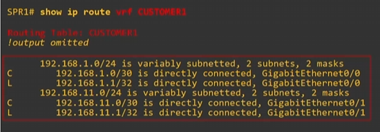

Each VRF routing table is separate from one another, and separate from the global routing table
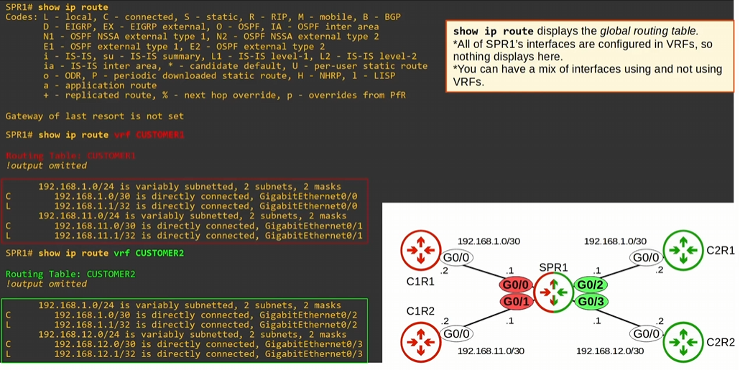

When pinging you need to specify the VRF with “ping vrf <vrf name> <ip address>”
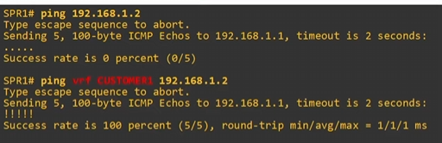
-there are to devices with the ip address 192.168.1.2, but since we clarified we want to ping VRF CUSTOMER1
-we are ping C1R1

Again, this is all VRF-lite which is not using VRF with MLPS

If an interface already has an IP address, that IP address will be removed when you assign it to a VRF

Day 55:
Looking at Radio Frequencies which are a range on electromagnetic frequencies
-includes radio AM/FM, microwaves, radar, and Wi-Fi
Examining 802.11 standards for Wi-Fi
-standard for wireless Lans

Wi-Fi is the trademark of the Wi-Fi alliance, NOT directly connected to the IEEE
-Wi-Fi alliance tests and certifies equipment for 802.11 standards compliance interoperability with other devices

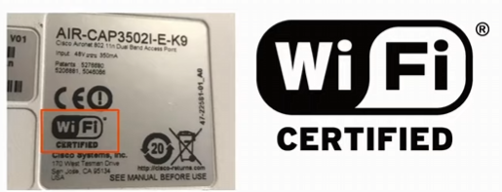
-this device is certified by the Wi-Fi alliance

Wireless Network issues:
- All devices within range, receive ALL frames (like a LAN using an ethernet Hub)
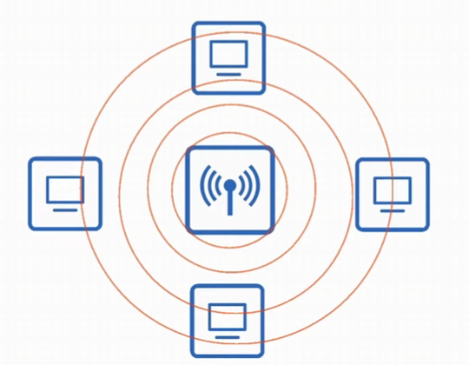
-like devices connected to an ethernet Hub, when a wireless device transmits a frame all wireless-enabled devices within range will be able to pick up that frame
-unlike a LAN with a switch, the signal isn’t contained within a physical wire, because the signal consists of electromagnetic waves radiating out from the transmitting device
-data privacy concerns (we need to encrypt data) !!!
-collision issues when devices communicate on the same channel at the same time !!!
-We use CSMA/CA (Carrier Sense Multiple Access with Collision Avoidance) to facilitate HALF-DUPLEX communications Wi-Fi uses

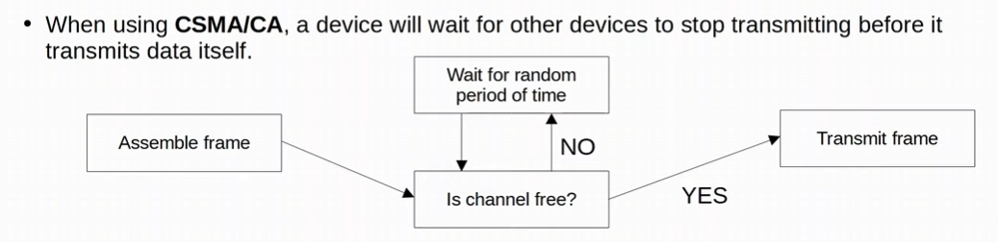
-transmitting device assembles the frame and prepares to be sent
-listens to see if the channel is free on the wireless network
-once it listens and notices the channel is free, it will transmit the frame

CSMA/CA has an optional feature to use an RTS packet (request to send) and the review device sends a CTS (Clear to Send) packet back!!
-not important for the CCNA

CSMA/CD: used in wired networks (carrier sense multiple access collision detection)
-half-duplex
-before sending a frame, the device listens to the collision domain until they detect that other device are not sending frames, and if a collision occurs a jamming signal is sent to all devices. Each device will wait a random period of time before sending another frame
CSMA/CA: used in Wi-Fi networks (carrier sense multiple access collision avoidance)
-half-duplex
-A device will wait for other devices to stop transmitting (by listening to the Wi-Fi channel) before it transmits data itself

- Wireless communications are regulated by various international and national bodies
  - Cannot transmitted data on any channel you want
  - Which channels you can use vary depending on the country
  - 802.11 standard label which channels can be used for wireless LAN and devices are designed to use those frequencies

- Wireless signal converge area must be considered
  - Wired networks we need to consider the cable length and some cases EMI
  - Signal range (how far can the signal travel) is affected by Absorption, Reflection, Diffraction, and Scattering

Signal range affected:
-Absorption: the signal wireless frequency is absorbed by a material and releases heat
-weakens the original signal
-Reflection: the signal bounces off the surface of a material (like metal)
-Refraction: the signal bends off the surface of a material
-Diffraction: the wave encounters an obstacle and travels around it
-Scattering: material causes a signal to scatter in all directions
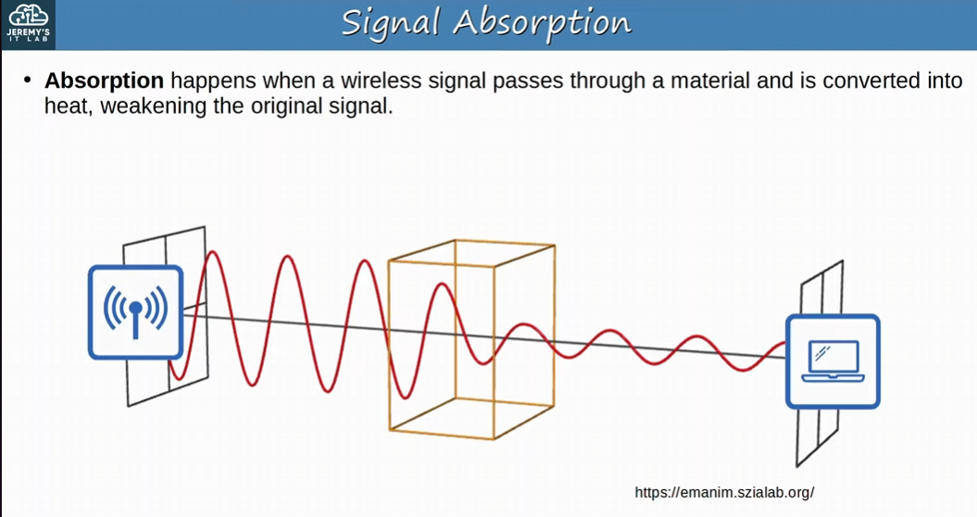
-the wall Absorbs the signal this is signal Absorption

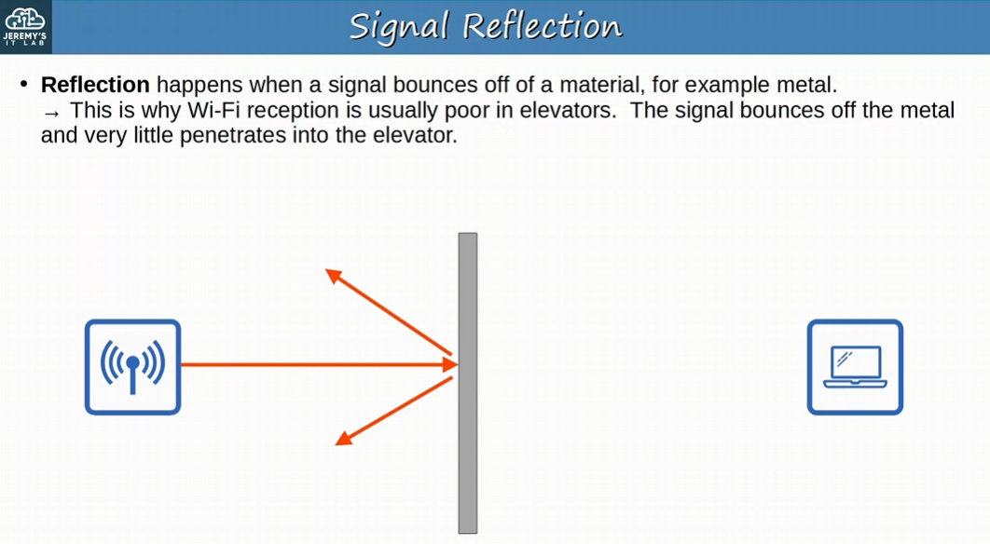
-signal bounces off the medium with signal Reflection
-reason why Wi-Fi is terrible in an elevator with metal surrounding it

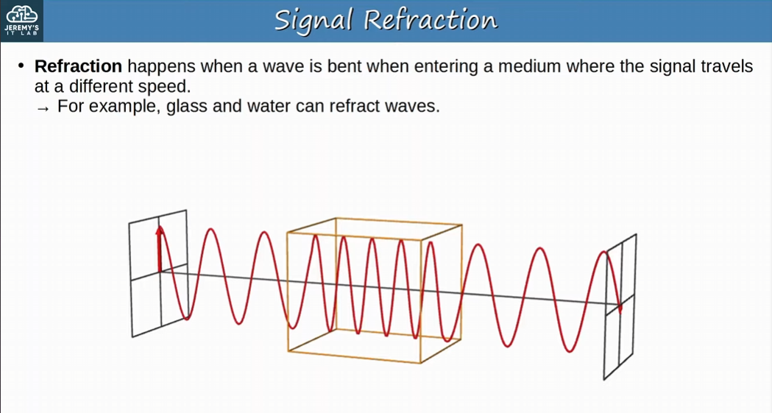
-water will refract/bend the wave with signal Refraction

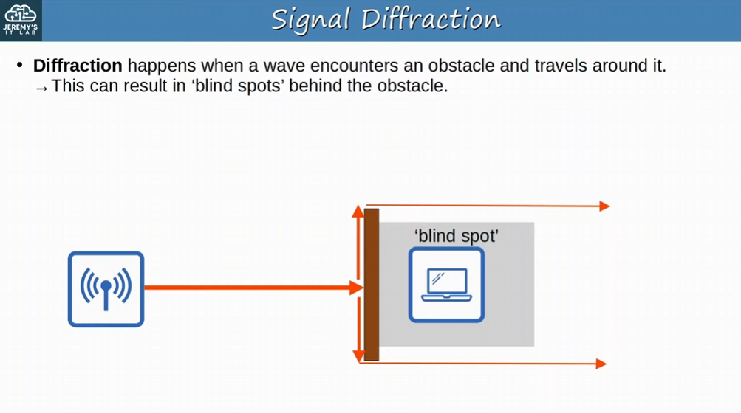
-Diffraction will cause blind spots

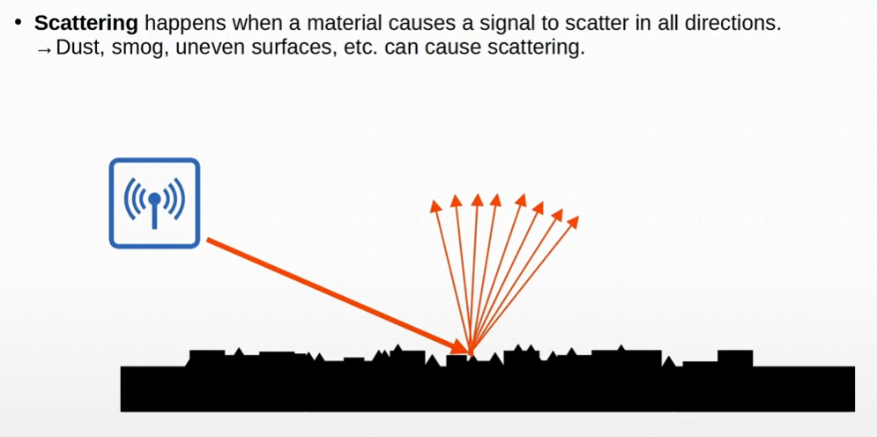
-signal scatters in all directions with Scattering
-dust, smog, uneven surfaces, etc. can cause Scattering

When planning the positioning of a WAP (Wireless Access Point) we must consider signal absorption, reflection, refraction, diffraction, and scattering

- Other devices using the same channels can cause interference
  - For example, a wireless LAN in your neighbor’s house/apartment
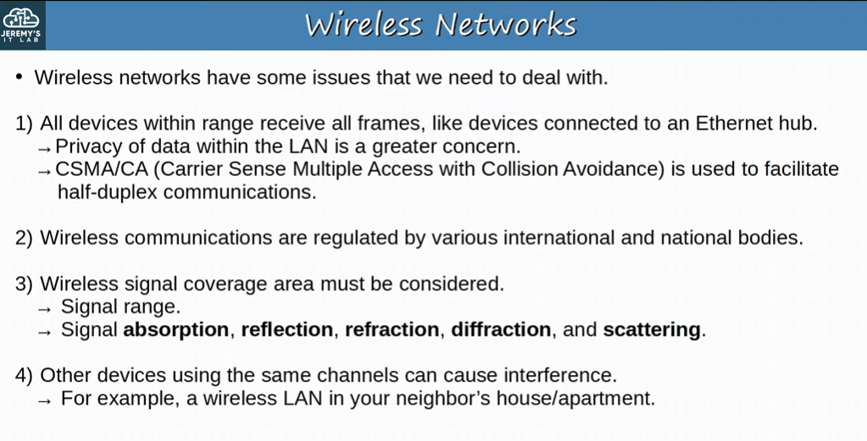
-Important to remember!
Radio Frequency:
-to send signals, the sender applies an alternating current to an antenna
-creates electromagnetic fields which propagate out as waves

Electromagnetic waves can be measured in multiple ways for example Amplitude and Frequency
-Amplitude: the maximum strength of the electric and magnetic fields (size of the wave
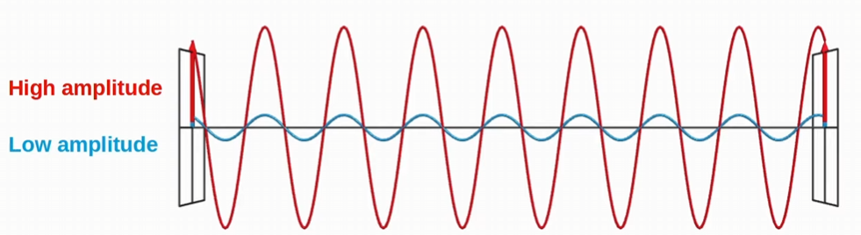
-Higher size

-Frequency: measures the number of up/down cycles per a given unit of time (measure by Hertz)

- Period: the amount of time of one cycle

Hz (Hertz) = cycles per second
kHz (Kilohertz) = 1000s of cycles per second
MHz (Megahertz) = Millions of cycles per second
GHz (Gigahertz) = Billions of cycles per second
THz (Terahertz) = Trillions of cycles per second

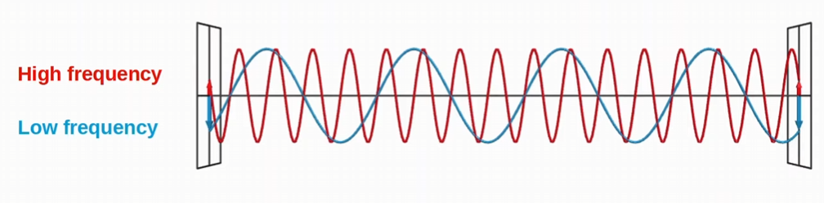
-the amplitude is the same (size of the wave) but the frequency is different (cycles per second)

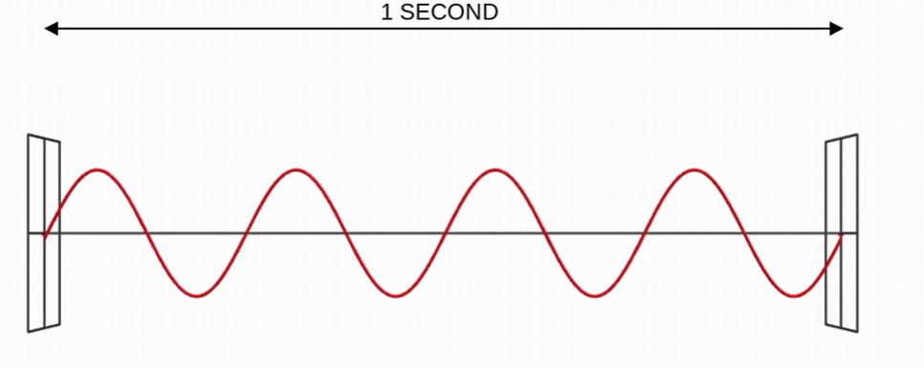
-How many Hertz? What is the period?
-4 Hertz, and a Period of 0.25 sec
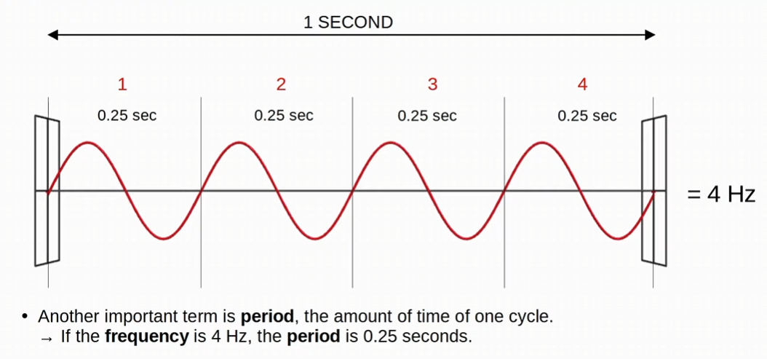
Frequency:
-Visible frequency range is about 400 THz to 790 THz
-Radio Frequency range is from 30 Hz to 300 GHz and is used for many purposes

Wireless frequency bands are 2.4 GHz and 5 GHz
-Bands are frequency ranges
-2 GHz band is 2.400 GHz to 2.4835 GHz
-5 GHz band range is 5.150 GHz to 5.825 GHz
-can be segmented down into 4 band ranges

-don’t need to memorize the band ranges, just that 2.4 GHz & 5 GHz exists

2.4 GHz band typically provides further reach in open space and better penetration of obstacles such as walls
-HOWEVER, most devices tend to use 2.4 GHz band so interference can be a bigger problem compared to the 5 GHz band

Modern devices typical support both 2.4 GHz and 5 GHz bands

Wi-Fi 6 (802.11ax) has expanded the spectrum range to include a band in the 5 GHz range

Each Band is divided up into multiple ‘channels’
-devices are configured to transmit and receive traffic on one (or more) of these channels
-Channel Bonding can be used to combine channels together

For example, the 2.4 GHz band is divided into several channels, each with a 22 MHz range
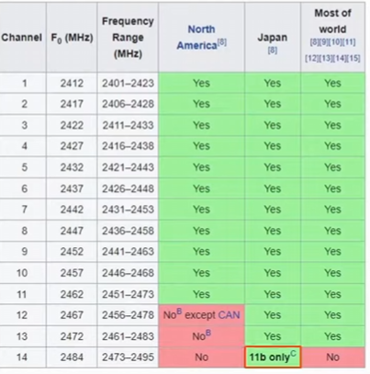
-channels are also different by country
-802.11b is an old and slow channel that was use in Japan but now it’s not used anymore

-these 2.4 GHz channels overlap
-channel 1 overlap with channel 2 3 4 & 5

-We want to use nonoverlapping channels: 1, 6 & 11 for enterprises in the 2.4 GHz band!

In small wireless LAN with only a single AP, you can use any channel, nothing will overlap if all you use is one channel
-however, in larger WLANs with multiple Aps, its important that adjacent Aps don’t use overlapping channels (avoids interference)
-avoids interference with devices transmitting on the same channel

If overlapping channels are used, you will have decreased performance and worse user experience
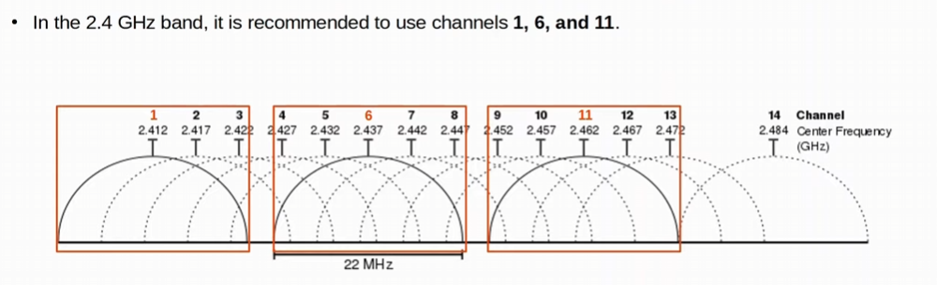
-One AP in the 2.4 GHz range will use channel 1, one AP using channel 6, and another AP using channel 11 within the wireless WAN
-won’t interfere with each other

-outside north America you could use other combinations, but for CCNA remember 1 6 11 for 2.4 GHz

5 GHz band HAS NON-OVERLAPPING CHANNELS
-we don’t have to worry about interference between adjacent Wireless Aps
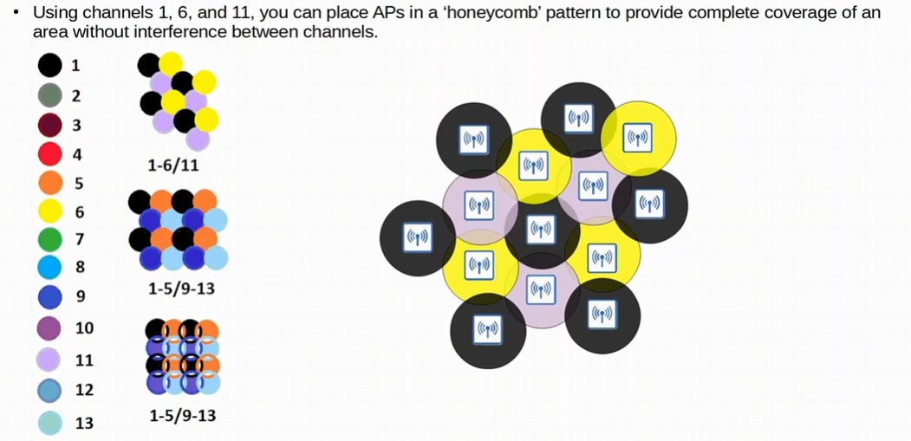
-Honeycomb pattern, where no AP is touching an AP with the same channel
-for channels 1 6 & 11
-the other patterns are used outside of North America
In the honeycomb pattern the alternate channels (for example 6 & 11) surrounding one AP channel (for example 1) will overlap for Roaming access

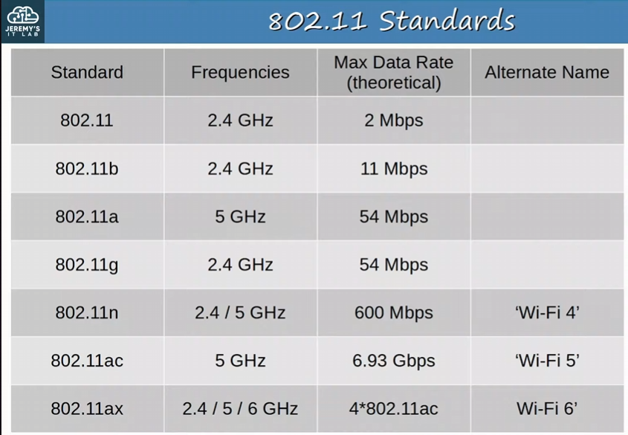
-MEMORIZE THIS!!!
-need to know standard, frequency, Theoretical Max Data Rate, & alternate name

-Maximum Data rates are theoretical, and for many reasons you probably won’t get this Data rate
-802.11 enabled devices might support one or multiple versions of these standards or even all!
-recommend checking which standard is supported before buying a device!!!

802.11 defines different kinds of Service Sets which are GROUPS of wireless network devices
-service sets describe how a group of wireless devices communicate with each other

Three types of Service Sets:
-independent
-Infrastructure
-Mesh

All devices in a service set share the same SSID (Service Set Identifier)
-SSID is a human readable name which identifies the service set
-SSID does not have to be unique
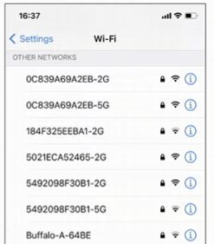
-example of an SSID

Different types of Service Sets: IBSS
-an IBSS (Independent Basic Service Set) is a wireless network in which two or more wireless devices connect directly WITHOUT using an AP (Access Point)
-Also known as an Ad Hoc network
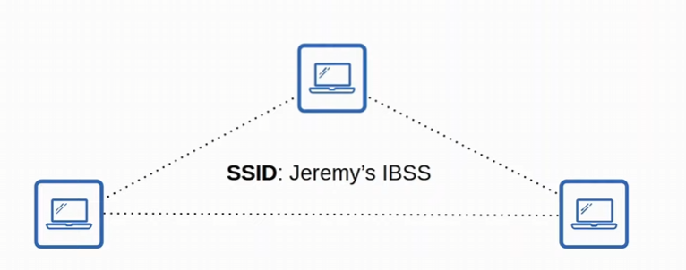
-can be used for file transfer (like an AirDrop)
-typically used for limited purposes such as quick file transfers
-Not scalable beyond a few devices
-Independent type of Service Set

Different types of Service Sets: BSS
-A BSS (Basic Service Set) is kind of Infrastructure Service Set in which clients connect to each other via an AP (Access Point), but not directly to each other
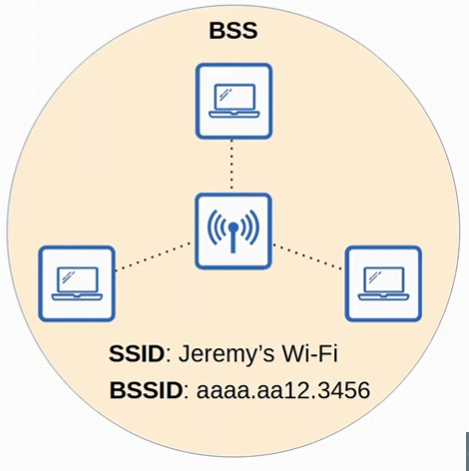
-BSS is an Infrastructure service set
-AP serves as an infrastructure

-BSSID (Basic Service Set ID) is used to uniquely identify the AP
-BSSID is the MAC address of the AP’s radio
-Other APs can used the same SSID, but not the same BSSID

-wireless devices request to associate with the BSS
-wireless devices that have associated with the BSS are called ‘Clients’ or ‘Stations’

The area around an AP where its signal is usable is called a BSA (Basic Service Set)

BSS is a group of devices connected with an AP, and a BSA is the AREA the AP provides coverage where devices can join in the AP and be a part of the BSS
-BSS group of devices
-BSA an area
Client communicates with each other via an AP, not directly with each other like IBSS/Ad Hoc
Different types of Service Sets: ESS
-ESS (Extended Service Set) is the use of multiple APs to create a larger wireless LAN
-this is an Infrastructure Service Set like BSS
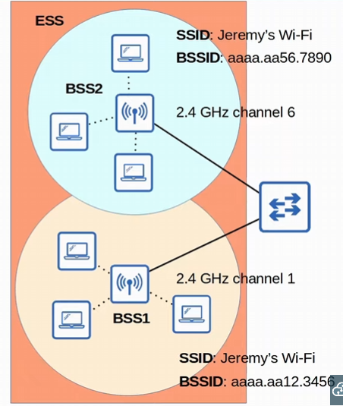
-two BSSs to form an extended service set
-APs with their own BSSs are connected by a wired network to a switch

-Each BSS uses the same SSID, but have unique BSSID (different MAC address on the APs radios)

-We also use a different channel to avoid interference
-channel 1 for BSS1 and channel 6 for BSS2 in this diagram
-BSA overlap should be around 10-15% for Roaming

-Roaming: Clients can pass between APs without having to reconnect, providing a seamless Wi-Fi experience when moving between APs
-moving between two APs in an Extended service set
Different type of Service Sets: MBSS
-MBSS (Mesh Basic Service Set) can be used in situations where its difficult to run an Ethernet connection to every AP
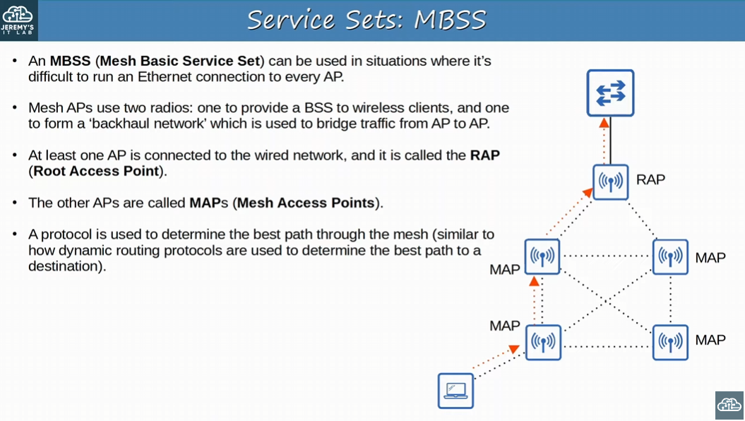
-2 RADIOS: one as a mesh network between the APs (backhaul network), and one to provide a BSS to wireless clients so they can connect to the network
-This is a Mesh Service Set

-the device connected to the AP via a BSS on a radio, and the traffic is bridged over the network with the backhaul network over the APs on a different radio

-At least one AP is connected to the wired network, and it’s called the RAP (Root Access Point)
-in this diagram a switch is connected to the Root Access Point

-The other APs are called MAPs (Mesh Access Points)

-Protocol used to determine best route thought the mesh

Most wireless networks aren’t standalone networks
-Rather, they are a way for wireless clients to connect to the wired network infrastructure via an AP and a switch
-AP servers to translate between the two mediums

-in 802.11, the upstream WIRED network is called the DS (Distribution System)

Each wireless BSS or ESS is mapped to a VLAN in the wired network
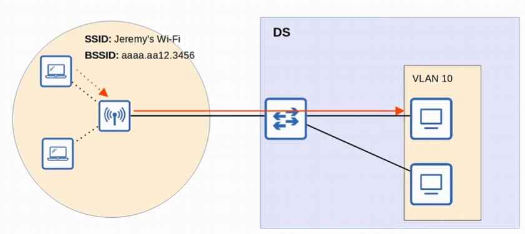
-this is the distribution system
-the SSID is translated to VLAN 10 on the wired network once in the DS
-for example, the SSID Jeremy’s Wi-Fi will be able to communicate with VLAN 10

Its possible for an AP to provide multiple wireless LANs, each with a unique SSID
-each WLAN is mapped to a separate VLAN and connected to the wired network via a trunk

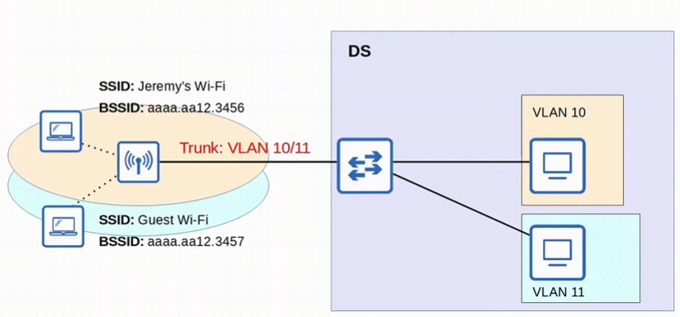
-two SSIDs mapped to two different VLANs
-SSID Jeremy’s Wi-Fi translated to VLAN 10
-SSID Guest Wi-Fi translated to VLAN 11

-remember SSIDs don’t need to be unique!

-AP is connected to the switch via a trunk!!!
-Each WLAN uses a unique BSSID, usually by incrementing the last digit of the BSSID by one
add one to make a need BSSID for the new SSID
-x.x.3456 -> x.x.3457

APs can operate in additional modes beyond the ones we’ve introduced so far

Repeater mode: can be used to extend the range of a BSS
-The repeater will simply retransmit any signal it receives from the AP
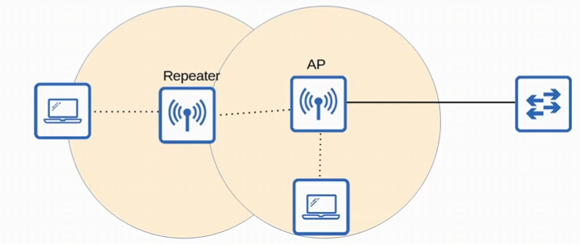
-this is extending the range of the BSS
-a repeater with a single radio must operate on the SAME channel as the AP, but this can drastically reduce the overall throughput on the channel
-the repeater will be repeating the AP signals back to it using the SAME channel
-cuts the effective throughput of the channel by 50% !!

-a repeater with TWO radios can receive on one channel, and then retransmit on another channel!!

Workgroup Bridge (WGB) operates as a wireless client of another AP, and can be used to connected wired devices to the wireless network
-this is another operational mode of an AP

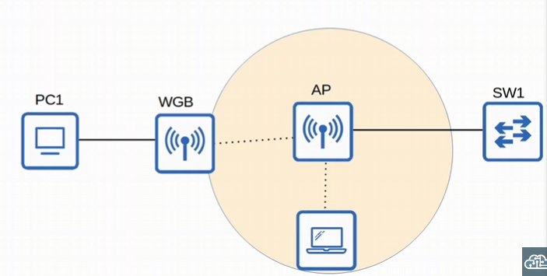
-the WGB is an AP in a mode to allow a wired device to connect wirelessly
-PC1 does not have wireless capabilities, and alco does not have access to a wired connection to SW1
-PC1 has a wired connection to the WGB, which has a wireless connection to the AP

Two Kinds of Workgroup Bridges: Universal WGB (uWGB) and WGB
-Universal WGB is an 802.11 standard that allows ONE device to be bridged to the wireless network
-WGB is a cisco-proprietary version of the 802.11 standard that allows multiple wired clients to be bridged to the wireless network

WGB allows clients that don’t support wireless connection to have a wireless connection by using an AP operational mode!

Outdoor bridge can be used to connect networks over long distances without a physical cable connecting them
-another AP operational mode

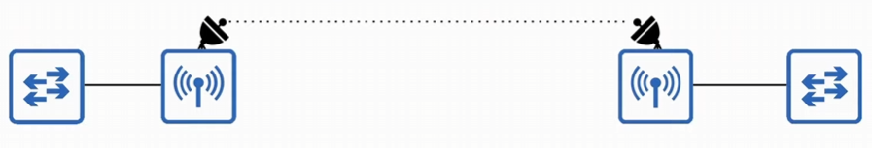
-APs will use specialized antennas that focus most of the signal power in one direction, which allows the wireless connection to be made over longer distances than normally possible

-connection can be point0to-point as in the diagram below, or point-to-multipoint in which multiple sites connect to one central site!

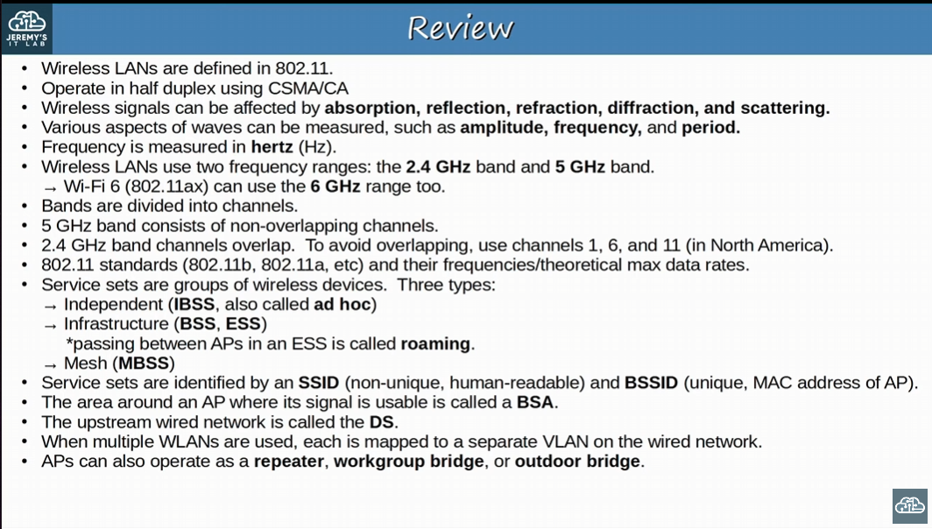
-important!

Day 56:
Looking at how wireless architecture fits into the entire network as a whole
Different wireless AP architectures: Autonomous AP, Lightweight AP & Cloud-based AP

WLC: Wireless LAN Controllers Deployments

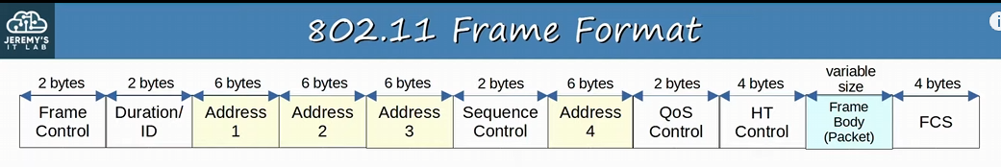 -802.11 frames have a different format than 802.3 ethernet frames
-depending on the 802.11 version and message type, some fields might not exist in the frame
-For Example, not all messages use all 4 address fields

-Frame control: provides information such as the message type and the subtype
-Duration/ID: depending on the message type, this field can indicate:
-the time (milliseconds) the channel will be dedicated for transmission of the frame
-OR the identifier for the association (connection between wireless client and AP)

-Addresses: Up to four addresses can be present in an 802.11 frame
-which addresses are present, and their order, depends on the message type

-Destination Address (DA): final recipient of the frame
-Source Address (SA): Original sender of the frame
-Receiver address (RA): Immediate recipient of the frame (not the final destination)
-Transmitter Address (TA): Immediate sender of the frame (not necessarily the original sender of the frame)

-Sequence Control: Used to reassemble fragments and eliminate duplicate frames
-QoS control: Used in QoS to prioritize certain traffic
-HT Control (High Throughput control): Added in 802.11n to enable High Throughput operations
-Frame Body: is the PACKET encapsulated within the 802.11 Frame
-FCS (Frame Check Sequence): Same as in an Ethernet frame, used to check for errors

Again, not all fields are present in 802.11 frames
-depends on version of 802.11 and message type

802.11n is also known as High throughput Wi-Fi (as well as Wi-Fi 4)
802.11ac is also known as Very High Throughput (VHT) Wi-Fi (as well as Wi-Fi 5)

802.11 Association Process:
-Access points bridge traffic between wireless stations and other devices
-for example, host connected to the wired network
-for a station to send traffic though the AP, it must be associated with the AP
-3 Connection States:
-Not authenticated, not associated with the AP
-Authenticated, not associated with the AP
-Authenticated and associated with the AP
-the station must be AUTHENTICATED and ASSOCIATED with the AP to send traffic through it

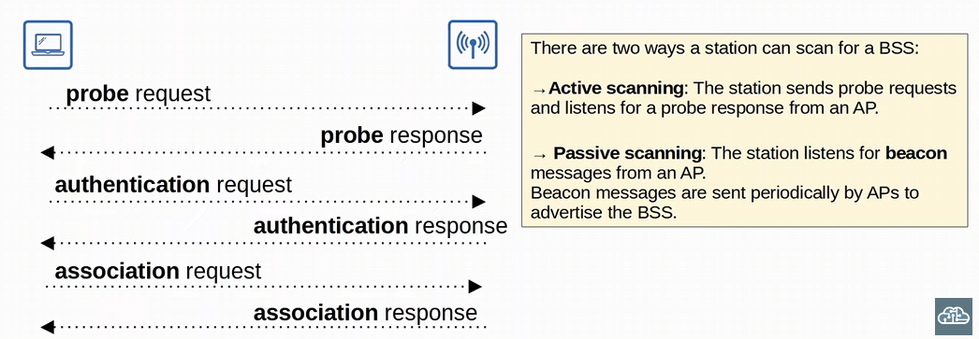
-first the station sends a Probe request to find what APs and BSSs are available
-Active Scanning: the station sends probe requests and listens for probe response from an AP
-this is the example we are looking at in the diagram
-Passive Scanning: the station listens for beacon messages from an AP
-beacon messages are sent periodically by APs to advertise the BSS
-next, the AP sends a probe response to say its available
-station now knows about the AP and the BSS
-1st Connection state: Not authenticated, Not associated
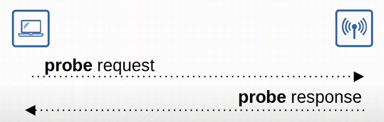

-afterwards, an authentication request is sent (station send a PASSWORD to the AP)
-the AP sends an authentication response accepting or rejecting the Password
-2nd Connection State: Authenticated but not associated with the AP
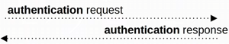

-Finally, there is an association request and response
-if successful we reached the final 3rd connection state (Authenticated & associated)
Once Authenticated and Associated the Traffic can finally send traffic through the AP!

All the messages, probe, beacon, authentication, and association are the same TYPE of 802.11 message

Three 802.11 Message Types:
- Management: 802.11 Frames used to manage the BSS
- Beacon, Probe request, Probe response, Authentication, Association Request, Association response (frames sent in the connection states!!)

- Control: Used to control access to the medium (radio frequency). Assists with delivery of management and data frames
- RTS (Request to Send) & CTS (Clear to Send) which is used is csma/ca, ACK (used to notify the message was received)

- Data: Used to send actual data packets

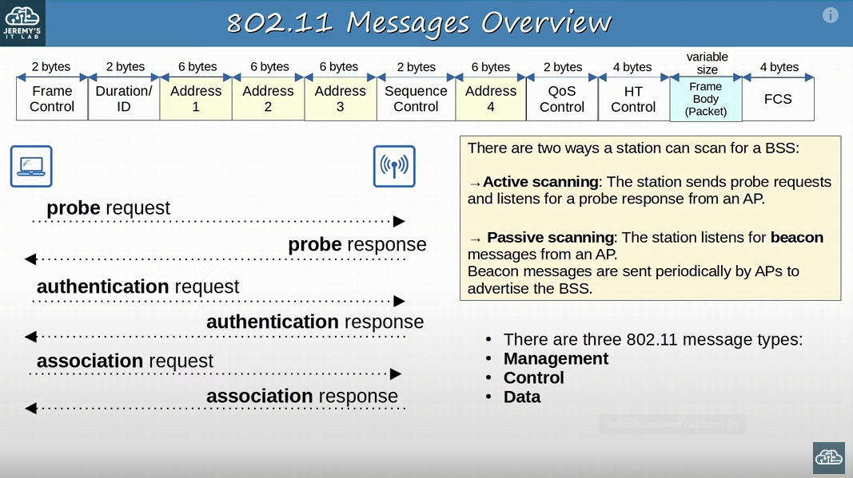
-Important!!

There are three main wireless AP deployment methods:
-how we use WAP: Autonomous, Lightweight, Cloud-Based

-Autonomous AP: self-contained systems that don’t rely on a WLC
-type of AP deployment
-configured individually by console cable (CLI), telnet/SSH (CLI), or even HTTP/HTTPS web connection (GUI)
-for a SMALL network this is fine, but configuring APs in a large network is tedious
-an IP address for remote management should be configured for telnet/SSH or HTTP/HTTPS!!!
-the Radio Frequency (RF) parameters must be manually configured per AP (transmit power, channel, etc.)
-security polices are handled individual by each AP
-QoS rules etc. are configured individually on each AP
-NO CENTRAL MONITORING or MANAGEMENT for the APs

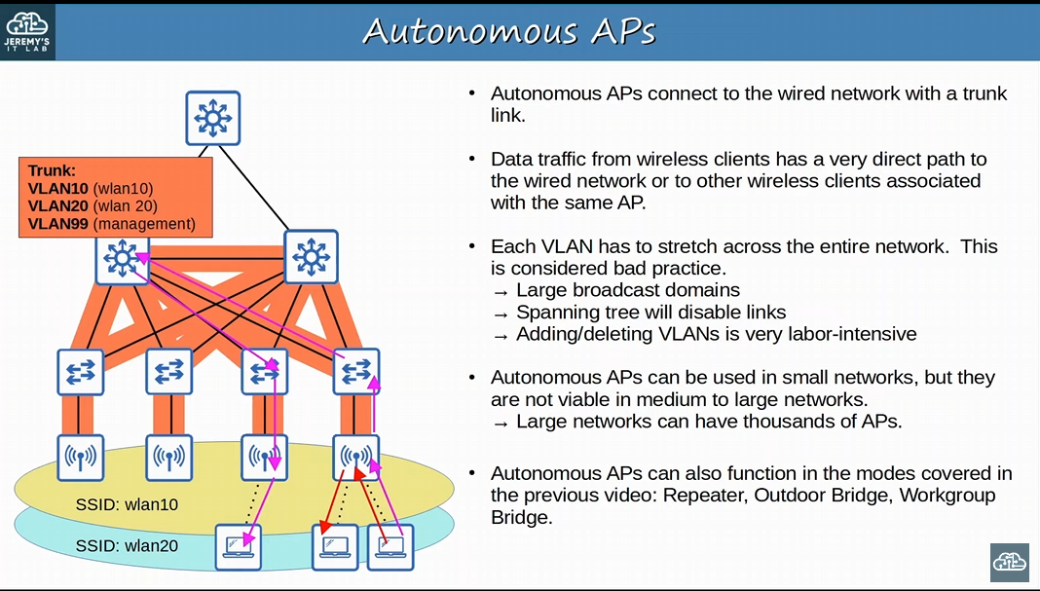
-Autonomous APs connect back to the wire network via a trunk link (EVEN if the AP is linked to ONE SSID)
-MANAGEMENT TRAFFIC needs to be in a SEPARATE VLAN than the data traffic!
-Data traffic from wireless clients has a very direct path to the wired network or to other wireless clients associated with the same AP
-no reason for the traffic to go to the wired network if the stations are connected to the SAME autonomous AP
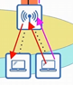

-with Autonomous APs the VLAN must be spread around the ENTIRE network
-issues with LARGE broadcast domains (broadcast message flooded around the whole network), STP disabling links, and editing VLANs would be painful

-USE AUTONOMOUS AP in SMALL networks, not medium to large networks
-managing thousands of autonomous APs is labor intensive
Autonomous APs can function in the modes covered in the previous video: Repeater, Outdoor bridge, Workgroup Bridge

A big part of modern design is to limit Spanning-tree as much as possible, because disabling links means a reduction of total bandwidth
Keep Management traffic separate from Data traffic with different subnet and VLAN

Lightweight AP: The functions of an AP can be split between the AP and a Wireless LAN Controller (WLC)
-type of AP deployment
-handles ‘real-time’ operations like transmitting/receiving RF traffic, encryption/decryption of traffic, sending out beacons/probes, etc.
-WLC carries out the functions of RF management, security/QoS management, client authentication/roaming management, etc.
-WLC is also used to centrally configure the lightweight APs (don’t need to log into each AP like you do with autonomous APs)
-Called a Split-MAC architecture (functions are split between LAP and WLC)
-WLC can be in the SAME subnet/VLAN as the lightweight APs it manages, OR in a DIFFERENT subnet/VLAN!!!
-WLC and the LAP AUTHENTICATE each other using digital certificates installed on each device (X.509 standard certificates, the same standard used by websites!!)
-x.509 digital certificate authentication prevents attackers from using their own APs to get on a network
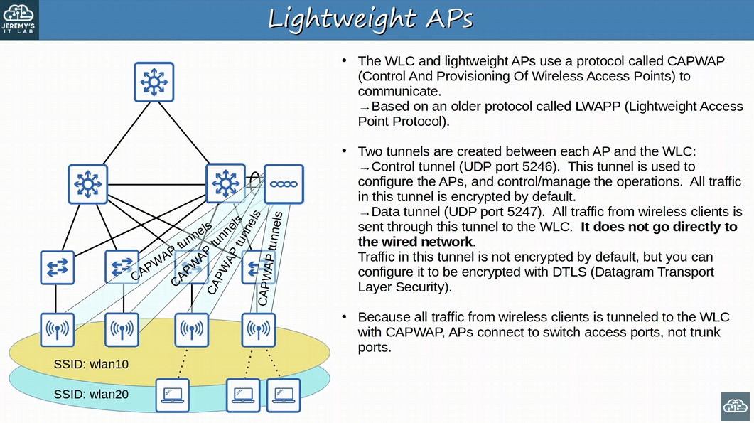
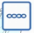 <- this is the Wireless LAN controller
-again, the WLC can be in the same OR different VLAN/subnet !!
-CAPWAP (Control and Provision Wireless Access Points) is a protocol used to communicate between WLC and the AP
-based on a legacy protocol: LWAPP (Lightweight Access Point Protocol)
-TWO tunnels are created between EACH AP and the WLC: Data and Control tunnels

-CAPWAP control tunnel (UDP 5246) configure APs, and control/manage the operations
-encrypted by default
-CAPWAP data tunnel (UDP 5247) all traffic from wireless clients is sent through this tunnel to the WLC
-data traffic does not go directly go to the wired network or even to another client associated with the same AP. It must go through the tunnel to the WLC FIRST!!
-it might go through the physical wired network with the tunnel, but conceptually the traffic is tunneled straight into the WLC skipping the physical
-the data is encapsulated with new headers to form the tunnel like GRE & IPSec tunnels
-NOT ENCRYPTED BY DEFAULT! (Can configure to be encrypted with DTLS)
DTLS protocol is similar to TLS, but uses UDP whereas TLS uses TCP
Because ALL traffic from Wireless clients is tunneled to the WLC with CAPWAP in Lightweight AP deployment, APs connect to switch access ports, NOT trunk ports
-no need for multiple VLANs to cross the link

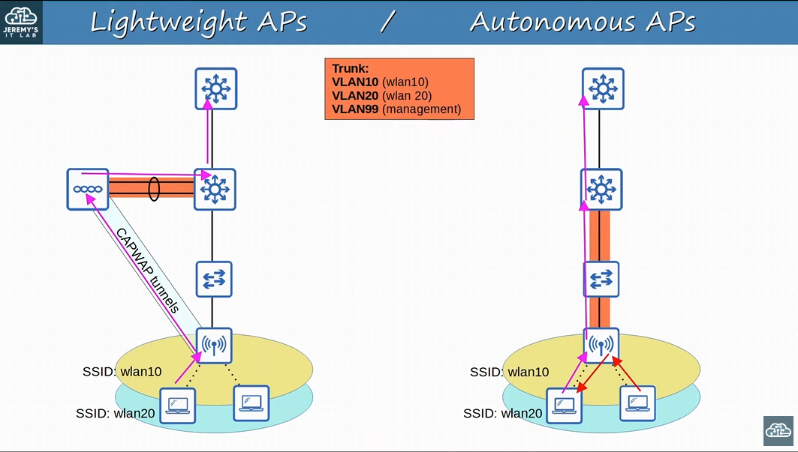
-Autonomous APs but connect to the network using a trunk link (for its management VLAN and SSID VLAN for data)
-each SSID needs a VLAN attributed to it, and management data needs to be separated into a different VLAN as well
-for autonomous the client doesn’t need to have its traffic sent into the wired network if the receiving client is connected to the same AP

-with Split-MAC the AP doesn’t have to connect to the switch with a trunk, an access link is fine since tunnel is occurring
-HOWEVER, a trunk link IS needed between the WLC and the wired network (since the CAPWAP tunneling header isn’t covering the VLAN information anymore)
-traffic from a wireless client is sent to the AP and then tunneled to the WLC, then the WLC sends it over the wired network to the default gateway, which will forward it as appropriate
Lightweight APs in a split-MAC architecture gives some key benefits:
-Scalability: with a WLC (or multiple in a very large network) its much simpler to build and support a network with thousands of APs
-Dynamic channel assignment: The WLC can AUTOMATICALLY select which channel each AP should use
-Transmit power optimization: The WLC can automatically set the appropriate transmit power for each AP
-to supply sufficient coverage without interfering with other APs
-Self-healing wireless coverage: When an AP stops functioning the WLC can increase the transmit power of nearby APs to avoid coverage holes
-Seamless Roaming: clients can roam between APs with no noticeable delay
-Client load Balancing: It a client is in range of two APs, the WLC can associate the client with the least-used AP, to balance the load among APs
-Security/QoS management: Central management of security and QoS polices ensures CONSISTENCY across the network

-just be aware of these benefits, don’t need to fully memorize

Lightweight APs can be configured to operate in various modes:
-Local: this is the default mode where the AP offers a BSS (more multiple BSSs) for clients to associate with
-standard operational mode of an AP

-FlexConnect: Like a lightweight AP in local mode, it offers one or more BSSs for clients to associate with (like local mode). HOWEVER, FlexConnect allows the AP to locally switch traffic between the wired and wireless networks if the tunnels to the WLC go down.

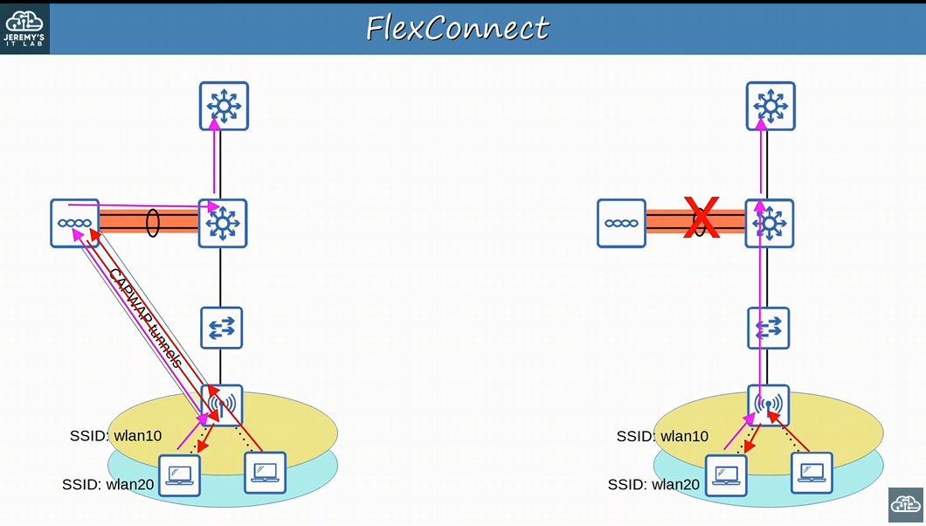
-if the CAPWAP tunnel goes down the FlexConnect mode LAP will stop acting like a local AP that needs the WLC. Instead, the FlexConnect mode LAP will start acting like an autonomous AP by locally switch traffic between wired and wireless networks!

-Sniffer: Ther AP does not offer a BSS for clients. It is dedicated to capturing 802.11 frames and sending them to a device running software such as wireshark
-listens to wireless traffic and send the packets to a software

-Monitor: Doesn’t offer a BSS for clients. It is dedicated to receiving 802.11 frames to detect rogue devices. If a client is found to be a rogue device, and AP can send de-authentication messages to disassociate the rogue device from the AP

-Rogue Detector: the LAP does not even use its radio. It listens to traffic on the WIRED network only, but it receives a list of suspected rogue clients and AP MAC addresses from the WLC. By listening to ARP messages on the wired network and correlating it with the information it receives from the WLC, it can detect rogue devices

-SE-Connect (Spectrum Expert Connect): the AP does not offer a BSS for clients. It is dedicated to RF spectrum analysis on all channels. It can send information to software such as Cisco Spectrum Expert on a PC to collect and analyze data
-Finds sources of interference

-Bridge/Mesh: Like the autonomous AP’s Outdoor Bridge mode, the lightweight AP can be a dedicated bridge between sites, even over long distances. A mesh can be made between the access points
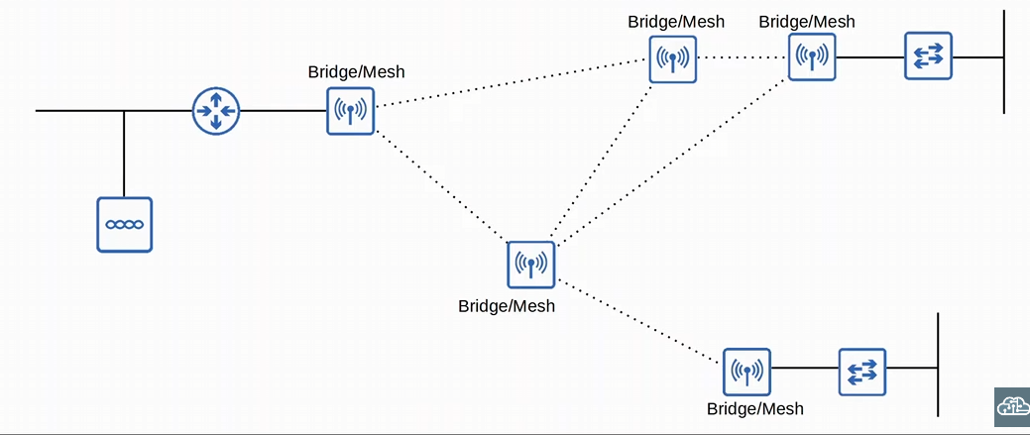
-connecting LAPs in a mesh

-Flex plus Bridge: Adds FlexConnect functionality to the Bridge/Mesh mode. Allows wireless access points to locally forward traffic in a mesh even if connectivity to the WLC is lost

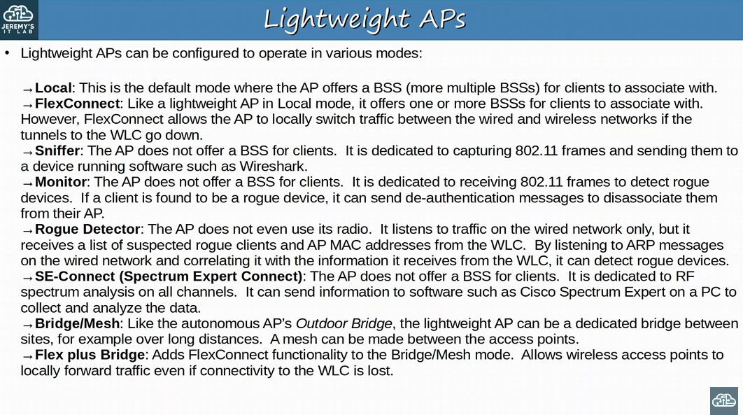
-Don’t memorize the list, just understand the basic purpose of each mode for LAP

Cloud-Based AP: architecture that is in between autonomous AP and Split-Mac architecture in terms of how it functions
-autonomous APs that are centrally managed in the cloud!!
-Cisco Meraki is a popular cloud-based Wi-Fi solution
-Meraki dashboard can be used to configure APs, monitor the network, generate performance reports, etc.
-Meraki also Tells each AP which channel to use, what transmit power, etc. (like WLC)

-regular data traffic is not sent to the cloud!
-sent direct to the wired network like when using autonomous APs
-Only management/control traffic is sent to the cloud!
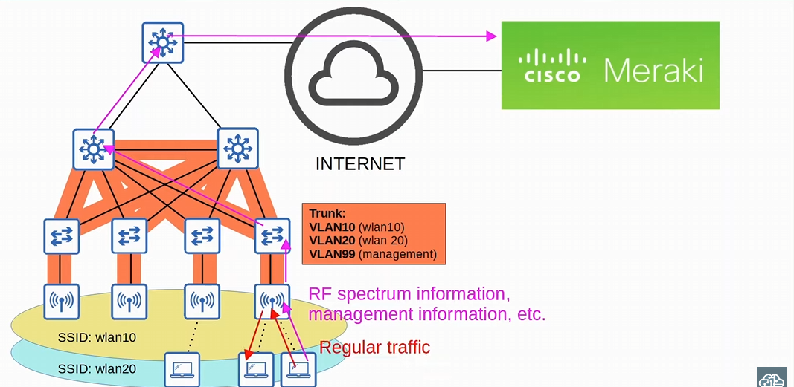
-regular traffic interact with each other, like two PCs interacting with each other in an autonomous AP deployment
-data traffic acts like regular traffic in an autonomous AP deployment method
-HOWEVER, the management/control data is sent to the cloud

These are the three AP deployment models: Autonomous, Lightweight, Cloud-Based
4 main WLC deployment models for a split-MAC architecture:
-Does not apply to Autonomous AP or Cloud-based AP

- Unified: The WLC is a hardware appliance in a central location of the network
-6000 APs

- Cloud-Based: The WLC is a VM running on a server, usually in a private cloud in a data centre. THIS IS NOT THE SAME AS THE CLOUD -BASED AP ARCHITECTURE!
- DO NOT CONFUSE THE TWO, the AP are LAPs and the WLC is the cloud
- 3000 APs

- Embedded: The WLC is integrated within a switch !!
- Using CAPWAP tunnels for other LAPs
- 200 APs

- Mobility Express: The WLC is integrated within an AP
- Using CAPWAP tunnels for other LAPs
- 100 APs

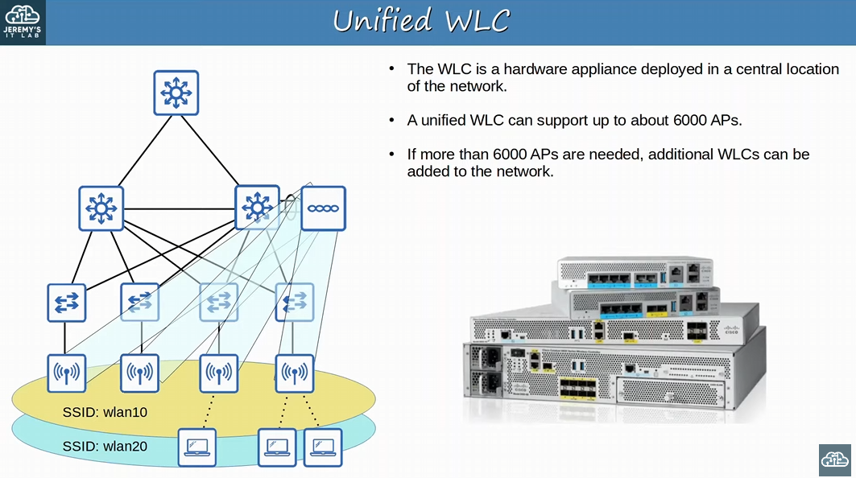
-Unified WLC is central and supports up to 6000 APs
-if more than 6000 APs are needed, buy more WLCs for the network

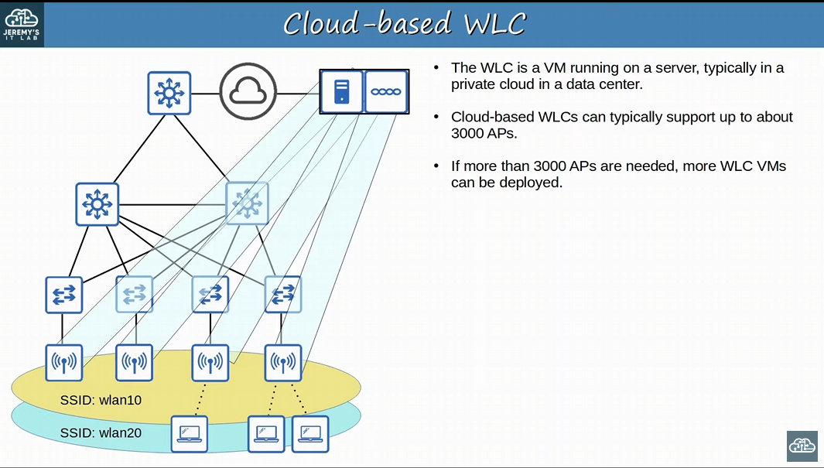
-WLC is a VM running in a server (private cloud in a data centre)
-support up to 3000 APs, if more APs exist, you need more WLC VMs
-DON’T mix up Cloud-based APs with Cloud-Based WLCs

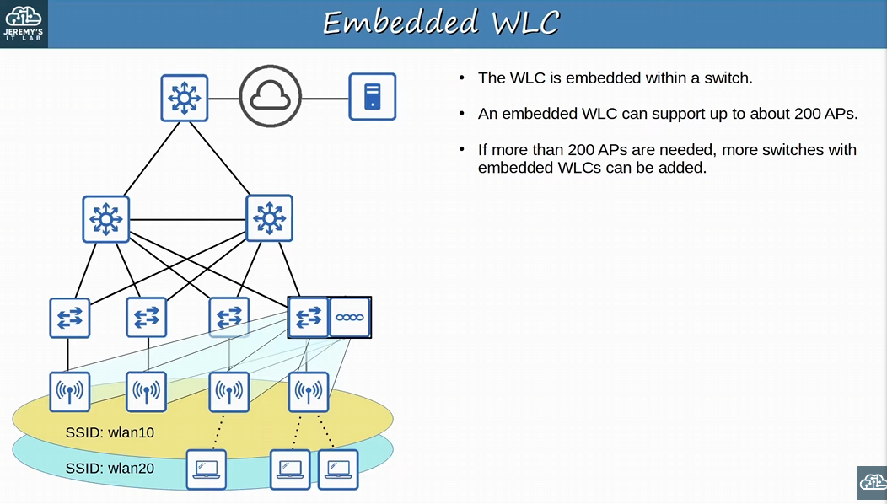
-Embedded WLCs have an WLC embedded within a switch
-the WLC embedded switch will create CAPWAP tunnels with the other LAPs
-Supports up to 200 LAPs, more switches with embedded WLC are needed for more LAPs
-for smaller campuses

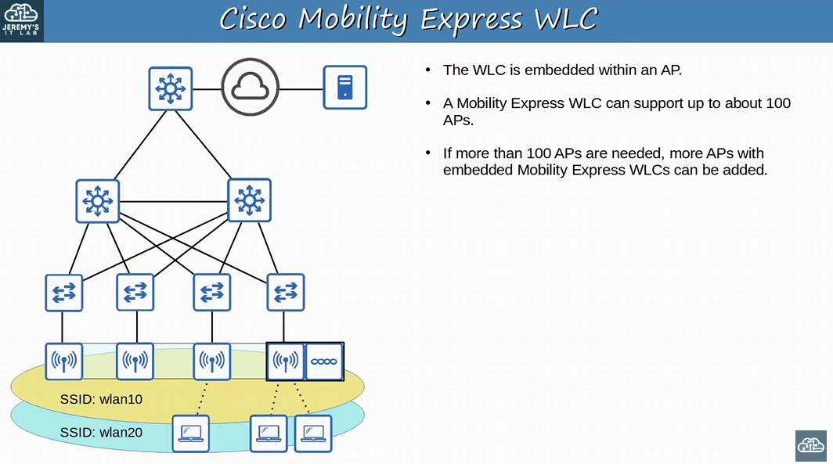
-WLC is embedded with an AP
-100 APs, and if you need more you need another WLC embedded within an AP
-good WLC deployment for a small branch office

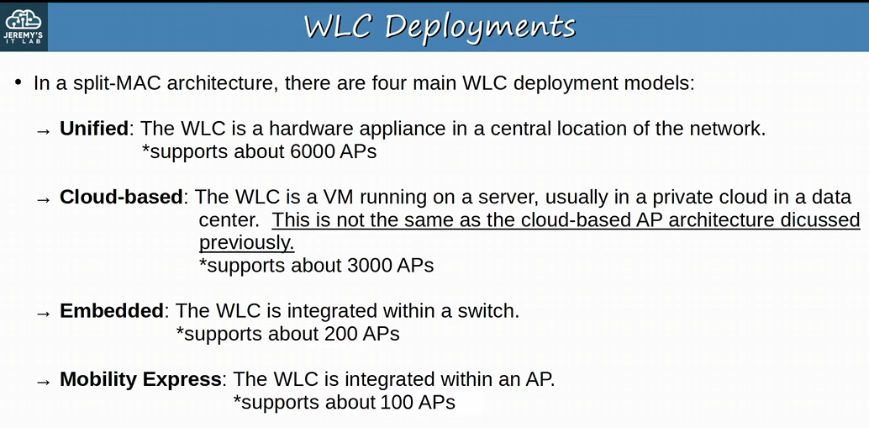

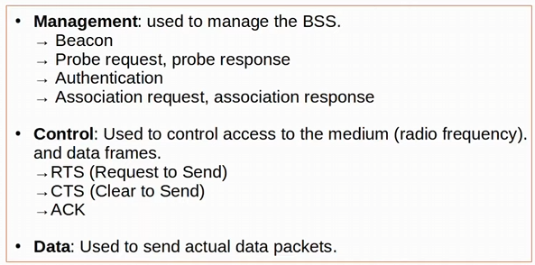

Day 57:
Looking at wireless security
-wireless security protocols WPA, WPA2, and WPA3
-authentication methods
-Also, encryption/integrity methods

Integrity means making sure the frames are not modified while in transit

WPA (Wi-Fi protected Access) was developed by the Wi-Fi alliance to provide standard sets of wireless network security protocols

Although security is important in all networks, it is even more essential in wireless network
-wireless frames are within range of any devices in the STA

In wired networks traffic is often only encrypted when sent over an untrusted network such as the internet
-don’t usually encrypt wired traffic within the LAN

Wireless networks its VERY important to encrypt traffic sent between the wireless clients and the AP
-any device within range of the signal can receive the traffic

Looking at three main concepts from a wireless perspective: authentication, encryption, integrity

Looking at three main concepts from a wireless perspective:
-Authentication: all clients must be authenticated before they can associate with an AP
-only trusted users/devices should be given access
-ideally, not only should the AP authenticate with the client (like we’ve seen before), but also the client should authenticate the AP
- to avoid associating with a malicious AP
-to prevent MITM attacks using APs

-in a corporate setting a separate SSID (like SSID: Guest) which doesn’t have access to the corporate network can be provided for guest users
-less strict authentication requirements but doesn’t access the company. Instead, usually for internet access

-there are multiple ways to authenticate: password, username/password, OR digital certificates
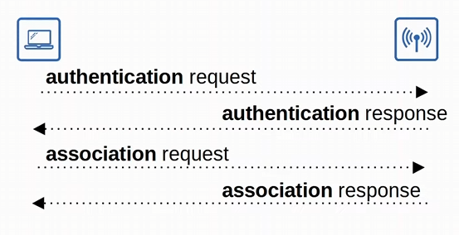

-Encryption: traffic sent between clients (any wireless traffic) and APs should be encrypted so that it can’t be read by anyone except the AP and the client
-encryption means scrambling the message so only the sender and the receiver can read it
-many protocols that can be used to encrypt traffic
-sender and receiver needs to use the SAME protocol!
-all devices on the WLAN will use the SAME encryption protocol, HOWEVER each client will use a unique encryption/decryption key so that other devices can’t read its traffic
-same protocol, different keys!
-only the AP will have the right key to decrypt the client’s messages

-A ‘group key’ is used by the AP to encrypt traffic that is wants to send to ALL of its clients
-all of the clients associated with the AP keep that key so they can decrypt the traffic

-two keys: a private key, and a group key

-Integrity: ensures that a message is not modified by a third-party (in transit)!
-the message that is sent by the source host should be the same as the message that is received by the destination host
-MIC (Message Integrity Check) helps to IDENTIFY if the integrity of a message has been compromised
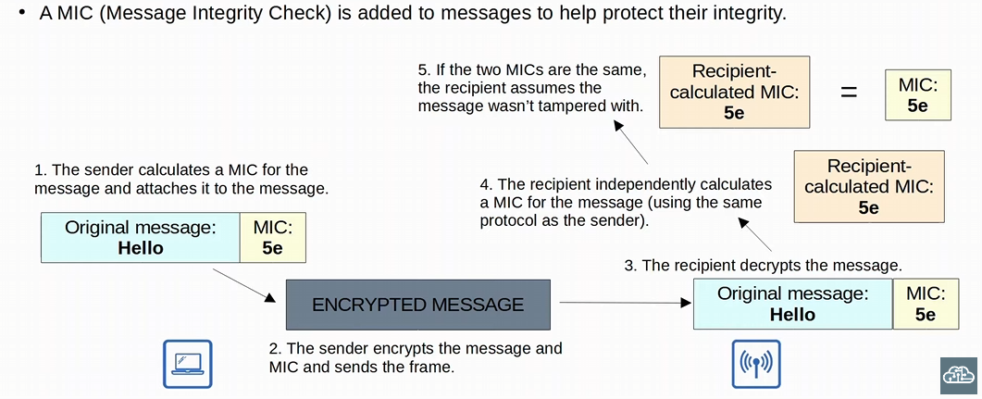
-PC is a client of the AP
-the sender calculates and attaches a MIC on the message
-again, the sender and the receiver need to use the same protocol
-the sender encrypts the message and the MIC and sends the frame
-the recipient decrypts the message and calculates a MIC for the message (using the same protocol)
-if the two MICs are the same, the recipient assumes the message wasn’t tampered with
-recipient calculated MIC and the MIC attached to the original sender’s message should be the same

-if recipient calculated MIC and the MIC on the original message aren’t the same, the message is discarded

Authentication Methods:
-Open Authentication: Client sends an authentication request, and the AP accepts it
-terrible and not secure, AP accepts ALL authentication requests
-Open authentication is used today alongside OTHER authentication methods
-after authenticating VIA open authentication and then using the second authentication method you will have access to the internet
-After the client is authenticated and associated with the AP, its possible to require the user to authenticate via other methods before access to the network is granted (for example, Starbuck Wi-Fi or another public Wi-Fi where you access the AP but need to login via a webpage)

-WEP (Wired Equivalent Privacy): WEP is used to provide BOTH Authentication and Encryption of wireless traffic
-for encryption, WEP uses the RC4 algorithm
-WEP is a ‘shared-key’ protocol, requiring the sender and receiver to have the same key
-Keys can be 40 bits or 104 bits in length but are combined with a 24-bit ‘IV’ (initialization vector) to bring the total length to 64 bits or 128 bits!!
-WEP encryption is NOT SECURE and can be easily cracked (regardless of the key length)
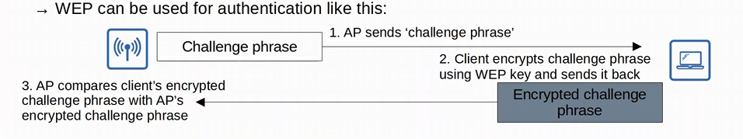
-AP’s challenge phrase is just a series of bits, the contents don’t matter
-AP sends a challenge phrase to the client, and the client encrypts the phrase using a WEP key and sends it back to the AP
-AP compares client’s encrypted challenge phrase with AP’s encrypted challenge phrase
-If they match it means the AP and the client use the same key to encrypt the phrase, so the authentication is successful
-AP is basically testing if the client knows the shared key or not
WEP can be used just to provide encryption, or to provide both encryption and authentication
-if WEP authentication is not used, open authentication will be used and WEP will only be used for encryption
Authentication Methods:
-EAP (Extensible Authentication Protocol): authentication framework (not really a protocol)
-isn’t a single authentication protocol, but rather a framework which many other protocols, called EAP methods, are based on (like LEAP, EAP-FAST, PEAP & EAP-TLS)
-defines a standard set of authentication functions that are used by the various EAP methods
-integrated with 802.1x, which provides port-based network access control
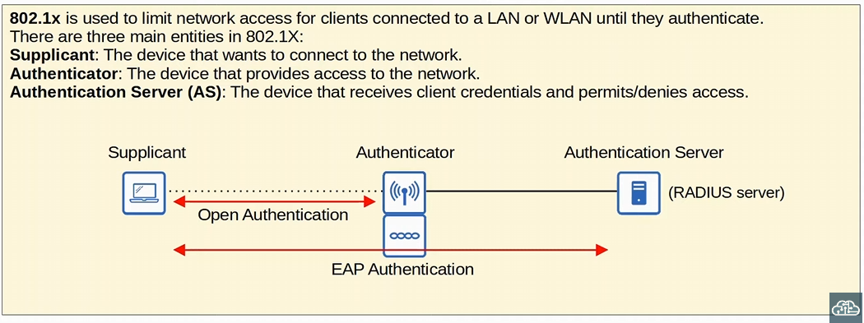
-802.1x limits network access for clients connected to a LAN or WLAN until they authenticate
Three entities in 802.1x: Supplicant, Authenticator & Authentication server

-Supplicant: is a device that wants to connect to the network
-Authenticator: the device that provides access to the network (could be an autonomous AP or the WLC in a split-Mac architecture)
-Authentication Server (AS): device that receives client credentials and permits/denies access! (Like a Radius server)

-the 802.11 wireless authentication required to associate with the AP is simply open authentication
-will not have full access to the network till EAP authentication is finished
-the supplicant will only be able to access the authenticator via open authentication until its credentials are verified by the authentication server
-authentication server will check the client’s credentials
802.1x is used both in wired and wireless networks
Authentication Methods:
-LEAP (Lightweight EAP): developed by cisco as an improvement over WEP
-clients must provide a username and password to authenticated
-mutual Authentication is provided by both the client and the server sending a challenge phrase to each other
-in WEP only the AP send the challenge phrase
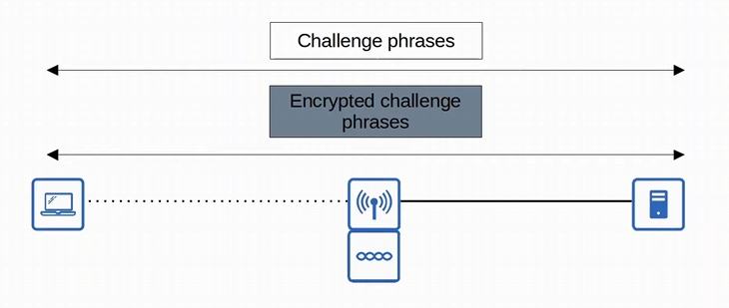
-there is a mutual authentication exchange of challenge phrases sent by both the client and the server
-client sends challenge phrase and the server encrypts and sends back to client, while the server sends its own challenge phrase to the client which will encrypt and send it to the server
-dynamic WEP keys are used, meaning that the WEP keys are changed frequently
-like WEP, LEAP is considered vulnerable and SHOULD NOT BE USED ANYMORE

The other EAP authentication methods should be used: EAP-FAST, PEAP & EAP-TLS

Authentication Methods:
-EAP-FAST (EAP Flexible Authentication via Secure Tunneling): Developed by cisco, with three phases
1) A PAC (Protected Access Credential) is generated and passed from the server to the client (similar to a shared key)
2) A secure TLS tunnel is established between the client and authentication server
3) Inside of the secure (encrypted) TLS tunnel, the client and server communicate further to authenticate/authorize the client
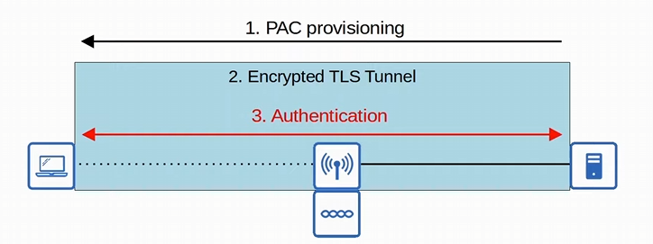

Authentication method:
-PEAP (Protected EAP): Like EAP-FAST, PEAP involves establishing a secure TLS tunnel between the client and server, but instead of using a PAC, the server has a digital certificate
-the client uses this digital certificate to authenticate the server and establishes a secure TLS tunnel!
-because only the server provides a certificate for authentication, the client must still be authenticated within the secure tunnel with a protocol
-for example, by using MS-CHAP (Microsoft Challenge-Handshake Authentication Protocol)
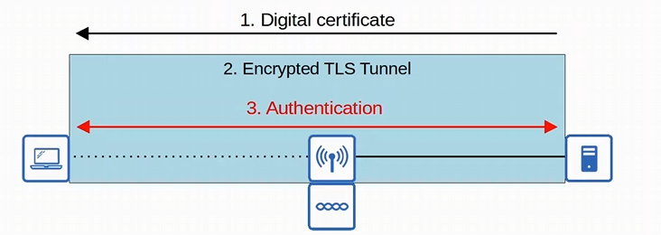
-Server sends a digital certificate and creates a TLS tunnel -> a protocol is used to start authentication

EAP-FAST uses a PAC (protected access credential) but PEAP uses a digital certificate
-both use TLS tunnels, then authentication occurs

Authentication Methods:
-EAP-TLS (EAP Transport Layer Security): requires a digital certificate on the AS and on every single client
-similar to PEAP, but PEAP only requires a digital certificate on the authentication servers
-is the MOST SECURE wireless authentication method, but it is more difficult to implement than PEAP because every client device needs a certificate
-no need to authenticate the client with a TLS tunnel, BUT the TLS tunnel is STILL used to exchange encryption key information

Enterprises might prefer PEAP instead of EAP-TLS cause its harder to configure

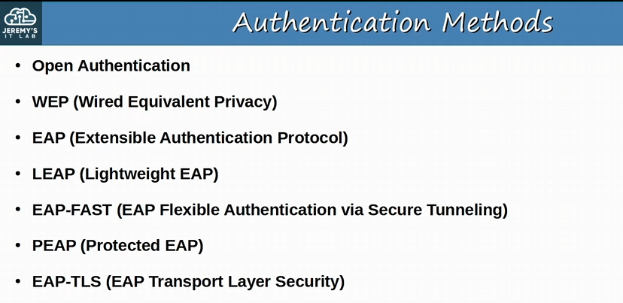
-authentication refers to verifying the identity of a device or user

The original 802.11 Standard included two options for authentication:
-Open Authentication, and WEP (Wired Equivalent Privacy)

Three Encryption & Integrity methods:
-TKIP (Temporal Key Integrity Protocol)
-CCMP (Counter/CBC-MAC Protocol)
-GCMP (Galois/Counter Mode Protocol)

-Technically WEP as well (which is both and authentication method and encryption method)

TKIP (Temporal Key Integrity Protocol):
-Encryption method & integrity method
-WEP was found to be vulnerable, but wireless hardware at the time was built to use WEP
-temporary solution was needed until a new standard was created and new hardware was built (TKIP)
-think of TKIP like a more secure version of WEP which was needed at the time

-TKIP adds various security features:
-A MIC (message Integrity Check) is added to protect the integrity of messages
-integrity check
-includes the sender’s MAC address to identify the frame’s sender
-Key Mixing algorithm is used to create a unique WEP key for every frame
-instead of each frame using the same WEP key
-harder to crack the encryption
-the Initialization Vector is doubled in length from 24 bits to 48 bits, making brute force attacks to crack the encryption much more difficult
-a Timestamp is added to the MIC to prevent replay attacks. Replay attacks involves resending a frame that has already been transmitted
-TKIP sequence number is used to keep track of frames sent from each source MAC address
-also protects against replay attacks (frame will be dropped is seq count is wrong)
-Don’t really need to memorize all of the above features
TKIP is used in WPA 1!

CCMP (Counter/CBC-MAC Protocol):
-Encryption method & integrity method
-developed after TKIP and is more secure
-used in WPA2
-for a device to use CCMP, it must be supported by the device’s hardware. Old hardware built only to use WEP/TKIP cannot use CCMP!!

-CCMP consists of two different algorithms to provide encryption and MIC
-for encryption:
1) AES (Advanced Encryption Standard) Counter Mode encryption
-AES is the MOST secure encryption protocol currently available
-multiple modes of AES, CCMP uses ‘counter mode’
-this is the encryption

2) CBC-MAC (Cipher Block Chaining Message Authentication Code) is used as a MIC to ensure the integrity of message
-CBC-MAC is a kind of MIC
-this is the integrity

GCMP (Galois/Counter Mode Protocol):
-Encryption method & integrity method
-More secure and efficient than CCMP
-its increased efficiency allows high data throughput than CCMP
-USED in WPA3!!!

-GCMP consists of two algorithms:
1) AES counter mode encryption
2) GMAC (Galois Message Authentication Code) is used as a MIC to ensure the integrity of messages

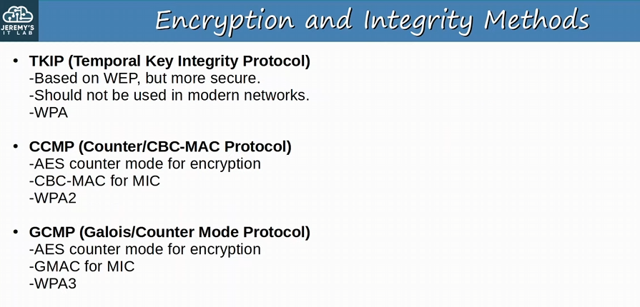

The Wi-Fi Alliance has developed three WPA certifications for wireless devices:
-WPA, WPA2 & WPA3
-Wi-Fi Protected Access
-for a device to be WPA certified, it must be tested in authorized testing labs

-All three WPAs support two authentication modes:
-Personal Mode: a pre-shared key (PSK) is used for authentication
-For example, when you connect to a home Wi-Fi network, enter the password and are authentication, this is Personal Mode
-common in small networks like SoHo networks

-PSK itself is not sent over the air. A four-way handshake is used for authentication, and the PSK is used to generate encryption keys
-if the devices use the same PSK to generate the encryption keys, they will be able to decrypt each other’s traffic, meaning that they will know that the other device is using the SAME PSK

-Enterprise mode: 802.1x is used with an authentication server (Radius Server)
-all EAP framework methods are supported! (PEAP, EAP-TLS, EAP-FAST, and LEAP)
-don’t use LEAP

WPA certifications take the various security protocols and package the protocols into standard sets!
-hardware is tested and certified to make sure it support these standards
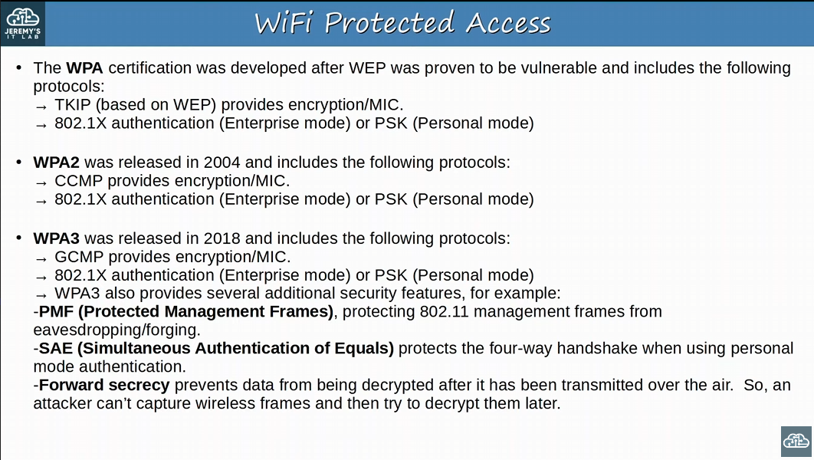
-WPA uses TKIP (based on WEP) which provides encryption/MIC
-MIC being integrity
-802.1x authentication (enterprise mode) OR PSK (personal mode)
-WPA didn’t last long

- WPA 2 uses CCMP for encryption/MIC
-Authentication was 802.1x (enterprise mode) OR PSK (personal mode)
-Optional feature of PMF

-WPA 3 uses GCMP for encryption/MIC
-Authentication was 802.1x (enterprise mode) OR PSK (personal mode)
-Adds other security features:
-PMF (Protected Management Frame), protecting 802.11 management frames from eavesdropping/forging (no longer optional like WPA2)
-SAE (Simultaneous Authentication of Equals) protects the four-way handshake when using PERSONAL MODE authentication
-Forward Secrecy: prevents data from being decrypted after it has been transmitted over the air. So, an attacker can’t capture wireless frames and then try to decrypt them later
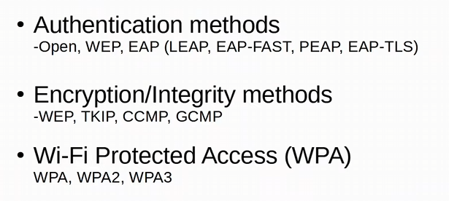

Day 58:
Looking at wireless configuration
-building a wireless LAN with a switch and a WLC setup

GUI: graphical user interface
-only was we need to configure WLAN with WPA2 PSK for CCNA

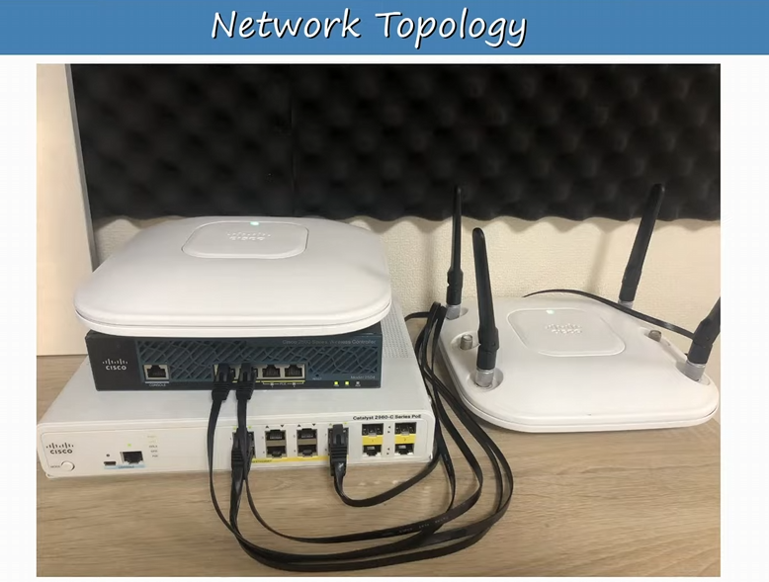
-we will work with one switch, one WLC, and 2 APs
-we don’t need to connect the APs because we are using PoE (power over ethernet)
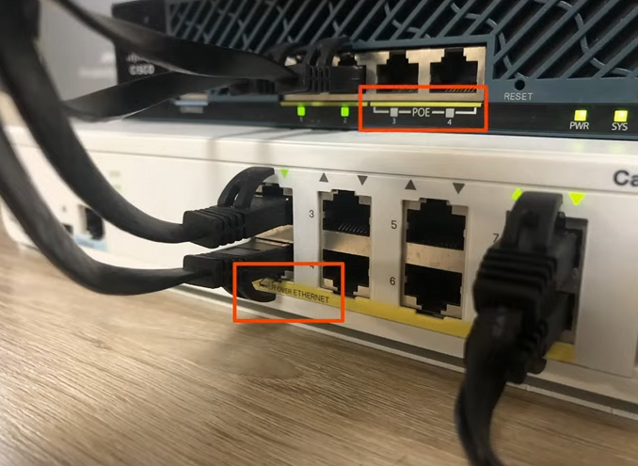
-can see the PoE ports on the AP
-WLC also has PoE cable too
-PoE interface will supply power and data!
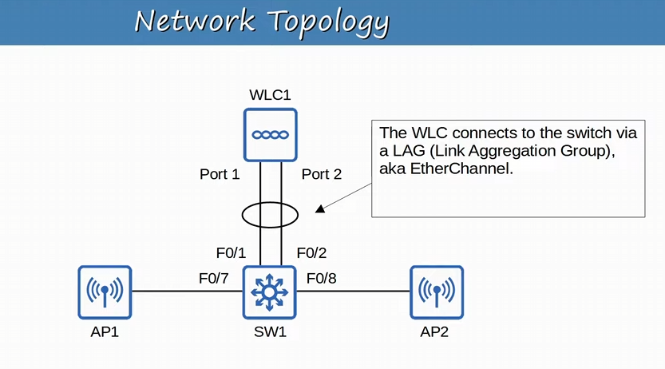
-you need to configure a STATIC etherchannel, or in the context of a Wireless network a LAG
-LAG: Link Aggregation Group
-need to use the command “channel-group <number> mode on”
-NOT “mode dynamic…” or “mode active” for PAgP or LACP, will not work!
-good idea to use a LAG to provide additional throughput and redundancy but not necessarily required
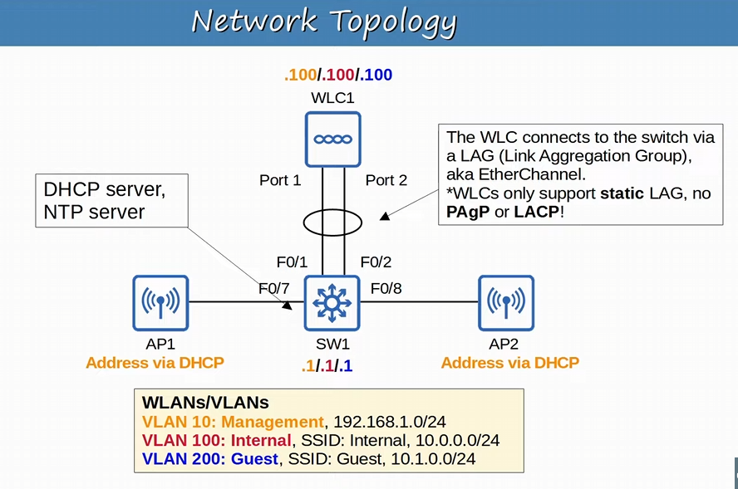
-we will use 3 VLANs, so we need to configure trunking on the LAG interfaces
-remember the switch and WLC link will ALWAYS need a trunk link since we are separating management traffic from regular data
-third VLAN will be for the guests on our network

-VLAN 10 (management) will be used to connecting to devices: switch AP & WLCs
-for example, managing them VIA CLI on an SSH connection!

-the data VLANs (100 & 200) will be mapped to two different SSIDs
-two different network IDs (100: 10.0.0.0/24 & 200: 10.1.0.0/24)

-in a real deployment you can limit the access of guest SSID to internet only and the internal VLAN would be able to access all internal company resources!

-Switch needs an SVI in each VLAN, and the WLC will need an Address in each VLAN as well
-APs need an IP address in the management VLAN so they can communicate with the WLC!!!
-will receive them VIA DHCP
-WLC could be the server, but we will use the layer 3 switch as the DHCP server and the NTP server!
-since we are using a split-MAC deployment the connections from the AP to the switch are ACCESS PORTS!
-only the connection between the WLC and the switch is the trunk with the VLANs

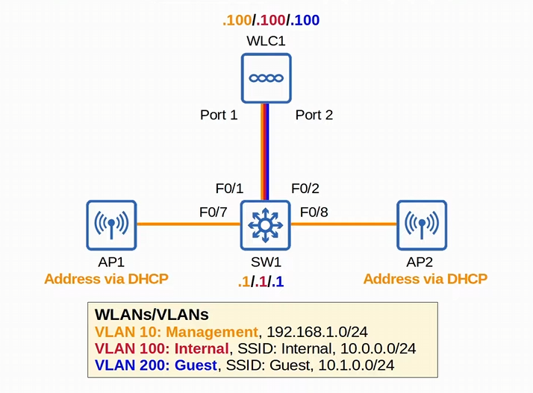
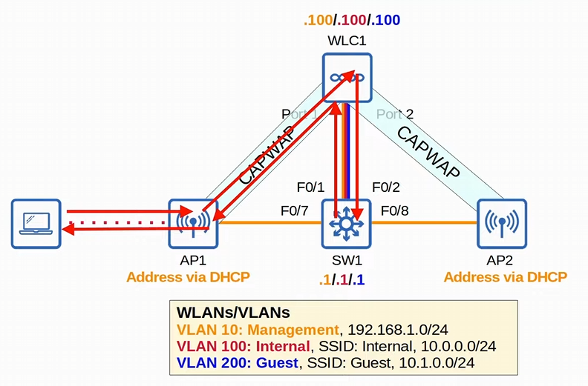
-if a client wants to interact with their default gateway (SW1) it will send the traffic through the CAPWAP tunnel to the WLC!
-AP doesn’t directly interact with SW1 since there is tunnel!!!
-2 CAPWAP tunnels: UDP 5426 control, UDP 5427 data
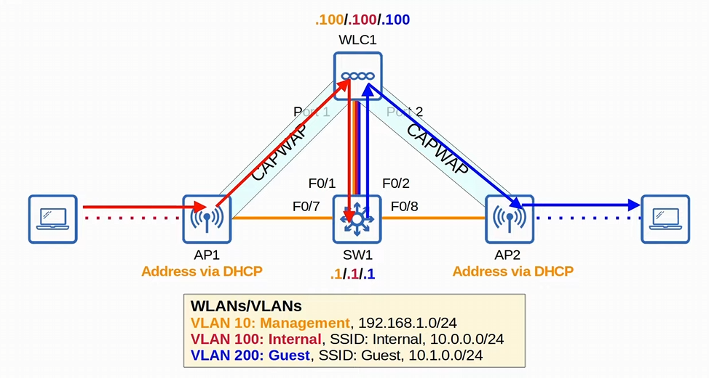
-if a client in the internal WLAN wants to interact with the client in the guest WLAN, traffic must go to the inter-VLAN routing device (SW1)
-traffic goes to the default gateway using the CAPWAP tunnel to the WLC, and WLC will send the traffic to SW1
-SW1 will send the traffic back up to WLC1, which then tunnels from the WLC to AP2
-AP 2 is advertising the guest WLAN

Remember, traffic in a split-MAC deployment will traffic through CAPWAP tunnels, not physical connections

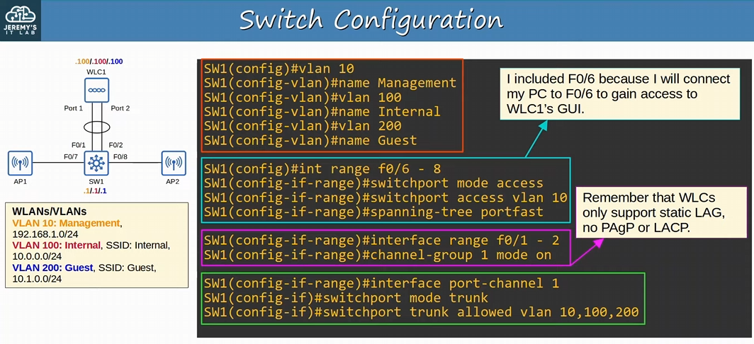
-we need to configure the VLANs, access ports connecting the APs and a single port for management, we can physically connect to the LAG, trunking on the LAG, the SVIs on SW1 for the multilayer switch, and finally DHCP for APs
-we will also add NTP configs to the multilayer switch
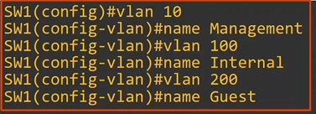
-create the VLAN with “vlan <vlan #>” -> then name the vlan in VLAN config mode “name <vlan name>”

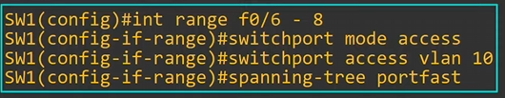
-the AP connections NEED TO BE ACCESS
-F0/7 & F0/8
-extra access port is needed for management, so we can connect to that port VIA a device and manage the WLC with its GUI!!!

A device’s CLI can be accessed via a console port or connected via VTY lines
BUT a device’s GUI CANNOT BE ACCESS VIA THE CONSOLE PORT!!!
-DO NOT FORGET, need to configure an access port for the GUI!

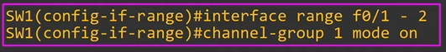
-we will configure the LAG with the command “channel-group <number> ON”
-this is a STATIC ETHERCHANNEL!
-WLC only supports static LAG, NO PAgP or LACP
-we will access the new LAG interface with the command “int po<LAG #> “ and create the trunk
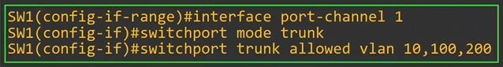
-REMEMBER, to allow the VLANs on the trunk interface with “switchport trunk allowed vlans <vlans>”

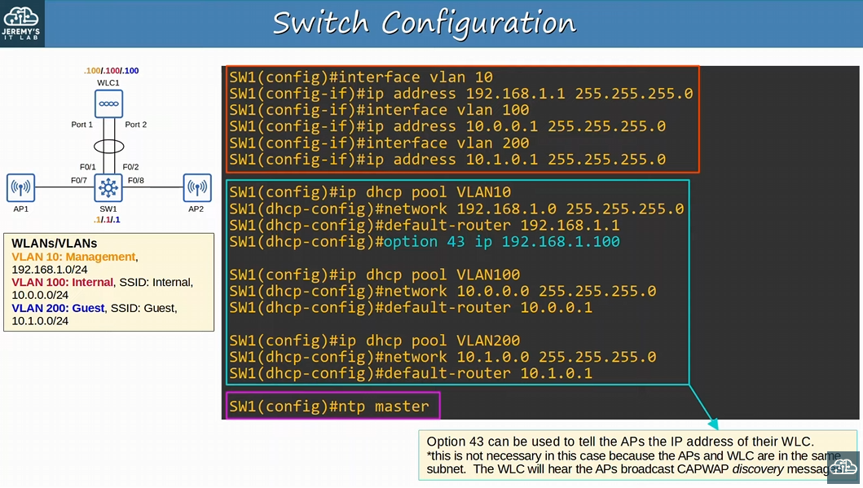
-second half of the configuration

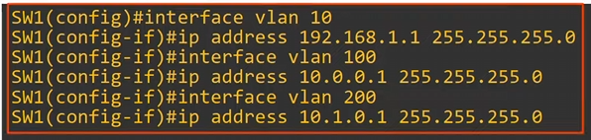
-set up the SVI of EACH vlan by using the command “vlan <vlan name>” -> and adding an IP address to the vlan “ip address <ip> <subnet mask>”
-these are the default gateway for each subnet

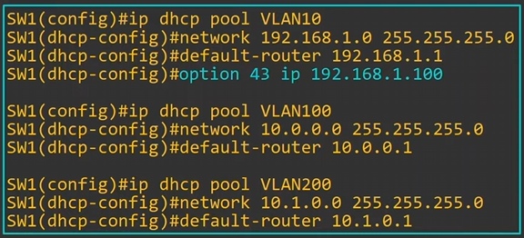
-now this is important, you need to configure DHCP for the APs so we will create DHCP pools, and the default gateway for each VLAN will be the SVIs we set up
-for the pool we use the command “ip dhcp pool <pool name>”, “network <network ip address> <subnet mask>”, and finally use the command “default-router <SVI of the Switch>” as the default gateway for each VLAN
-do this for EACH VLAN
-you can add “option 43 ip <WLC IP>” in DHCP config mode to the management VLAN
-option 43 is used to tell the APs the IP address of the WLC
-is vendor specific (cisco and some other vendors)
-for example, when AP get an IP address from the switch, it’ll tell the APs the WLC’s IP address
-AP will try to communicate with the WLC and forum the CAPWAP tunnels

-in this case it’s not necessary since the APs and WLC are in the SAME subnet & VLAN. The APs will send broadcast CAPWAP discovery messages to check if there are any WLCs in the local subnet
-the WLC will hear those broadcast messages, so the APs will be able to join the WLC

-option 43 is necessary if the AP is located in a different subnet & VLAN, where it won’t be able to hear the broadcast discovery messages from the APs
-REMEMBER the DHCP option 43 for the management VLAN!
You will configure the same DHCP pool configs, without the option 43, on the data VLANs
-the dhcp pool, network in DHCP pool, and the SVI’s of the switch as a default router!

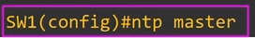
-we will later tell the WLC to use the switch as the NTP server
-to configure an NTP server use the command “ntp master <optional: stratum number>”

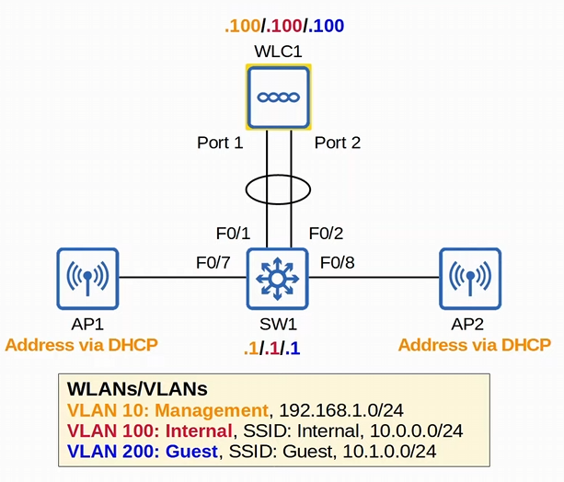
-we cannot connect to the WLC GUI yet, we need to connect to the console port and do some configurations in the CLI!

When the WLC first boots up, you’ll be given an Initial setup
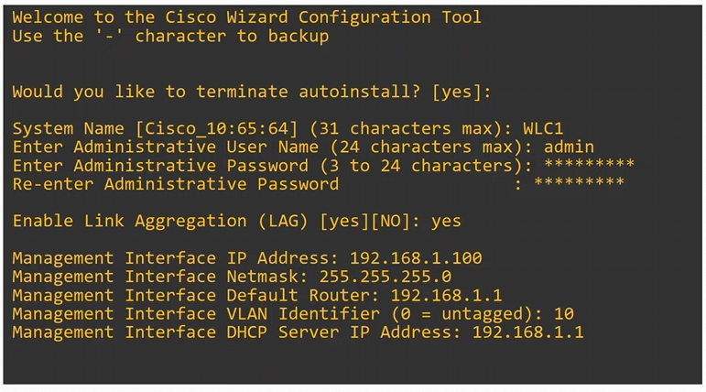
-don’t need to know CLI command, just use the wizard
-the capital word, like [YES] [no], means it’s the default config. You can just hit enter instead of typing yes
-No is the default here
-if it’s the only square bracket option, hit enter to use it

-autoinstall can be used to automatically download the WLC’s configuration from a TFTP server
-we want to configure it ourselves, so we hit enter to terminate autoinstall and not do it

-set up the system name, admin user and password
-make sure to allow a LAG to forum
-finally set up the management interface information
-management default router is the SVI ip of the switch we set up for the management VLAN
-the management interface is NOT a physical port, but a VIRTUAL interface within the WLC

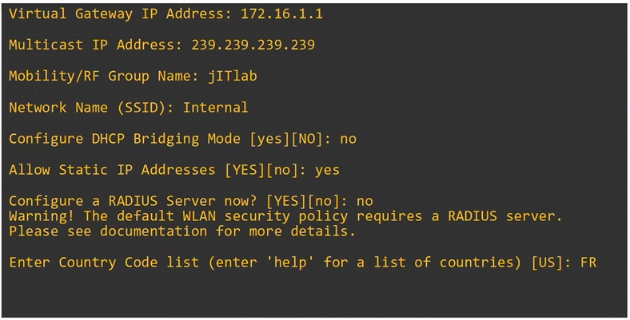
-this is still part of the WLC initial setup
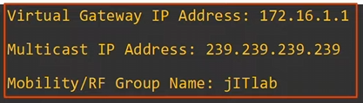
-not important for the CCNA, but good to know
-virtual gateway IP is the IP address used when the WLC is communicating DIRECTLY with wireless clients such as the relaying DHCP request
-multicast IP address is used when forwards traffic to its APs
-want to use an address in the class D range for multicast address (224.x.x.x-239.x.x.x)

-mobility/RF group name is when you have multiple WLC, and you want them to work together
-increase the number of APs in a WLC architecture with more WLCs

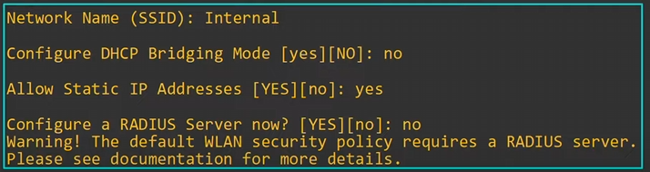
-configuring a wireless LAN
-we will make more in the GUI, but we will configure one in the setup wizard
-making the internal vlan 100 SSID
-for wireless clients DHCP requests to reach the DHCP server, SW1, they must pass through WLC1 first. If DHCP bridging mode is enabled, the WLC becomes totally transparent to the clients
-with DHCP bridging mode on, the WLC will appear as if they are communicating directly to the server
-use no in this example

-choose if you want to use Static IP addresses
-don’t have to use DHCP, can use static IP addresses
-doesn’t affect our DHCP configuration

-can choose a RADIUS server here as well
-we will change the WLAN security policy to PSK (for personal mode), so we don’t want to use a RADIUS server

-IMPORTANT: If you set up a country code on the WLC that is OUTSIDE the realm of the regulatory domain of the AP, the WLC and AP will NOT INTERACT

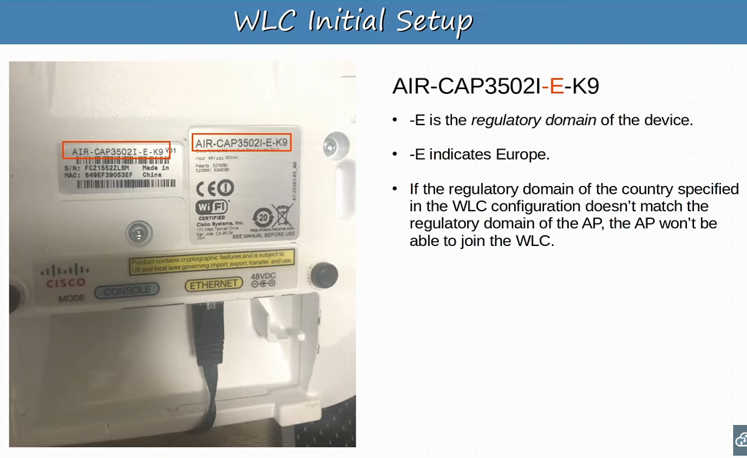
-in Canada or America, A is used instead of E
-need to use a country in Europe for this WLC, since the APs are from Europe as well

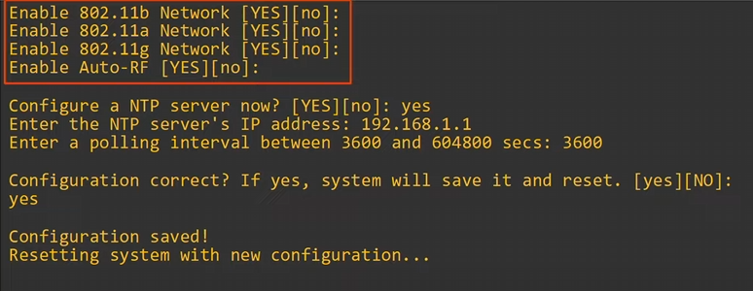
-selecting all the 802.11 standard the WLC can support
-enable Auto-RF allows the WLC to automatically select which channels to use and how much transmit power to use (self-healing wireless coverage)
-good idea to enable this!
Finally want to enable NTP settings so the WLC will have the correct time
-using the multilayer switch as the NTP server
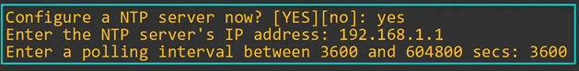

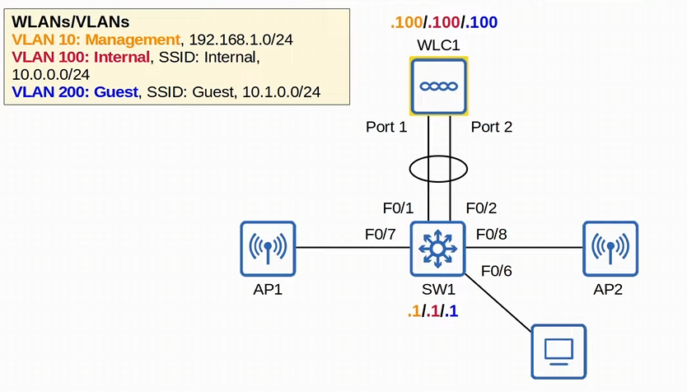
-since the WLC’s initial setup is complete, the WLC has an IP address in the management VLAN
-both the WLC & the Switch are now in the same management VLAN!
-instead of connecting the PC to the WLC’s console port and using the CLI, we can connect the PC to the Switch’s access port we configured to be in the management VLAN!
-management VLAN is vlan 10 in this example
-we will now use the GUI from this access port (F0/6) on the switch to manage the WLC
-GUI will use HTTP or HTTPs in a web browser

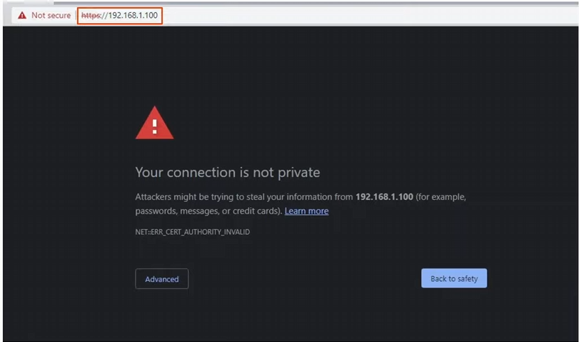
-the PC does not trust the certificate on the WLC
-not really an issue since this is on your private LAN
-hit advanced and go on to use the link!

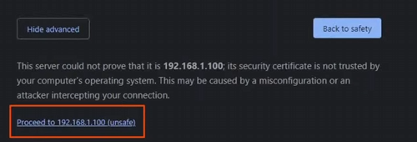

If you get the Net-err_cert_authority_invalid on the internet DO NOT USE THE LINK
-its on your own local network so no issues here

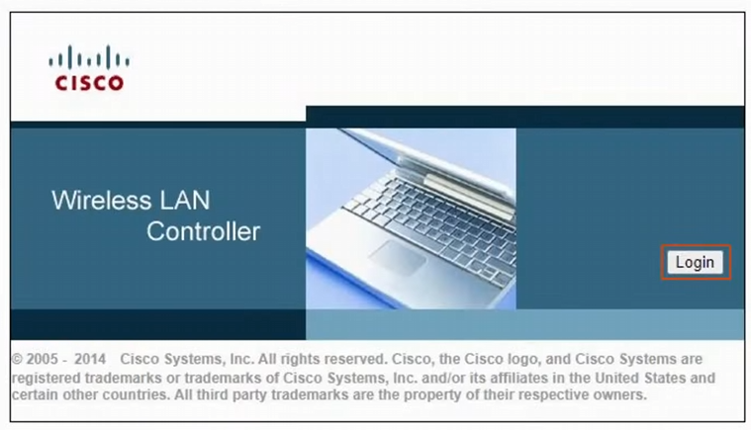
-we will login here
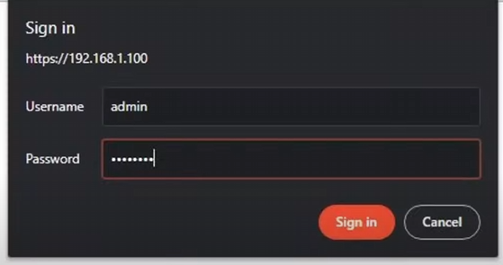
-sign in with the username and password we created in the initial setup of the WLC

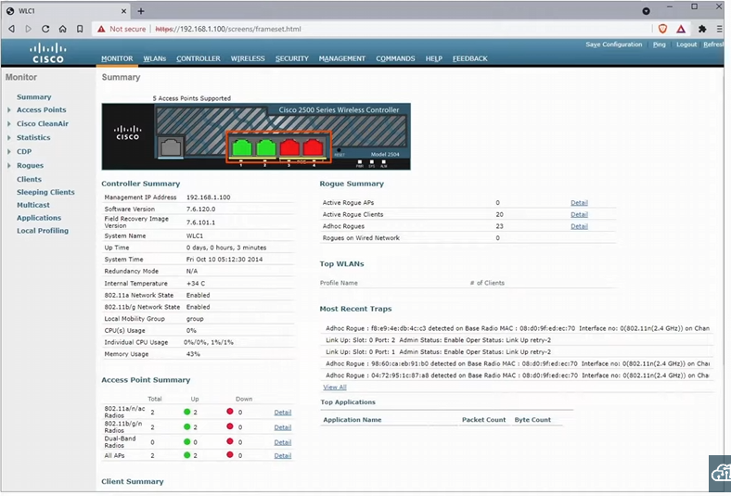
-this is the WLC dashboard
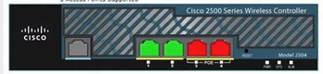
-the interfaces that are green are UP, and the interfaces that are down are red
-the two green interfaces are forming a LAG to the switch we configured!
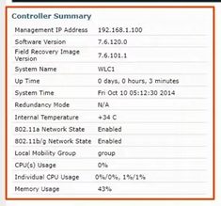 <- shows the management info, and other details about the WLC
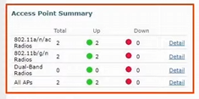
-summary about the APs
-both APs have joined

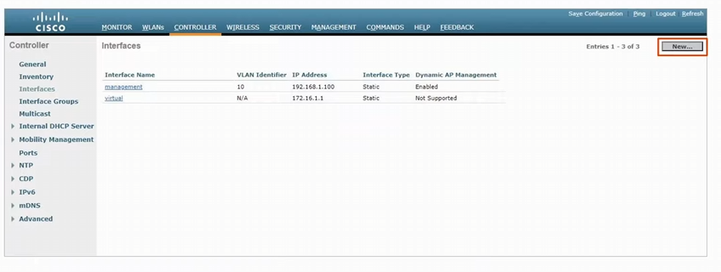
-we go into the controller tab -> interfaces
-these are not physical ports, but logical interfaces in the WLC
-in the context of WLC, port and interfaces are two different things!
-physical: port
-logical: interface (within the device

WLC ports are physical ports that cables connect to
WLC interfaces are the logical interfaces within the WLC
-like SVI’s on a switch of logical

WLC have a few different kinds of Ports:
-Service port: A dedicated management port used for OUT-OF-BAND management
-out-of-band traffic: keeping management traffic totally separate from regular data traffic, and not using the same physical interface
-must connect to a switch access port because it will only support ONE VLAN
-port can be used to connect to the device while it is booting, perform system recovery, etc.

-in our topology the WLC doesn’t have a dedicated service port, so the management traffic will use the same physical port as the regular data traffic

-Distribution system port: standard network ports that connect to the ‘distribution system’ (wired network) and are used for data traffic
-distribution system ports usually connect to switch trunk ports, and if multiple distribution ports are used, we can create a LAG
-we created a LAG in our network topology with distribution system ports

-Console port: a normal console port, either RJ45 or USB (or both)

-Redundancy port: port is used to connect to ANOTHER WLC to form a high availability (HA) pair
-have redundant WLCs, if one WLC fails, the other one can continue to support the network

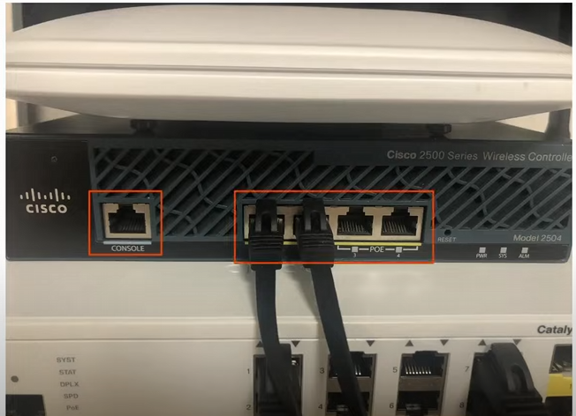
-we are using an old WLC
-one console port
-4 distribution system ports

-we don’t see a redundancy port or a service port on this old WLC

-status LEDs

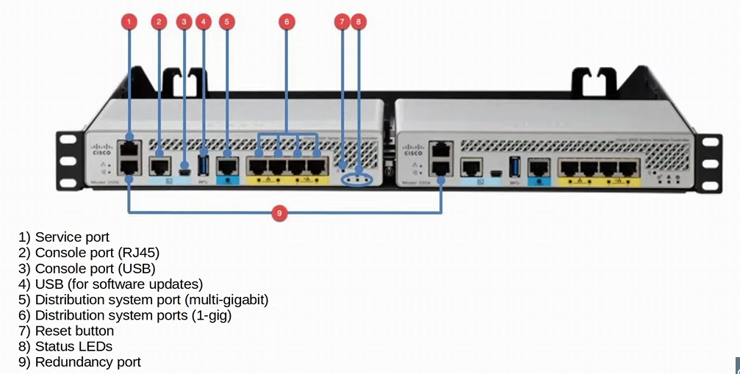
-a modern WLC
-service port will keep the management traffic physically separate from data traffic (connecting to a switch’s access port)
-there is another USB port not used for networking, but for plugging in a USB into for transferring data (like software updates)
-for example, a new OS version to update the software

-distribution system port multi-gigabit port supports beyond 1 gig!

-connect the two WLCs in this picture to each other, and they will forum a redundant pair

WLC have a few different kinds of interfaces:
-remember, interfaces are logical interfaces in terms of a WLC

-Management interface: Used for management traffic such as Telnet SSH, HHTP, HTTPs, Radius authentication, NTP, syslog, etc. CAPWAP tunnels are also formed to/from the WLC’s management interface

-Redundancy Management Interface: When two WLCs are connected by their redundancy ports, one WLC is ‘active’ and the other is ‘standby’. This interface is used to connect and manage the ‘standby’ WLC
-to manage the active WLC you can connect to the management interface
-to manage the standby WLC you can use the redundancy management interface!

-Virtual Interface: this interface is used when communicating with wireless clients to relay DHCP requests, perform client web authentication, etc.
-the virtual gateway IP address in the WLC initial setup
-port used in client web authentication!!

-Service Port Interface: if the service port is used, this interface is bound to it and used for out-of-band management instead of the regular management interface

-Dynamic Interface: These are interfaces used to map a WLAN to a VLAN
-for example, traffic from the ‘internal’ WLAN will be sent to the wired network from the WLC’s ‘internal’ dynamic interface

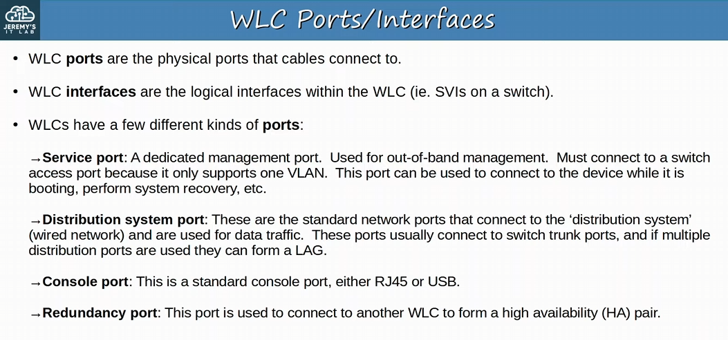
-service port, distribution system port, console port, redundancy port

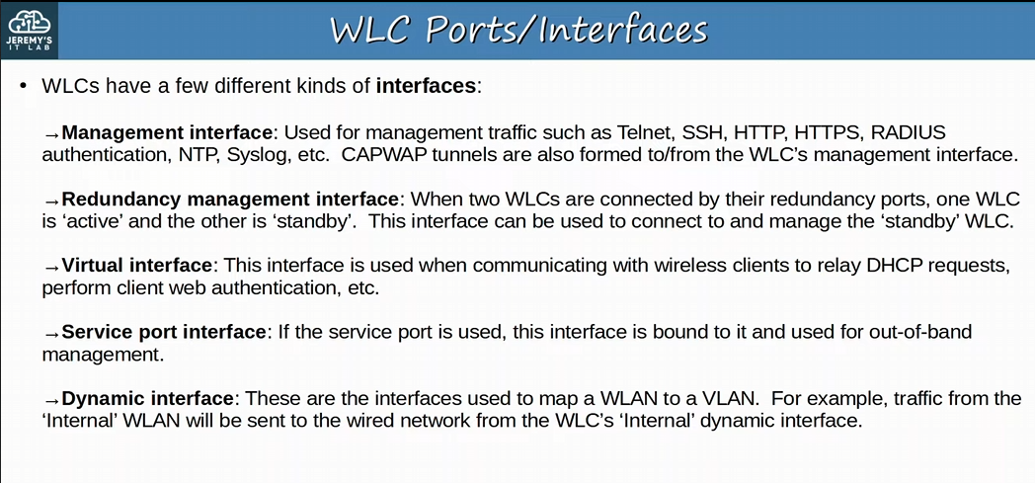
-management interface, redundancy management port, virtual interface, service port interface, dynamic interface

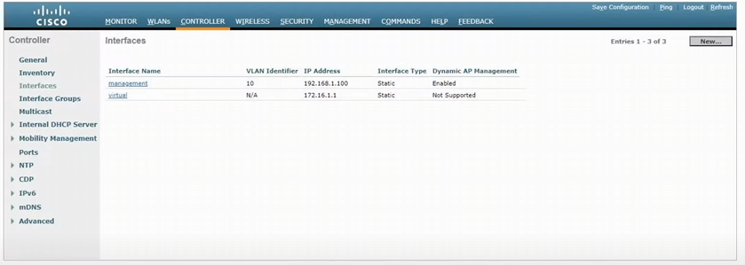
-we will hit new top create a new interface on the WLC

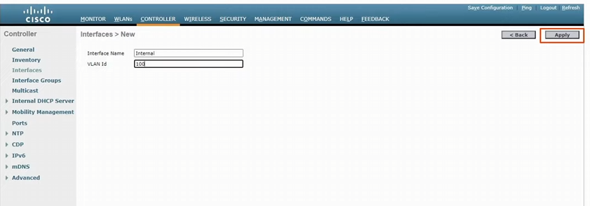
-first, we will create an internal WLAN and mapping it to a VLAN
-then we hit apply

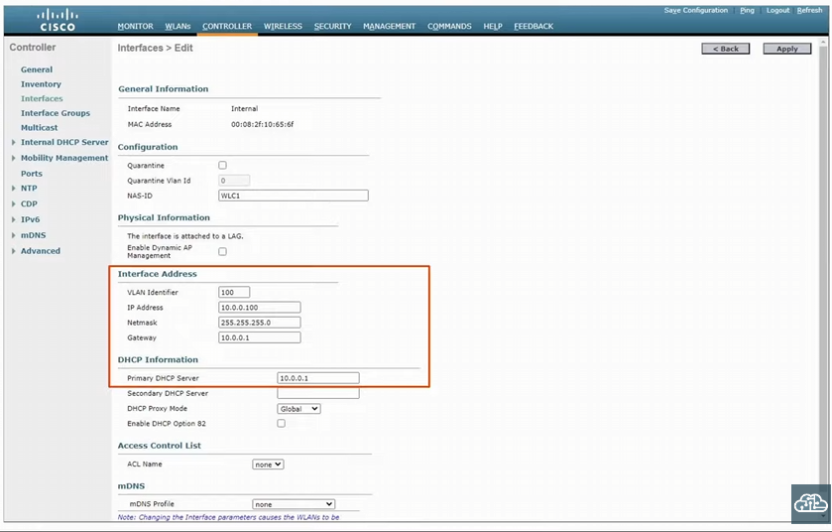
-brings us to this screen on the GUI
-the VLAN is already set at 100
-we will add the IP address, Netmask, default gateway, and DHCP server address

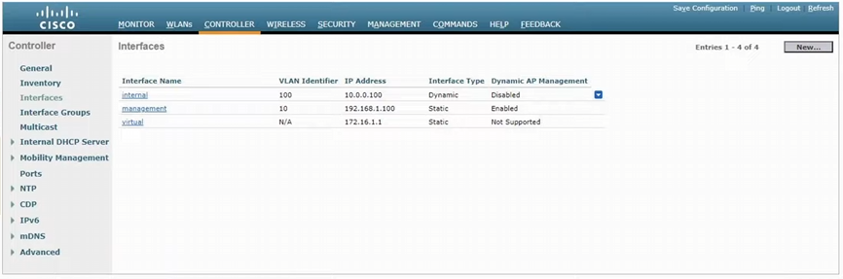
-internal has now been created with our GUI configurations
-we will want to map this interface to the internal WLAN later

-we have one more interface to create, which is the guest interface
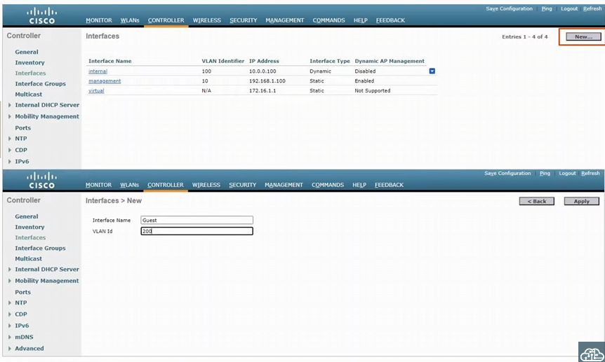
-VLAN 200 is the guest WLAN mapping
-we will hit apply
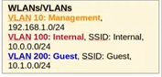

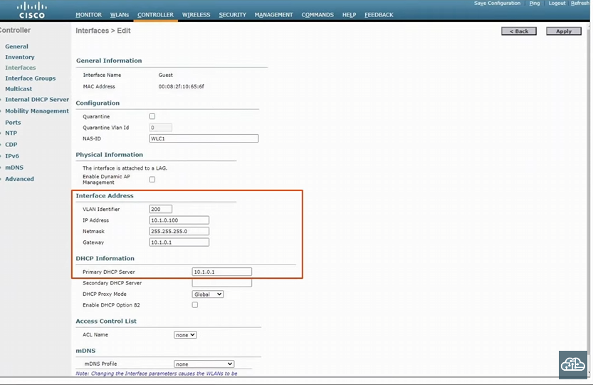
-again, like the internal WLAN, for the guest WLAN we will configure the IP address, Netmask, default gateway and the primary DHCP server
-hit apply

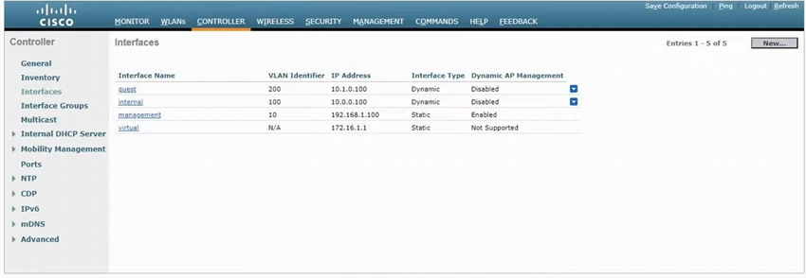
-now the WLC has all the interfaces created, and now we need to create the WLANs
-management, internal & guest
-select the WLAN

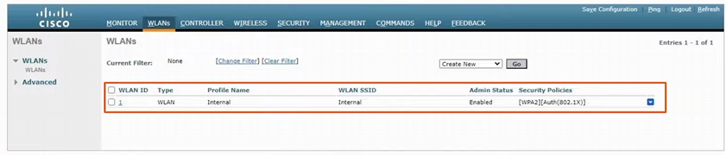
-one WLAN already exists (internal), which is the one we created in the CLI
-we need to edit this WLAN’s security policy into using PSK (for personal mode)

-the security policy is in enterprise mode
-for the CCNA we need to learn how to configure PSK (personal mode)!

-to edit, press on the 1 on the left
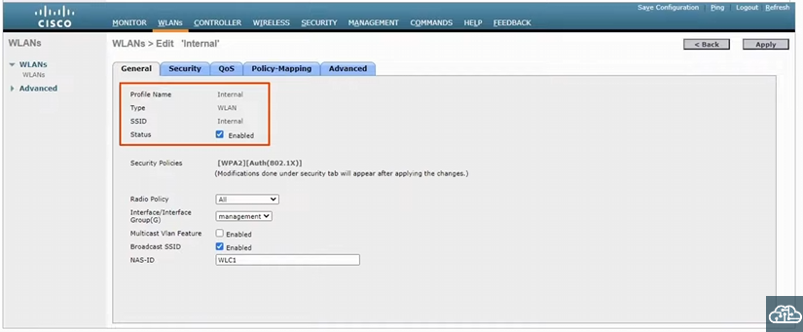
-profile name is internal, the SSID is internal as well, and it’s an enabled WLAN (this looks good)
-we need to change this security policy
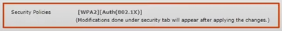
-done in the security tab

-the internal WLAN is mapped to the management interface
-we want the internal VLAN mapped to the internal WLAN, we need to change this!
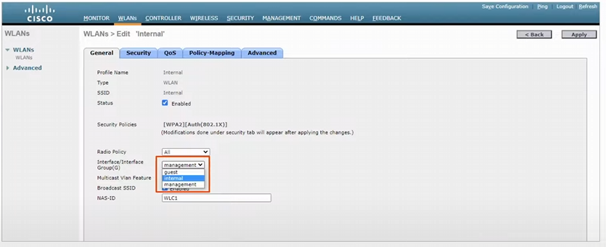
-selected the internal VLAN to map to the internal WLAN
-hit the security tab to change the security policies to PSK instead of 802.1x

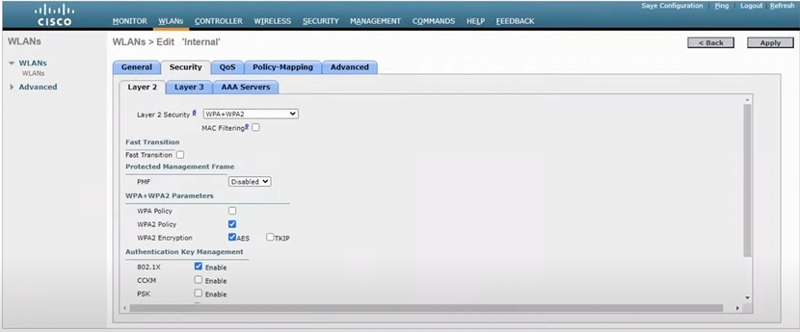
-this is the security tab
-the layer 2 security tab allows us to choose WEP, 802.1x, different versions of WPA, etc.
-WPA + WPA2 is what we will use for the CCNA
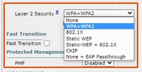

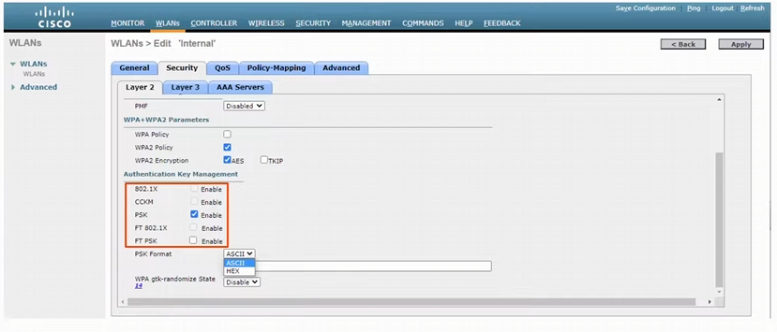
-we will deselect 802.1x and select PSK for personal mode
-PSK can either be in ascii or in hex
-ascii American standard code for information Interchange
-it mean you can enter your password using regular letters, numbers & symbols

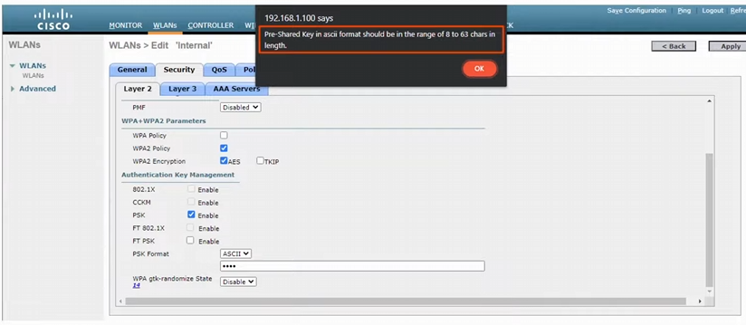
-the range of the PSK ascii password should be a range of 8-63 characters
-any shorter you’ll get an error

-don’t forget to hit apply

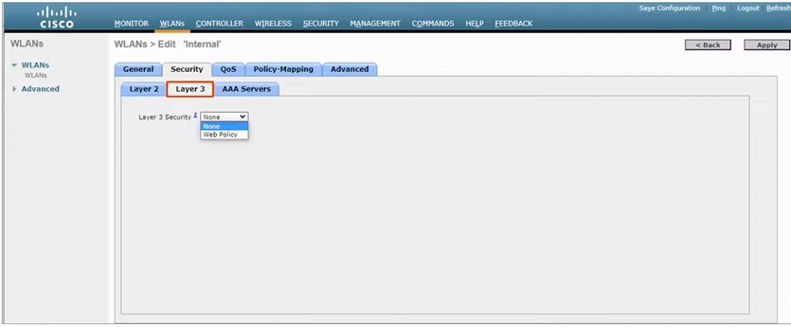
-WLC supports Layer 3 security via a web policy
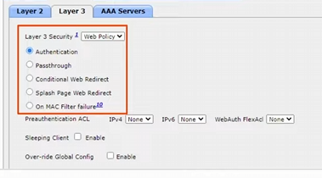
-Web Authentication: after the wireless clients gets an IP address and tries to access a web page, they will have to enter a username and password to authenticate
-Web Passthrough: similar to Web authentication, but no username or password are required. A warning or statement is displayed, and the client simply has to agree to gain internet access
-typically, some TOS of the company

-for either of these examples the Layer 2 authentication can be open!
-common for public Wi-Fi

-the Conditional and Splash Page web redirect options are similar, but additionally require 802.1x layer 2 authentication
-we won’t configure any layer 3 policy, so select none
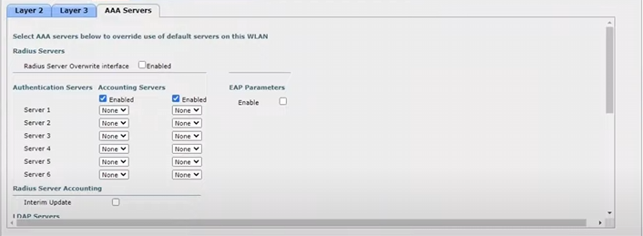
-AAA server tab, but since we are using PSK authentication only, we don’t need an authentication server

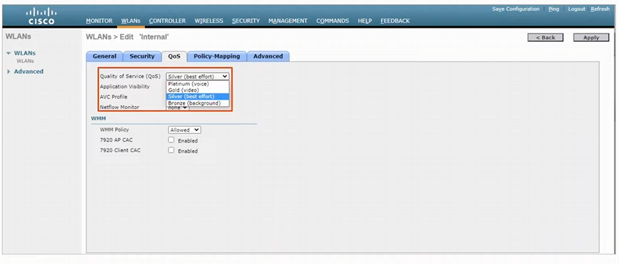
-QoS tab has best effort, by default

-there are four tiers of QoS in a WLC (IMPORTANT!)
1) bronze: background (lowest)
2) silver: best effort (default)
3) gold: video
4) platinum: voice (for Wi-Fi IP phone vlans!)

-quality of service given to the clients
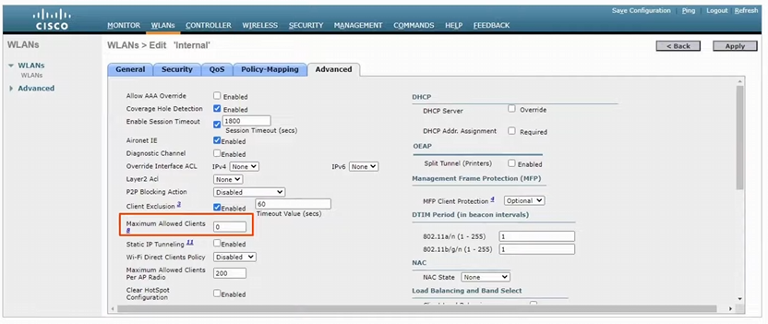
-we can select the maximum amount of client allowed
-0 means there is no maximum! (Default)
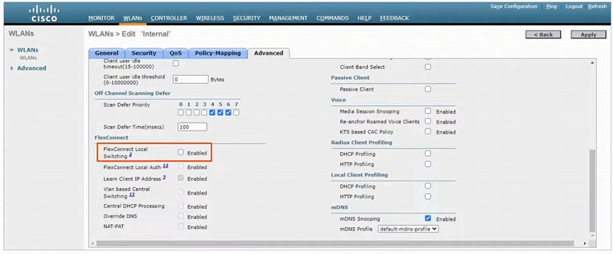
-you can add FlexConnect over here
-don’t need it here

-hit apply

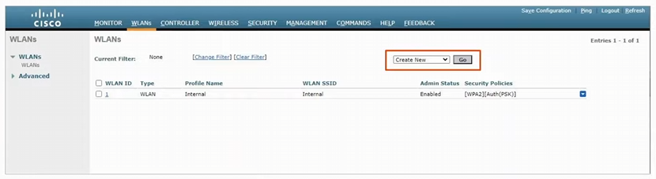
-we will create a new WLAN

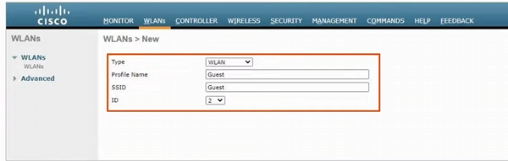
-since we are creating a new WLAN, we need to specify the profile name, the SSID & ID we want to create
-usually just use the same name for the profile name and the SSID
-profile name and SSID don’t have to be the same though

-ID is the unique number identifying the WLAN
-we have internal as 1, so will create this as 2

-hit apply to continue

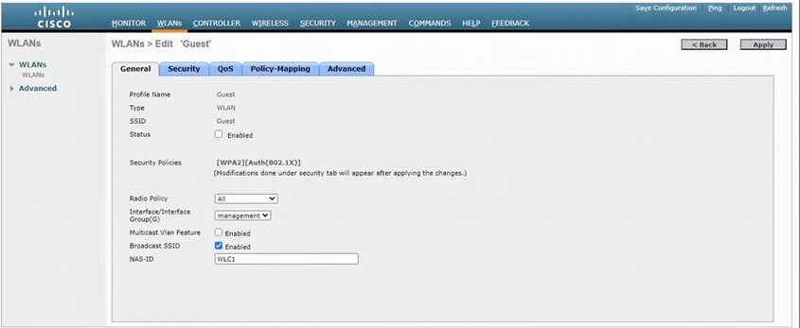
-need to change the status to enable, and the interface
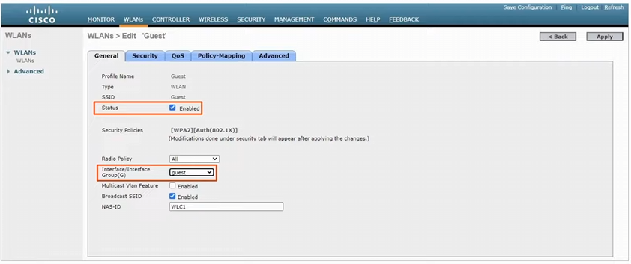
-hit apply, and now we need to change the security policy to PSK
-we already did it before, use the same steps of deselecting 802.1x -> hit PSK, select ascii and finally add a password

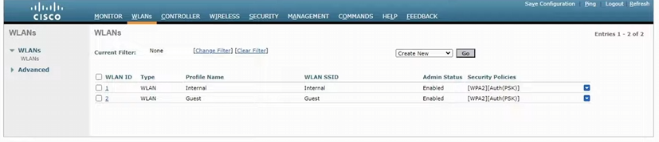
-we now have two WLANs
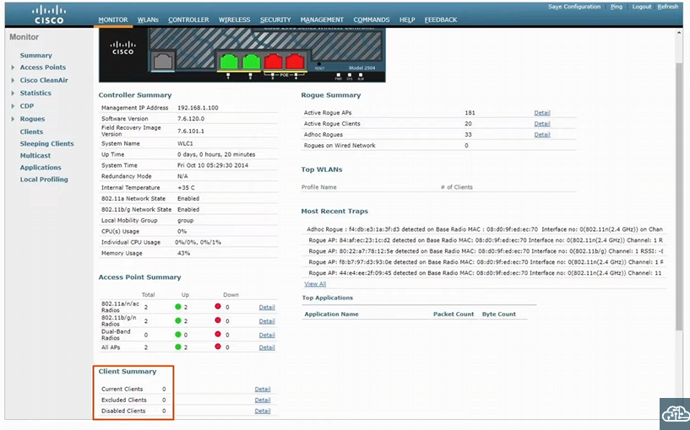
-go to the monitor tab, and look at the client summary
-0 clients connected, so we will connect a Phone to one of the WLANs

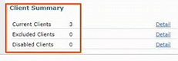
-3 clients have joined with the APs

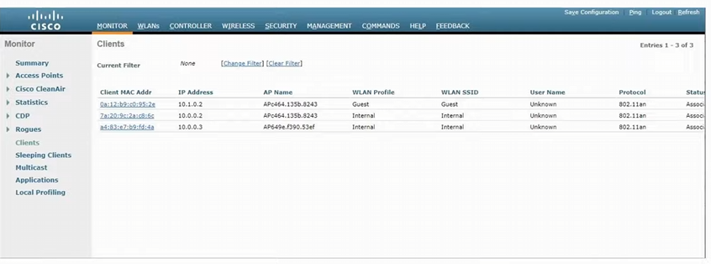
-we hit clients on the sidebar to see all the client information

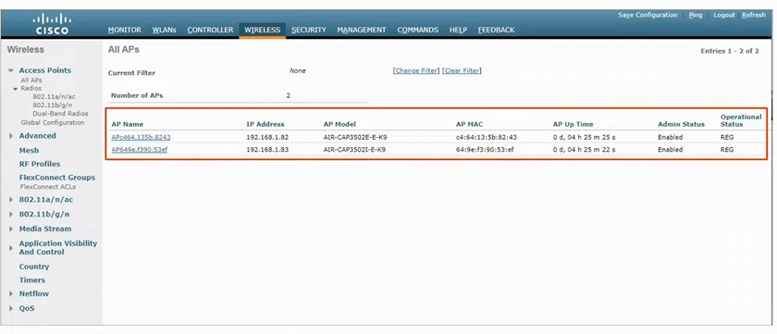
-wireless tab shows a list of APs
-to check the AP setting, click on one of the APs in the list

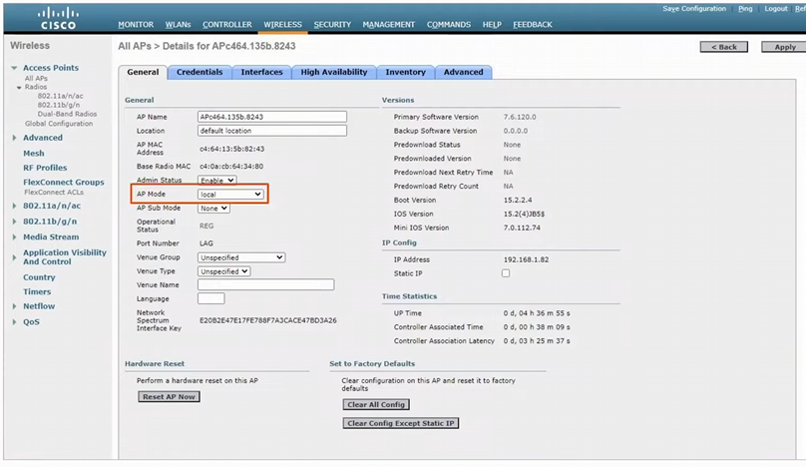
-this is default AP mode as local!
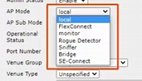
-can choose other AP operational modes

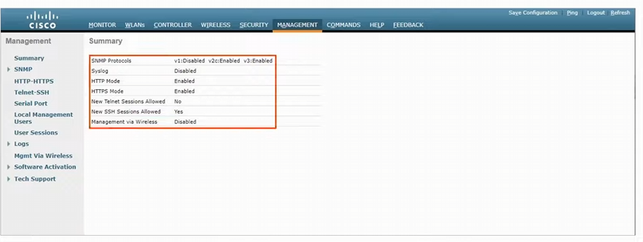
-management tab shows the summary of the SNMP protocols, syslog, http mode, https mode, telnet, SSH, and management being done VIA wireless
-a wireless client cannot connect to the WLC and manage it
-only a device connected to the wired network can (f0/6 on the switch)

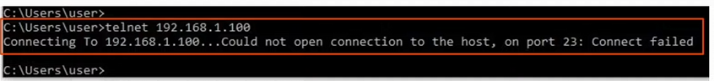
-tried to TELNET but it failed

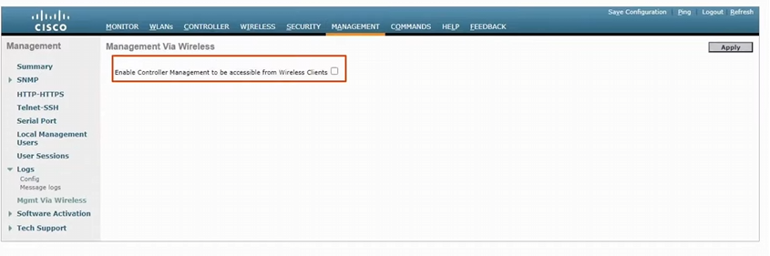
-we can allow wireless management by hitting this side tab
-check this box here and hit apply to allow wireless clients to manage the WLC!
-hit apply

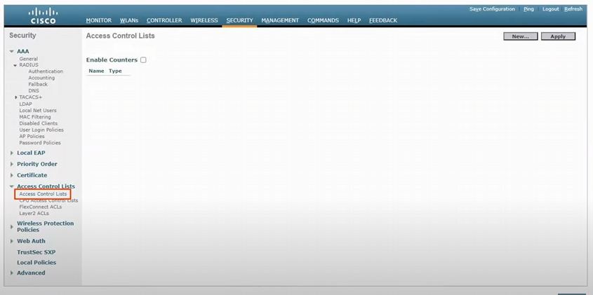
-hit the security tab, and click on the access control list on the side tab
-we are going to configure an ACL to limit the management traffic allowed to access the WLC

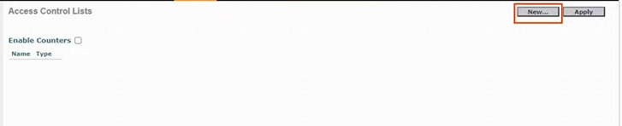
-no ACLs on the list at the moment so hit new
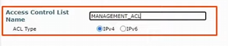
-we name the ACL, and leave the default IPv4
-we hit apply to move forward
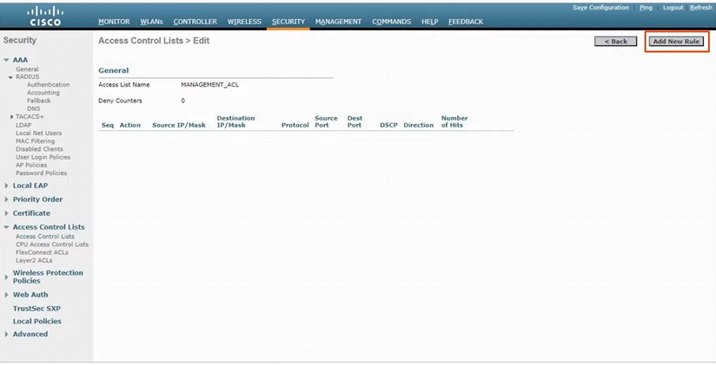
-the ACL in the WLC has a name but no rules
-need to hit the add new rule

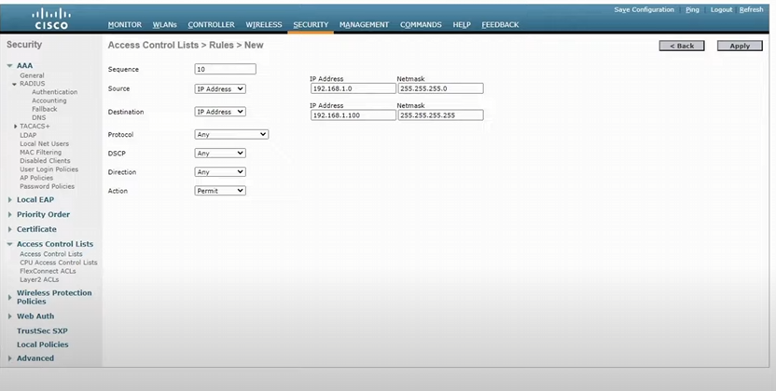
-we specify the sequence number, select the source and destination IP, select any protocol, any DSCP, any direct, and finally the action of permit
-hit apply to make the rule

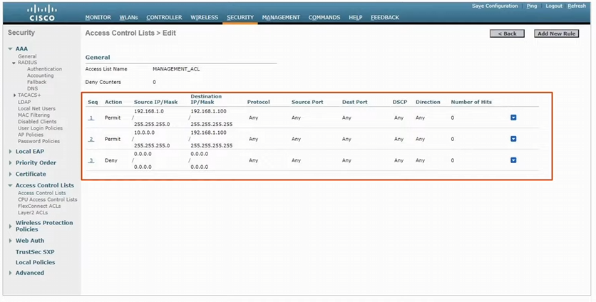
-we created two more rules in the ACL on top of the first one we configured

-after the ACL is made, we need to apply the ACL so that it limits access to manage the WLC

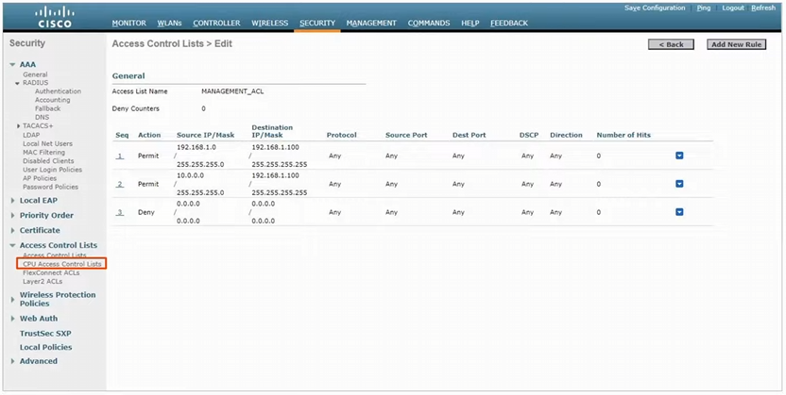
-to apply we need to click on the side tab, CPU access control lists

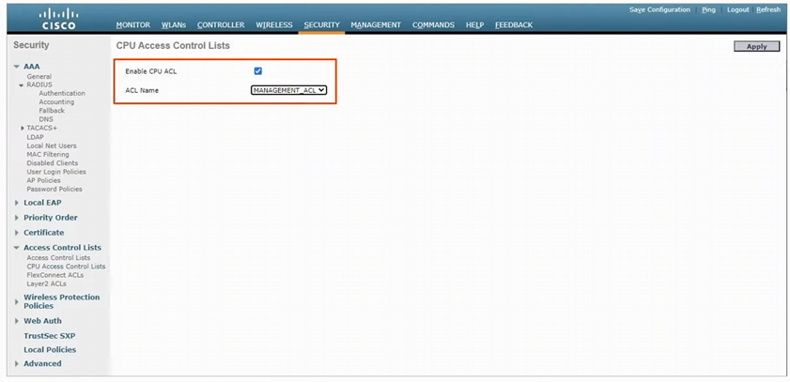
-hit enable CPU ACL here and select the ACL
-finally hit apply, to apply the ACL

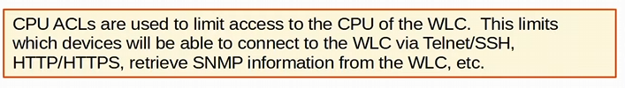
-WLC CPU ACLs limits which devices are able to connect to the WLC, retrieve information, etc.
-DOESN’T AFFECT traffic passing through the WLC, just traffic destinated FOR the WLC
-IMPORTANT

Day 59:
Looking at network automation
-don’t need to automate anything for CCNA

Network automation is used so you don’t have to configure a bunch of devices one at a time
-connecting to the CLI via SSH one at a time is tedious
-don’t want to configure the same thing on all devices one at a time
-typos and other small mistakes are common
-time consuming and very inefficient in large-scale networks
-it is difficult to ensure that all devices adhere to the organization’s standard configurations
-troubleshooting becomes more difficult as more network engineers change the configuration away from the standard configuration

Network automation provides many key benefits:
-human error (typos etc.) is reduced
-a network engineer won’t need to directly log into the CLI
-networks become more scalable
-changes and troubleshooting can be implemented in a fraction of the time
-network-wide policy compliance can be assured (standard configurations, software versions, etc.)
-the improved efficiency of network operations reduces the Opex (operating expenses) of the network
-fewer man hours
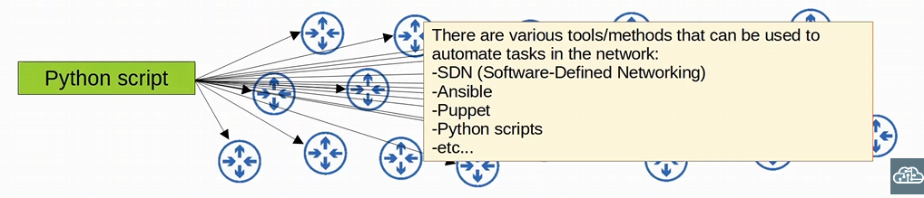
-using a python script to make the configuration
SDN: Software Define Networking

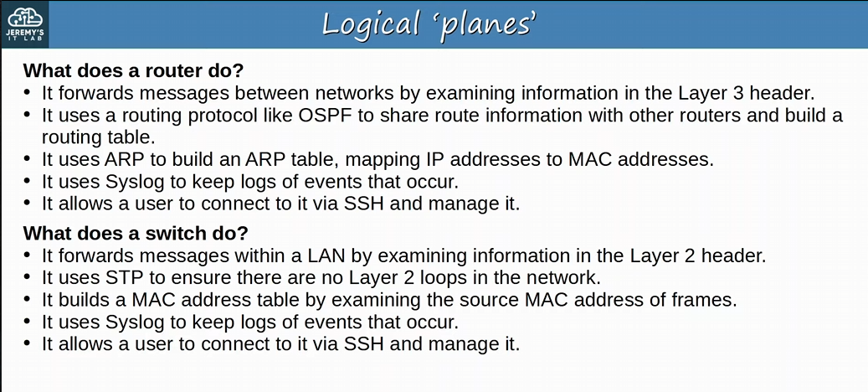
-Routers and switches do various things, not just routing messages or switching
-these various functions of network devices can be logically divided up (categorized) into Planes

Logical ‘Planes’:
-Data Plane
-Control Plane
-Management Plane

Logical ‘Planes’:
-Data Plane: all tasks involved in FORWARDING user data/traffic from one interface to another
-for example, a router receives a message, looks for the most specific matching route in its routing table and forwards if out of the appropriate interface for the next hop or destination (if directly connected)
-also, de-encapsulates the original Layer 2 header, and re-encapsulates with a new header destined for the next hop’s MAC address
-switch receives a message, looks at the destination MAC address, and forwards it out of the appropriate interface (or floods it)
-includes functions like adding or removing 802.1q VLAN tags
-NAT (changing the src/dst address before forwarding) is part of the data plane
-part of the process of forwarding the message
-deciding to forward or discard message due to ACLs, port security, etc. is part of the data plane

-Also called the Forwarding Plane (it forwards messages)
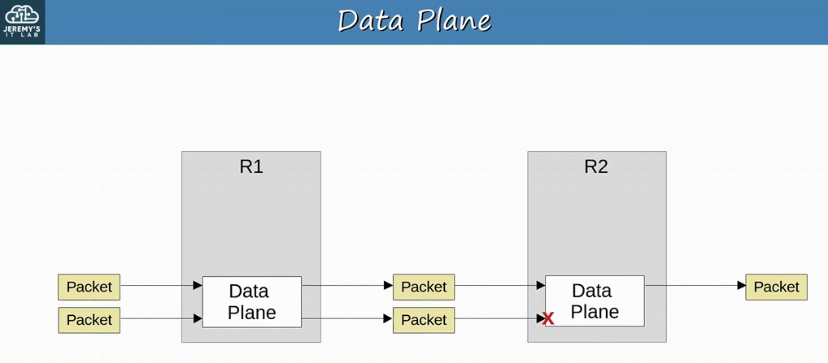
-R1 receives the packet, and the data plane processes the packet (encap and de-encap) to forward it out of another interface to R2
-R2 decides to discard a packet from R1 (again data plane choice)
-perhaps an ACL configuration

-Control Plane: CONTROLS what the data plane does (for example, by building the router’s routing table)
-influences the data plane
-how the device makes its forwarding decisions
-the control plane performs Overhead work
-routing table, MAC address table, ARP table, STP, etc. (all Control plane) to make forward decisions for the data plane to work

-OSPF itself doesn’t forward user data packets, but it informs the data plane about HOW packets should be forwarded
-STP itself isn’t directly involved in the process of forwarding frames, but it informs the data plane about which interfaces should and should be used to forward frames
-ARP messages aren’t user data, but they are used to build an ARP table which is used in the process of forwarding data

-these protocols aren’t directly involved in forwarding data, but informs the data plane HOW to forward the data
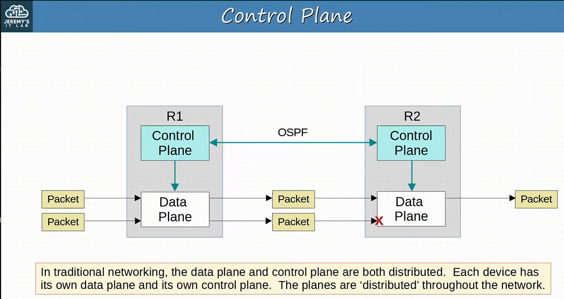
-routing tables from OSPF (management plane) control the actions of the data plane
-there isn’t one centralized control plane, controlling the data plane (it is distributed throughout the network) (Different than SDN networking)
-Management Plane: Management plane performs overhead work (like the control plane) but doesn’t directly affect the forwarding of messages in the data plane
-control plane does DIRECTLY affect the forwarding of messages, Management plane DOESN’T

-consist of protocols that are USED to manage devices:
-SSH/telnet: used to connect to the CLI of a device to configure/manage it
-Syslog: used to keep logs of events that occur on the device
-SNMP: used to monitor the operations of the device
-NTP: used to maintain accurate time on the device

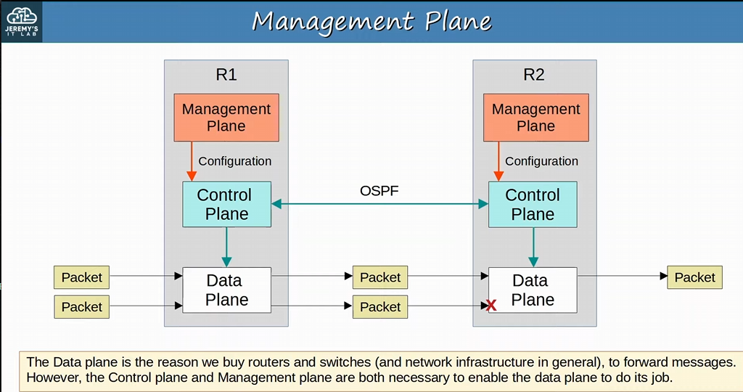
-for example, we SSH on the management plane, to configure something on the control plane (like OSPF), which is inevitably affect the data plane’s data forwarding (routing packets via OSPF neighbor relations)
-in order to allow the data plane to do its job, we need the control plane and the management plane

The operations of the Management plane and Control plane are usually managed by the CPU of the device
-Not desirable for Data plane operations because CPU processing is very slow (relatively speaking

Data plane uses an ASIC chip (Application-Specific Integrated Circuit)
-build to specific purposes, such as forwarding frames in a switch

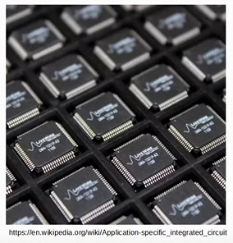
-using a switch as an example
-when a frame is received, the ASIC (NOT THE CPU) is responsible for the switching logic
-ASIC is specialized chip made to forward frames
-MAC address table is stored in a kind of memory called TCAM (Ternary Content-Addressable Memory)
-TCAM allows for very fast lookups of MAC addresses
-IMPORTANT!
-another common name for the MAC addresses table is CAM table (Content-Addressable Memory)
-ASIC feeds the destination MAC address of the frame into the TCAM, which returns the matching MAC address table entry!!!
-Frame is forwarded out of the appropriate interface
Modern Routers also use a similar hardware data plane: an ASIC designed for forwarding logic, and tables stored in TCAM

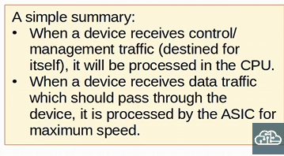

Software-Defined Networking (SDN) is an approach to networking the centralizes the CONTROL plane into an application called a controller
-already familiar with this concept from learning about Wireless LAN controllers. When using a WLC, many functions are removed from the APs and centralized in the controller, so the AP roles is primarily forwarding traffic
-SDN is also called Software-Defined architecture (SDA) or Controller-Based Networking

-Traditional control planes use a Distributed Architecture
-for example, each router in the network runs OSPF and the routers share routing information and then calculate their preferred routes to each destination

-An SDN controller centralizes control plane functions like calculating routes
-this is an example, and how much of the control plane is centralized varies greatly

-many different SDN solutions available, and the role of the controller and the network device VARIES in each solution
-the controller can interact programmatically with the network devices using APIs (Application Program Interface)

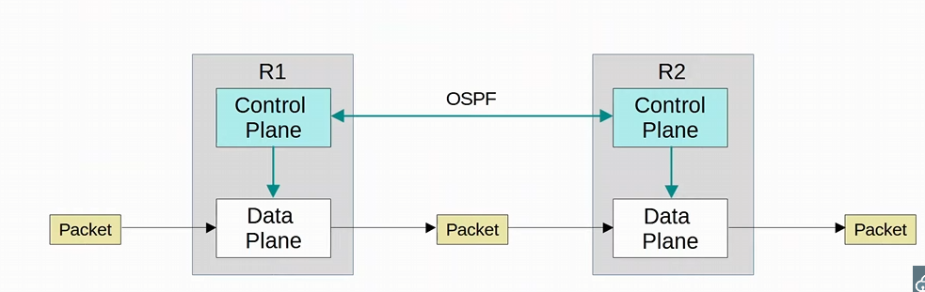
-Traditional architecture (without the management plane, we are leaving it out)
-just focusing on the functions of the control plane
-the control plane is distributed (each router has its own control plane)

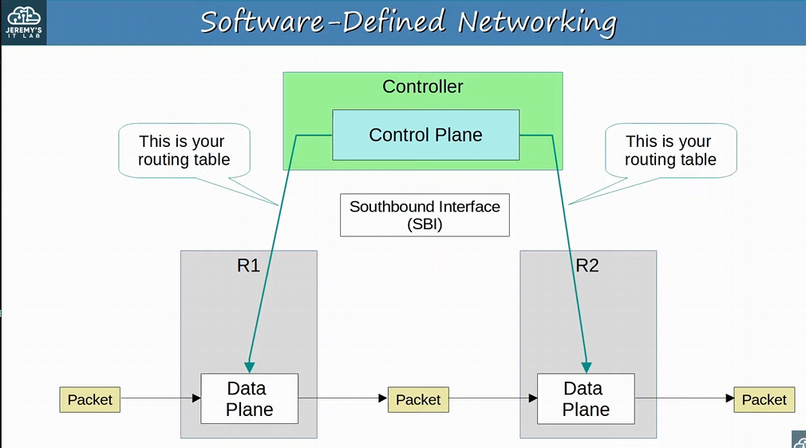
-the controller will centralize the control plane
-instead of R1 and R2 using OSPF to exchange routing information and then calculate routes, the controller communicates with R1 and R2 to program their data planes
-the control plane is centralized and no longer distributed (like the traditional model)
-this example is only 2 routers, but you can have 100s of routers with a centralized control plane
-the communication BETWEEN the devices and the controller is done via the SBI (Southbound Interface)
-called southbound because in diagrams we usually draw the controllers on TOP and the networking devices on the bottom (the south)
-does not refer to any physical interface on a device, but rather a software interface that is used to allow the controller and network device to communicate

-even though this diagram shows a totally centralized control plane, in reality there are many solutions
-some centralize the entire control plane
-some centralize some functions of the control plane

SBIs (Southbound Interfaces): are used for communication between the controller and the network devices it controls
-its BETWEEN the control plane of the controller and the DATA plane of the network device
-typically consists of a Communication Protocol & API (Application Programming Interface)!!

-APIs facilitate data exchange between programs
-the controller is a program, and the network devices are programs too running within their hardware
-data is exchanged between the controller and the network devices for SBIs
-APIs have a big role in automating network tasks in general
-an API on the network devices allows the controller to access information on the devices, control their data plane tables, etc.

-some examples of SBIs: OpenFlow, Cisco OpFlex, Cisco onePK (Open Network Environment Platform Kit), NETCONF
-remember these Southbound Interfaces used by the controller to communicate with the devices it controls

Using the SBI, the controller communicates with the managed devices and GATHERS information about them:
-the devices in the network
-the topology (how the devices are connected together)
-the available interfaces on each device
-their configuration

Northbound Interfaces (NBI) : allows us to interact with the controller, access the data if gathers about the network, program it, and make changes in the network via the SBI
-for example, we can tell the controller to make a change and it will make the change via the SBI

-A Rest API is used on the controller as an interface for apps to interact with it
-REST = Representational State Transfer
-REST API isn’t a specific API but a TYPE of API

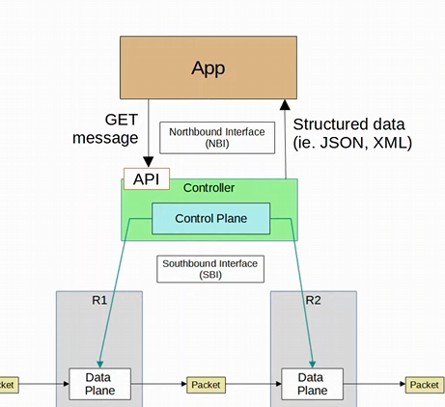
-the interface on the controller isn’t a physical interface, but a software one
-its code that facilitates communication between the controller and the apps
-App sends a GET message to the API
-request for data
-the controller will reply with the requested data in a structured format like JSON or XML
-data is sent in a structured (Serialized) format such as JSON or XML
-structured data makes it easier for programs to use the data
Networking tasks can be automated in traditional network architecture too:
-scripts can be written (using python) to push commands to many devices at once
-Python with good use of Regular Expressions can parse though show commands to gather information about the network devices
-regular expressions: searching for patterns in text
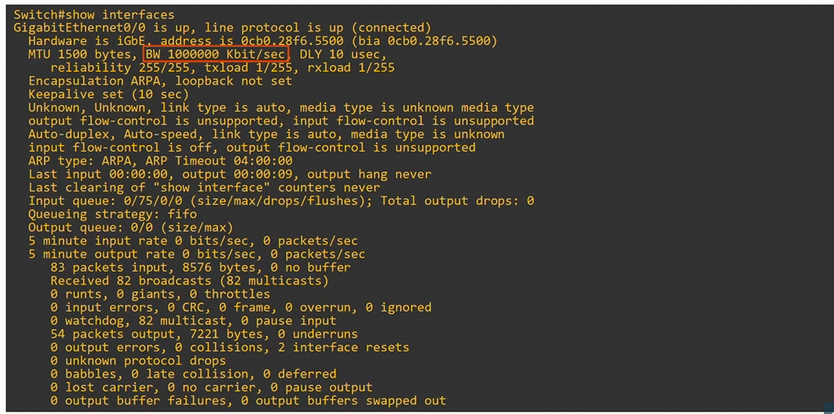
-for example, we can write a python script to SSH to the device, use the show interface command, then parse through the output with regular expressions to find the information you want for a traditional network

HOWEVER, the robust and centralized data collected by SDN controllers greatly facilitates these functions
-the controllers collect information about all devices in the network (providing a network wide view)
-northbound APIs allow apps to access information in a format that is easy for programs to understand (like JSON & XML)
-no need to write scripts to parse through specific SHOW commands to get the information
-the centralized data facilitates network-wide analytics (rather than parsing every individual device, and having to corelate the data yourself)

SDN tools can provide the benefits of automation without the requirement of third-party scripts & apps
-you don’t need expertise in automation to make use of SDN tools
-many of the SDN tools are easy to use
-However, APIs allow third-party applications to interact with the controller, which can be VERY powerful

Although SDN and automation aren’t the same thing, the SDN architecture greatly facilitates the automation of various task in the network VIA the SDN controller and APIs
-IMPORTANT!

SBI will facilitate data exchange between the controller and network devices
NBI would be facilitating data exchange between the controller and apps

Day 60:
Looking at JSON, XML & YAML
-data serialization languages/formats, we can format or structure data in a standardized way so it can be communicated between applications
-CCNA wants us to focus on JSON
-JSON (JavaScript Object Notation)

Data Serialization: process of converting data into a STANDARDIZED format/structure that can be stored (for example, in a file) or transmitted (for example, over a network) and reconstructed later (i.e. By a different application)
-this allows the data to be communicated between applications in a way both applications understand

Data serialization languages allows us to represent variable within text
-like JSON
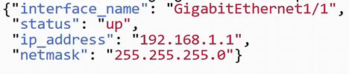
-these are variables
-these are values

-this is a JSON object ( with the { } )

Variables are containers that store values
-“interface _name” = container (or variable)
-“GigabitEthernet1/1” = value

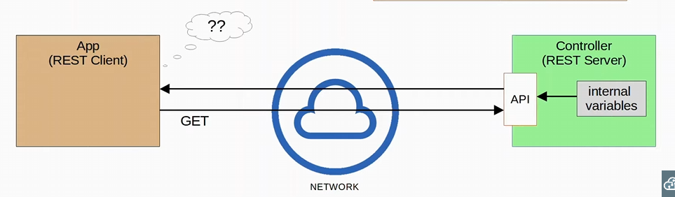
-The App and the Controller are written in different languages, and store data differently
-this is a problem that data serialization fixes by standardizing data
-the controller needs to transmit the data in a standardized way (like JSON)
-APP has 0 clue what it got and is confused after receiving the data

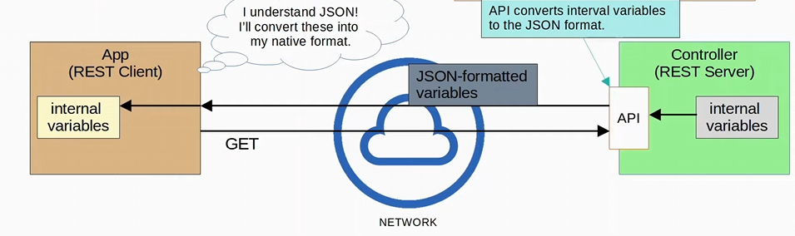
-the App and Controller are still written in a different language, but before the controller sends the data requested from the GET message, it will convert the internal variables into a JSON format
-the App can read the JSON data and convert it into the native format for the App!

JSON (JavaScript Object Notation) is an open standard file format and data interchange format that uses human-readable text to store and transmit data objects
-store data as files (file format) OR send data over a network (data interchange format)
-it’s both machine-readable and human-readable
-Standardized in RFC 8259
-derived from JavaScript, but it is language-independent and many modern programming languages are able to generate and read JSON data
REST APIs often use JSON

Whitespace is insignificant in JSON
-spaces and line breaks DO NOT MATTER in JSON
-doesn’t change the meaning of the data

JSON has four ‘primitive’ data types:
-Strings
-Numbers
-Booleans
-Null

JSON also has two ‘structured’ data types
-Objects
-Array

String
-primitive data type
-text value surrounds by double quotes “ ”
- “Ye”

Number
-primitive data type
-a numeric value, not surrounded by quotes
-6

-IF ITS SURROUNDED BY QUOTES IT’S A STRING NOT A NUMBER

Boolean
-primitive data type
-Two possible values, not surrounded by quotes
-true
-false

-has to be in lowercase!!!

-again, if it’s surrounded by quotes it’s a string not a Boolean value

Null
-primitive data type
-represents the intentional absence of any object value. Not surrounded by quotes
-null

-has to be lowercase!

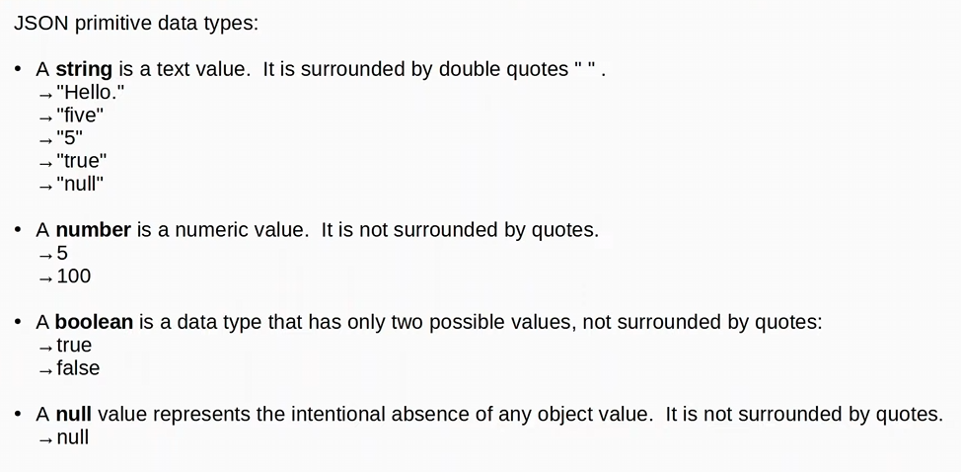
-“true” “false” “6” & “null” are all strings! They are using “ ” !
Object
-structured data type
-object is an unordered list of key-value pairs (aka variables)
-unorder means the order of the variables do NOT matter
-Key is a string (name of the variable, the container)
-must use “ ”
-Value is ANY valid JSON data type (string, number, Boolean, null, object, array)

-Key and value are separated by a colon :
-“interface_name” : “FastEthernet1/1”

-if there are multiple key-value pairs, each pair is separated by a comma

-Objects are surrounded by { } curly brackets!

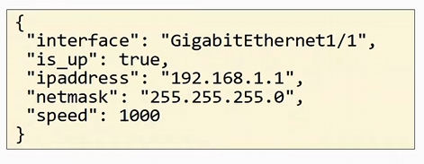
-this is a JSON object
-has the { }

-the 5 Key-value pairs are separated by commas in this example
-this is one key-value pair
-we have multiple key value pairs in an object

-the Key IS A STRING denoted by the “ ” !!!
-“interface” in this example

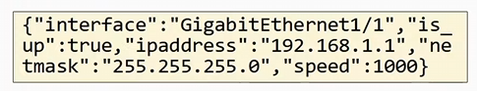
-this is the same JSON object
-again, in JSON, whitespace (spaces etc.) is insignificant

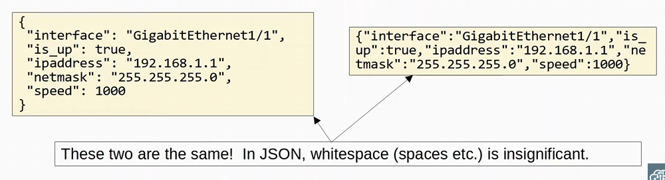

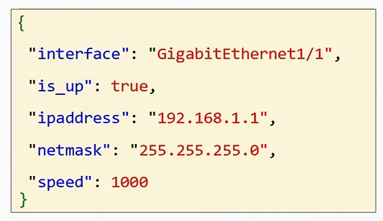
-keys are blue, Values are red
- : separates a key and the value, key : value

-value is a string, since it has “ ”

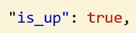
Value is a Boolean
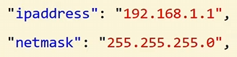
-value is a string, since it has “ ”

-value is a number

Again, KEYS in the key-value pair of an object are ALWAYS strings
-Key Value pairs are separated with a ,

Again Objects = {}

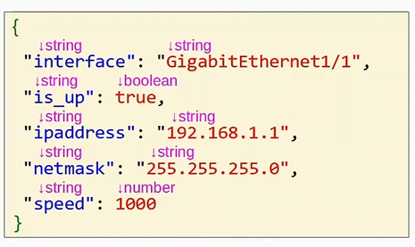

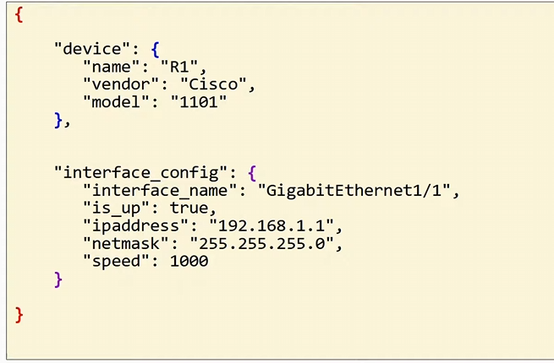
-there are nested objects, object within and object

-“device” is a key, and the value is an object
-there are other key value pairs within the object as well!

-“interface_config” is a key, and the value is another object

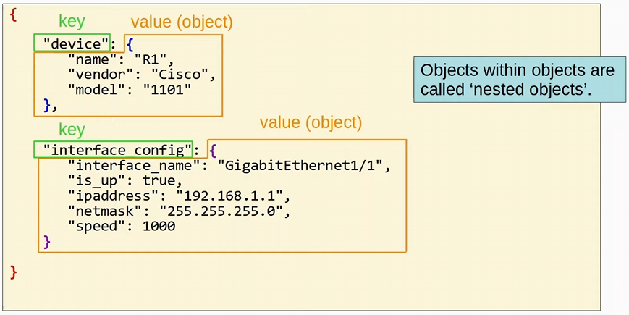
-applications themselves don’t need whitespace

Array is a series of values separated by commas
-Not a series of key-value pairs! That’s an object
-values don’t have to be the same data type
-for example, one could be a string, and another a number
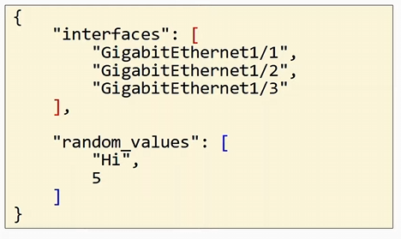
-one JSON object, with two key-value pairs
-the value in the key-value pair is an array, denoted with [ ]
Arrays will have commas between values, and it can be ANY data type within the array!

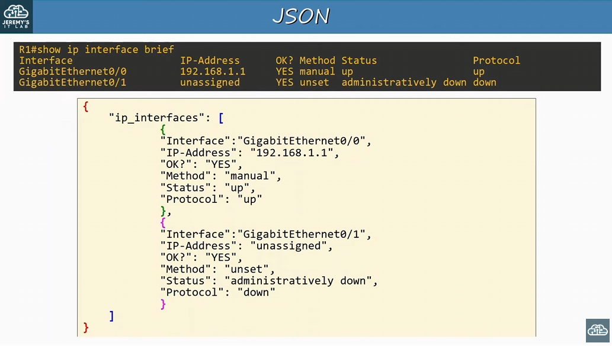
-the JSON info Jeremy wrote himself

-there is an object with the key-value pair of “ip interfaces” : [array]
-the array contains 2 different objects within it, which are separated by a comma
-the 2 objects have multiple key-value pairs!
-the values contain strings!

-JSON is in a format that computers can understand

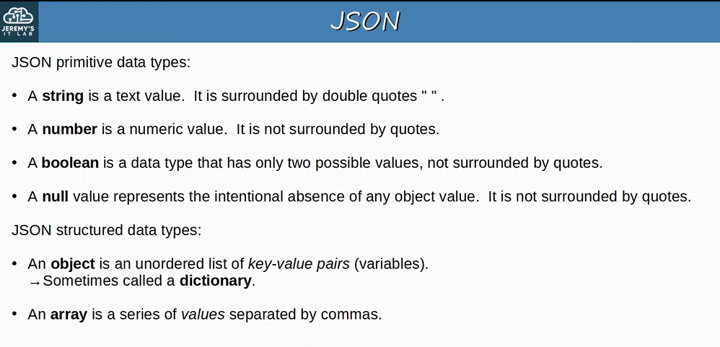
-string, number boolean & null are all primitive data types
-boolean and null values are written lowercased
-object and array are structure data types

-Objects can sometimes be called a Dictionary

XML (Extensible Markup Language) was developed as a markup language, but is now used as a general data serialization language
-markup languages (like HTML) are used to format text (font, size, color, headings, etc.)
-is generally less human-readable than JSON
-Whitespace is insignificant (like JSON)
-XML is often used by REST APIs (same as JSON)
- <Key>value<key>
-this is how the key value pair is shown

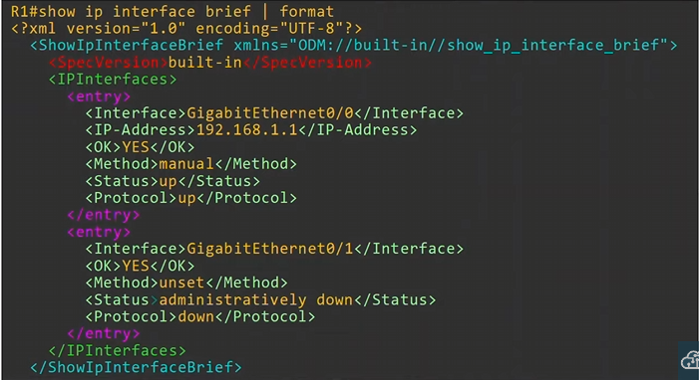
-adding “| format” in a show command will pull out data in XML format
-color isn’t included in the show command, Jeremy added it in
-the value is in the middle of the keys in the key-value pair
- <key> value </key>

YAML (Yet Another Markup Language), but to distinguish its purpose as a data-serialization language rather than a markup language, it was repurposed to YAML Ain’t Markup Language
-Used by the network automation tool Ansible!
-has other uses too, but we will look at only network automation
-very human-readable
-Whitespace IS SIGNIFICANT! (Unlike JSON and XML)
-indentation is VERY important since it is using whitespace
-YAML files start with --- (three hyphens)
- one hyphen – is used to indicate a list
-keys and values are represented as key: value
-more rules to YAML but we don’t need to go too in-depth
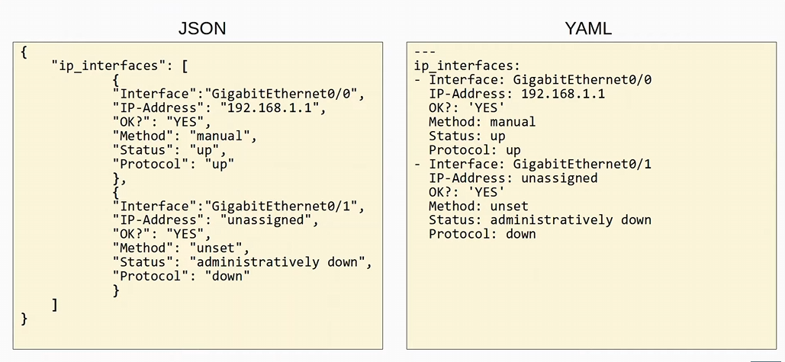
-both are used in applications to communicate data

All you really need to know about YAML is that whitespace is significant, and it’s used in ansible

Day 61:
Rest APIs
-commonly used for the Northbound interface in an SDN architecture

APIs are used to allow programs to exchange information with each other
-important for network automation because they allow our programs to easily interact with network devices and controllers
-Application Programming Interface, is software that allows two applications to communicate with each other
-APIs are essential not just network automation, but for all kinds of applications
-if you want other applications to access data from your application, you should design an API that allows them to access it
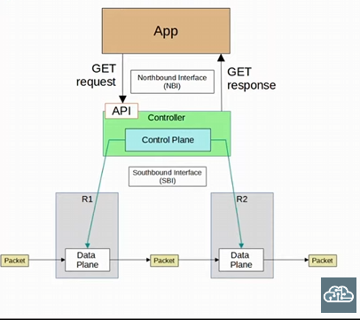
-IN SDN (Software design network) architecture, APIs are used to communicate between apps and the SDN controller (via the NBI), and between the SDN control and the network devices (via the SBI)
-NBI typically uses a REST API
-some other examples of APIs that can be used to configure network devices via the southbound interface are NETCONF and RESTCONF
CRUD: Different actions we perform when using rest APIs
-Create: create variable
-Read: used to retrieve the value of a variable
-Update: Change the value of a variable
-Delete: Delete the variables

-we will be using HTTP

HTTP uses verbs (or Methods) that map to these CRUD operations
-CRUD operations match the actions we typically want to perform with an application
-when an HTTP client send a request to an HTTP server, it includes a verb indicating what the client wants to do
-for example, if the client is trying to access a web page on a server, it will use the GET verb to retrieve that web page, to get it, from the server

-REST APIs typically use HTTP

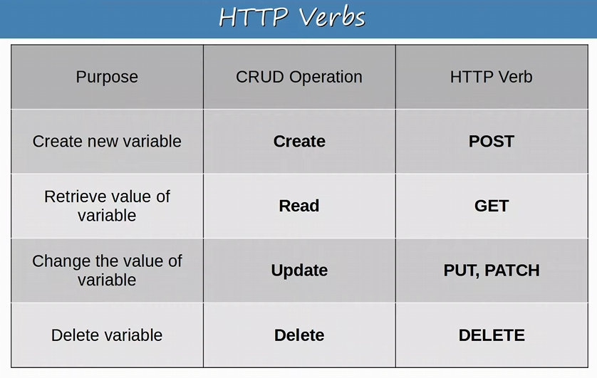
-DO NOT mix Post with Put & Patch
-you will delete the variable with a new variable, instead of updating it
-IMPORTANT

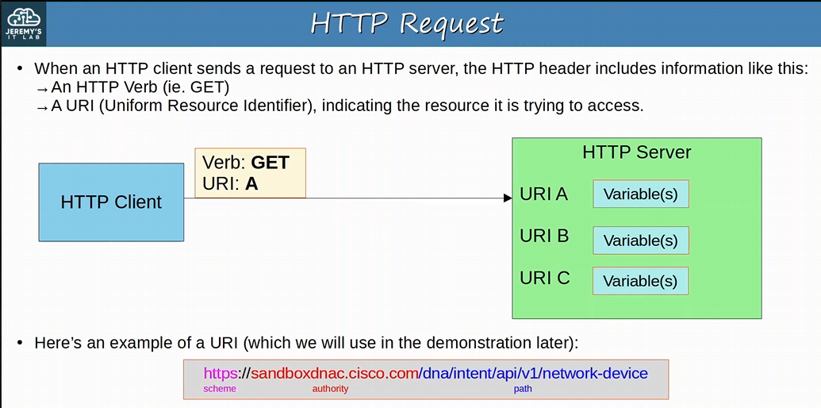
-HTTP client or a rest client using HTTP sends a request to a server, it’ll include formation such as:
-a HTTP Verb & a URI (Uniform Resource Identifier)

-the data on the HTTP server is the variables
-we send an HTTP GET verb with the resource of URI A

-three main sections of a URI: Scheme (protocol) , Authority (address/hostname) & Path (resource you want to access)
-Scheme is HTTPS
-Authority is the HTTP server address
-Path is where in the server’s files will we find the information

HTTP verb and URI are just some parts of the HTTP request
-there are more parts, like additional headers which pass additional information to the server

-HTTP request
-on the outside is an IP header and TCP Header
-an example would be the Accept Header, which informs the server about the types of data that can be sent back to the client
-client might only accept JSON data or only accept XML data

When a REST client makes an API call (request) to a rest server, it will send an HTTP request like this
-REST APIs don’t have to use HTTP for communication, HOWEVER HTTP is the most COMMON choice
-keep in mind HTTP is a specific communication protocol, and REST is a framework for building APIs (they aren’t the same thing and aren’t always used together!)

After an HTTP request, the server will send an HTTP response:
-response would include a status code indicating if the request succeeded or failed, as well as other details

HTTP Response Status Code:
-First digit: Class of the response
-1xx informational: the server request was received, continue process
-2xx successful: the request was successfully received, understood, and accepted
-3xx redirection: further action needs to be taken in order to complete the request
-for example, if the URI of the resource has been changed, this response tells the client to request the new URI
-4xx client error: the request contains bad syntax or cannot be fulfilled
-such as requesting for a resource that doesn’t exist
-5xx server error: the server failed to fulfill an apparently valid request
-for example, perhaps the server doesn’t support the HTTP version of the request

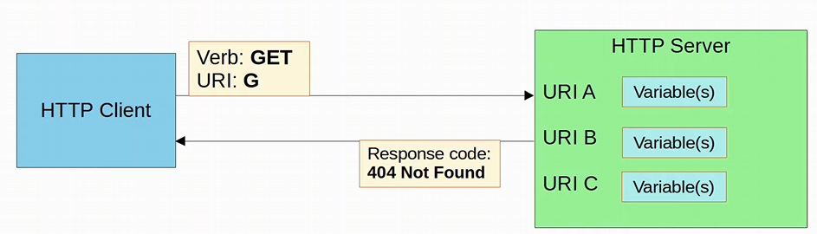
-URI G doesn’t exist on the HTTP server, so the server sends a response of 404 Not Found

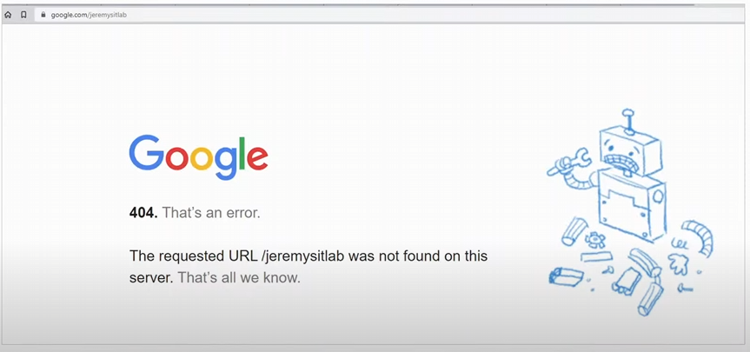
-the classic 404 error
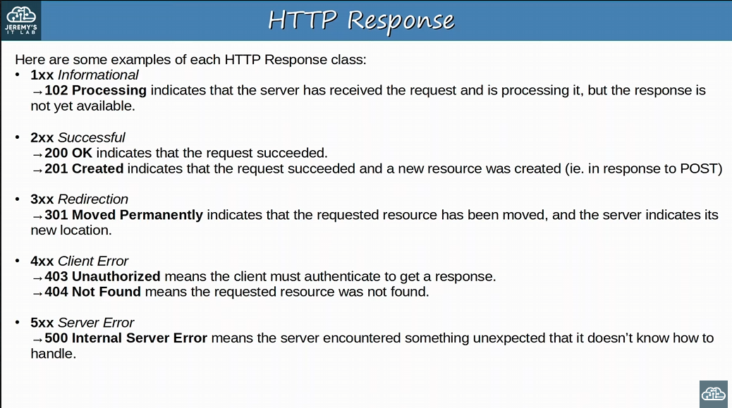
-some examples of the HTTP Response class
-send from the server to the client as a response
-201 is a response to the POST HTTP request

-1: Informational, 2: Successful, 3: Redirect, 4: Client Error & 5 Server Error

REST APIs (Representation State Transfer)
-also known as REST-based APIs or RESTful APIs
-IS NOT a specific API, but a set of rules about HOW the API should work
-REST APIs is a framework for APIs

Six constraints of a RESTful architecture are:
-Uniform Interface
-Client-server
-Stateless
-Cacheable or non-cacheable function
-Layered system
-Code-On-Demand (optional)

-we will look at only the important ones: Client-server, stateless, Cacheable or Non-cacheable function

Rest APIS use a Client-server architecture
-client uses API calls (like HTTP request) to access the resources on the server
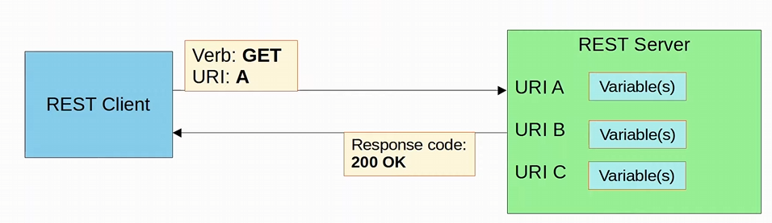
-the separations between the client and server means they can both change and evolve independently of each other
-when the client application changes or the server application change, the interface between them must not break!
-should continue to function

-client-server architecture is used in various areas of networking!

REST APIs exchanges are Stateless
-each API exchange is a SEPERATE event, INDEPENDENT of all past exchanges between the client and server

-the server does not store information about previous requests from the client to determine how it should respond to new requests
-each new request is a separate event

-If authentication is required, this means that the client must authenticate with the server for EACH request it makes
-since every request is independent from each other

TCP is an example of a Stateful Protocol
-establishes connections with the 3-way handshake -> sends data -> then terminates connection with the 4-way handshake
-the current exchanges of TCP data are DEPENDENT on the 3-way handshake being first established
-the SEQ and ACK numbers to keep track of exchanges between hosts

UDP is an example of a Stateless Protocol
-no connection is set up
-no forward acknowledgement, or sequence number

ALTHOUGH REST APIs use HTTP, which uses TCP (stateful) as its Layer 4 protocol, HTTP and REST APIs themselves aren’t stateful
-each OSI model’s layer’s stateless/stateful function are separate!
-Application is stateless (layer 7), and transport TCP is stateful (layer 4), must think of them as separate things
-just because a stateful layer 4 protocol is used, doesn’t mean the application layer must be stateful!!!
Rest API’s Cacheable or Non-Cacheable requirement
-REST APIs must support caching of data
-Caching: storing data for future use
-computer might cache many elements of a webpage so that it doesn’t have to retrieve the entire page every time you visit it
-improves performance for the client and reduces the load on the server

-Caching must be supported, but that doesn’t mean EVERY resource needs to be cacheable
-Cacheable resources MUST be declared as cacheable!!!

For applications to communicate over a network, networking protocols must be used to facilitate those communications!
-for REST APIs, HTTP(s) is the most common choice
-HTTPs, the encrypted version, is used most often

For the CCNA, remember the CRUD actions, HTTPS client request verbs, HTTP server response codes, and the basic characteristics of REST APIs

We will look at simple rest API calls using cisco devnet

Cisco DevNet: a cisco developer program to help developers and IT professionals who want to write applications and develop integrations with Cisco products, platforms, and APIs
-devnet offers lots of free resources such as courses, tutorials, labs, sandboxes, documentation, etc. to learn about automation and develop your skills
-we will use the Cisco DNA centre sandbox to send a REST API call using Postman
-Cisco DNA centre: Digital Network Automation

-DNA centre is one of Cisco’s SDN controllers!!
-Postman is a platform for building and using APIs

Follow Jeremy’s instructions in the video to use postman

URL: Unified Resource Locator
URL is a type of URI (Unified Resource Identifier)

We had to authorize our Post request to the sandboxdna.cisco.com URL, specifying the exact path
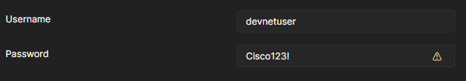

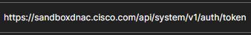
-Scheme, Authority, & Path

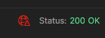
-getting a 200 Ok HTTPs code!

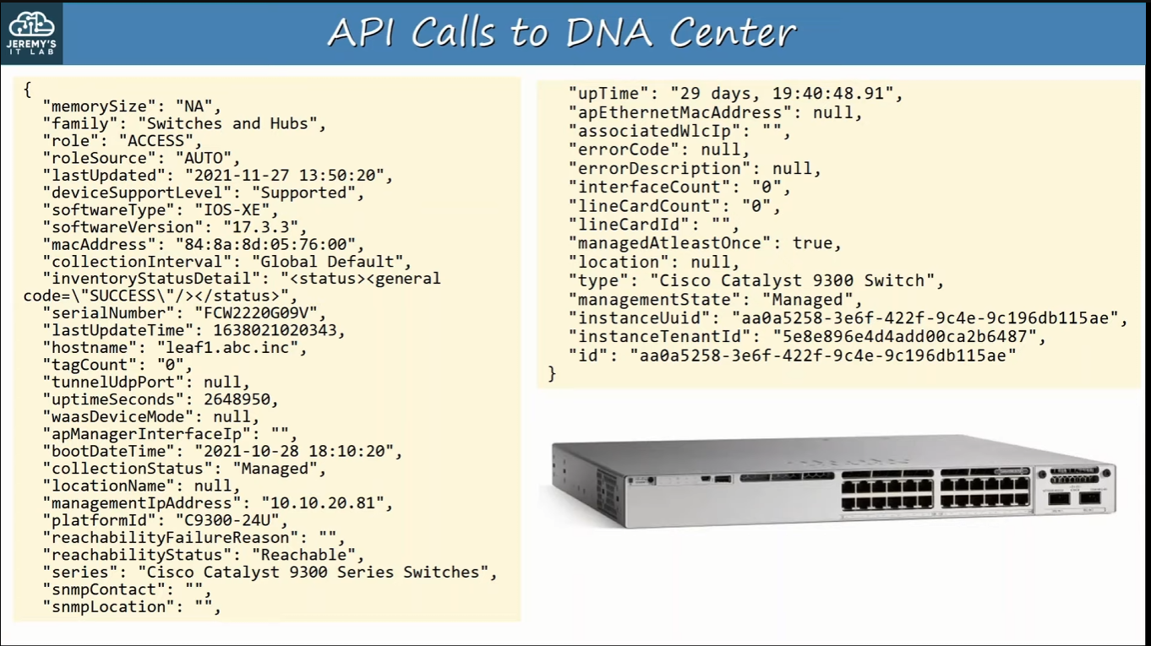
-we retrieved data in a machine-readable format (JSON)
-we can write applications to gather information like this and interact with it

REST APIs encode data in either JSON or XML format!

And SDN controller uses two different sets of APIs: one to communicate with applications and another set to communicate with devices
-SDN uses an Application Plane via the NBI
-SDN uses the data plane via the SBI

Day 62:
SDN: Software Define Networking
-an approach to networking that centralizes the control plane into an application called a Controller

Traditional control planes use a distributed architecture
-every network device has its own control plane
-control planes of each device use things like OSPF to communicate with each other

An SDN controller centralizes control plane functions like calculating routes
-for example, the controller would calculate the routes for each device and send that information to them, no longer needing OSPF

-depending on the controller, the entire control plane might be centralized by the SDN controller or perhaps only a part of the control plane is centralized
-the controller can interact programmatically with the network devices using APIs
-SBI is used for communications between the controller and the network devices it controls

-the NBI allows us to interact with the controller with out scripts and applications

SDN architecture: Application Layer, Control Layer, Infrastructure Layer
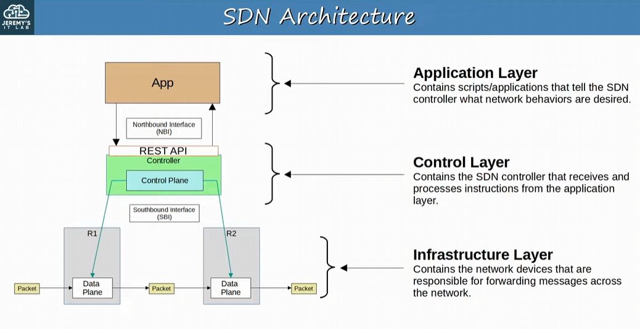
-the application layer is NOT the same application layer of the OSI model
-contains script/applications that tell the SDN controller what network behaviors are desired

-control layer contains the SDN controller that receives and processes instructions from the application layer
-different concept than the Control PLANE, however this layer contains the centralized control plane on the network

-Infrastructure layer contains the network devices that are responsible for forwarding messages across the network

Cisco SD-Access is Cisco’s SDN solution for automating campus LANs
-for example, office wired and wireless LANs

ACI (Application Centric Infrastructure) is the Cisco SDN solution for automating data centre networks
-Spine-Leaf topology use ACI

SD-WAN is Cisco’s solution for automating WANs

Cisco’s DNA (Digital Network Architecture) Center is the controller at the centre of SD-access

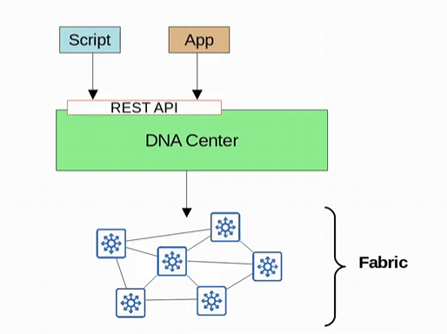
-Application Layer has the scripts and apps we develop, cisco tools, or 3rd party tools
-DNA centre itself has a GUI we can control
-the control plane is the DNA centre
-the Fabric is the network devices in our Campus LAN

Fabric:
-Underlay is the underlying physical network of devices and connections (including wired and wireless) which provide IP connectivity (for example using a routing protocol like IS-IS)
-basically, is the multilayer switches and their connections

-Overlay is the virtual network built on top of the physical underlay network
-for example, SD-Access uses VXLAN (Virtual Extensible LAN) to build tunnels

-The Fabric is the combination of the overlay and underlay -> the physical and virtual networks as a whole
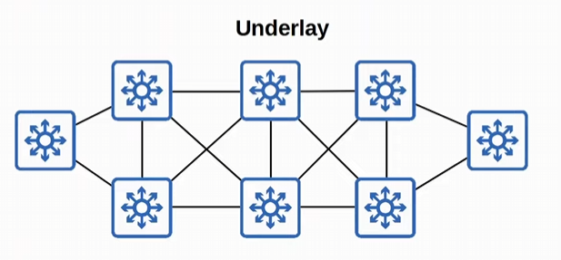
-Underlay is the physical networks

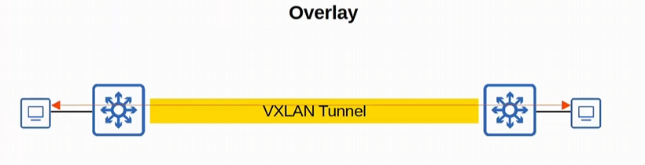
-Overlay is the virtual network (like tunnels)

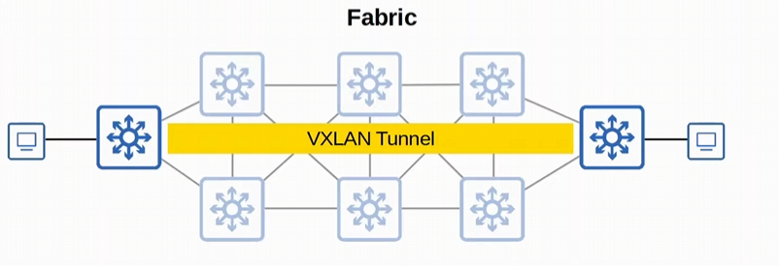
-Fabric is the underlay & overlay

SD-Access Underlay
-the underlay’s purpose is to support the VXLAN tunnels of the overlay
-top make a virtual network of tunnels, the devices first need to be connected and able to reach each other!

-three different roles for switches in SD-Access:
-Edge Node: connect to end hosts (basically access layer switches)
-Border nodes: connect to devices outside of the SD-Access domain (like WAN routers)
-Control nodes: Use LISP (Locator ID Separation Protocol) to perform various control plane functions

-You can add SD-Access on top of an existing network (Brownfield deployment) if your network hardware and software supports it
-in this case DNA centre won’t configure the underlay!

SD-Access Underlay
-A NEW deployment (Greenfield Deployment) will be configured by DNA centre to use the optimal SD-Access underlay
-a totally new network built for the purpose of SD access
-DNA centre will configure the devices for the optimal SD-Access underlay
-for example, all switches are Layer 3 and use IS-IS as their routing protocol
-all link between switches are ROUTED PORTS (no STP required)
-Edge Nodes (Access Switches) acts as the default gateway of endhosts (routed access layer)
-brought layer three all the way down to the access switches that end hosts connect to

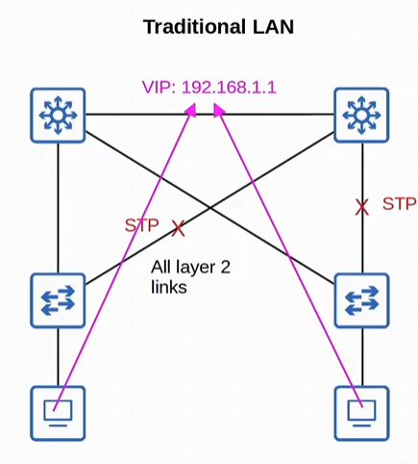
-this is a traditional LAN using STP, and HSRP is used to provide a redundant DG for the end hosts
-must send the traffic to the virtual IP of the HSRP protocol
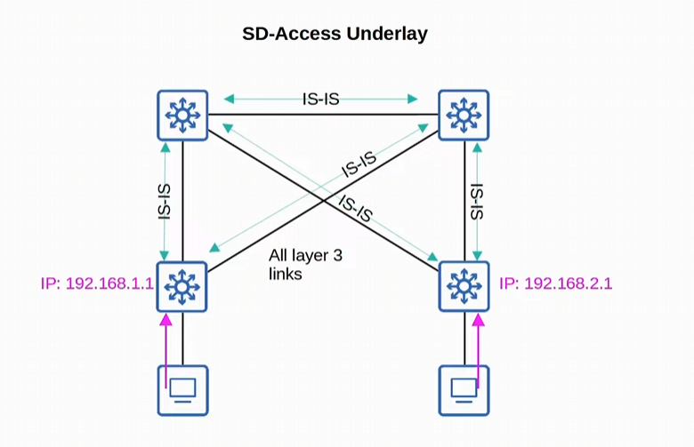
-ALL CONNECTIONS between switches are LAYER 3 and IS-IS is used to exchange routing information
-STP and FHRP aren’t used here!
-Access layer switches are the default gateways of the endhosts
-we are using a routed access layer!

SD-Access Overlay:
-LISP provides the control plane of the SD-Access

-a list of EIDs (endpoint identifiers) to RLOCs (router locators) is kept
-EIDs identify endhosts connected to edge switches
-RLOCs identify the edge switch which can be used to reach the end host

-sort of like a DNS mapping of hosts is used

-Cisco TrustSec (CTS) provides policy control (QoS, security policy, etc.)
-don’t need to know more than that for the CCNA

-VXLAN provides the data plane of SD-Access
-the tunnels actually used to forward in the data plane

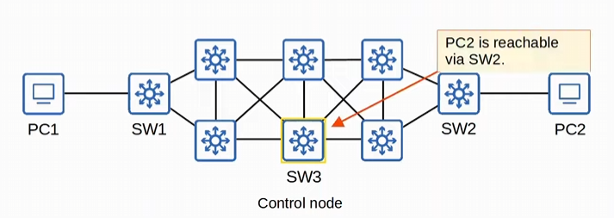
-SW3 creates the mapping to SW2
-PC1 wants to send traffic to PC2
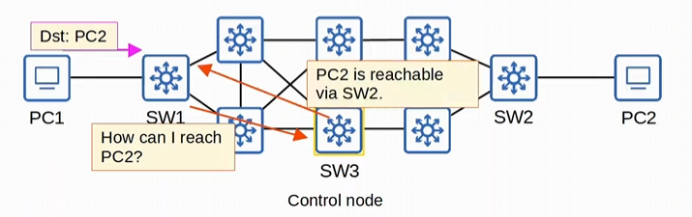
-PC2 sends the traffic to its default gateway SW1
-SW1 asks SW3 how to access PC2, and switch 3 says use this VXLAN tunnel

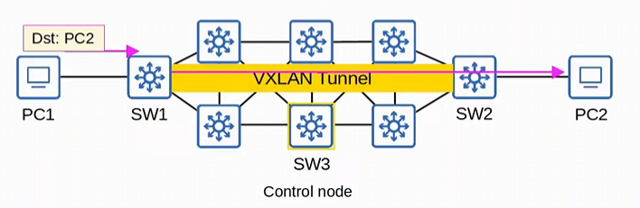
-SW3 is the control node giving information about the mappings!

VXLAN does a lot more than creating tunnels, and provides a lot of features to SD-Access, but that not important for the CCNA

Cisco DNA Centre has two main roles
-SDN controller in SD-Access
-it can be a network manager in a traditional network (non-SD-Access)
-acts like a central point to monitor analyze and configure the network
-we will focus on the SD-Access portion

-DNA Centre is an application installed on Cisco UCS (Unified Computing System) server hardware
-Cisco USC is a server hardware

-it has a REST API which can be used to interact with DNA centre
-the SBI supports protocol such as NETCONF and RESTCONF (as well as traditional protocols like Telnet, SSH, SNMP)

-DNA centre enables Intent-Based Networking (IBN)
-the goal is to allow the engineer to communicate their intent for network behavior to DNA centre, and then DNA Centre will take care of the details of the actual configurations and policies on devices

-Traditional security policies using ACLs can become VERY cumbersome
-ACL can have thousands of entries
-the intent of entries is forgotten with time and as engineers leave and new engineers take over

-DNA Centre allows the engineer to specify the intent of the policy (this group of users can’t communicate with this group, this group can access this server but not that server, etc.)
-DNA Centre will take case of the exact details of implementing the policy

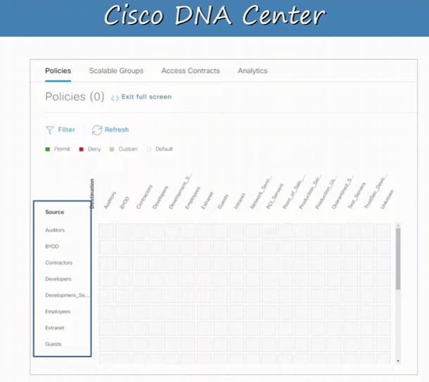
-these are the source groups
-these are destinations groups

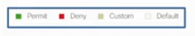
-the policy Legend for the grid
-everything in the grid is white, which is default!

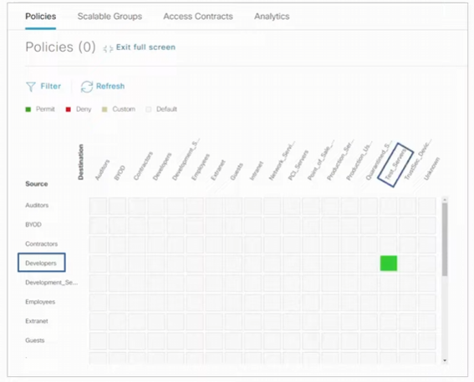
-traffic sourced from developers’ group to the destination of test servers are permitted here
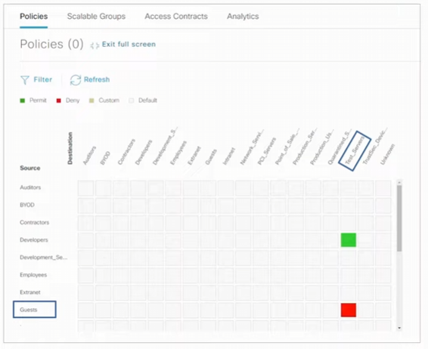
-guests are not permitted to access the test servers
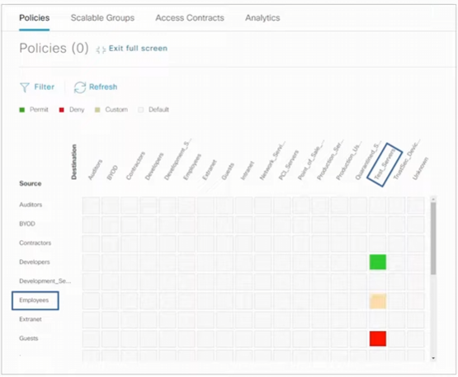
-create a custom policy for various employees!
-engineer can write an explanation for each policy configuration

We can go ahead and define policies with Cisco DNA centre like this, it’s a very simply way.
-won’t need to configure every network device individually, we apply it across the entire SD-Access fabric!

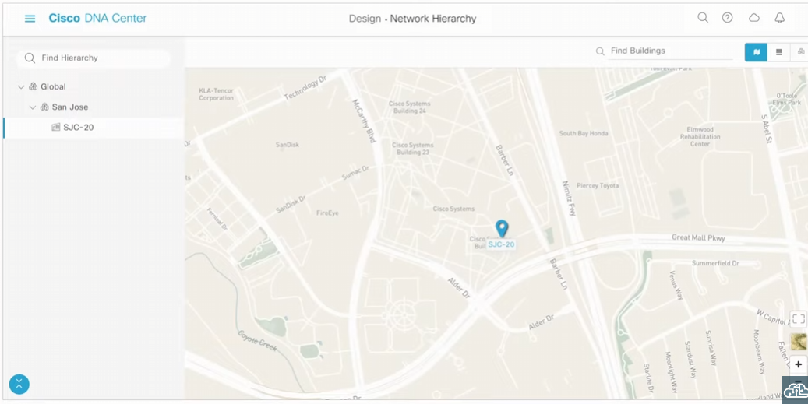
-you can map your network hierarchy around the world
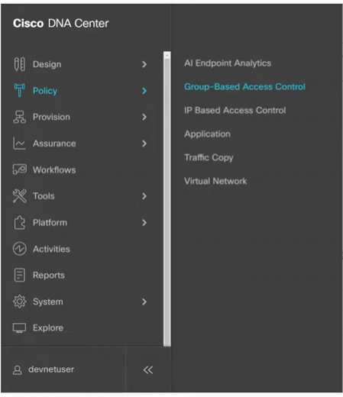
-you can choose a policy (like the group-based access control we just looked at)

-in the provision menu we can add new devices, and manage the device inventory
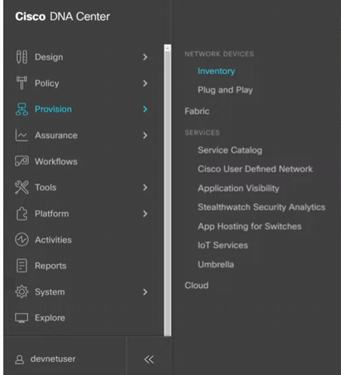
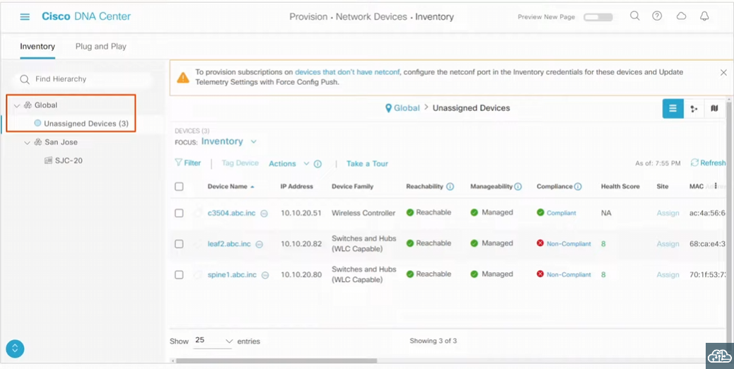
-by default, when you add devices to Cisco DNA centre they will be under the global site until you set it up to a specific site
-managed means their controlled by you, not independent devices (default setting)
-non-compliant devices need to be fixed to become compliant
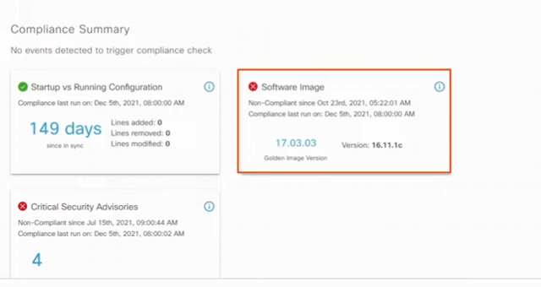
-we can use DNA centre to update this
-security advisory need to be fixed as well

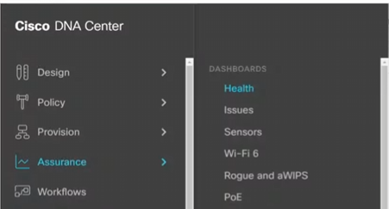
-assurance is to check the health of the system, and if its up and running
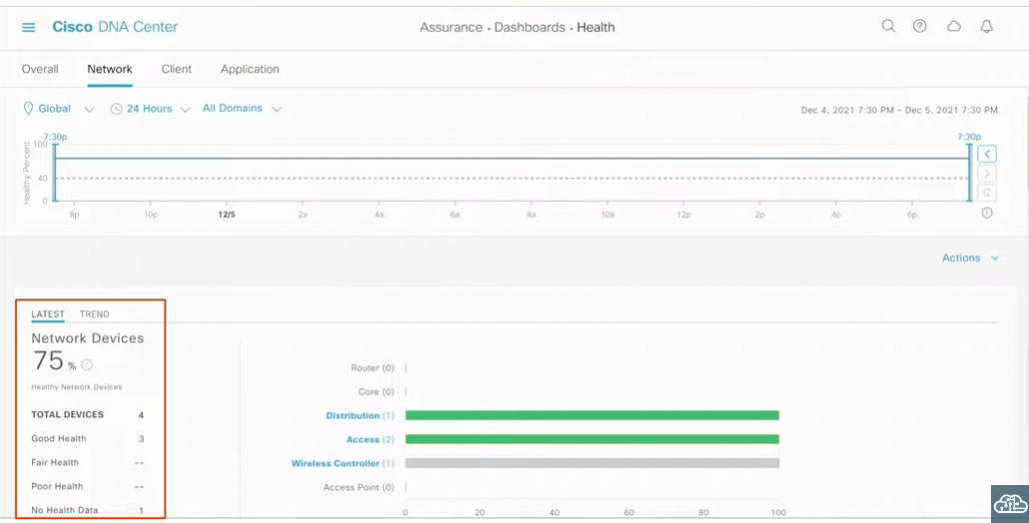
-3 network devices are considered healthy, and 1 of them has no health data

You don’t need to be familiar with all the functions of DNA centre
-understand DNA centre has a role as a network controller in SD-Access Architecture
-DNA Centre can also be a network manager platform for a traditional network

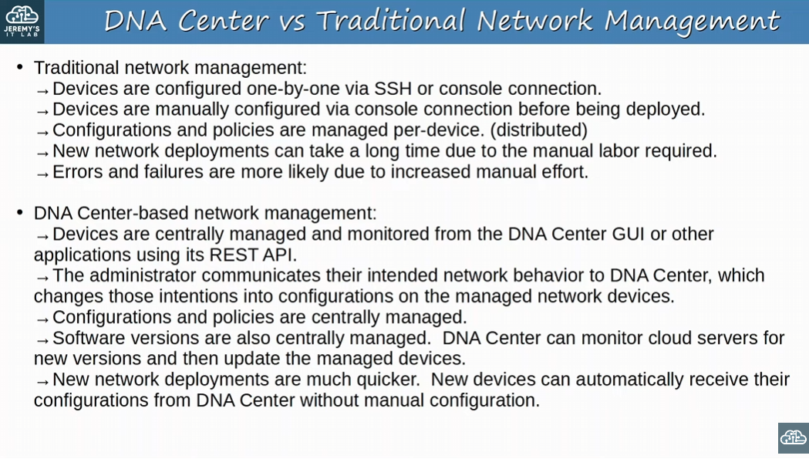
-Important to know this!!
-traditional network management, configs and policies are managed per-device (distributed!)

-DNA Centre-based network management: devices are centrally managed and monitored from the DNA centre GUI or other applications using its REST API

Day 63:
Last Day! You got this!

Looking at Ansible, Puppet, & Chef
-configuration management tools
-some are suitable from some jobs, and others are suitable for others
-depending on the company you work for and its size

Configuration Drift is when individual changes made over time cause a device’s configuration to deviate from the standard/correct configurations as defined by the company
-although each device will have unique parts of its configuration (IP address, host name, etc.) most of a device’s configuration is usually defined in standard templated designed by the network architects/engineers of the company
-as individual engineers make changes to devices (for example to troubleshoot and fix network issues, text configs, etc.), the configuration of a device can drift away from the standard
-records of these individual changes and reasons aren’t kept
-this can lead to future issues (because you don’t know if the configuration is necessary)

-Configuration Management tools can help with this
-but even without the tools, its best to have standard configuration management practices
-for example, when a change is made, save the config as a text file, and place it in a shared folder

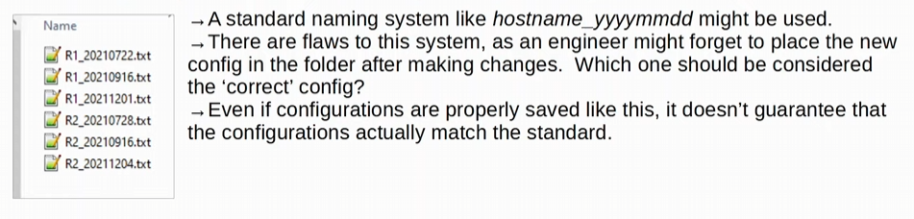
-using a text file
-this manually approach isn’t useful in a system with hundreds of devices

Configuration Provisioning refers to HOW configuration changes are applied to devices
-configuration management tools also help with Configuration Provisioning

-this includes configuring new devices too (not just making changes to current devices)
-traditionally configuration provisioning is done by connecting to devices one-by-one via SSH or console
-not practical in large networks

-Configuration Management Tools like Ansible, Puppet, and Chef allow us to make changes to devices on a mass scale with a fraction of the time/effort
-two essential components in all these tools: Templates and Variables

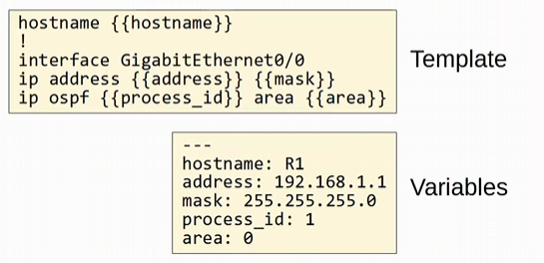
-the configuration management tools (Ansible, Puppet, and Chef) use Templates and Variables

-Templates have no configured values, it’s a template
-Variables have the configured values
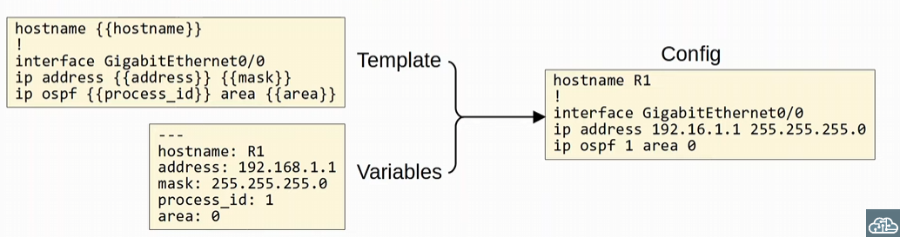
-using the template and the variables, a config is generated and sent to the device
-all devices can share the template, and we just need to specify the variables!

How the template and variables are managed is different depending on the tool
-all use the above system with templates and variables



-Configuration Management Tools are network automation tools that facilitate the centralized control of large numbers of network devices
-popularity wise: Ansible > Puppet > Chef

-these tools weren’t originally developed for the management devices
-originally developed after the rise of VMs, to enable server system admins to automate the process of creating, configuring, and removing VMs
-however, they are also used widely to manage network devices (especially Ansible)

Configuration Management Tools can be used to perform tasks such as:
-generate configuration for new devices on a large scale
-using templates, it’s easy to create new configurations for a new device
-perform configuration changes on devices (all devices in your network, or a certain subset of devices)
-check device configurations for compliance with defined standards
-an alert can be sent out if a client doesn’t match the defined standard
-manually configure the change back to the standard or even automate it

-compare configurations between devices, and between different versions of configurations on the same device

-basically, these tools solve the problem of managing the configurations of devices in networks with hundreds or thousands of devices

Looking at the basics of each configuration management tool
Ansible: configuration management tool owed by Red Hat
-written in Python!
-is Agentless: doesn’t require and special software to run on the managed devices
-ansible uses SSH to connect to devices, make configuration changes, extract information, etc.
-makes ansible very versatile and a HUGE advantage over other tools

-Ansible uses a Push Model. The Ansible server (Control Node) uses SSH to connect to managed devices and push configuration changes to them
-puppet and Chef use a pull model (where the managed devices connect to the server to receive their configurations)

After installing Ansible itself, you must create several text files:
-Playbooks: these files are ‘blueprints of automation task’. They outline the logic and actions of the tasks that Ansible should do
-written in YAML!!!

-Inventory: these files LIST the DEVICES that will be managed by ansible, as well as CHARACTERISTICS of each device such as their device role (access switch, core switch, WAN router, firewall, etc.) Written in INI, YAML, or other formats
-Templates: these files represent a device’s configuration file, but specific values for variables are not provided. Written in Jinja2 format
-Variables: These files list variables and their values. These values are substituted into the templates to create complete configuration files. Written in YAML.

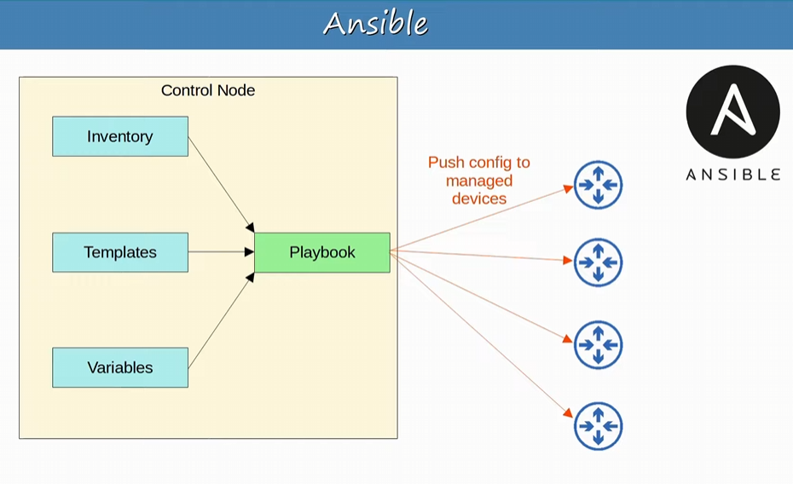
-inventory files provide a list of devices
-template files provide configuration template
- variable files provide specific variable and their values

-inventory files, template files, and variables are put into the playbook, which takes the necessary action to push the config to the managed devices

-know that ansible is agentless, written in Python, uses a push model, uses SSH to connect to devices, and uses YAML for it necessary files

Puppet: is a configuration management tool written in Ruby
-typically, Puppet is agent-based (specific software must be installed on the managed devices)
-the software is called a ‘Puppet agent’
-Not all Cisco devices support a Puppet agent
-another major reason Ansible is more popular for network device management

-Puppet CAN be run agentless, in which a proxy agent runs on an external host, and the proxy agent uses SSH to connect to the managed devices and communicate with them

-Puppet server is called the ‘Puppet master’
-Puppet uses a pull model (clients ‘pull’ configurations from the Puppet master)
-clients use TCP 8140 to communicate with the Puppet master

-Instead of YAML, it uses a proprietary language for files

Text files required on the Puppet master includes:
-Manifest: This file defines the desired configuration state of network devices
-Puppet master uses the Manifest file to generate specific configurations for the managed devices
-Templates: Similar to Ansible Templates. Used to generate manifests for the devices

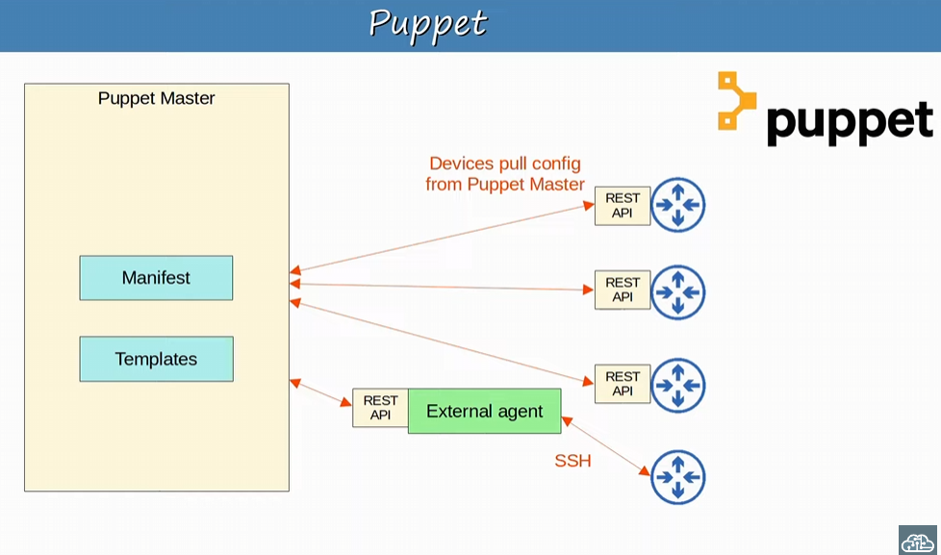
-some devices have a puppet agent installed, which provides a REST API to communicate with the device (agent based)
-one doesn’t, and it will communicate via the external agent
-agent-less

-in both cases, the network devices are able to PULL configurations from the Puppet master

Remember Puppet is written in Ruby, is typically agent-based, the server is called the Puppet Master, it uses a pull model, clients use TCP 8140 to communicate with the Puppet master, it uses a proprietary language for its files instead of YAML, and uses Manifests to define the desired configuration state of devices

Chef: is a configuration management tool written in Ruby
-Agent-based (specific software must be installed on the managed devices)
-most Cisco devices don’t support a Chef agent
-least popular of the three choices
-Uses a Pull model
-like Puppet

-server uses TCP 10002 to send configurations to clients
-files use a DSL (Domain-specific Language) based on Ruby

Text files used by Chef include:
-Resources: the ‘ingredients’ in a recipe. Define configuration objects managed by Chef!
-for example, configuration object could be a set of configuration commands
-Recipes: the ‘recipes’ in a cookbook. Outline the logic and actions of the tasks performed on the resource.
-Cookbooks: a set of related recipes grouped together
-Run-list: an ordered list of recipes that are run to bring a device to the desired configuration state

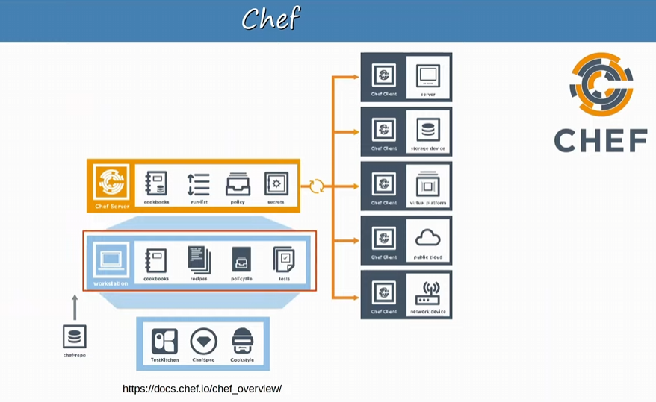
-Admins will do their work on a Chef Workstation, a computer they use to prepare cookbooks, recipes etc.
-required information is stored on a Chef server, and managed devices, the chef clients, communicate with the Chef server

-possible clients include servers, storage devices, virtual platforms, public clouds, and of course network devices
-Chef wasn’t primarily made for network devices! (Much like the Ansible and Puppet)

Remember Chef is written in Ruby, is agent-based, uses a pull model, uses TCP 10002 to send configurations, and its files such as cookbooks use a language based on Ruby

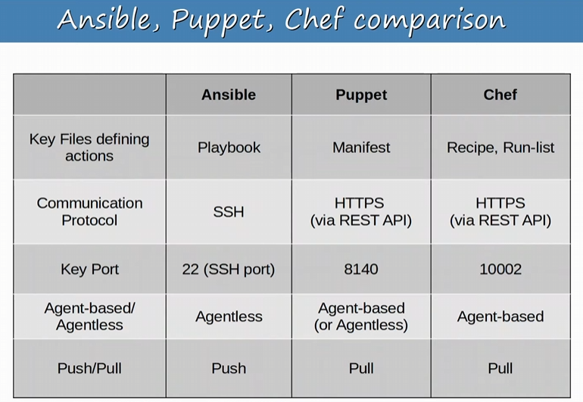
-Puppet and Chef are written in Ruby, Ansible is written in Python
-Puppet and Chef use pull model, Ansible uses a push model with SSH
-chef does use other ports too, but just remember 10002

-Puppet and Chef use HTTPs via a REST API

-Ansible Puppet and Chef all use a client server model!

AND WE ARE DONE!

